Supplementary figures and figure legends
Supplementary figure 1
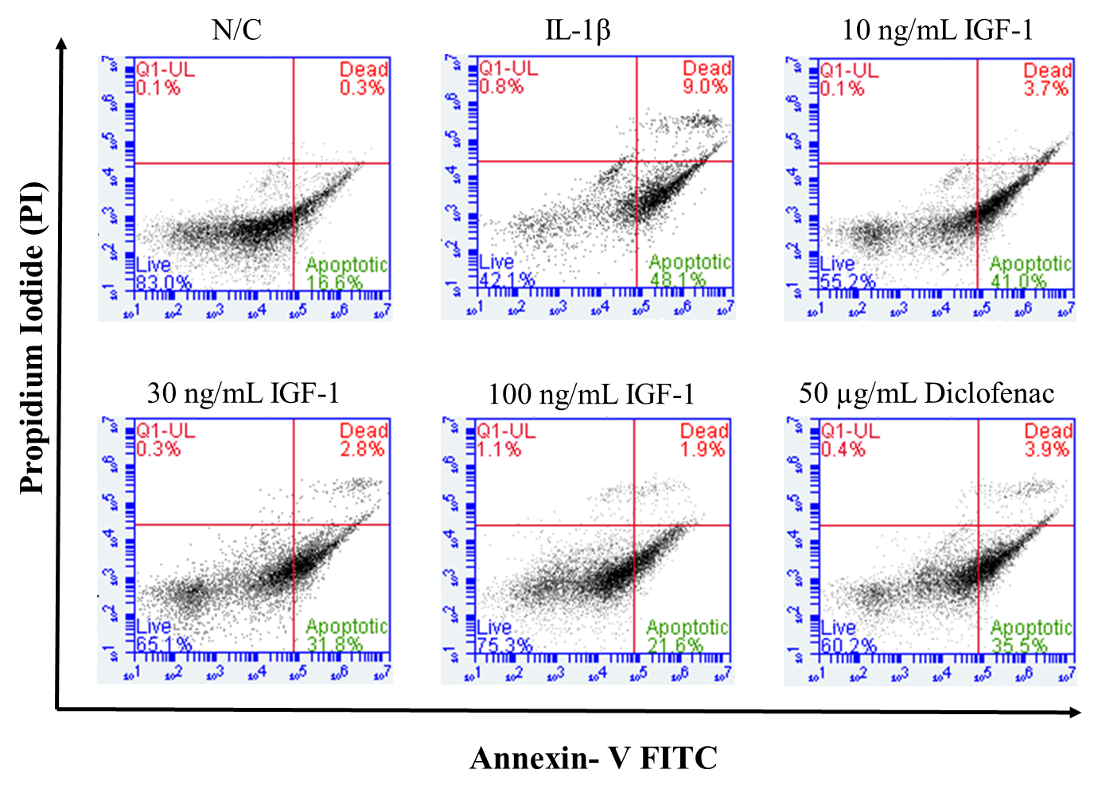

Supplementary figure 1:
Evaluations of cell apoptosis of chondrocytes was performed by flow cytometry analysis (BD AccuriTM) according to the Annexin V/PI method (FITC Annexin V apoptosis Detection Kit, BD pharmingen). Cells were plated in a 6-well plate at a density of 5x10⁶ cells/well. Chondrocytes were pretreated with various doses of IGF-1 for 1 h, stimulated with IL-1β for 24 h. The result showed that the rates of apoptosis cells significantly increased in the IL-1β group whereas the IGF-1 dose dependently decreased.

Supplementary figure 2
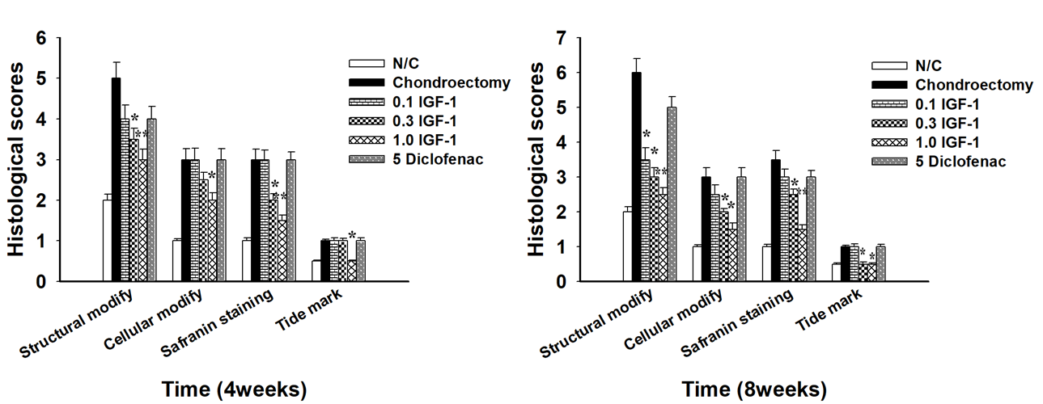

Supplementary figure 2:
According to the Mankin score histological evaluation of rabbit femoral articular cartilage was identified as defined in the table 2. The IGF-1 significantly repaired the cell morphology in rabbits defect articular cartilage with smooth surface. Values are the mean ± SD. * p < 0.05, and ** p < 0.01.

