SUPPLEMENTARY DOCUMENT

Mandibular movements are a reliable noninvasive alternative to esophageal pressure for measuring respiratory effort during sleep apnea syndrome
Jean-Louis Pépin^{1§}
Nhat-Nam Le-Dong^{2,§}
Valérie Cuthbert³
Nathalie Coumans³
Renaud Tamisier¹
Atul Malhotra^{4*}
Jean-Benoit Martinot^{3,5*}
§Co-first authors
*Co-second authors

¹HP2 Laboratory, Inserm U1300, University Grenoble Alpes, Grenoble, France; ²Sunrise, Namur, Belgium; ³Sleep Laboratory, CHU Université Catholique de Louvain (UCL) Namur Site Sainte-Elisabeth, Namur, Belgium; ⁴University of California San Diego, La Jolla, CA, USA; ⁵Institute of Experimental and Clinical Research, UCL Bruxelles Woluwe, Brussels, Belgium

Physiological aspects and significance of the mandibular signal
During wakefulness, upper airway muscles are involved in complex interactions allowing to prioritize or combine breathing, swallowing, speech or masticatory activities.
The position and movements of the mandible are key during sleep to preserve or restore upper airway patency by stiffening pharyngeal walls.^{1,2} Such mandibular movements are reflecting both respiratory drive and variations in upper airway resistances typically occurring during abnormal respiratory events.
The following figures are depicting typical changes in mandibular movements and position concurrently recorded with classical respiratory effort signals during obstructive and central episodes in a sleep apnea patient. The signal of mandibular movements was inserted in the polysomnograph for comparison with the other PSG conventional signals.

Episodes of obstructive apneas and hypopneas
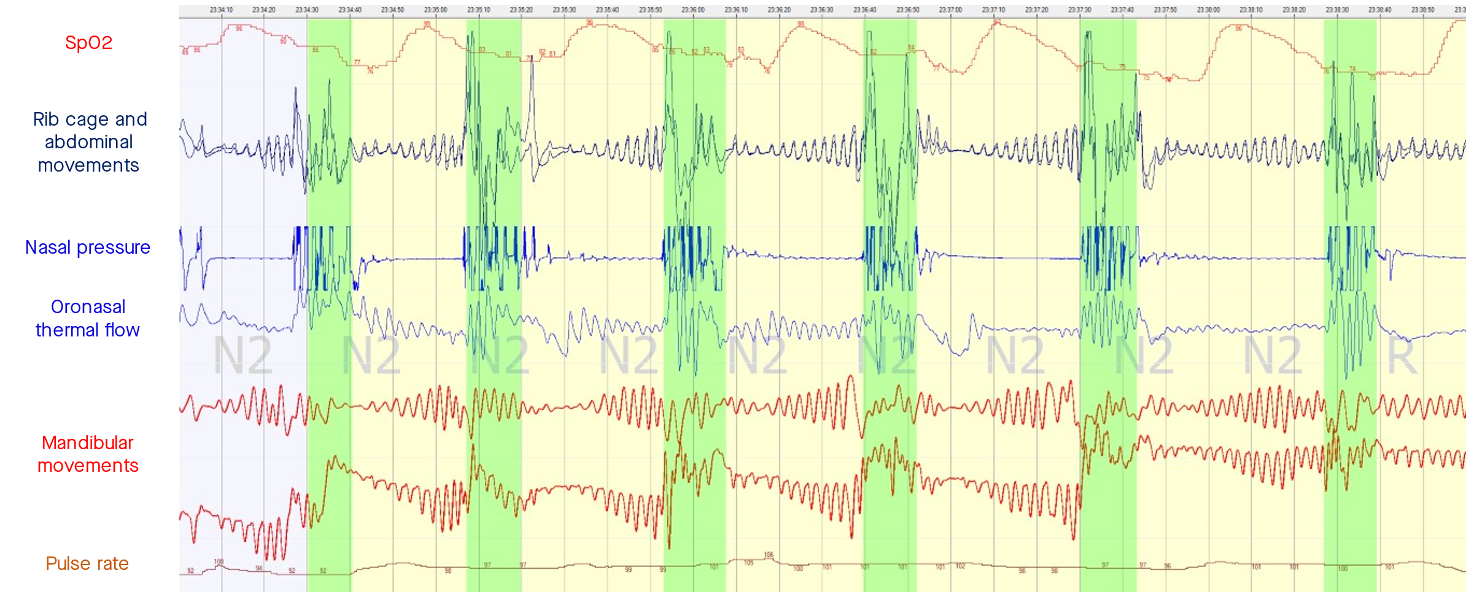
From the top to the bottom: Sp02, the RIP bands, nasal pressure, the oronasal thermistors and the signals of mandibular movements (issued from the gyroscope and the accelerometer). The respiratory drive increases during obstructive events as shown by the gyroscope in accordance with the bands signals. The more negative the signal of the accelerometer the more mouth opens until an arousal occurs closing the mouth and preceding flow restoration.
Opposite patterns occur during central episodes: no mandibular jaw movements with a mild passive mouth opening due to the decrease in the drive addressed to the mandible elevators muscles.

Episodes of central apneas
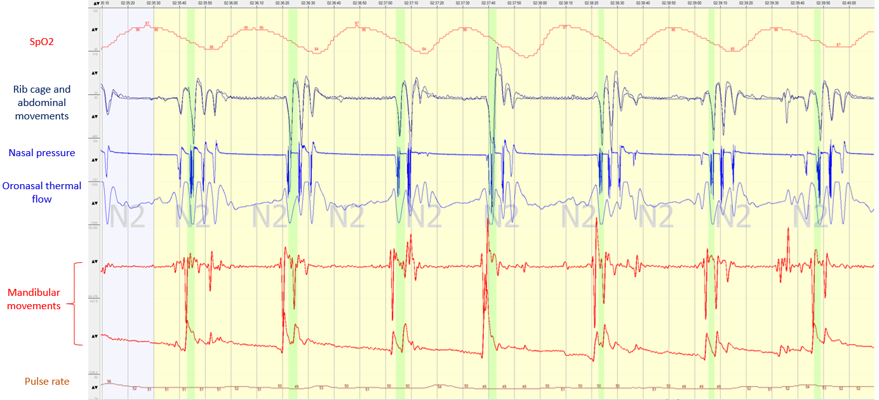
Again, in this study, mandibular movements monitoring does not attempt to assess the masticatory muscle activities directly, but the translocation/displacement of the mandible is providing a surrogate signal of respiratory effort.^{3,4}

Technical aspects regarding capture and measurements of sleep mandibular movements
In a normal situation the mandibular jaw moves slightly around a fixed position and the mouth is almost closed during sleep. Only a physiological displacement of a few tenths of mms related to the respiratory cycle and controlled by the respiratory centers occurs during normal sleep. This rotational movement is produced by the rotation of the mandibular condyle in the temporo-mandibular joint.
The Sunrise device measures the position and the movements of the mandible with a small sensor taped on the chin that captures:
- the displacement of the mandible is provided with the rotational speed measured by a gyroscope;
- the position of the mandible, resulting from elevation or depression, is provided by an accelerometer.
These are 3 dimensional inertial measurement units providing 6 derived channels in total. Some channels are more informative overtime depending on the body, head and mandible position.

Supplementary Figure 1. A 5-minute example of polysomnography data showing esophageal pressure (PES) and mandibular jaw movement (MM) signal patterns during successive episodes of mixed and central apneas (GyrX and and AccZ are gyroscope and accelerometer MM signals, Flow P is flow pressure, Th.Flow is thermistance oronasal flux, and RIP is respiratory inductive plethysmography of the chest and the abdomen).
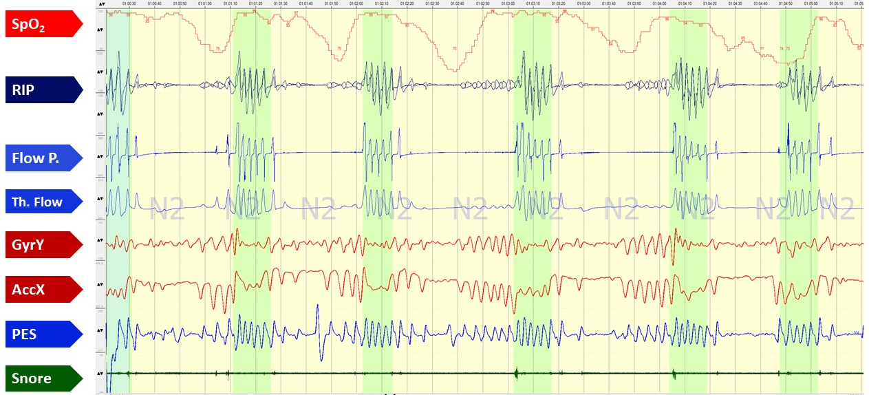

Supplementary Table 1. Details of normal breathing and the different respiratory event periods.
Events | n | Median duration (s) | Mean duration (s) | SD | 5th centile |  | 95th centile
Normal breathing | 1481 | 55.90 | 102.74 | 165.76 | 30.90 | 310.60
RERA | 874 | 105.10 | 244.72 | 403.72 | 19.23 | 938.50
Obstructive hypopnea | 2519 | 21.70 | 25.43 | 16.31 | 11.10 | 51.95
Central hypopnea | 1180 | 19.55 | 21.17 | 10.41 | 10.80 | 32.91
Obstructive apnea | 100 | 20.50 | 21.63 | 6.76 | 12.98 | 32.62
Central apnea | 1233 | 13.90 | 15.97 | 6.10 | 9.76 | 29.12
Mixed apnea | 655 | 20.80 | 21.69 | 7.00 | 12.50 | 33.63
CI, confidence interval; RERA, respiratory effort-related arousal; SD, standard deviation.

Supplementary Table 2. Number and duration of normal breathing and the different types of respiratory events.
Events | Number of points | Duration (h) | Duration (min) | Proportion (%)
Normal | 425267 | 11.81 | 708.78 | 20.37
RERA | 1316182 | 36.56 | 2193.64 | 63.05
Obstructive hypopnea | 158024 | 4.39 | 263.37 | 7.57
Central hypopnea | 72700 | 2.02 | 121.17 | 3.48
Obstructive apnea | 5159 | 0.14 | 8.60 | 0.25
Central apnea | 72125 | 2.00 | 120.21 | 3.46
Mixed apnea | 38027 | 1.06 | 63.38 | 1.82
RERA, respiratory effort-related arousal.

Supplementary Table 3. Distribution of esophageal pressure (PES) signal amplitude during the scored period of normal breathing and the scored breathing disturbances.
 | PES signal amplitude (mmHg)
 | Mean | SD | Percentile
 |  |  | 5% | 25% | 50% | 75% | 95%
Central apnea | 1.74 | 1.09 | 0.59 | 0.98 | 1.43 | 2.13 | 4.12
Central hypopnea | 8.59 | 2.89 | 3.68 | 6.38 | 8.70 | 10.81 | 13.13
Normal breathing | 8.99 | 4.69 | 1.65 | 5.06 | 9.07 | 12.77 | 16.40
Mixed apnea | 12.36 | 6.10 | 3.87 | 8.36 | 11.98 | 15.35 | 21.33
RERA | 17.74 | 10.89 | 2.94 | 10.46 | 14.78 | 24.12 | 37.88
Obstructive hypopnea | 19.06 | 10.32 | 3.21 | 12.27 | 16.67 | 25.22 | 39.81
Obstructive apnea | 22.06 | 9.53 | 10.91 | 14.37 | 19.86 | 28.10 | 40.98
RERA, respiratory effort-related arousal; SD, standard deviation.

Supplementary Table 4. Distribution of gyroscope mandibular jaw movement (MM-Gyr) signal amplitude during the scored period of normal breathing and the scored breathing disturbances.
 | MM-Gyr signal amplitude (degrees/s)
 | Mean | SD | Percentile
 |  |  | 5% | 25% | 50% | 75% | 95%
Central apnea | 0.875 | 0.958 | 0.165 | 0.398 | 0.604 | 0.986 | 2.426
Central hypopnea | 1.515 | 1.721 | 0.225 | 0.408 | 0.827 | 2.084 | 4.715
Normal | 2.123 | 3.464 | 0.269 | 0.635 | 1.177 | 2.577 | 6.081
Mixed apnea | 2.343 | 1.759 | 0.539 | 1.212 | 1.933 | 2.973 | 5.572
RERA | 3.608 | 3.991 | 0.462 | 1.019 | 1.990 | 4.807 | 12.436
Obstructive hypopnea | 5.509 | 6.133 | 0.721 | 1.794 | 3.231 | 6.997 | 18.087
Obstructive apnea | 9.708 | 8.812 | 0.881 | 1.855 | 6.423 | 15.945 | 26.809
RERA, respiratory effort-related arousal; SD, standard deviation.

Supplementary Table 5. Distribution of accelerometer mandibular jaw movement (MM-Acc) signal amplitude during the scored period of normal breathing and the scored breathing disturbances.
 | MM-Acc signal amplitude (m/s²)
 | Mean | SD | Percentile
 |  |  | 5% | 25% | 50% | 75% | 95%
Central apnea | 0.004 | 0.007 | 0.001 | 0.001 | 0.002 | 0.004 | 0.012
Central hypopnea | 0.007 | 0.008 | 0.001 | 0.002 | 0.004 | 0.009 | 0.021
Normal | 0.012 | 0.022 | 0.001 | 0.004 | 0.007 | 0.014 | 0.031
Mixed apnea | 0.012 | 0.010 | 0.002 | 0.006 | 0.009 | 0.015 | 0.031
RERA | 0.018 | 0.021 | 0.003 | 0.006 | 0.011 | 0.023 | 0.058
Obstructive hypopnea | 0.026 | 0.030 | 0.004 | 0.008 | 0.016 | 0.029 | 0.094
Obstructive apnea | 0.035 | 0.027 | 0.004 | 0.008 | 0.032 | 0.055 | 0.077
RERA, respiratory effort-related arousal; SD, standard deviation.

References:
- Isono S. (2004). Contribution of obesity and craniofacial abnormalities to pharyngeal collapsibility in patients with obstructive sleep apnea. Sleep and Biological Rhythms, 2(1), 17-21
- Ayappa I., & Rapoport DM. (2003). The upper airway in sleep: physiology of the pharynx. Sleep medicine reviews, 7(1), 9-33
- Martinot JB. et al. (2020). Bruxism relieved under CPAP treatment in a patient with OSA syndrome. Chest, 157(3), e59-e62
- Martinot et al (2021). Artificial Intelligence Analysis of Mandibular Movements Enables Accurate Detection of Phasic Sleep Bruxism in OSA Patients: A Pilot Study. Nature and science of sleep, 13, 1449

