ORIGINAL RESEARCH

M. Takikawa et al

# Intracellular distribution of lipids and encapsulated model drugs composing cationic liposomes with different uptake pathways

Masato Takikawa1, Mizuki Fujisawa2, Kazuma Yoshino2, Shinji Takeoka2,3

1Department of Advanced Science and Engineering, Faculty of Advanced Science and Engineering, Waseda University, Shinjuku-ku, Tokyo 162-8480, Japan; 2Department of Life Science and Medical Bioscience, Faculty of Advanced Science and Engineering, Waseda University (TWIns), Shinjuku-ku, Tokyo 162-8480, Japan; 3Institute for Advanced Research of Biosystem Dynamics, Waseda Research Institute for Science and Engineering, Waseda University, Tokyo 169-8555, Japan

Correspondence: Shinji Takeoka

Department of Life Science and Medical Bioscience, Faculty of Advanced Science and Engineering, Waseda University (TWIns), Shinjuku-ku, Tokyo 162-8480, Japan

Tel +81-3-5369-7324

Fax +81-5369-7324

Email takeoka@waseda.jp

ORCID:

Masato Takikawa: 0000-0003-4856-9717

Shinji Takeoka: 0000-0002-6230-1517

**Table S1** Stability test of cationic liposomes encapsulating FITC-dextran (n = 1).



**Notes:** Liposomes were stored at 4°C in dark for at most 5 days.

**Abbreviation:** PDI, polydispersity index.

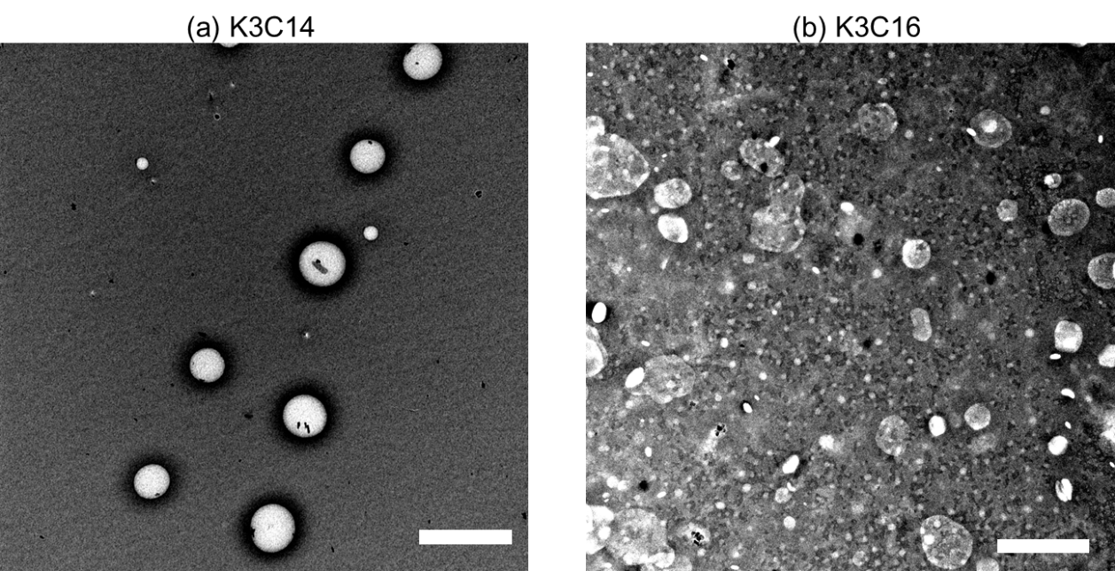

**Figure S1** TEM images of cationic liposomes composed of K3C14 (a) or K3C16 (b). Scale bar: 50 nm.

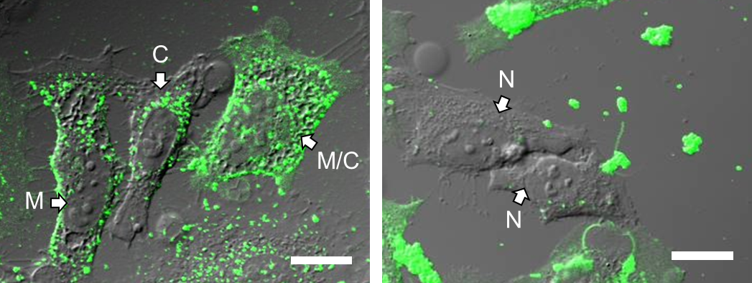

**Figure S2** Representative images of intracellular distribution of cationic lipids fluorescently labelled with Alexa Fluor® 488. The distribution of fluorescent lipids was classified in four grades: on the membrane (M); on the membrane and in the cytosolic space (M/C); in the cytosolic space (C); and not taken up (N). Scale bar: 10 μm.

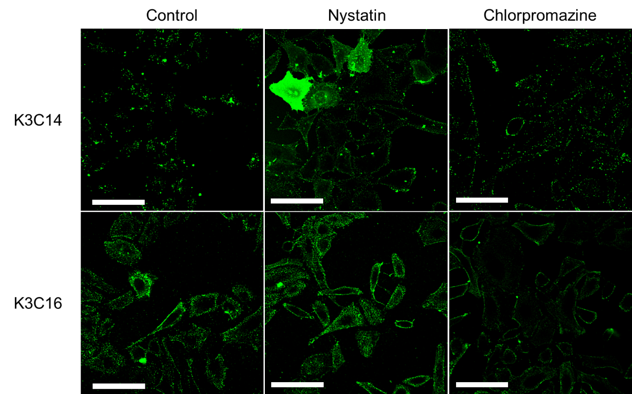

**Figure S3.** Representative confocal laser scanning microscopic images of HeLa cells treated with cationic liposomes after the treatment with endocytosis inhibitors. Cationic liposomes composed of K3C14 or K3C16 were modified with Alexa Fluor® 488 on their membrane, and were treated for 20 min to HeLa cells after the treatment for 30 min with endocytosis inhibitors including nystatin or chlorpromazine, which are caveolae- or clathrin-dependent endocytosis inhibitors, respectively. Concentration of cationic liposomes: 100 mM. Concentration of each endocytosis inhibitors: 10 mg/mL. Scale bar: 50 mm.