**Supplementary information**

**A caner targeted and redox-responsive mesoporous silica nanoparticle for control release of Doxorubicin and siRNA against metastatic breast cancer**

Jialang Zhuang1,2#, Siqi Chen1#, Ye Hu1, Fan Yang1, Qin Huo1 and Ni Xie1*

1Biobank, Shenzhen Second People’s Hospital, First Affiliated Hospital of Shenzhen University, Shenzhen 518035, People’s Republic of China;

2Shenzhen institute of advanced technology, Chinese academy of sciences, Shenzhen 518035, People’s Republic of China.

# These authors contributed equally to this work.

Corresponding Author:

*Email for Ni Xie: xn100@szu.edu.cn

includes:

Supplementary Figures. S1-S8

Supplementary Table S1-S2

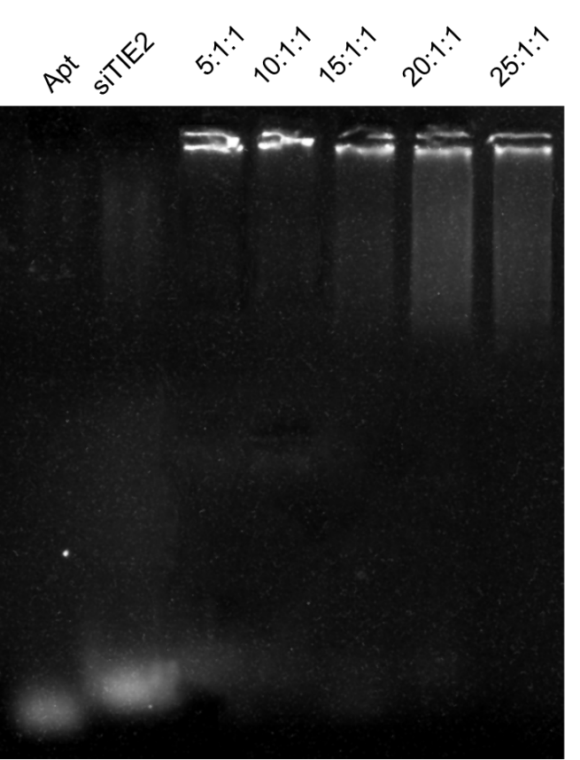

**Figure S1. Binding of Aptamer and siRNA in developed NPs at different ratio**



**Figure S2. Components of the siRNA and Apt in MSN-siRNA/Apt.**

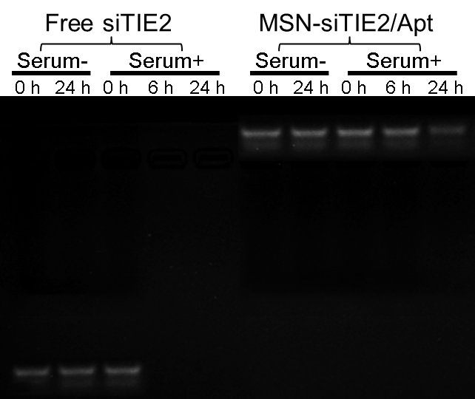

**Figure S3. Stability profile of siTIE2 in absence of serum (Serum-) and in presence of serum (Serum+) as evaluated by gel electrophoresis.**

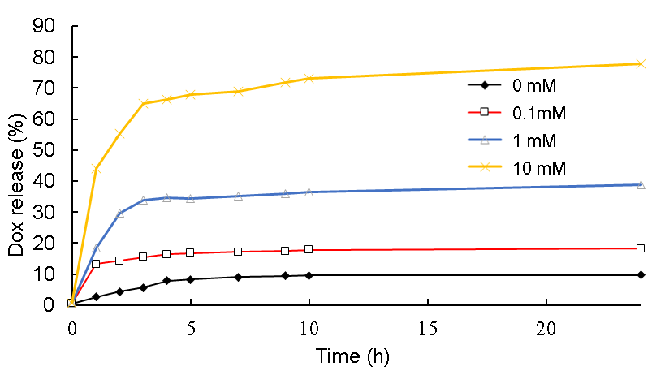

**Figure S4. DOX release from MSN-siTIE2/Apt@dox with different concentrations of GSH (0 mM, 0.1 mM, 1 mM, 10 mM).**



**Figure S5. Cellular uptake of MSN-siTIE2 and MSN-siTIE2/Apt among HEK293T and MDA-MB-231**



**Figure S6. Cancer-targeting capacity of MSN-siRNA/Apt@Dox *in vivo*.**

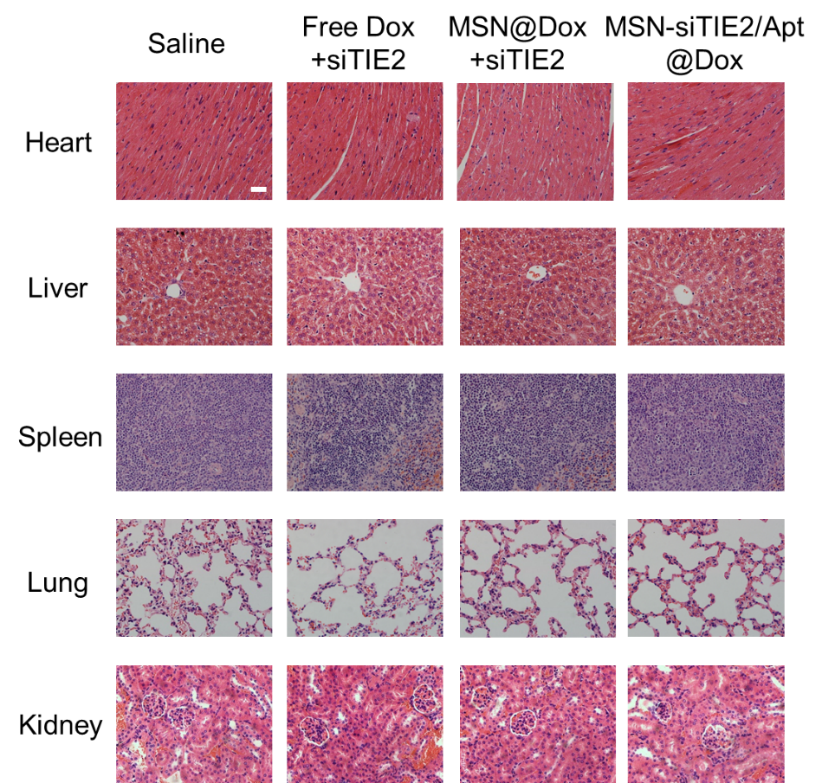

**Figure S7. H＆E staining of major organs of mice treated with different dox and siRNA-loaded nanoparticles**



**Figure S8. The quantification of the lung metastasis nodules in mice against different treatments**

**Table S1. Physical characterization of the obtained MSNs**

|  |  |  |  |
| --- | --- | --- | --- |
| NPs | Hydrodynamic size (nm) (PBS) | PDI | Zeta potential (mV) |
| MSN | 124.23 | 0.074 | -13.4 |
| MSN-SH | 130.9 | 0.062 | -21.7 |
| MSN-siTIE2/Apt | 156.6 | 0.299 | -44.3 |

**Table S2. Plasma pharmacokinetic parameters of doxorubicin in different groups after IV** **administration of Dox, MSN@Dox and MSN-siRNA/Apt@Dox.**

|  |  |  |  |
| --- | --- | --- | --- |
| Parameters | Formulations | | |
| Free Dox | MSN@Dox | MSN-siRNA/Apt@Dox |
| *C*max(ng/mL) | 132.59±12.59 | 103.72±5.23 | 116.97±14.04 |
| *t*1/2(h) | 8.14±0.26 | 9.28±1.84 | 17.49±3.68 |
| MRT (h) | 5.37±0.97 | 6.43±1.30 | 8.14±3.65 |
| *AUC*0-t(ng/mL·h) | 632.18±18.91 | 711.13±59.83 | 875.31±49.36 |
| *AUC*0→∞(ng/mL·h) | 717.59±25.02 | 841.78±117.24 | 1396.28±238.61 |