**Supporting Information**

Size and PEG Length-controlled PEGylated Monocrystalline Superparamagnetic Iron Oxide Nanocomposite for MRI Contrast Agent

Lihua Deng1,2, Hai Jiang1, Fulin Lu1, Hanwei Wang1, Yu Pu1, Changqiang Wu1*, Hongjie Tang3, Ye Xu4, Tianwu Chen1, Jiang Zhu1, Chengyi Shen1, Xiaoming Zhang1*

1 Sichuan Key Laboratory of Medical Imaging and School of Medical Imaging, Affiliated Hospital of North Sichuan Medical College, Nanchong 637000, China

2 Department of Radiology, First People's Hospital of Neijiang, Neijiang 641000, China

3 Department of Radiology, Nanchong Hospital of Traditional Chinese Medicine, Nanchong 637000, China

4 Department of Radiology, Children’s Hospital of Chongqing Medical University, Chongqing 401122, China

*Corresponding author: C. Wu (wucq1984@163.com); Xiaoming Zhang (zhangxm@nsmc.edu.cn)

**1. Synthesis of SPIO nanocrystals**

**Chemicals.** Iron (Ⅲ) acetylacetonate (Fe(acac)3, 99 %), 1,2-hexadecanediol (THCH, 90%), oleic acid (CH3(CH2)7CH=CH(CH2)7COOH, 90%), oleylamine (CH3(CH2)7CH=CH(CH2)7CH2HN2, 70%), phenyl ether, benzyl ether, 1-octadecylene, carbonyldiiazole, and mPEG-OH (Mn = 550, 2k, or 5k Da) were purchased from Sigma-Aldrich. All chemicals were used as received without further purification. Ultrapure water (18 MΩ/cm) in all experiments was obtained by passing through an ultra-pure purification system.

**Synthesis of 4 nm SPIO nanocrystal.** Fe(acac)3 (1 mmol), 1,2-hexadecanediol (5 mmol), oleic acid (3 mmol), oleylamine (3 mmol), and phenyl ether (10 ml) were mixed and magnetically stirred under a flow of nitrogen after deoxidized in a two-necked flask. The mixture was heated to 200 °C for 30 min. Then, under a blanket of nitrogen, the mixture was heated to reflux (265 °C) for another 30 min. The black-brown mixture was cooled to room temperature by removing the heat source. Under ambient conditions, ethanol (160 mL) was added to the mixture, and a black material was precipitated and separated via centrifugation (5000 rpm, 10 min). The black product was dissolved in hexane, centrifugation (12000 rpm, 20 min) was applied to remove any undispersed residue. The productwas then precipitated with ethanol, centrifuged (6000 rpm, 10 min) to remove the solvent, and redispersed into hexane.

**Synthesis of 6 nm SPIO nanocrystal.** Fe(acac)3 (1 mmol), 1,2-hexadecanediol (5 mmol), oleic acid (3mmol), oleylamine (3 mmol), and benzyl ether (10 ml) were mixed and magnetically stirred under a flow of nitrogen after deoxidized in a two-necked flask. The mixture was heated to 200 °C for 2 h. Then, under a blanket of nitrogen, the mixture was heated to reflux (∼290 °C) for 1 h. The black-colored mixture was cooled to room temperature by removing the heat source. Following the workup procedures described in the synthesis of 4 nm SPIO.

**Synthesis of 8 nm SPIO nanocrystal.** Fe(acac)3 (1 mmol), 1,2-hexadecanediol (5 mmol), oleic acid (3 mmol), oleylamine (3 mmol), and 1-octadecylene (10 ml) were mixed and magnetically stirred under a flow of nitrogen after deoxidized in a two-necked flask. The mixture was heated to 200 °C for 2 h. Then, under a blanket of nitrogen, the mixture was heated to reflux (∼310 °C) for 1 h. The black-colored mixture was cooled to room temperature by removing the heat source. Following the workup procedures described in the synthesis of 4 nm SPIO.

**2. Supporting Figures and Tables**



**Figure S1** Synthesis scheme of dopamine-modified polyethylene glycol (mPEG-DA)

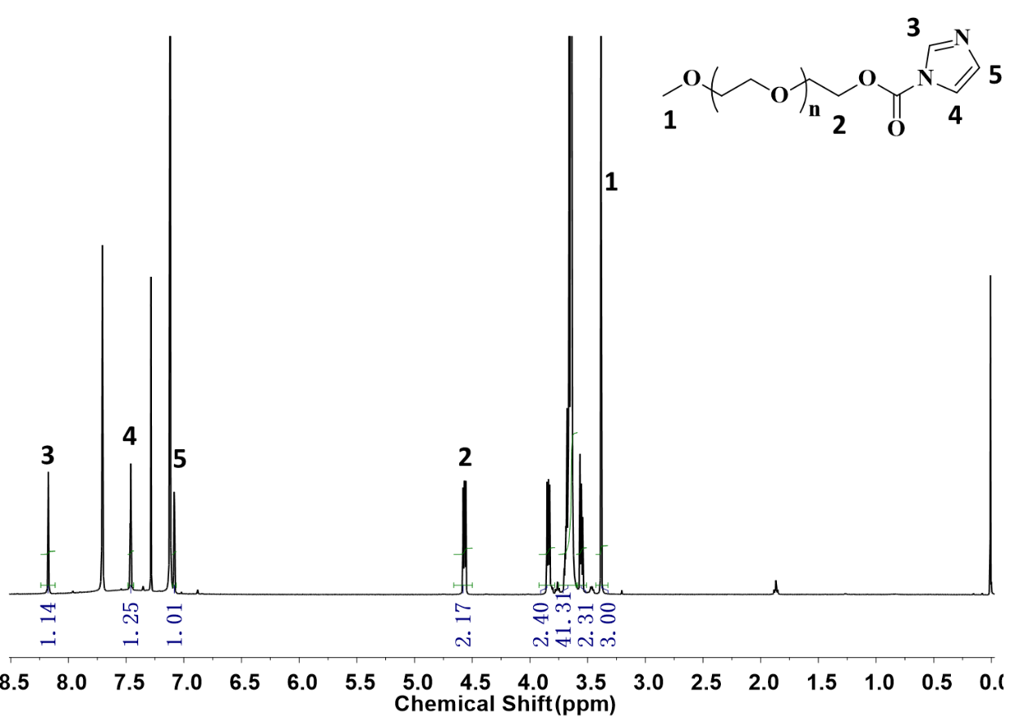

**Figure S2** 1H NMR spectra (CDCl3) and characteristic peaks assignment of mPEG-CI (Mn = 550 Da)

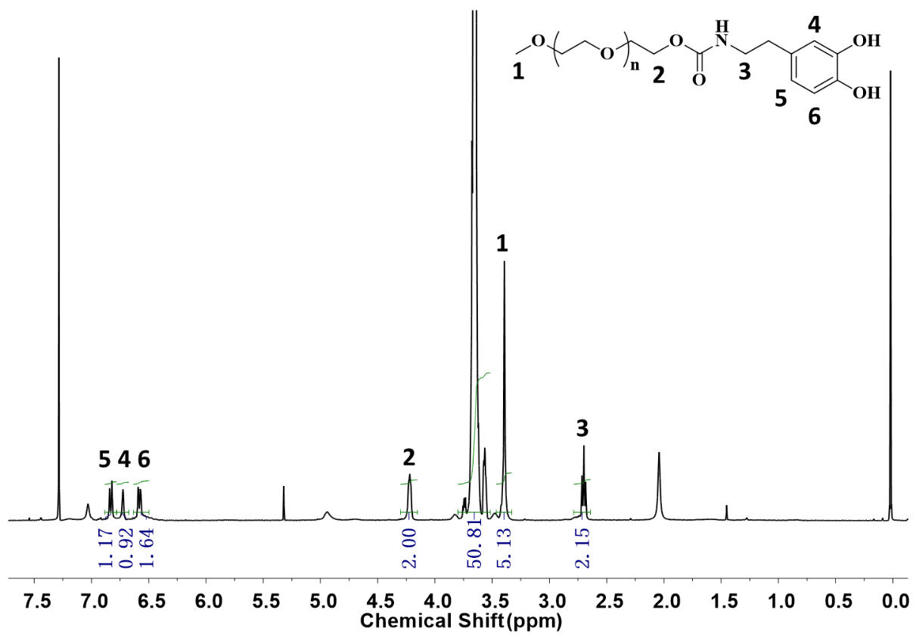

**Figure S3** 1H NMR spectra (CDCl3) and characteristic peaks assignment of mPEG-DA (Mn = 550 Da)

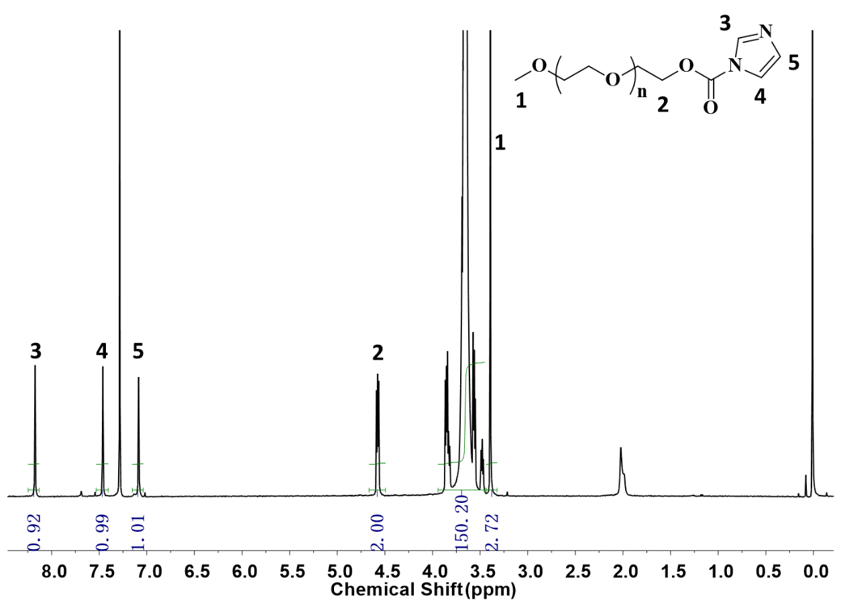

**Figure S4** 1H NMR spectra (CDCl3) and characteristic peaks assignment of mPEG-CI (Mn = 2k Da)

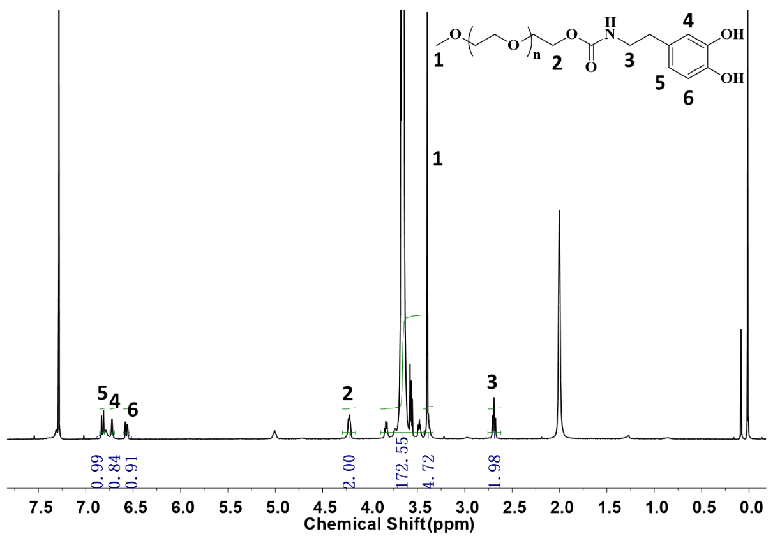

**Figure S5** 1H NMR spectra (CDCl3) and characteristic peaks assignment of mPEG-DA (Mn = 2k Da)

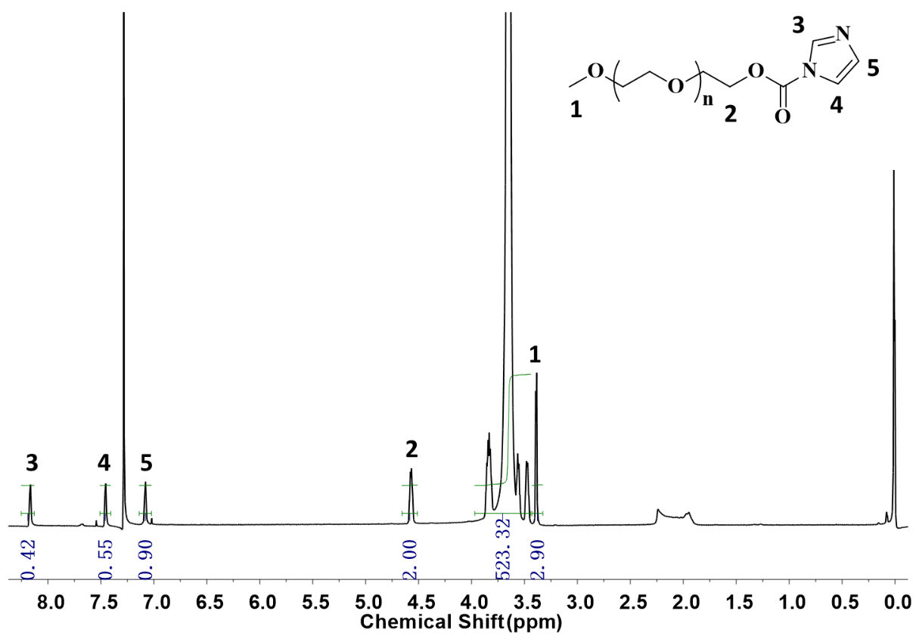

**Figure S6** 1H NMR spectra (CDCl3) and characteristic peaks assignment of mPEG-CI (Mn = 5k Da)

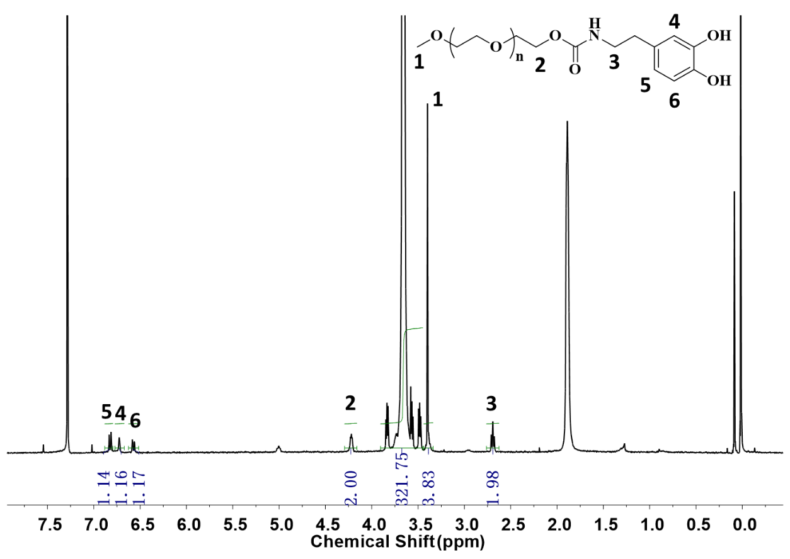

**Figure S7** 1H NMR spectra (CDCl3) and characteristic peaks assignment of mPEG-DA (Mn = 5k Da)

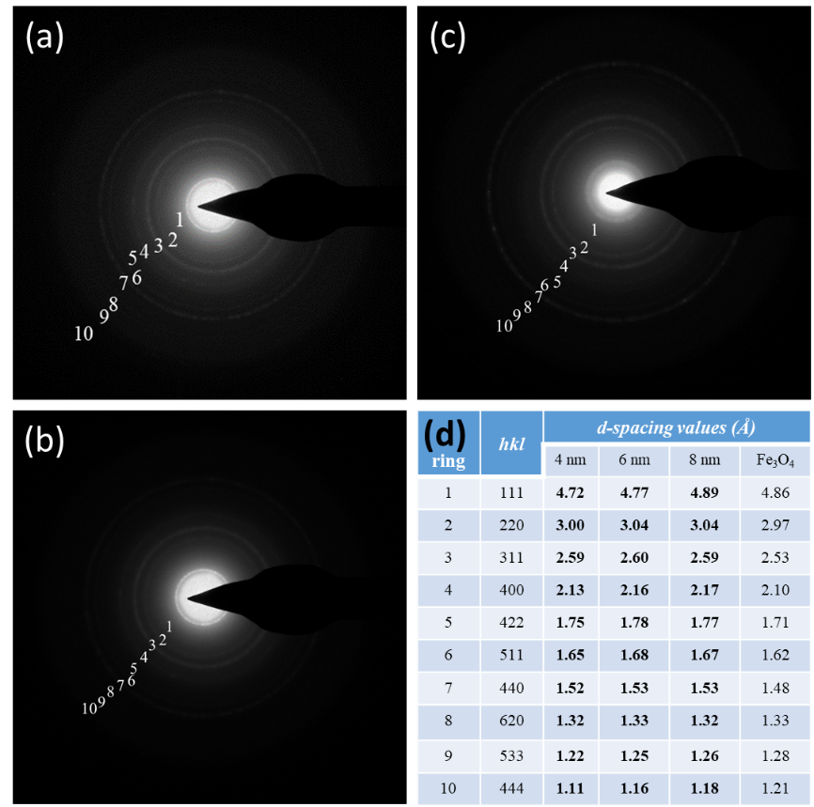

**Figure S8** SAED pattern of SPIO nanocrystals. (a) 4 nm SPIO; (b) 6 nm SPIO; (c) 8 nm SPIO; (d) The d-spacing values along with their respective hkl indexes for 4 nm, 6 nm, and 8 nm SPIO, and compared to the known lattice spacing for bulk Fe3O4 from the PDF database.

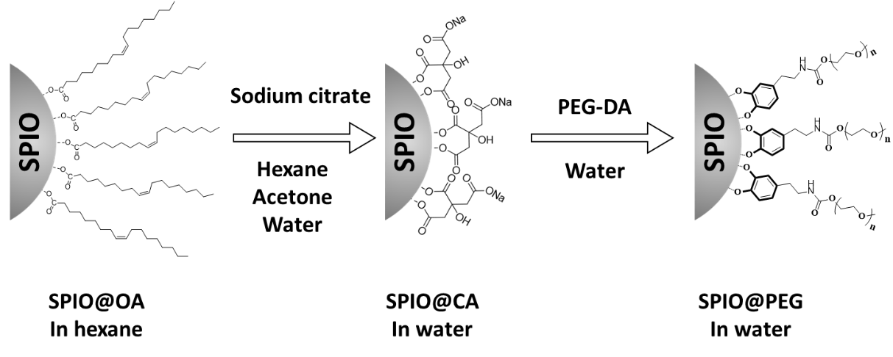

**Figure S9** The schematic preparation of PEGylated SPIO nanoparticles (SPIO@PEG)

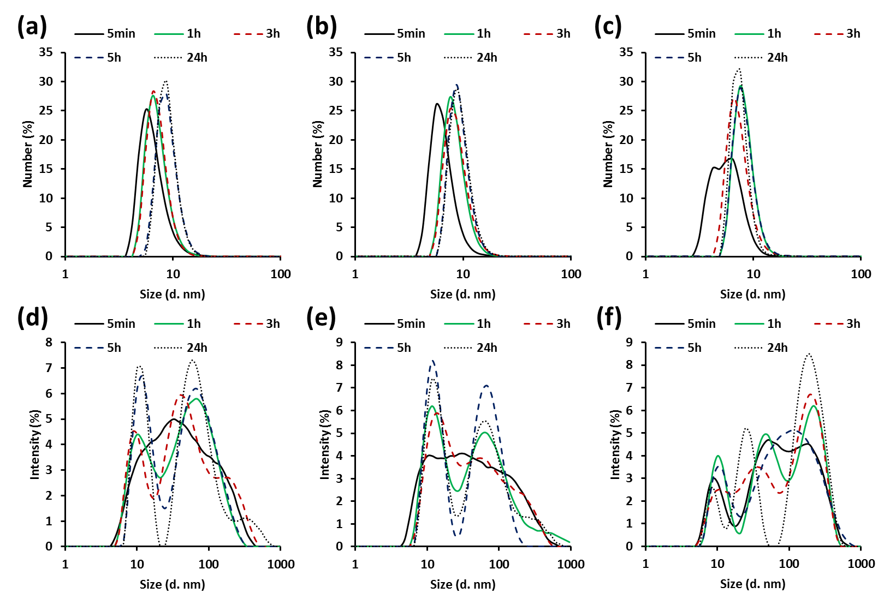

**Figure S10** DLS size changes of PEGylated 4 nm SPIO with time in 20% FBS solution at 37 ºC. (a) and (d): 4-nm SPIO@PEG550; (b) and (e): 4-nm SPIO@PEG2k; (c) and (f): 4-nm SPIO@PEG5k

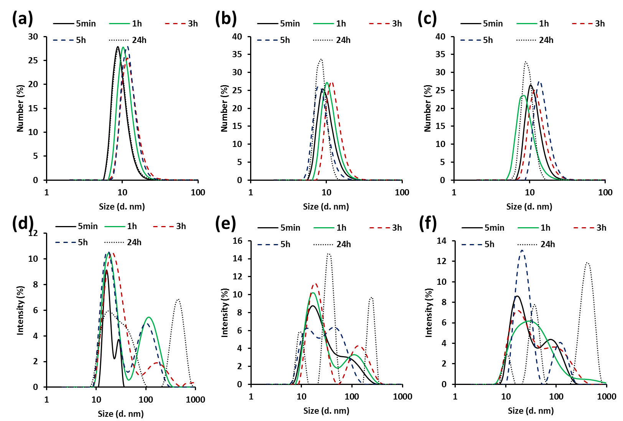

**Figure S11** DLS size changes of PEGylated 6 nm SPIO with time in 20% FBS solution at 37 ºC. (a) and (d): 6-nm SPIO@PEG550; (b) and (e): 6-nm SPIO@PEG2k; (c) and (f): 6-nm SPIO@PEG5k

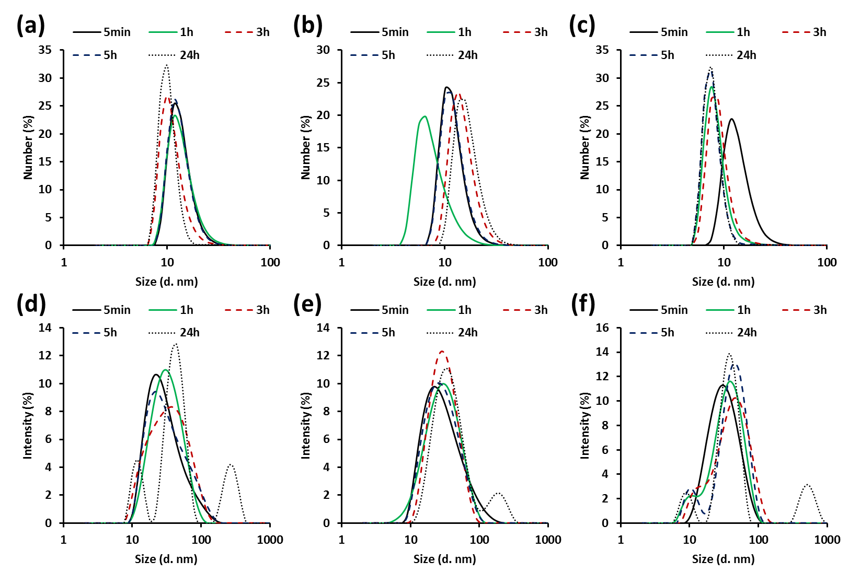

**Figure S12** DLS size changes of PEGylated 8 nm SPIO with time in 20% FBS solution at 37 ºC. (a) and (d): 8-nm SPIO@PEG550; (b) and (e): 8-nm SPIO@PEG2k; (c) and (f): 8-nm SPIO@PEG5k

**Figure S13** Cytotoxicity test of PEGylated SPIO nanoparticles with mouse macrophage cell line Raw 264.7

**Figure S14** Cytotoxicity test of PEGylated SPIO nanoparticles with mouse macrophage cell line Raw 264.7

**Figure S15** Cytotoxicity test of PEGylated SPIO nanoparticles with mouse macrophage cell line Raw 264.7

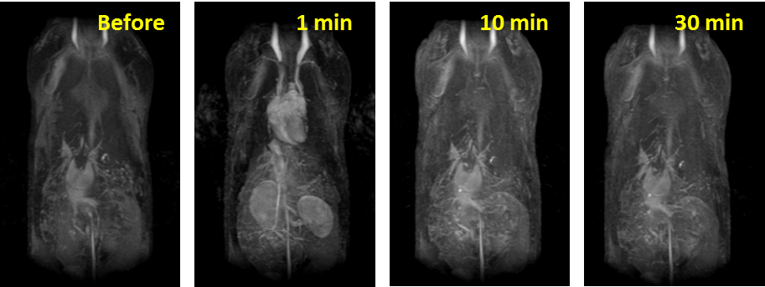

**Figure S16** MRA images of SD rats before and after intravenous injection of Magnevist (GdDTPA).

**Table S1** Mean particle size (mean ± standard deviation) in DLS of nine PEGylated SPIO.

|  |  |
| --- | --- |
| **Sample** | **Size**  **(nm)** |
|
| 4-nm SPIO@PEG550 | 6.1 ± 1.1 |
| 4-nm SPIO@PEG2k | 7.7 ± 1.6 |
| 4-nm SPIO@PEG5k | 10.2 ± 1.3 |
| 6-nm SPIO@PEG550 | 11.4 ± 5.8 |
| 6-nm SPIO@PEG2k | 13.4 ± 9.2 |
| 6-nm SPIO@PEG5k | 15.8 ± 10.0 |
| 8-nm SPIO@PEG550 | 15.6 ± 10.5 |
| 8-nm SPIO@PEG2k | 18.1 ± 12.2 |
| 8-nm SPIO@PEG5k | 20.2 ± 10.4 |

**Table S2** The results of Cytotoxicity and Serum stability test of 4-nm SPIO@PEG550 nanoparticle, and statistical analysis.

|  |  |  |  |  |  |  |  |
| --- | --- | --- | --- | --- | --- | --- | --- |
| **A**  **Sample（ classify）** | Fetal bovine serum(20%) and PBS(80%) were bathed in 37 ℃ water(size d.nm) | | | | | | |
| **5min** | **1h** | **3h** | **5h** | **24h** | **F** | **P** |
| 4-nm SPIO@PEG550（ Number） | 6.55±5.86 | 7.24±5.55 | 7.26±5.05 | 8.95±6.15 | 8.97±5.62***a*** | 3.25 | 0.02 |
| 4-nm SPIO@PEG550（ Intensity ） | 37.84  (18.17,91.28) | 43.82  (15.69,78.82) | 43.82  (18.17,91.28) | 43.82  (13.54,78.82) | 50.75  (13.54,78.82) | 0.32 | 0.864 |
| **B** | Fe concentration(optical density, OD=ODSPIO-ODcontrol) | | | | | | |
| **0ug/ml** | **5ug/ml** | **10ug/ml** | **15ug/ml** | **20ug/ml** | **F** | **P** |
| 4-nm SPIO@PEG550 | 0.79±0.05 | 0.78±0.06 | 0.78±0.05 | 0.79±0.06 | 0.72±0.06 | 1.39 | 0.256 |

*a*: P<0.05 compared with 5min