Supplementary Materials
Table S1 ICD Diagnosis Codes for Clinical Diagnoses Related to DR
ICD-9-CM Codes for DR and DME
Background DR |  | 362.01
Proliferative DR |  | 362.02
NPDR NOS |  | 362.03
Mild NPDR |  | 362.04
Moderate NPDR |  | 362.05
Severe NPDR |  | 362.06
DME |  | 362.07
ICD-10-CM Codes for DR, With and Without DME
 |  | DM due to Underlying Condition | Drug-Induced DM |  | Type 1 DM | Type 2 DM | Type Not Specified
DR NOS with DME |  | E08.311 | E09.311 |  | E10.311 | E11.311 | E113.311
DR NOS without DME |  | E08.319 | E09.319 |  | E10.319 | E11.319 | E13.319
Mild NPDR with DME |  | E08.321 | E09.321 |  | E10.321 | E11.321 | E13.321
Mild NPDR without DME |  | E08.329 | E09.329 |  | E10.329 | E11.329 | E13.329
Moderate NPDR with DME |  | E08.331 | E09.331 |  | E10.331 | E11.331 | E13.331
Moderate NPDR without DME |  | E08.339 | E09.339 |  | E10.339 | E11.339 | E13.339
Severe NPDR with DME |  | E08.341 | E09.341 |  | E10.341 | E11.341 | E13.341
Severe NPDR without DME |  | E08.349 | E09.349 |  | E10.349 | E11.349 | E13.349
PDR with DME |  | E08.351 | E09.351 |  | E10.351 | E11.351 | E13.351
PDR with TRD in macula |  | E08.352 | E09.352 |  | E10.352 | E11.352 | E13.352
PDR with TRD not in macula |  | E08.353 | E09.353 |  | E10.353 | E11.353 | E13.353
PDR with TRD and RRD |  | E08.354 | E09.354 |  | E10.354 | E11.354 | E13.354
Stable PDR |  | E08.355 | E09.355 |  | E10.355 | E11.355 | E13.355
PDR without DME |  | E08.359 | E09.359 |  | E10.359 | E11.359 | E13.359
DR with ME resolved following treatment |  | E08.37X | E09.37X |  | E10.37X | E11.37X | E13.37X
ICD-9/10-CM Codes for Other Retinal Diseases
Age-Related Macular Degeneration
ICD-9-CM | 362.52 |  |  | Exudative senile macular degeneration
ICD-10-CM | H3532 |  |  | Exudative age-related macular degeneration
Retinal Vein Occlusion
ICD-9-CM | 362.35 |  |  | Central retinal vein occlusion
ICD-9-CM | 362.36 |  |  | Venous tributary (branch) occlusion
ICD-10-CM | H34812 |  |  | Central retinal vein occlusion, left eye
ICD-10-CM | H34811 |  |  | Central retinal vein occlusion, right eye
ICD-10-CM | H34813 |  |  | Central retinal vein occlusion, bilateral
ICD-10-CM | H34819 |  |  | Central retinal vein occlusion, unspecified eye
ICD-10-CM | H34833 |  |  | Tributary (branch) retinal vein occlusion, bilateral
ICD-10-CM | H34839 |  |  | Tributary (branch) retinal vein occlusion, unspecified eye
ICD-10-CM | H34832 |  |  | Tributary (branch) retinal vein occlusion, left eye
ICD-10-CM | H34831 |  |  | Tributary (branch) retinal vein occlusion, right eye
Myopic Choroidal Neovascularization
ICD-9-CM | 360.21 |  |  | Progressive high (degenerative) myopia
ICD-10-CM | H35.051 |  |  | Retinal neovascularization, unspecified, right eye
ICD-10-CM | H35.052 |  |  | Retinal neovascularization, unspecified, left eye
ICD-10-CM | H35.053 |  |  | Retinal neovascularization, unspecified, bilateral
ICD-10-CM | H35.059 |  |  | Retinal neovascularization, unspecified, unspecified eye
ICD-10-CM | H44.20 |  |  | Degenerative myopia, unspecified eye
ICD-10-CM | H44.21 |  |  | Degenerative myopia, right eye
ICD-10-CM | H44.22 |  |  | Degenerative myopia, left eye
ICD-10-CM | H44.23 |  |  | Degenerative myopia, bilateral
ICD-10-CM | H44.2A1 |  |  | Degenerative myopia with choroidal neovascularization, right eye
ICD-10-CM | H44.2A2 |  |  | Degenerative myopia with choroidal neovascularization, left eye
ICD-10-CM | H44.2A3 |  |  | Degenerative myopia with choroidal neovascularization, bilateral
ICD-10-CM | H44.2A9 |  |  | Degenerative myopia with choroidal neovascularization, unspecified eye
ICD-10-CM | H35.051 |  |  | Retinal neovascularization, unspecified, right eye
ICD-10-CM | H35.052 |  |  | Retinal neovascularization, unspecified, left eye
ICD-10-CM | H35.053 |  |  | Retinal neovascularization, unspecified, bilateral
ICD-10-CM | H35.059 |  |  | Retinal neovascularization, unspecified, unspecified eye
ICD-10-CM | H44.20 |  |  | Degenerative myopia, unspecified eye
ICD-10-CM | H44.21 |  |  | Degenerative myopia, right eye
ICD-10-CM | H44.22 |  |  | Degenerative myopia, left eye
ICD-10-CM | H44.23 |  |  | Degenerative myopia, bilateral
ICD-10-CM | H44.2A1 |  |  | Degenerative myopia with choroidal neovascularization, right eye
ICD-10-CM | H44.2A2 |  |  | Degenerative myopia with choroidal neovascularization,  left eye
ICD-10-CM | H44.2A3 |  |  | Degenerative myopia with choroidal neovascularization, bilateral
ICD-10-CM | H44.2A9 |  |  | Degenerative myopia with choroidal neovascularization, unspecified eye
ICD-10-CM | H35.051 |  |  | Retinal neovascularization, unspecified, right eye
ICD-10-CM | H35.052 |  |  | Retinal neovascularization, unspecified, left eye
ICD-10-CM | H35.053 |  |  | Retinal neovascularization, unspecified, bilateral
ICD-10-CM | H35.059 |  |  | Retinal neovascularization, unspecified, unspecified eye
Vitreous Hemorrhage
ICD-9-CM | 379.23 |  |  | Vitreous hemorrhage
Abbreviations: DM, diabetes mellitus; DME, diabetic macular edema; DR, diabetic retinopathy; ICD-9/10-CM, International Classification of Diseases Ninth/Tenth Revision, Clinical Modification; ME, macular edema; NPDR, nonproliferative diabetic retinopathy, NOS, not otherwise specified; PDR, proliferative diabetic retinopathy; RRD, rhegmatogenous retinal detachment; TRD, tractional retinal detachment.
Table S2 HCPCS and CPT Codes for Treatments and Procedures
Intravitreal Anti-VEGF Therapies
Bevacizumab
01/01/2005–Present
HCPCS | J9035 | Injection, bevacizumab, 10 mg
CPT | 67028 | Intravitreal injection of a pharmacologic agent
01/01/2010–Present
HCPCS | C9257 | Injection, bevacizumab, 0.25 mg
Payor Dependent
HCPCS | J7999 | Unlisted compounded drug
HCPCS | Q9977 | Unlisted compounded drug
HCPCS | J3490 | Unclassified injection
Ranibizumab
1/1/2008–Present
HCPCS | J2778 | Injection, ranibizumab, 0.1 mg
CPT | 67028 | Intravitreal injection of a pharmacologic agent
Aflibercept
11/18/2011–4/1/2012
HCPCS | J3490 or J3590* | Unclassified injection or unclassified biologics
4/1/2012–6/30/2012
HCPCS | C9291† | Injection, aflibercept, 2 mg vial
7/1/2012–12/31/2012
HCPCS | Q2046‡ | Injection, aflibercept, 1 mg
1/1/2013–Present
HCPCS | J0178 | Injection, aflibercept, 1 mg
Intravitreal Steroid Therapies
HCPCS | C9256 | Injection, dexamethasone intravitreal implant, 0.1 mg
HCPCS | J1094 | Injection, dexamethasone acetate, 1 mg
HCPCS | J1100 | Injection, dexamethasone sodium phosphate, 1 mg
HCPCS | J7312 | Injection, dexamethasone, intravitreal implant, 0.1 mg
HCPCS | J3300 | Injection, triamcinolone acetonide preservative free, 1 mg
HCPCS | J3301 | Injection, triamcinolone acetonide, not otherwise specified, 10 mg
HCPCS | J3302 | Injection, triamcinolone diacetate, per 5 mg
HCPCS | J3303 | Injection, triamcinolone hexacetonide, per 5 mg
HCPCS | J7311 | Fluocinolone acetonide, intravitreal implant
CPT | 67028 | Intravitreal injection of a pharmacologic agent
CPT | 67027 | Implantation of intravitreal drug delivery system (eg, ganciclovir implant); includes concomitant removal of vitreous
Laser Therapies
Local Photocoagulation
CPT | 67220 | Destruction of localized lesion of choroid (eg, choroidal neovascularization); photocoagulation (eg, laser), ≥1 session
CPT | 0017T§ | Destruction of macular drusen, photocoagulation
ICD-9-CM | 14.24 | Destruction of chorioretinal lesion by laser photocoagulation
Photodynamic Therapy
CPT | 67221 | Destruction of localized lesion of choroid (eg, choroidal neovascularization); photodynamic therapy (includes intravenous infusion)
CPT | 67225 | Destruction of localized lesion of choroid (eg, choroidal neovascularization); photodynamic therapy, second eye, at single session (list separately in addition to code for primary eye treatment)
Panretinal Photocoagulation
CPT | 67228 | Treatment of extensive or progressive retinopathy (eg, diabetic retinopathy), photocoagulation
Retinal Surgery
Vitrectomy
CPT | 67036 | Vitrectomy, mechanical, pars plana approach
CPT | 67039 | Vitrectomy, mechanical, pars plana approach; with focal endolaser photocoagulation
CPT | 67040 | Vitrectomy, mechanical, pars plana approach; with endolaser panretinal photocoagulation
CPT | 67041 | Vitrectomy, mechanical, pars plana approach; with removal of preretinal cellular membrane (eg, macular pucker)
CPT | 67042 | Vitrectomy, mechanical, pars plana approach; with removal of internal limiting membrane of retina (eg, for repair of macular hole, diabetic macular edema), includes, if performed, intraocular tamponade (ie, air, gas, or silicone oil)
CPT | 67043 | Vitrectomy, mechanical, pars plana approach; with removal of subretinal membrane (eg, choroidal neovascularization), includes, if performed, intraocular tamponade (ie, air, gas, or silicone oil) and laser photocoagulation
Retinal detachment
CPT | 67113|| | Repair of complex retinal detachment (eg, proliferative vitreoretinopathy, stage C-1 or greater, diabetic traction retinal detachment, retinopathy of prematurity, retinal tear of >90 degrees), with vitrectomy and membrane peeling; may include air, gas, or silicone oil
Notes: *Cost reported on claims with HCPCS code J3490 or J3590 must be ≥$1500. †HCPCS code C9291 was deleted on June 30, 2012. ‡HCPCS code Q2046 was deleted on December 31, 2012. §CPT code 0017T was deleted on December 31, 2010. ||CPT code 67113 replaced the CPT code combination of 67038 and 67108, which was deleted effective January 2008.
Abbreviations: CPT, Current Procedural Terminology; HCPCS, Healthcare Common Procedure Coding System; ICD-9-CM, International Classification of Diseases Ninth Revision, Clinical Modification; VEGF, vascular endothelial growth factor.
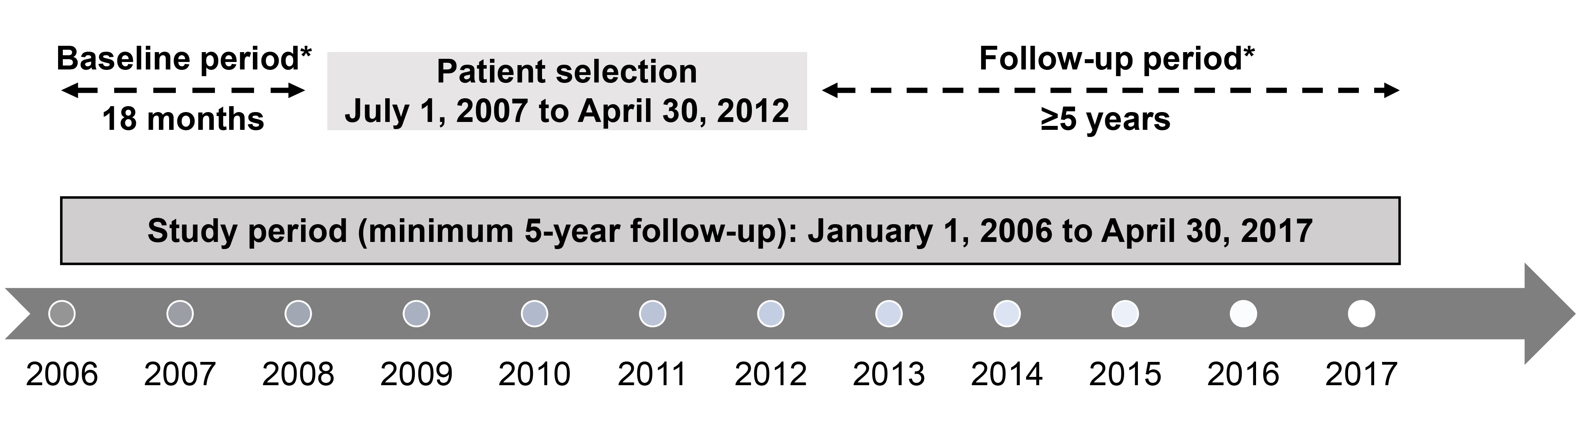
Figure S1 Study design schematic.
Notes: *To ensure that the index date for each patient accurately represented an initial diagnosis of diabetic retinopathy, and that data were available for the entire study period, continuous insurance coverage was required for ≥18 months before and ≥5 years after the index date.
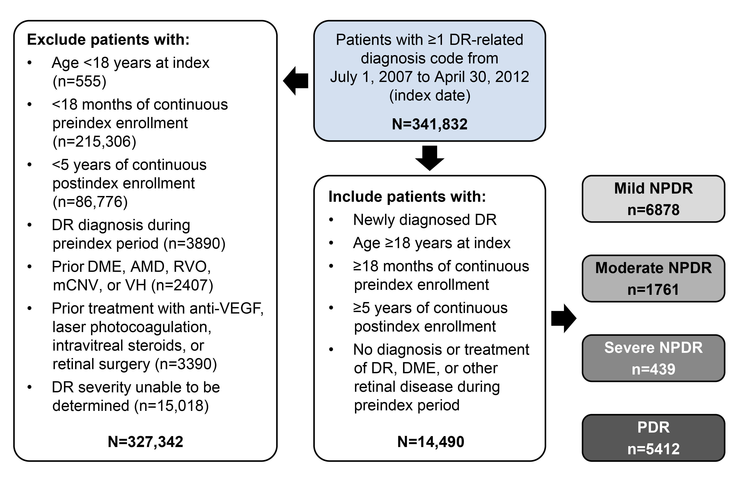
Figure S2 Patient selection flow chart.
Abbreviations: AMD, age-related macular degeneration; mCNV, myopic choroidal neovascularization; DME, diabetic macular edema; DR, diabetic retinopathy; NPDR, nonproliferative diabetic retinopathy; PDR, proliferative diabetic retinopathy; RVO, retinal vein occlusion; VEGF, vascular endothelial growth factor; VH, vitreous hemorrhage.

