Overcoming radiation resistance by iron-platinum metal alloy nanoparticles in human copper transport 1-overexpressing cancer cells via mitochondrial disturbance
Tsung-Lin Tsai, ^{1, 2} Yu-Hsuan Lai, ^{3, 4} Helen H. W. Chen, ^{1, 2, 4, *} Wu-Chou Su, ^{1, 2 , *}

¹Center of Applied Nanomedicine, National Cheng Kung University, Tainan 701, Taiwan; ²Department of Oncology, National Cheng Kung University Hospital, College of Medicine, National Cheng Kung University, Tainan 701, Taiwan; ³Institute of Clinical Medicine, College of Medicine, National Cheng Kung University, Tainan 701, Taiwan; ⁴Department of Radiation Oncology, National Cheng Kung University Hospital, College of Medicine, National Cheng Kung University, Tainan 701, Taiwan

Correspondence: Wu-Chou Su
Rm. 6065, 6F., No. 35, Xiaodong Rd., North Dist., Tainan 704, Taiwan.
Tel +886-6-2353535#3120
Fax +886-6-2084112
Email sunnysu@mail.ncku.edu.tw

Correspondence: Helen H. W. Chen
No. 138, Sheng Li Rd., North Dist., Tainan 704, Taiwan.
Tel +886-6-2353535#2461
Fax +886-6-2359333
Email helen@mail.ncku.edu.tw

Supplementary Fig. S1 Mitochondrial morphology and structure were intact in SR3A cells, SR3A-13 cells and SR3A-14 cells without FePt NPs treatment.

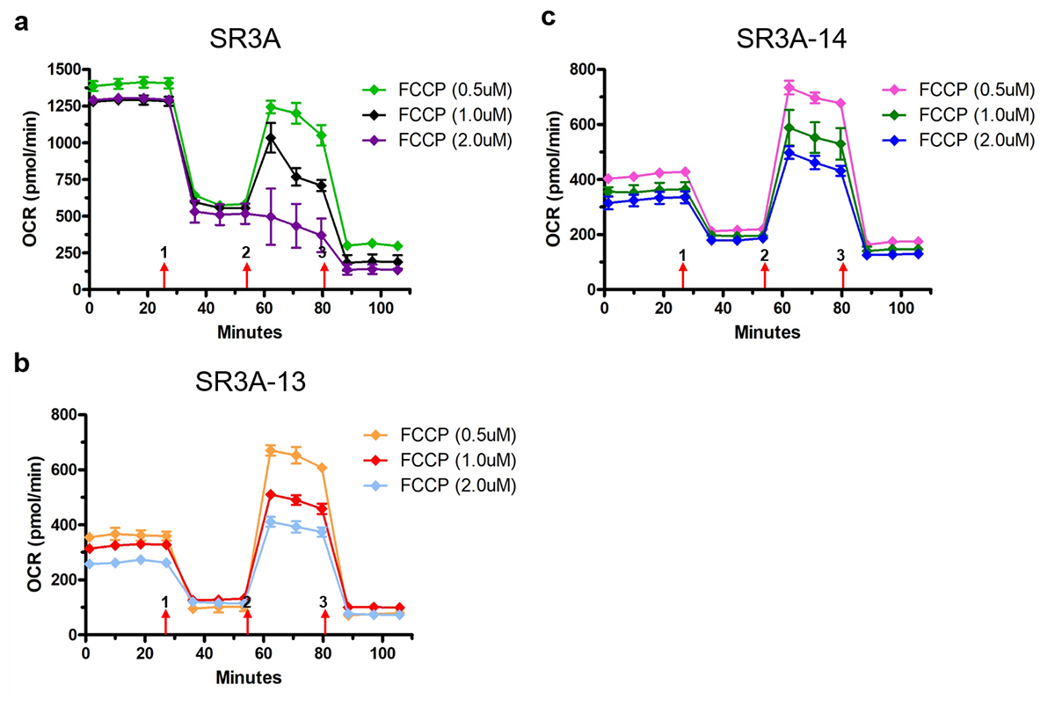

Supplementary Fig. S2 Validation of different concentrations of FCCP (0.5, 1.0 and 2.0 μM) for optimizing the oxygen consumption rate in (a) SR3A, (b) SR3A-13 and (c) SR3A-14 cells.

Supplementary Fig. S3 Establishing stable clones of hCtr1-overexpressing cells by using hCtr1-transfected parental SR3A cells. (a) The expression level of hCtr1 was measured by western bolts in different selected clones. Clone #3 was selected and named as SR3A-hCtr1-WT for further experiments. (b) Uptake of FePt NPs was assayed by ICP-OES.

Supplementary Fig. S4 Validation of different concentrations of FCCP (0.5, 1.0 and 2.0 μM) for optimizing the oxygen consumption rate in SR3A-hCtr1-WT cell.

