Supplemental Materials

Supplemental Table 1. Descriptions of studies in the OLZ/SAMª clinical development program.
Study | Design  (duration) | Patient Population | No. of Patients | Interventions  (mg/day) | Key Findings
Antipsychotic Efficacy Study
ENLIGHTEN-1 (ALK3831-A305)⁶¹ | R,DB,C  (4 weeks^{b}) | Adults with schizophrenia and a recent exacerbation of disease | 401 | - OLZ/SAM (10/10 or 10/20)  - Olanzapine (10 or 20)  - Placebo | - Treatment with OLZ/SAM resulted in significant improvement in PANSS total score (1° EP) at week 4 vs placebo (LS mean: −23.9 vs −17.5; P<0.001)  - Magnitude of PANSS changes observed with OLZ/SAM was similar to that observed with olanzapine vs placebo at week 4 (LS mean: −22.8 vs −17.5, P=0.004)  - The LS mean change in PANSS total score from baseline to week 4 was −6.4 (P<0.001) with OLZ/SAM and −5.3 (P=0.004) with olanzapine  - LS Mean change in CGI-S scores (key 2° EP) at week 4 were −1.21, −1.27, and −0.84 in the OLZ/SAM, olanzapine, and placebo groups, respectively; OLZ/SAM and olanzapine provided significant improvements vs placebo (P=0.002 and P<0.001, respectively)  - Key safety findings are presented in Table 2

Weight Efficacy Study
ENLIGHTEN-2 (ALK3831-A303)⁶² | R,DB,C  (24 weeks^{b}) | Adults with schizophrenia | 561 | - OLZ/SAM (10/10 or 20/10)  - Olanzapine (10 or 20) | - Percent change in body weight from baseline to week 24 was 4.21% with OLZ/SAM and 6.59% with olanzapine, yielding a LS mean difference between OLZ/SAM and olanzapine of −2.38%; P=0.003 (co-1° EP)  - Fewer patients gained ≥10% of their baseline body weight with OLZ/SAM vs olanzapine (17.8% vs 29.8%, respectively), such that patients had half the risk of clinically significant weight gain with OLZ/SAM vs olanzapine at week 24 (NNT^{c}=8 ; odds ratio=0.50; P=0.003; co-1° EP)  - LS mean absolute change in body weight from baseline to week 24 was 3.18 kg with OLZ/SAM and 5.08 kg with olanzapine  - Proportion of patients who gained ≥7% of their baseline weight was significantly lower for OLZ/SAM at week 24 than for olanzapine (27.5% vs 42.7%; NNT^{c}=7; odds ratio=0.50; P=0.001; 2° EP)  - LS mean change from baseline to week 24 in waist circumference was 2.36 cm with OLZ/SAM and 4.47 cm with olanzapine (LS mean difference: –2.12 cm [95% CI: –3.35, –0.89])  - Proportion of patients with a waist circumference increase of ≥5 cm from baseline was 26.8% and 43.2% in the OLZ/SAM and olanzapine groups, respectively (NNT^{c}=6 [95% CI: 4,13])  - The LS mean change from baseline to week 24 in PANSS total score was −8.2 with OLZ/SAM and −9.4 with olanzapine  - Mean CGI-S scores at baseline were 3.7 and 3.5 in the olanzapine and OLZ/SAM groups, respectively; the LS mean change from baseline to week 24 was −0.5 and −0.4, respectively  - Key safety findings are presented in Table 2
Phase 2 Supportive Efficacy and Safety Study
Dose-finding study (ALK3831-302)⁶⁰ | R,DB,C^{d}  (12 weeks^{b}) | Adults with schizophrenia | 309 | - Olanzapine^{e} + placebo  - Olanzapine^{e} + samidorphan (5)  - Olanzapine^{e} + samidorphan (10)  - Olanzapine^{e} + samidorphan (20) | - PANSS score changes were similar between groups: the LS mean (95% CI) change from baseline to week 12 in PANSS total score was −2.2 (−3.2, −1.3) with olanzapine + samidorphan and –2.9 (−4.5, −1.3) with olanzapine + placebo (1° EP)  - Weight change with olanzapine + samidorphan was lower at week 12 than with olanzapine + placebo (mean absolute change was 1.9 kg vs 2.9 kg, respectively; LS mean difference: –1.0 [95% CI: –1.8, –0.2)  - Key safety findings are presented in Table 2
Long-Term Safety and Durability of Treatment Effect Studies
ENLIGHTEN-1-EXT (ALK3831-A306)⁷⁴ | OL  (52 weeks^{b}) | Adults with schizophrenia | 277 | - OLZ/SAM (10/10, 15/10, or 20/10) | - Assessment of safety and tolerability were primary study objectives  - AEs occurred in 136 (49.1%) patients; most were mild or moderate in severity  - The most common AEs were weight increased (13.4%), somnolence (8.3%), nasopharyngitis (4.0%), and headache (4.0%)  - Mean change from baseline to week 52 in body weight was 1.86 kg  - Parkinsonism, akathisia, and dyskinesia occurred in 7%, 5%, and 3% of patients, respectively  - During the treatment and follow-up periods, 5 (1.8%) patients had suicidal ideation, suicidal behavior, or intentional overdose  - Mean PANSS total score was 78.9 (n=248) at study start  - Schizophrenia symptoms improved over 52 weeks of treatment, with PANSS total scores decreasing by 16.2 points at week 52  - CGI-S scores also improved over the 52-week treatment period; mean CGI-S baseline score was 3.9 (n=248) and decreased by 0.9 points at week 52 (n=182 patients with available assessments)
ENLIGHTEN-2-EXT (ALK3831-A304)⁷⁵ | OL  (52 weeks^{b}) | Adults with schizophrenia | 265 | - OLZ/SAM (10/10, 15/10, or 20/10) | - Assessment of safety and tolerability were primary study objectives  - Overall changes in weight, waist circumference, and metabolic laboratory parameters were small and remained stable during the extension  - In total, 60.8% of patients experienced any AE; the majority were mild or moderate in severity  - AEs occurring in ≥5% patients: weight decreased (8.7%), extra dose administered (7.9%), headache (6.8%), and weight increased (6.0%)  - Mean change from baseline to week 52 in body weight was −0.03 kg  - Rates of parkinsonism, akathisia, and dyskinesia were 4%, 2%, and 2%, respectively  - 6.8% of patients experienced suicidal ideation and 0.4% experienced the suicidal behavior  - These outpatients had a mean baseline PANSS total score of 59.0 (n=265)  - Mean PANSS total score remained stable (58.3 at week 52 in 168 patients with available assessments  - CGI-S scores changed little over the course of ENLIGHTEN-2-EXT (mean score at baseline: 3.1; mean score at week 52: 3.0)
Additional Studies
Long-term follow-up safety (ALK3831-A308); NCT03201757 | OL  (208 weeks^{b}) | Adults with schizophrenia | 253^{f} | - OLZ/SAM (5/10, 10/10, 15/10, or 20/10) | - This study is ongoing  - For patients with 12 months of data in this study as of April 1, 2019, schizophrenia symptoms remained stable (mean change from A308 baseline in CGI-S score was -0.09) and weight gain was limited (mean change from A308 baseline was 0.09 kg) with long-term OLZ/SAM treatment

ENLIGHTEN-Early (ALK3831-307); NCT03187769 | R,DB,C  (12 weeks^{b}) | Young adults with schizophrenia, schizo-phreniform disorder, or BD-I with little cumulative exposure to antipsychotics | 425^{g} | - OLZ/SAM (5/10, 10/10, 15/10, or 20/10)  - Olanzapine (5, 10, 15, or 20) | - This study is currently recruiting patients  - The main objectives are to assess the effects of OLZ/SAM and olanzapine on body weight as well as provide information on the safety/tolerability profiles of OLZ/SAM and olanzapine in individuals early in their illness
Other Populations
Treatment effects in schizophrenia and comorbid alcohol use disorder (ALK3831-401)⁷³ | R,DB,C  (42–66 weeks^{b}) | Adults with schizophrenia and alcohol use disorder with a recent exacerbation of disease | 234 | - OLZ/SAM^{h}  - Olanzapine^{h} + placebo | - The difference between OLZ/SAM and olanzapine on time to first event of exacerbation of disease symptoms was not significant (1° EP; hazard ratio: 0.91; 95% CI: 0.53, 1.56; P=0.746)  - There were no between-group differences in alcohol use behaviors, as measured by changes in WHO drinking risk level, number of heavy drinking days, or desire for alcohol  - Similar improvements in PANSS total scores were observed with either treatment at week 63 relative to randomization (change of −5.4 for OLZ/SAM and of −3.4 for olanzapine)  - Key safety findings are presented in Table 2
Clinical Pharmacology Studies
Bioequivalence
Bioequivalence study (ALK3831-A101)⁶⁴ | 3-period crossover, separated by 14-day washouts  (≈8 weeks) | Healthy adults | 48 | - Single dose of OLZ/SAM (10/10), Alkermes olanzapine (10), or Zyprexa (10) on day 1 of each treatment period | - Olanzapine component of OLZ/SAM was bioequivalent to olanzapine and Zyprexa

Pharmacokinetics With Potential Interaction
Food effect  (ALK3831-A107)⁶⁷ | 2-period crossover separated by 14-day washout  (≈4 weeks) | Healthy adults | 36 | - Single dose of OLZ/SAM (10/10) in fed and fasted conditions | - Food did not have a clinically relevant impact on the PK of olanzapine or samidorphan when given as OLZ/SAM
Effect of rifampin on PK of olanzapine and samidorphan (ALK3831-A103)⁶⁵ | OL  (≈5 weeks) | Healthy adults | 24 | - OLZ/SAM (10/10) on day 1 → rifampin (600) on days 15–21 → OLZ/SAM (10/10) with rifampin (600) on day 22 → rifampin (600) on days 23–28 | - Coadministration of OLZ/SAM with rifampin decreased the total systemic exposure (AUC∞) of olanzapine and samidorphan by 48% and 73%, respectively
Effect of OLZ/SAM on PK of lithium or valproate (ALK3831-B101)⁶⁸ | OL  (≈4 weeks) | Healthy adults | 34 | - Lithium alone and coadministered with OLZ/SAM^{i}  - Valproate alone and coadministered with OLZ/SAM^{j} | - Coadministration of OLZ/SAM with lithium or valproate did not have a clinically significant effect on the PK of lithium or valproate
Pharmacokinetics in Special Populations
Hepatic impairment (ALK3831-A105)⁶⁹ | OL  (≈6 weeks) | Healthy and hepatically impaired adults (without psychiatric illness) | 20 | - Single dose of OLZ/SAM (5/10) | - In individuals with moderate hepatic impairment, there was an approximately 1.5-fold and 2.2-fold increase in AUC∞ and C_{max} of olanzapine, respectively, and an approximately 1.5-fold increase in AUC∞ and C_{max} of samidorphan compared with healthy controls
Renal impairment (ALK3831-A106)⁶⁹ | OL  (≈6 weeks) | Healthy and renally impaired adults (without psychiatric illness) | 20 | - Single dose of OLZ/SAM (5/10) | - In individuals with severe renal impairment, there was an approximately 1.5-fold and 2.3-fold increase in AUC∞ of olanzapine and samidorphan, respectively, and a <1.5-fold increase in C_{max} for both olanzapine and samidorphan, compared with healthy controls

Other Clinical Pharmacology Studies
Cardiac safety (ALK3831-A109)⁷⁰ | R,DB,C  (≈4 weeks) | Adults with schizophrenia | 100 | - Moxifloxacin-matched placebo on days 1 and 14; OLZ/SAM on days 2–13 (10 /10 for 3 days, then 20/10 for 4 days, and then 30/30 for 5 days)  - Single dose of moxifloxacin (400) and moxifloxacin-matched placebo on days 1 and 14 (nested crossover fashion); OLZ/SAM-matched placebo on days 2–13 | - OLZ/SAM, at doses up to supratherapeutic level (30/30 mg), did not have a clinically relevant effect on electrocardiogram parameters, including the QTc interval
Proof-of-concept study (ALK33-301)⁷¹ | R,DB,C  (3 weeks^{b}) | Healthy adults | 106 | - OLZ/SAM (10/5)  - Olanzapine (10)  - Samidorphan (5)  - Placebo | - Mean body weight change from baseline to last assessment (1° EP) was signiﬁcantly less for OLZ/SAM vs olanzapine (2.2 kg vs 3.1 kg, respectively; P=0.02)  - When administered in combination, samidorphan did not affect the PK of olanzapine and vice versa
PK study  (ALK3831-A104)⁶⁶ | OL  (≈3 weeks) | Adults with schizophrenia | 42 | - Olanzapine (≤15) for 7 days → OLZ/SAM (10/10 or 20/10) thereafter | - Steady-state exposure to olanzapine increased dose proportionally over the clinical dose range of 10/10 mg to 20/10 mg of OLZ/SAM  - Different dose levels of olanzapine in OLZ/SAM had no effect on samidorphan exposure

Metabolic effects of OLZ/SAM  (ALK3831-A108)⁷² | R,DB,C, exploratory  (3 weeks^{b}) | Healthy adults | 60 | - OLZ/SAM (10/10)  - Olanzapine (10)  - Placebo | - Olanzapine resulted in relative hyperinsulinemia and reduced insulin sensitivity during an OGTT at day 19, changes not observed with OLZ/SAM or placebo  - Insulin sensitivity, measured by hyperinsulinemic-euglycemic clamp, was decreased in all treatment groups relative to baseline; this effect was greatest with olanzapine and OLZ/SAM  - Postprandial (OGTT) glucose and fasting cholesterol concentrations were similarly increased with olanzapine or OLZ/SAM, but on other metabolic parameters, distinct effects were observed (eg, post-OGTT C-peptide concentrations; aspects of energy metabolism)
ªOLZ/SAM doses are given in the form X/Y, where X is the dose of olanzapine and Y is the dose of samidorphan.
^{b}Treatment period.
^{c}NNT values were calculated from the proportion of patients using a logistic regression model based on the multiple imputation for missing postbaseline assessments. Thus, the NNT and 95% CI values described here can differ from raw NNT estimates calculated from the actual rates provided.
^{d}Olanzapine dosing was open label; the dose of coadministered samidorphan was blinded.
^{e}Olanzapine was dosed per clinical judgement; the mean olanzapine dose/day across all treatment groups was 11–13 mg.
^{f}Enrolled as of the April 1, 2019 data cutoff date.
^{g}Estimated enrollment.
^{h}Doses of study drug were selected by investigators; the mean prescribed olanzapine dose/day was 14–15 mg; the samidorphan dose was 10 mg.
^{i}Lithium (600 mg/day; 300 mg twice daily separated by 12 hours) on days 1–6 → lithium (300 mg) on day 7 → OLZ/SAM (10/10) on days 8–11 → OLZ/SAM (10/10) + lithium (600 mg/day; 300 mg twice daily separated by 12 hours) on days 12–17 → OLZ/SAM (10/10) + lithium (300 mg) on day 18.
^{j}Valproate (1000 mg/day; 300 mg twice daily separated by 12 hours) on days 1–6 → valproate (500 mg) on day 7 → OLZ/SAM (10/10) on days 8–11 → OLZ/SAM (10/10) + valproate (1000 mg/day; 500 mg twice daily separated by 12 hours) on days 12–17 → OLZ/SAM (10/10) + valproate (500 mg) on day 18.
In a study of human abuse potential, samidorphan had no abuse potential and had a profile consistent with naltrexone, a negative control in the study.⁹⁰
1° EP, prespecified primary endpoint; 2° EP, prespecified secondary endpoint; AE, adverse event; AUC∞, area under the plasma concentration-time curve from time 0 to infinity; BD-I, bipolar I disorder; CGI-S, Clinical Global Impression-Severity; CI, confidence interval; C_{max}, maximum plasma concentration; EXT, extension; LS, least squares; NNT, number needed to treat; OGTT, oral glucose tolerance test; OL, open label; OLZ/SAM, combination of olanzapine and samidorphan; PANSS, Positive and Negative Syndrome Scale; PK, pharmacokinetics; QTc, QT interval corrected for heart rate; R, DB, C, randomized, double-blind, controlled (placebo and/or active comparator) trial; WHO, World Health Organization.

Supplemental Table 2. Proportion of patients with potentially clinically significant value shifts in lipid and glycemic parameters from baseline to week 24 in ENLIGHTEN-2.
Shift category | Olanzapine  Anytime, % / Sustained,ª % | OLZ/SAM  Anytime, % / Sustained,ª %
Fasting^{b} Total cholesterol
≥240 mg/dL | 14.9 / 2.5 | 17.5 / 0.9
Increase ≥40 mg/dL | 27.4 / 5.3 | 26.4 / 4.0
Fasting^{b} HDL cholesterol
<40 mg/dL | 17.0 / 4.1 | 13.3 / 4.0
Decrease ≥20 mg/dL | 15.6 / 3.4 | 17.4 / 4.5
Fasting^{b} LDL cholesterol
≥160 mg/dL | 17.2 / 1.7 | 16.3 / 3.5
Increase ≥30 mg/dL | 34.8 / 8.0 | 35.1 / 4.5
Fasting^{b} Triglycerides
≥200 mg/dL | 28.7 / 5.6 | 25.7 / 4.4
Increase ≥50 mg/dL | 58.1 / 11.4 | 57.7 / 11.7
Fasting^{b} Glucose
≥126 mg/dL | 8.6 / 0 | 13.4 / 0.8
Increase ≥10 mg/dL | 57.0 / 11.4 | 65.7 / 17.5
HbA1c
≥5.7% | 36.0 / 10.8 | 42.6 / 10.5
ªSustained potentially clinically significant values refers to patients in whom the last 2 assessments through the end of treatment met potentially clinically significant criteria.
^{b}Fasting status was based on patient self-report without independent confirmation.
HbA1c, hemoglobin A1c; HDL, high-density lipoprotein; LDL, low-density lipoprotein; OLZ/SAM, combination of olanzapine and samidorphan.

Supplemental Table 3. Mean Changes From Baseline to Week 52 in Metabolic Parameters With Long-term OLZ/SAM Treatment in ENLIGHTEN-1-EXT or ENLIGHTEN-2-EXT.
Parameter | ENLIGHTEN-1-EXT | ENLIGHTEN-2-EXT
Total cholesterol (fastingª), mg/dL
Baseline, n | 276 | 265
Mean (SD) | 191.8 (36.1) | 186.9 (37.2)
Week 52, n | 180 | 155
Change from baseline, mean (SD) | 3.4 (31.2) | −2.4 (26.5)
LDL cholesterol (fastingª), mg/dL
Baseline, n | 276 | 265
Mean (SD) | 120.4 (32.2) | 113.9 (33.7)
Week 52, n | 180 | 155
Change from baseline, mean (SD) | 5.7 (28.8) | −1.5 (25.5)
HDL cholesterol (fastingª), mg/dL
Baseline, n | 276 | 265
Mean (SD) | 51.7 (14.6) | 57.0 (19.5)
Week 52, n | 180 | 155
Change from baseline, mean (SD) | 1.7 (12.9) | −1.3 (11.5)
Triglycerides (fastingª), mg/dL
Baseline, n | 276 | 265
Mean (SD) | 141.7 (93.1) | 130.8 (88.8)
Week 52, n | 180 | 155
Change from baseline, mean (SD) | 14.6 (70.1) | −10.7 (65.6)
Glucose (fastingª), mg/dL
Baseline, n | 276 | 265
Mean (SD) | 94.3 (12.7) | 94.2 (14.1)
Week 52, n | 180 | 154
Change from baseline, mean (SD) | 6.0 (14.4) | 1.3 (16.0)
HbA1c (%)
Baseline, n | 276 | 265
Mean (SD) | 5.5 (0.4) | 5.5 (0.4)
Week 52, n | 181 | 168
Change from baseline, mean (SD) | −0.07 (0.3) | 0.03 (0.3)
Insulin (fastingª), μIU/mL
Baseline, n | 275 | 265
Mean (SD) | 15.4 (18.0) | 15.6 (24.7)
Week 52, n | 181 | 153
Change from baseline, mean (SD) | −1.7 (14.8) | 2.5 (29.0)
ªFasting status was based on patient self-report without independent confirmation.
HbA1c, hemoglobin A1c; HDL, high-density lipoprotein; LDL, low-density lipoprotein; OLZ/SAM, combination of olanzapine and samidorphan; SD, standard deviation.

Supplemental Figure 1. Key pharmacokinetic findings: plasma concentrations (mean + SD) of olanzapine after a single dose of OLZ/SAM or Zyprexa (A)⁶⁴; plasma concentrations (mean + SD) of lithium 300 mg (B) or valproate 500 mg (C) after administration alone or concurrently with OLZ/SAM 10/10 mg.⁶⁸ OLZ/SAM, combination of olanzapine and samidorphan; SD, standard deviation.
A.
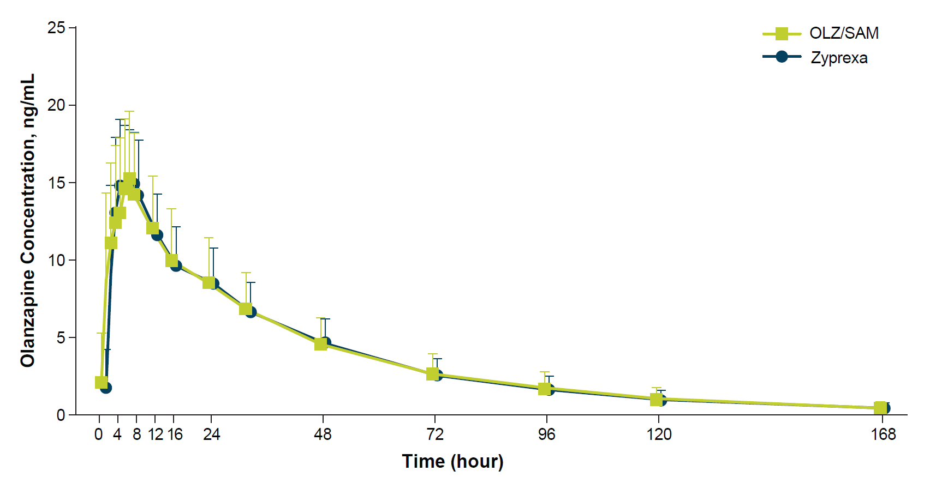
B.
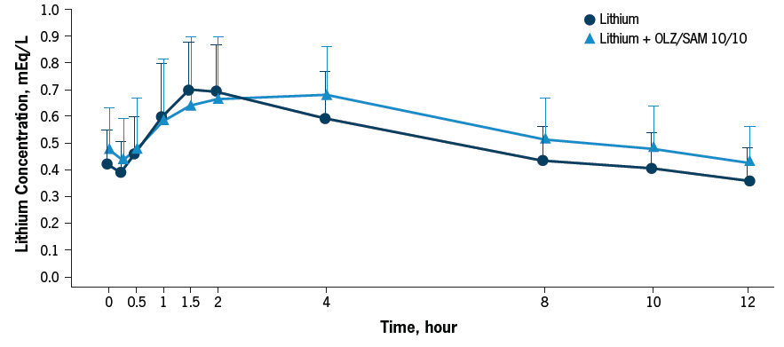
C.

