Supplementary materials

New Acaciin-loaded Self-assembled Nanofibers as M^{Pro} Inhibitors Against BCV as a Surrogate Model for SARS-CoV-2

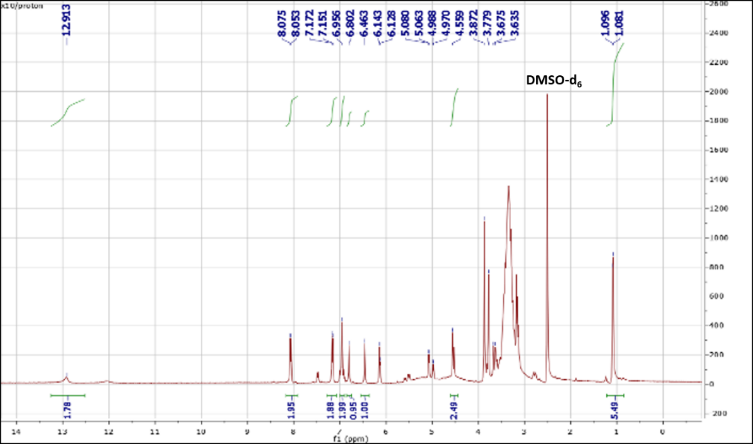
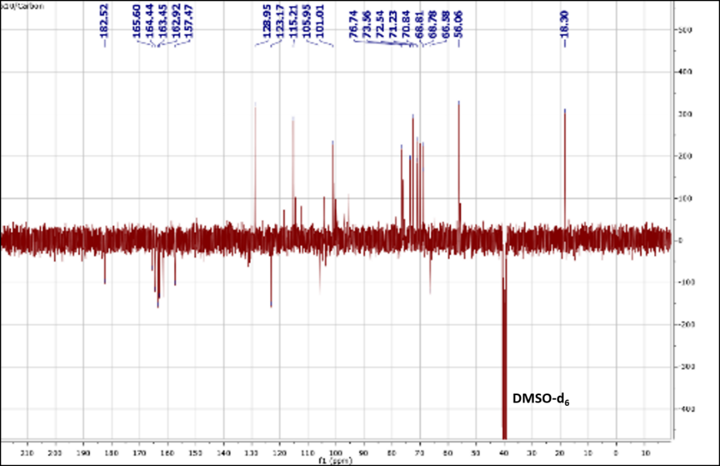
Figure. S1: a) ¹H-NMR data (400 MHz, DMSO-d₆), b) DEPT-Q ¹³C- NMR data (100 MHz, DMSO-d₆) of acaciin.
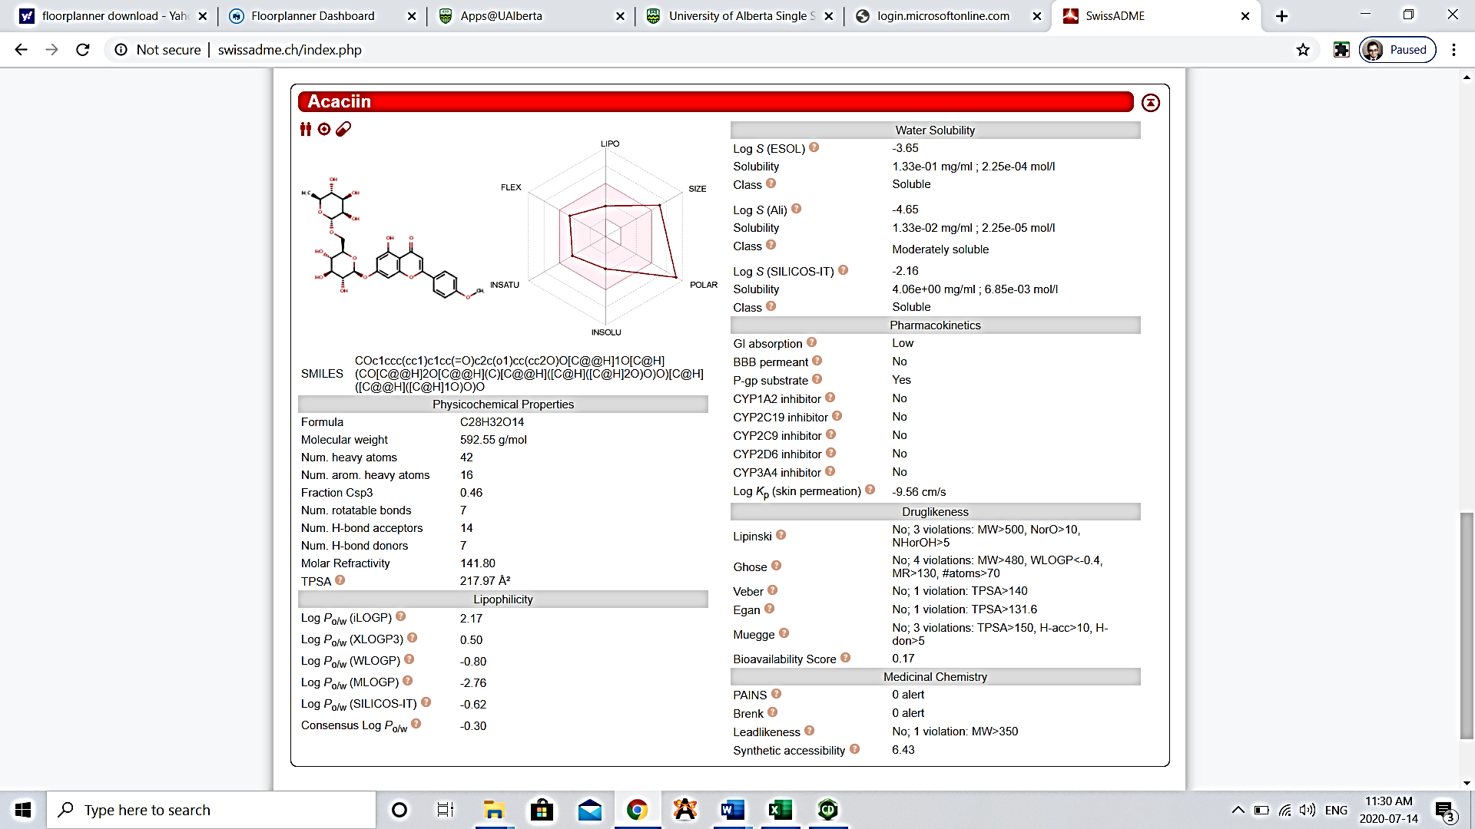
Figure. S2: Swiss ADME prediction chart of acaciin

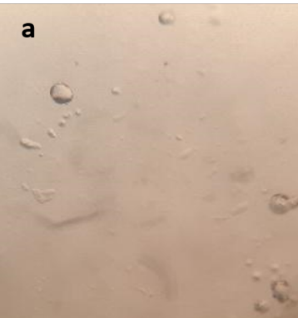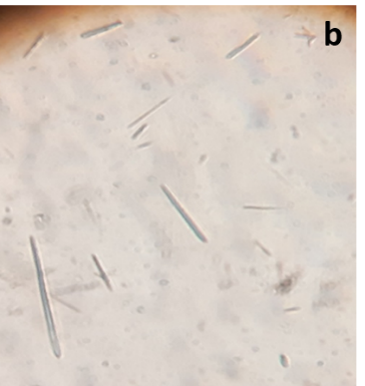
Figure. S3: LEM of a) PVA and chitosan NPs, b) Lecithin and chitosan NFs (magnification 200 X)

Table S1: Different physicochemical parameters of the formed NFs
Formulations | EE (%) | DL (%) | Particle size (nm) | PDI | Viscosity | Ʒ-potential (mV)
Form 1 | 54.07±0.48 | 2.7±0.37 | 200±23 | 0.2±0.1 | 8.887 | +51.8±2
Form 2 | 76.6±0.83 | 4.3±0.34 | 232±15 | 0.25±0.5 | 9.32 | +53.7±3
Form 3 | 97.5±0.53 | 4.9±0.76 | 220±13 | 0.2±0.02 | 10.235 | +50.9±3
Form 4 | 39.4±0.28 | 3.9±0.43 | 308±27 | 0.57±0.1 | 10.878 | +58.7±1
Form 5 | 43.3±0.41 | 4.3±0.34 | 257±32 | 0.43±0.5 | 12.34 | +49.5±1
Form 6 | 43.3±0.42 | 4.3±0.31 | 258±23 | 0.3±0.1 | 13.9 | +44.3±4
Form 7 | 28.9±0.45 | 4.3±0.34 | 330±44 | 0.42±0.5 | 11.9 | +43.1±0.2
Form 8 | 25.3±0.13 | 3.7±0.9 | 358±10 | 0.57±0.3 | 12.87 | +45.7±3
Form 9 | 28.9±0.45 | 4.3±0.34 | 380±18 | 0.61±0.1 | 13.12 | +45.4±3

Table S2. Results of antiviral MTT based assay on MDBK against BVDV by microplate reader
Group | Antiviral activity | Cell toxicity
Acaciin (12.5 µg/ml) | 75.40 %a | 10.8 ± 0.1 %b
ACA-L/Cs NFs 10 ppm | 98.30 %a | 9.21 ± 0.01 %b
ACA-L/Cs NFs 6 ppm | 98.88 %a | 8.3 ± 0.16 %b
ACA-L/Cs NFs 3 ppm | 87.16%a | 5.00 ± 0.023 %b
ACA-L/Cs NFs 1 ppm | 78.14%a | 6.30 ± 4.31 %b
Cells only | 100a | 0
Virus control | 0 | 100b

