Appendix 1- Questionnaire
- Where do you currently practice?
- Private Sector
- Royal Medical Services
- Ministry of Health
- Academic / University Sector

- Have you completed residency program in ophthalmology?
- Yes
- No

- Number of YEARS practicing ophthalmology?

- Do you have any training in infection control in ophthalmology?
- Yes
No

- Have you attended any training or received lectures regarding COVID-19?
- Yes
- No

- Where do you receive information on COVID-19 pertaining to you as an ophthalmologist? Select all that apply.
- E-mail newsletters from official organizations eg American Academy ophthalmology, ESCRS, Royal college of ophthalmologists
- Google search
- Social media eg Facebook, Whatsapp
- Your local hospital eg. administration, infection control committee
- Jordan ophthalmological society
- Peer reviewed journals

- Has your hospital / employing authority provided a clear strategy / infection control plan to reduce transmission of COVID-19 between patients or to ophthalmologists at the eye clinic?
- No
- A clear plan was implemented, including infection control measures
- Written instructions to cancel routine consultations and surgeries, but no infection control measures.
- General verbal instructions given.
- I prefer not to answer
8. If you are employed at a public hospital, is the hospital officially acknowledged to receive and quarantine patients with COVID-19 cases?
- Yes
- No
- Self employed

9. Age in Years?

10. Are you?
- Male
- Female

11. What is the incubation period of COVID-19?
2-7 days
2-14 days
7-14 days
  - days

12. Which of the following are symptoms of COVID-19? (Select all that apply)
- Fever
- Cough
- Runny nose
- Sore throat
- Shortness of breath
- Joint/muscle pain
- Red eyes
- Skin rash
- Diarrhea
- Vomiting
- May present with no symptoms

- How can COVID-19 be transmitted (Select all that apply)
- Via coughing and sneezing
- Hand shaking
- Touching surfaces as doorknobs, slitlamp, and tables
- Finger contact with patients’ tears
- Aerosol contamination to the conjunctiva
- Which of the following should be considered to identify patients at risk of having COVID-19? (Select all that apply)
- The presence of diarrhea
- The presence of symptoms of a respiratory infection
- History of travel to areas experiencing transmission of COVID-19
- History of contact with possible infected patients
- Presence of fever
- Acute conjunctivitis within 14 days

- Do you think that ophthalmic patients are at a higher risk of COVID-19 than other patients?
- Yes
- No
- I do not know

- Do you think that COVID-19 could be detected in tears?
- Yes
- No
- I do not know

- Do you think that COVID-19 can be transmitted by aerosol contact with conjunctiva?
- Yes
- No
- I do not know

- Which of the following measures should be taken to prevent transmission from known or suspected COVID-19 patients? (Select all that apply)
- Frequently clean hands by using alcohol-based hand rub or soap and water
- Taking Multivitamins to boost immunity
- Put facemask on known or suspected patients
- Place known or suspected patients in adequately ventilated single rooms
- All health staff members wear protective clothing
- Avoid moving and transporting patients out of their area unless necessary
- Routinely clean and disinfect surfaces in contact with known or suspected patients

- COVID-19 can be transmitted from an asymptomatic carrier to an ophthalmologist during routine eye exam.
- Agree
- Disagree
- I do not know

20. Do you have a clear shield mounted on the slitlamp that you use routinely? Shown in picture below

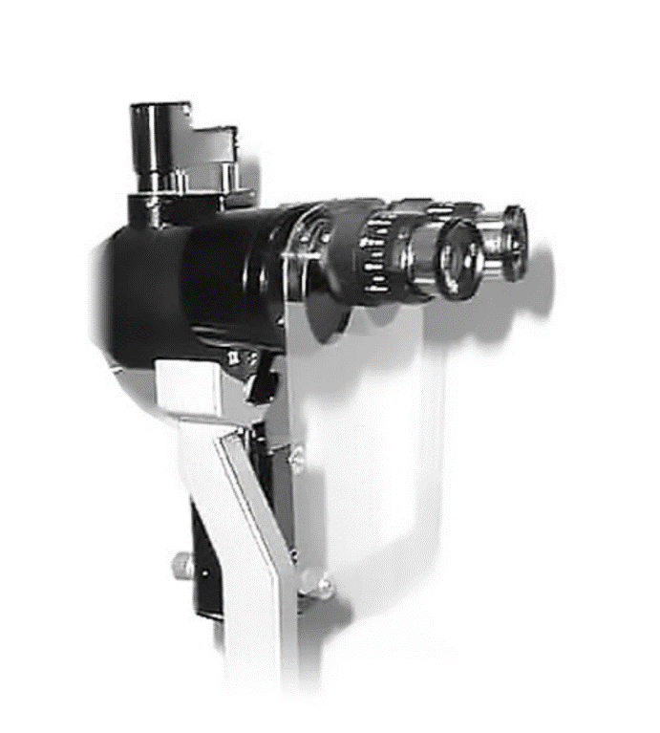
- Yes
- No

- How important is to change both masks and gloves to reduce the possibility of transmitting infections to patients and to myself?
- Very important
- Important
- Little important
- Not important

- How do you perceive COVID-19?
- Very dangerous
- Moderately dangerous
- Not dangerous
23. COVID-19 symptoms often resolve with time and do not require any special treatment
- Agree
- Disagree
- I prefer to avoid encountering / examining a patient who is a suspect of COVID-19
- Agree
- Disagree

- When patients call for an appointment, I would: (select all that apply)
- Reduce the total number of appointments in a day
- Avoid listing more than one patient at the same time
- Ask the patient to bring no more than one accompanying person if necessary
- Ask the patient not to attend if they have cough or sore throat
- Ask whether they or a family member have traveled to a high-risk area in the past 14 days.
- In case a patient was sneezing or coughing in your clinic ( outside hospital), what would you do?
- Refuse treating the patient and ask him/her to leave the clinic
- Treat the patient with extra precautions and ask him/her to go to the hospital
- Refer the patient to the hospital without treating him/her
- I work at a hospital and this is not applicable to me

- If a patient with known COVID-19 infection presents to your clinic (outside hospital), in need of urgent ophthalmic care, you would:
- Take all necessary precautions and treat the patient
- Send the patient to a hospital equipped to deal with COVID-19 and urgent eye conditions
- I work at a hospital and this is not applicable to me

- For an urgent ophthalmology consultation today, the patient has no respiratory illness symptoms, no fever, and no COVID-19 risk factors. Patient management includes:
- Standard precautions that apply to all patient care is enough
- Added precaution of not speaking during slit-lamp biomicroscopic examinations is appropriate.
- Mask, gown, and gloves are not routinely required for patient or clinician.

- For an urgent ophthalmic problem in a patient with respiratory illness symptoms, but no fever or other COVID-19 risk factor
- Patient should wear a surgical mask.
- Ophthalmologist and health care personnel require surgical masks.
- Gloves and eye protection are recommended
- The examining room must be cleaned after examination

- If local health authorities permit all doctors to work, do you support seeing patients at your clinic?
- Only urgent cases
- All routine cases provided they are low risk (no symptoms or travel)
- I prefer seeing no patients at all at my practice
- I work at a hospital and this is not applicable to me

- Refraining from talking to your patient during slitlamp exam, as well as asking the patient not talk can decrease the risk of any virus transmission
- True
- False

- I believe that asking patients to set far from each other, wearing masks while in the waiting room, and rubbing hands with alcohol before setting on the slitlamp chair is:
- Necessary and help to decrease disease transmission
- Not necessary and could cause panic

- The virus that causes COVID-19 is very likely susceptible to the same alcohol- and bleach-based disinfectants that ophthalmologists commonly use to disinfect ophthalmic instruments and office furniture
- Agree
- Disagree

- Would you allow any of your staff (optician) to work with patients if there have flu – like symptoms?
- Yes
- No

- The ophthalmologists’ role in teaching others about COVID-19 is:
- Very significant
- Moderately significant
- Mildly significant
- Not significant at all

Copyright statement: Certain questions were derived from Khader Y, Al Nsour M, Al-Batayneh OB, Saadeh R, Bashier H, Alfaqih M, Al-Azzam S, AlShurman BA
Dentists’ Awareness, Perception, and Attitude Regarding COVID-19 and Infection Control: Cross-Sectional Study Among Jordanian Dentists
JMIR Public Health Surveill 2020;6(2):e18798
https://publichealth.jmir.org/2020/2/e18798
DOI: 10.2196/18798
PMID: 32250959
PMCID: 7147327

