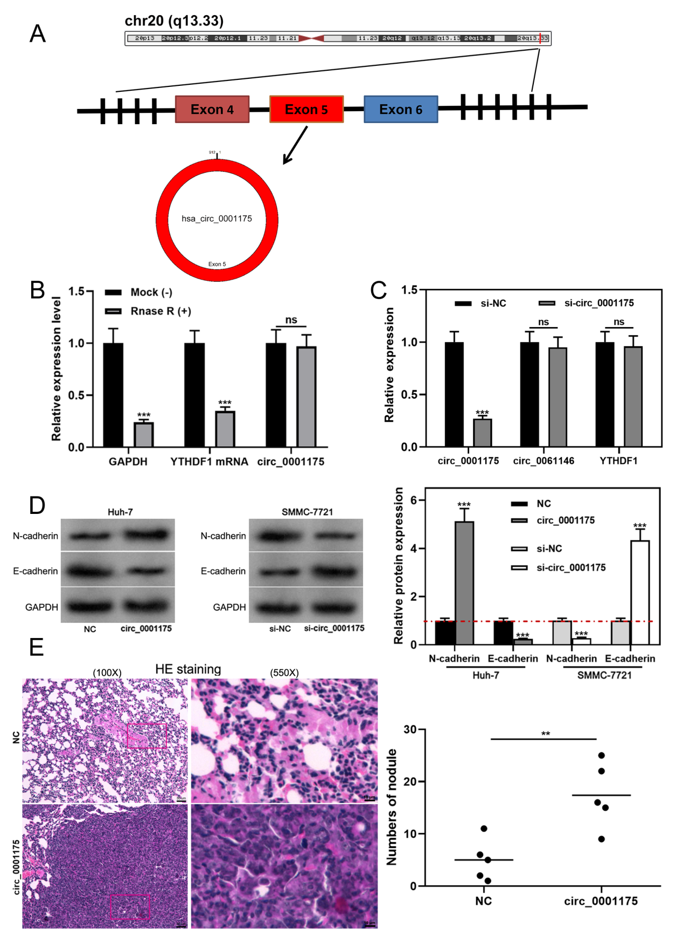
Supplementary Figure 1
- The schematic diagram of circ_0001175 generation.
- RT-qPCR assay indicated that circ_0001176 was more resistant to RNase R, compared with YTHDF1 mRNA and GAPDH mRNA.
- Circ_0001175 siRNA (or control siRNA) was transfected into Huh-7 cells, and then the expressions of circ_0001175, circ_0061146 and YTHDF1 mRNA were detected by RT-qPCR.
D. Western blot was used to detected the expression of N-cadherin and E-cadherin in HCC cells after circ_0001175 was overexpressed or knocked down.
E. Lung metastasis of HCC cells in vivo was evaluated after the nude mice were injected with Huh-7 cells (control group or circ_0001175 overexpression group). The ordinate indicates the number of nodules per section.

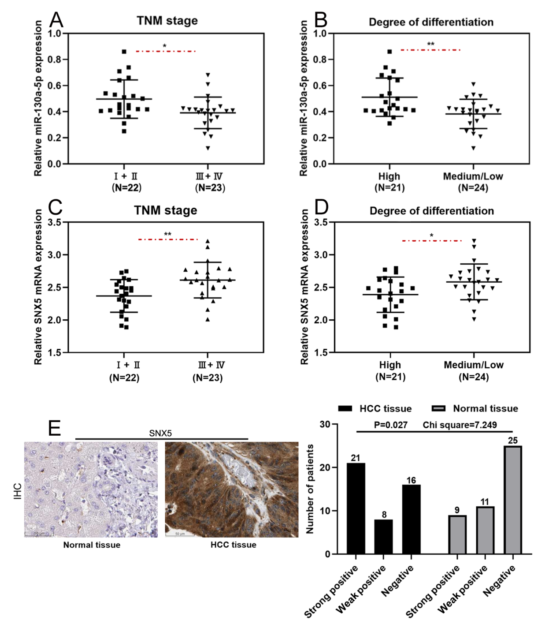
Supplementary Figure 2
A-B. Relationship between miR-130a-5p expression and TNM stage and tumor differentiation of HCC patients.
C-D. Relationship between SNX5 mRNA expression and TNM stage and tumor differentiation of HCC patients.
E. IHC was performed to evaluate the expression of SNX5 protein in HCC samples.

