Molecular Antenna-sensitized Upconversion Nanoparticle for Temperature Monitored Precision Photothermal Therapy
Supplementary data
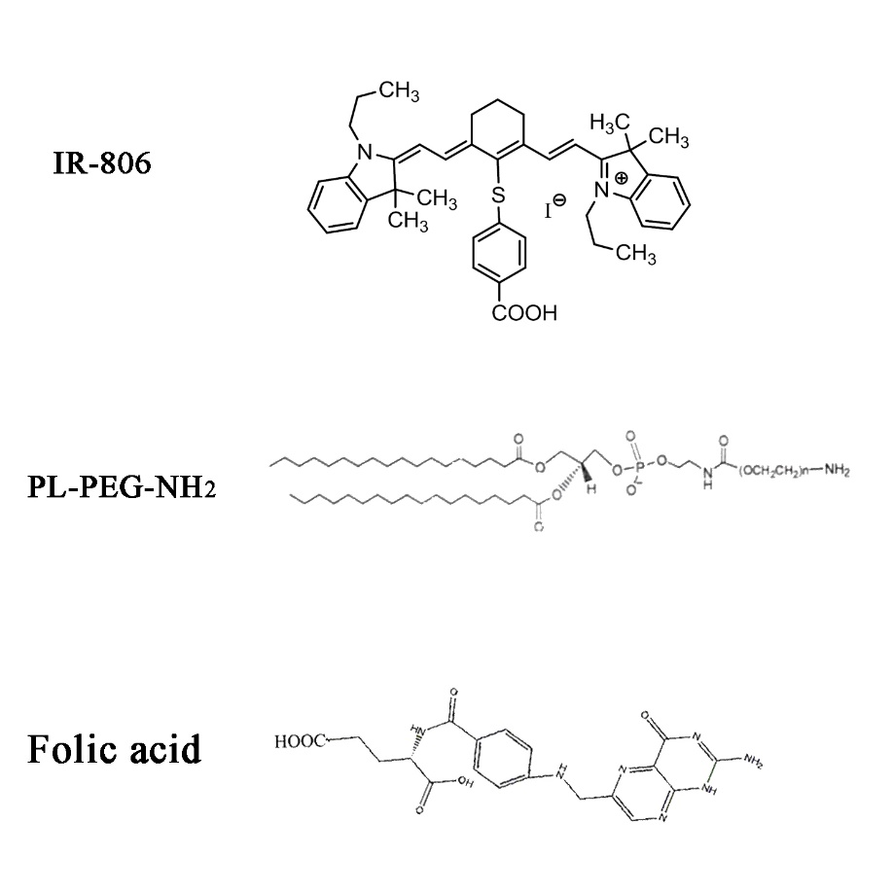
Figure S1. Molecular structures of IR-806, PL-PEG-NH₂ and Folic acid.
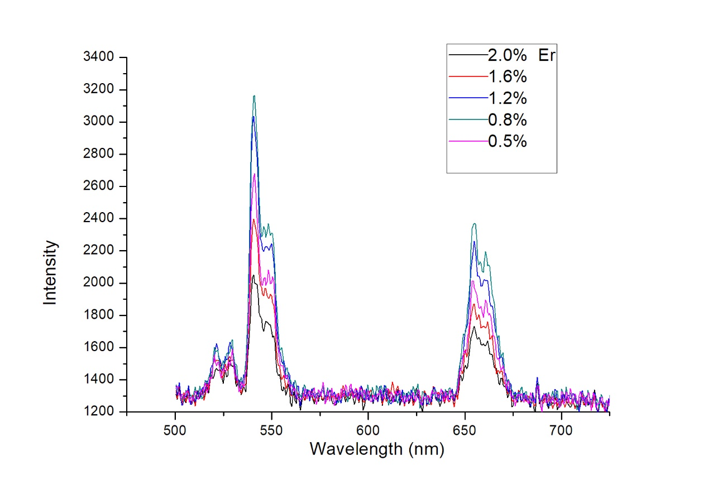
Figure S2. Spectra of different Er³⁺-Dopped nanoparticles.
Figure S2 NaYF₄:Yb,Er,Nd upconversion nanocrystal with different Er³⁺ doping were synthesized via a hydrothermal synthesis method. In a typical procedure for the synthesis of NaYF₄:10%Yb³⁺, (2%,1.6%,1.2%,0.8% and 0.5% )Er³⁺, (2% )Nd³⁺ UCNs, 30 mmol of NaOH was dissolved in 3 mL of DI water. 8 mL of ethanol, and 20 mL of Oleic acid were added to the above solution with constant stirring for 20 min. Then, 0.885 mmol of Y(CH₃COO)₃·4H₂O, 0.1 mmol of Yb(CH3COO)₃·4H₂O, 0.005 mmol of Er(CH₃COO)₃·4H₂O and 0.01 mmol of Nd(CH₃COO)₃·4H₂O (with and without) were added and stirred for another 30 min. Subsequently, 10 mL of ethanol containing 10 mmol of NaF was added to the above solution and stirred for another 30 min. The resulting mixture was then transferred into a 50 mL stainless Teflon-lined hydrothermal reactor, to be sealed and heated to 190°C for 24 h. After that, the hydrothermal reactor was cooled to room temperature naturally, and the reaction mixture was separated through centrifugation (6000 rpm, 5 min). The precipitate was washed with cyclohexane, ethanol and DI-water several times and dried under vacuum at 40°C for 12h to obtain the NaYF₄:Yb,Er,Nd nanoparticles.

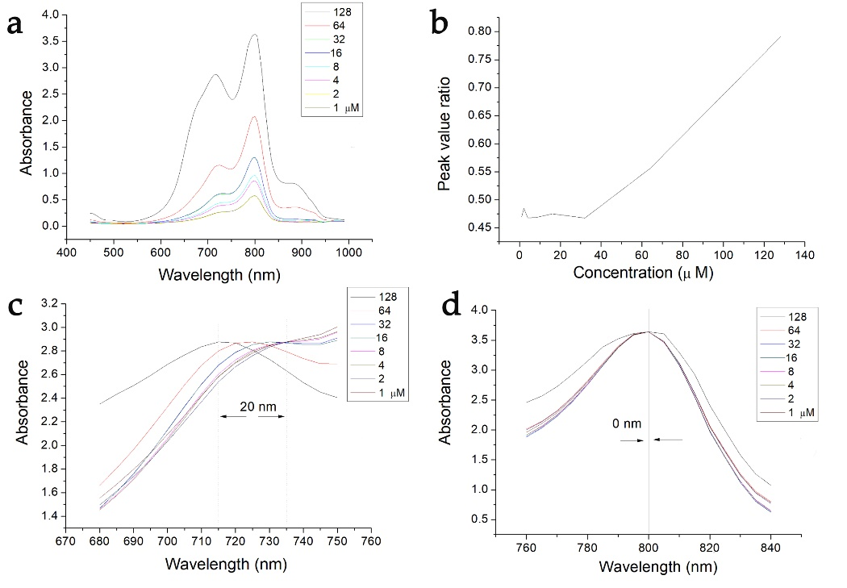
Figure S3. Absorption spectra of IR-806 at different concentrations. (a) Absorption spectrum of IR-806. (b) The absorbance peak ratio (P_{720 nm}/P_{800 nm}) of IR-806. (c) Comparation of the absorption peaks at 720 nm range. (d) Comparation of the absorption peaks at 800 nm.
Figure S3 IR-806 was dissolved in water (1-128 μM) and put into a quartzose cuvette. After that, the absorption spectra with wavelength from 450 to1000 nm were measured by a fiber spectrometer (QE65000, Ocean Optical Co., Ltd., Dunedin, USA).

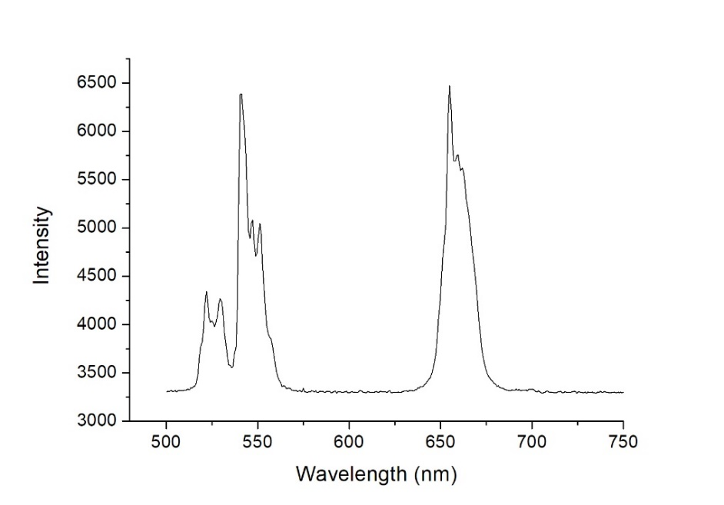
Figure S4. Luminescence spectrum of the nanocrystal excited by a 980 nm laser.
Figure S4 Synthesized Upconversion nanoparticles was dissolved in pure water (0.5 mg/ml) and excited by a 980 nm laser. The spectrum of the nanoparticles with wavelengths from 500 to 750 nm was detected by the fiber spectrometer mentioned above.

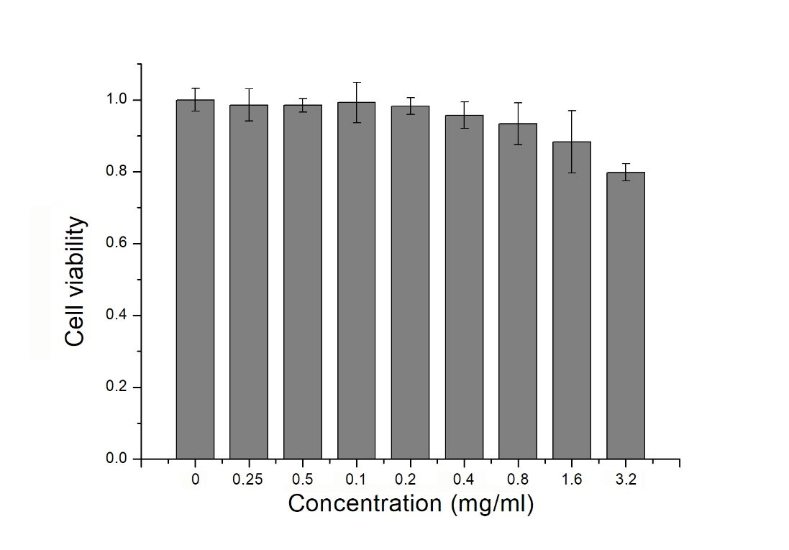
Figure S5. Dark cytotoxicity of the NPs at different concentrations.

Figure S5 EMT-6 cells were collected and then seeded into 96-well plates (10⁴ cells per well). After cells being cultured for 24 h at 37 °C in a humidified incubator, NPs in PBS solution (50 μl) were added to the wells with different concentrations (0-3.2 mg/ml). After incubation at 37 °C for 12 h, 500 μL of 10% CCK-8 1640 solution was added to each well. After 2 h, the absorbance value at 450 nm was measured with a 96-well plate reader (Flx800, Bio-Tek instrument inc., Thermo, Germany) to determine the cell’s viability. The cell viability was calculated as follows: cell viability (% of control) = ODTre/ODCon × 100% (where ODTre is the absorbance value of treated cells; ODCon is the absorbance value of untreated cells). Four samples were used for each study.

