Supporting information

Reactive oxygen species-mediated inflammation and apoptosis in hand-foot syndrome induced by PEGylated liposomal doxorubicin

Xiaolin Hu,^{a,b} Mengmeng Dong,^{b} Xiao Liang,^{b} Ziling Liu,^{a,*} Quanshun Li^{b,*}

ªDepartment of Cancer Center, The First Hospital of Jilin University, Changchun 130012, China
^{b}Key Laboratory for Molecular Enzymology and Engineering of Ministry of Education, School of Life Sciences, Jilin University, Changchun 130012, China

*Corresponding author.
Tel.: +86-431-85155201; Fax: +86-431-85155200.
E-mail: quanshun@jlu.edu.cn (Q. Li); ziling@jlu.edu.cn (Z. Liu).

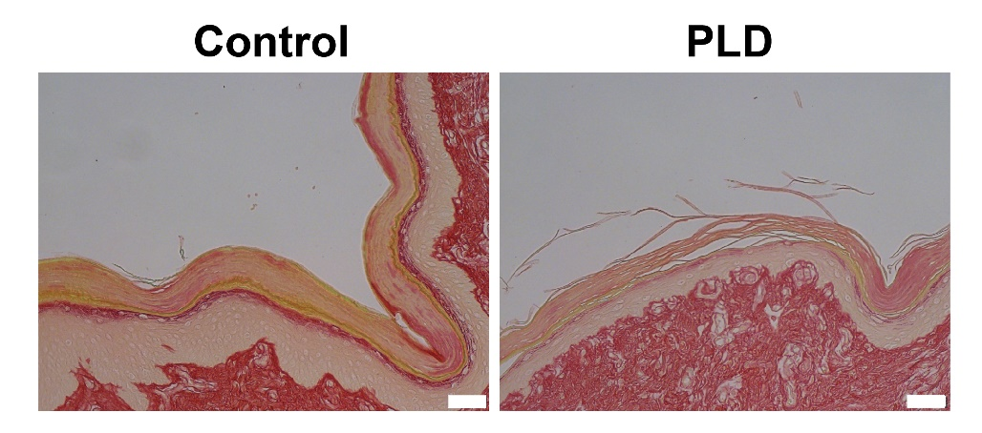
Figure S1. The picrosirius red staining of the paws’ skin tissues observed under non-polarized light microscopy. Scale bar: 50 μm.

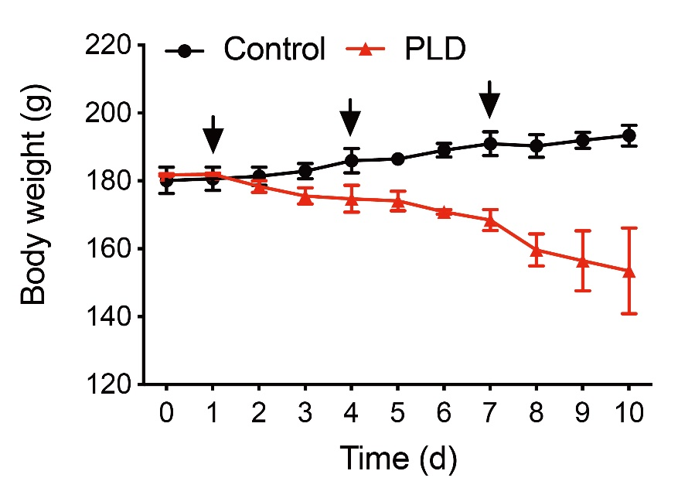
Figure S2. The change of rats’ body weight after the PLD administration.

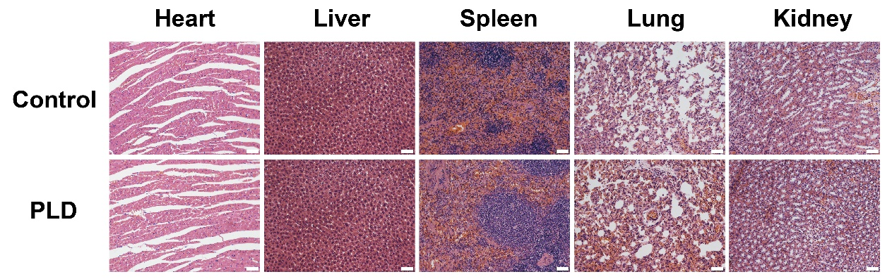
Figure S3. Histological analysis of main organs in normal rats and PLD-treated rats. Scale bar: 50 μm.

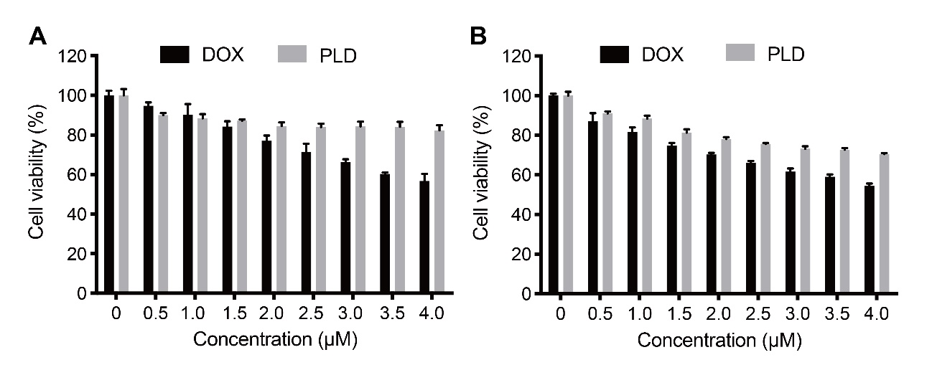
Figure S4. The cytotoxicity analysis of HaCat cells treated with DOX and PLD at various concentrations for 24 h (A) and 48 h (B).

