Supplementary materials
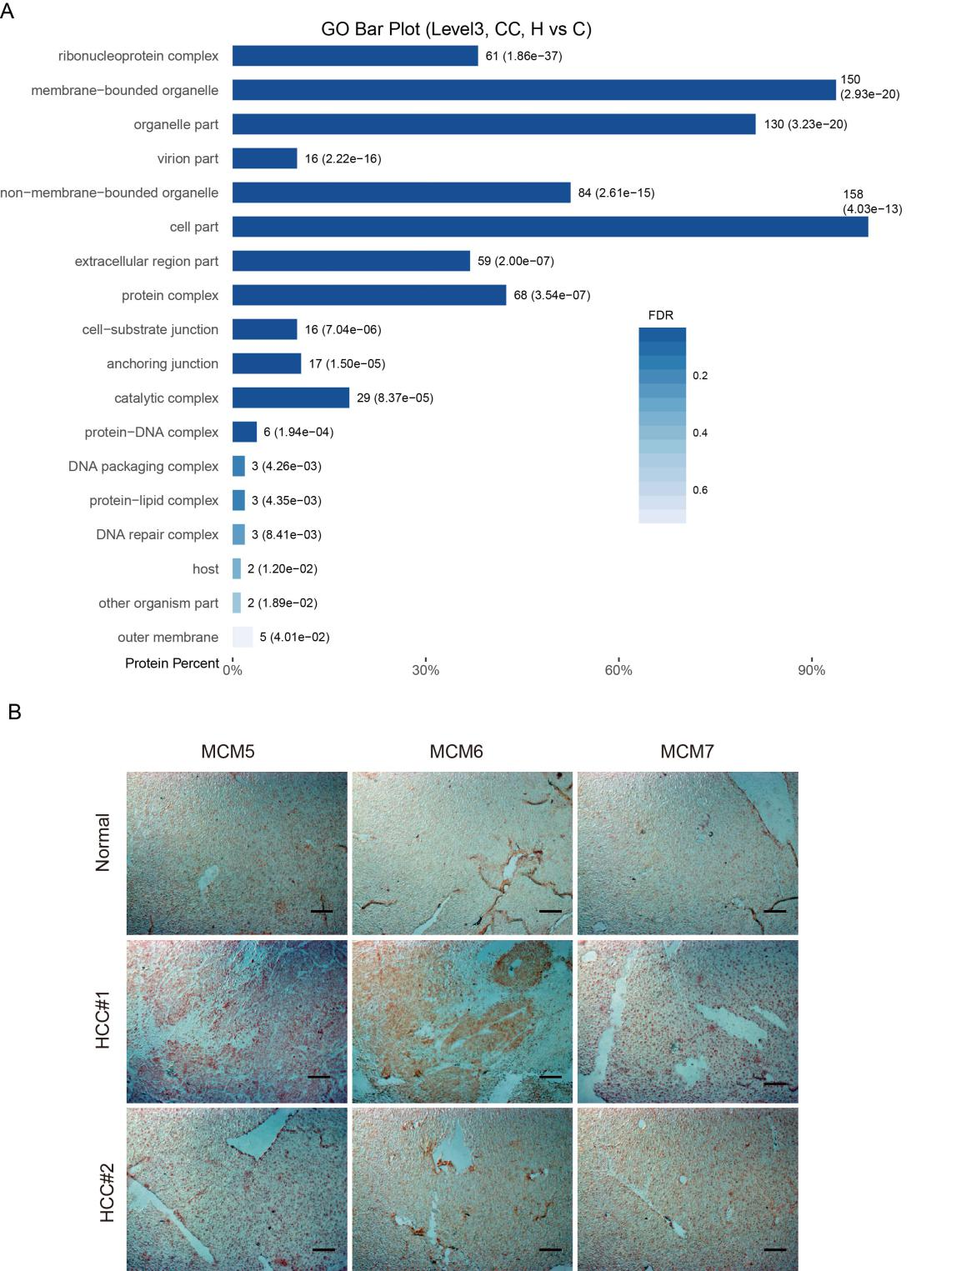
Fig. S1 Bioinformatics analysis of differentially expressed proteins after Huaier treatment. (A) Pie diagram of GO enrichment of differential proteins. The three basic classifications of Go term. CC: cellular component. (B) Representative IHC images of MCM5, MCM6, and MCM7 staining from normal liver tissues and HCC tissues, scar bar 100μm.

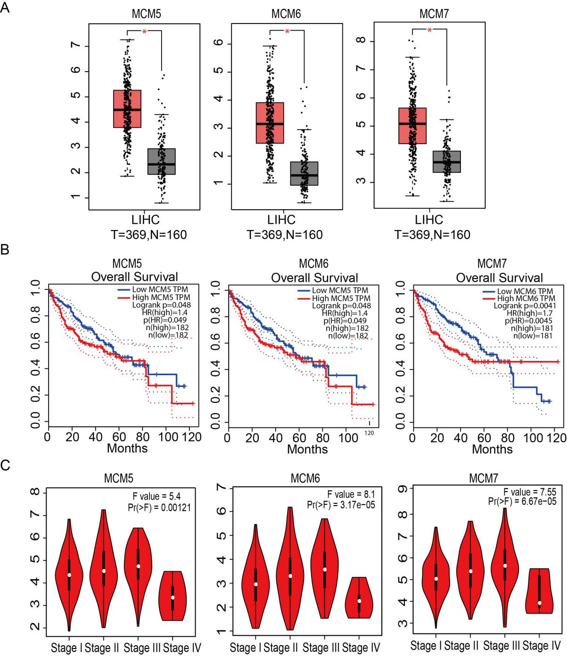
Fig. S2 Up-regulated of MCM proteins were closely correlated with shorter survival time and inhibited by Huaier. (A) Relative expression levels of MCM5, MCM6, and MCM7 in 369 HCC tissues and 160 normal tissues retrieved form GEPIA database. (B) Kaplan-Meier survival curves for HCC patients with low (n=182) or high (n=182) MCM expressions (MCM5, MCM6, and MCM7) got from GEPAI database. (C) The correlations of MCM5, MCM6, and MCM7 proteins with clinicopathologic stages extract from database.
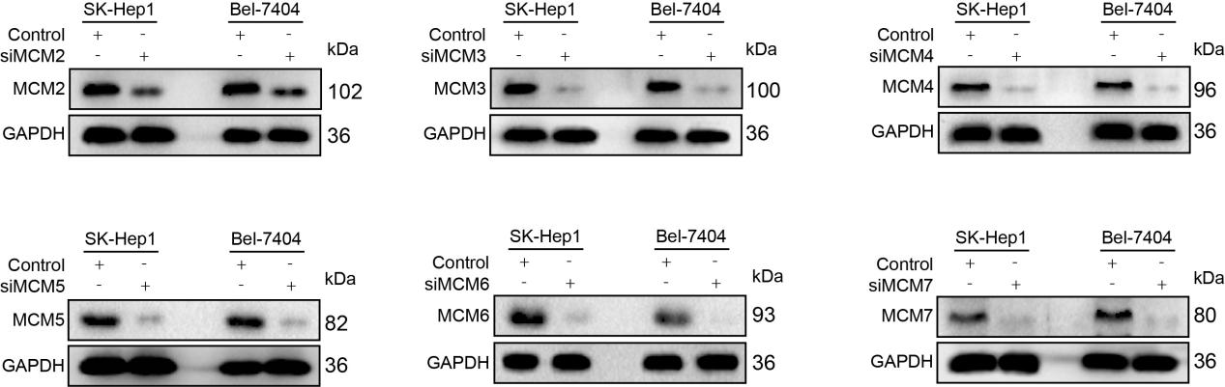
Fig. S3 Western blot analysis of MCMs expressions in SK-Hep1 and Bel-7404 cells transfected with siRNA against indicated MCM.

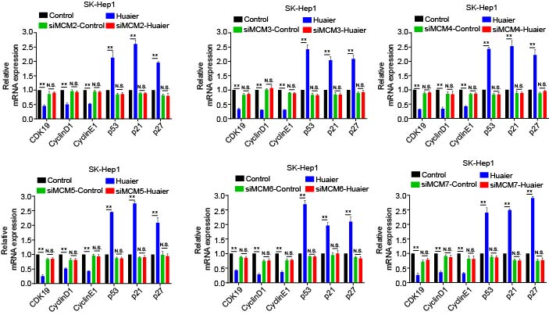
Fig.S4 Huaier suppressed SK-Hep1 cell cycle via regulating MCM proteins. (A-F) The mRNA levels of cell cycle related genes in SK-Hep1 cell lines treated with Huaier (0 and 15 mg/ml) for 24 h with or without a knockdown of indicated MCM.

Table S1. Sequence for siRNAs
Name | Sequence (5’→3’)
siMCM2-F | GCGACAUGUGCAAAGAGAACC
siMCM2-R | UUCUCUUUGCACAUGUCGCUG
siMCM3-F | GGCUGAUUGUCAAUGUGAAUG
siMCM3-R | UUCACAUUGACAAUCAGCCGG
siMCM4-F | CGACAGCUAGAGUCAUUAAUC
siMCM4-R | UUAAUGACUCUAGCUGUCGAG
siMCM5-F | CGAACUUGAAGUAAGAUUAUU
siMCM5-R | UAAUCUUACUUCAAGUUCGUG
siMCM6-F | CGAAGAUUGAGAUAGUGAAAG
siMCM6-R | UUCACUAUCUCAAUCUUCGAG
siMCM7-F | CGACCGAGACAAUGACCUACG
siMCM7-R | UAGGUCAUUGUCUCGGUCGGG

Table S2. Primers for qRT-PCR
Name | 5’－3’（Forward） | 5’－3’(Reverse)
GAPDH | GGGTGTGAACCATGAGAAGTATG | AGTAGAGGCAGGGATGATGTTCT
MCM2 | TGCCAGCATTGCTCCTTCCATC | AAACTGCGACTTCGCTGTGCCA
MCM3 | CGAGACCTAGAAAATGGCAGCC | GCAGTGCAAAGCACATACCGCA
MCM4 | CTTGCTTCAGCCTTGGCTCCAA | GTCGCCACACAGCAAGATGTTG
MCM5 | GACTTACTCGCCGAGGAGACAT | TGCTGCCTTTCCCAGACGTGTA
MCM6 | GACAACAGGAGAAGGGACCTCT | GGACGCTTTACCACTGGTGTAG
MCM7 | GCCAAGTCTCAGCTCCTGTCAT | CCTCTAAGGTCAGTTCTCCACT
CDK19 | GGATTTGTTTGAGTACGAAGGGT | CTACAAGCCGACATGGATATTCC
Cyclin D1 | GCTGCGAAGTGGAAACCATC | CCTCCTTCTGCACACATTTGAA
Cyclin E1 | AAGGAGCGGGACACCATGA | ACGGTCACGTTTGCCTTCC
p53 | CAGCACATGACGGAGGTTGT | TCATCCAAATACTCCACACGC
p21 | TGTCCGTCAGAACCCATGC | AAAGTCGAAGTTCCATCGCTC
p27 | AACGTGCGAGTGTCTAACGG | CCCTCTAGGGGTTTGTGATTCT

