Supplementary Material
Fig. S1 KEGG pathway
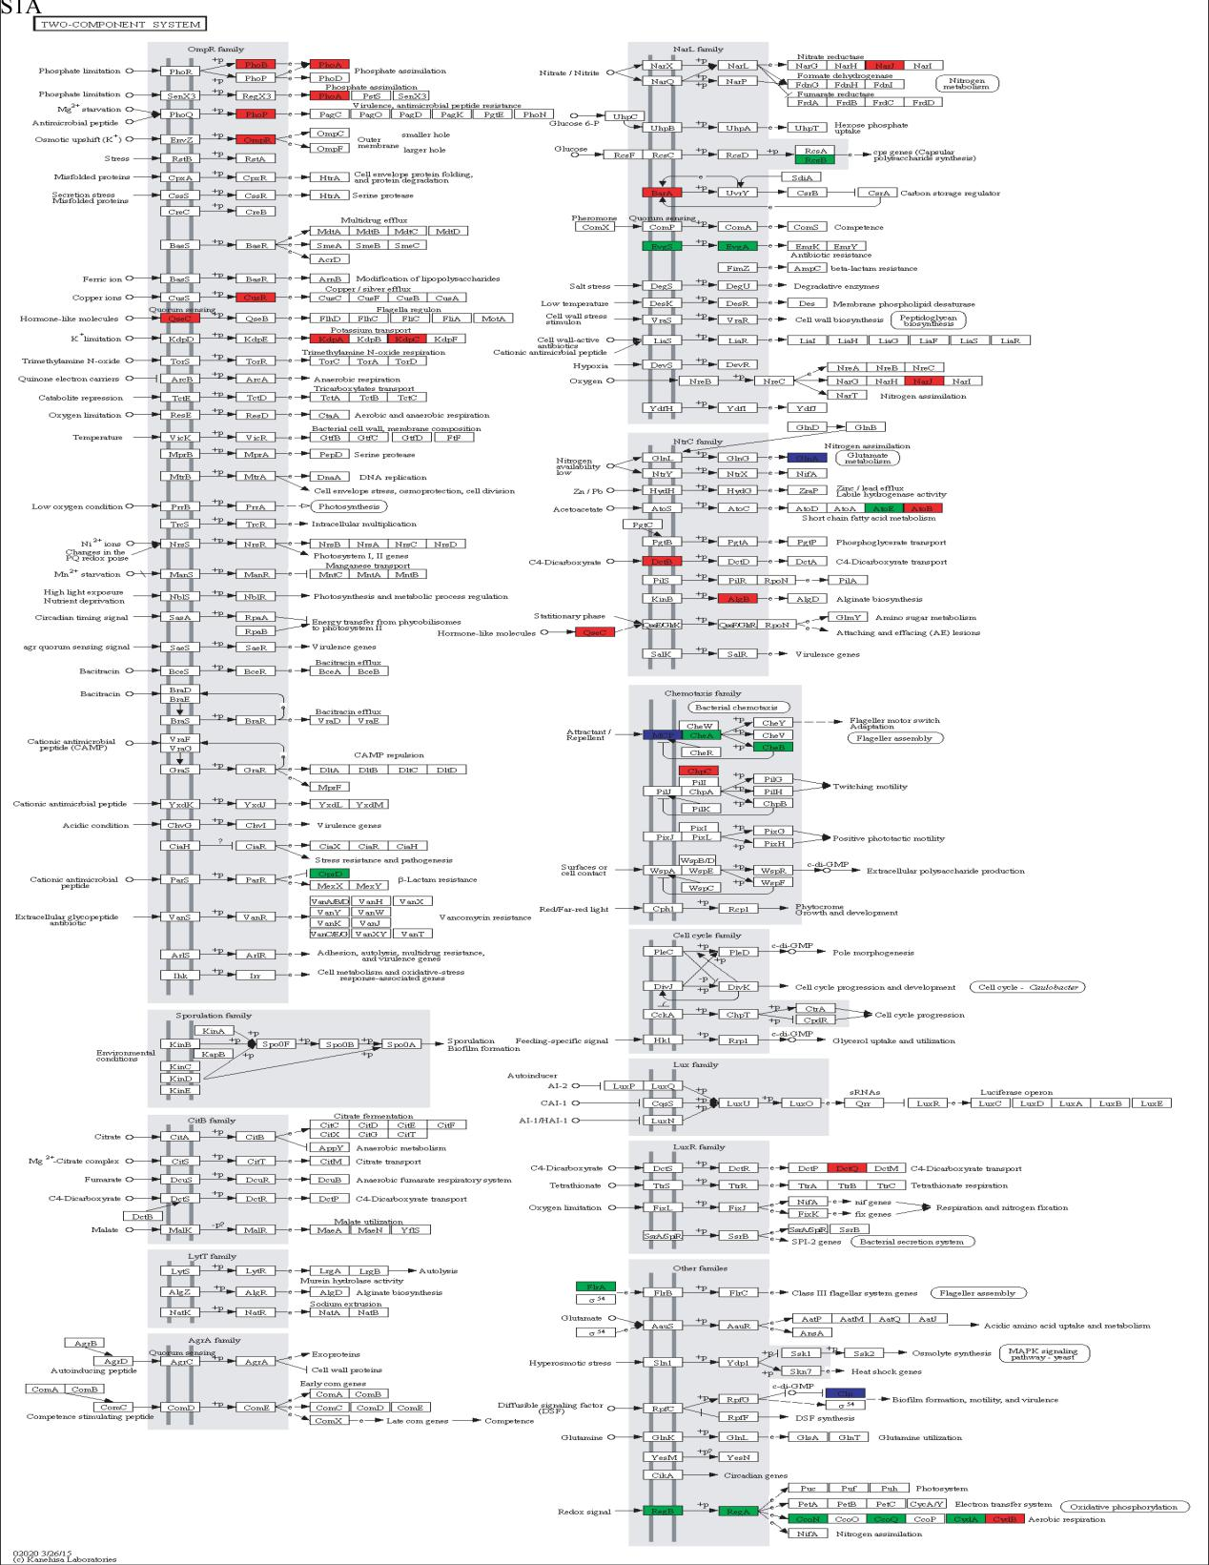

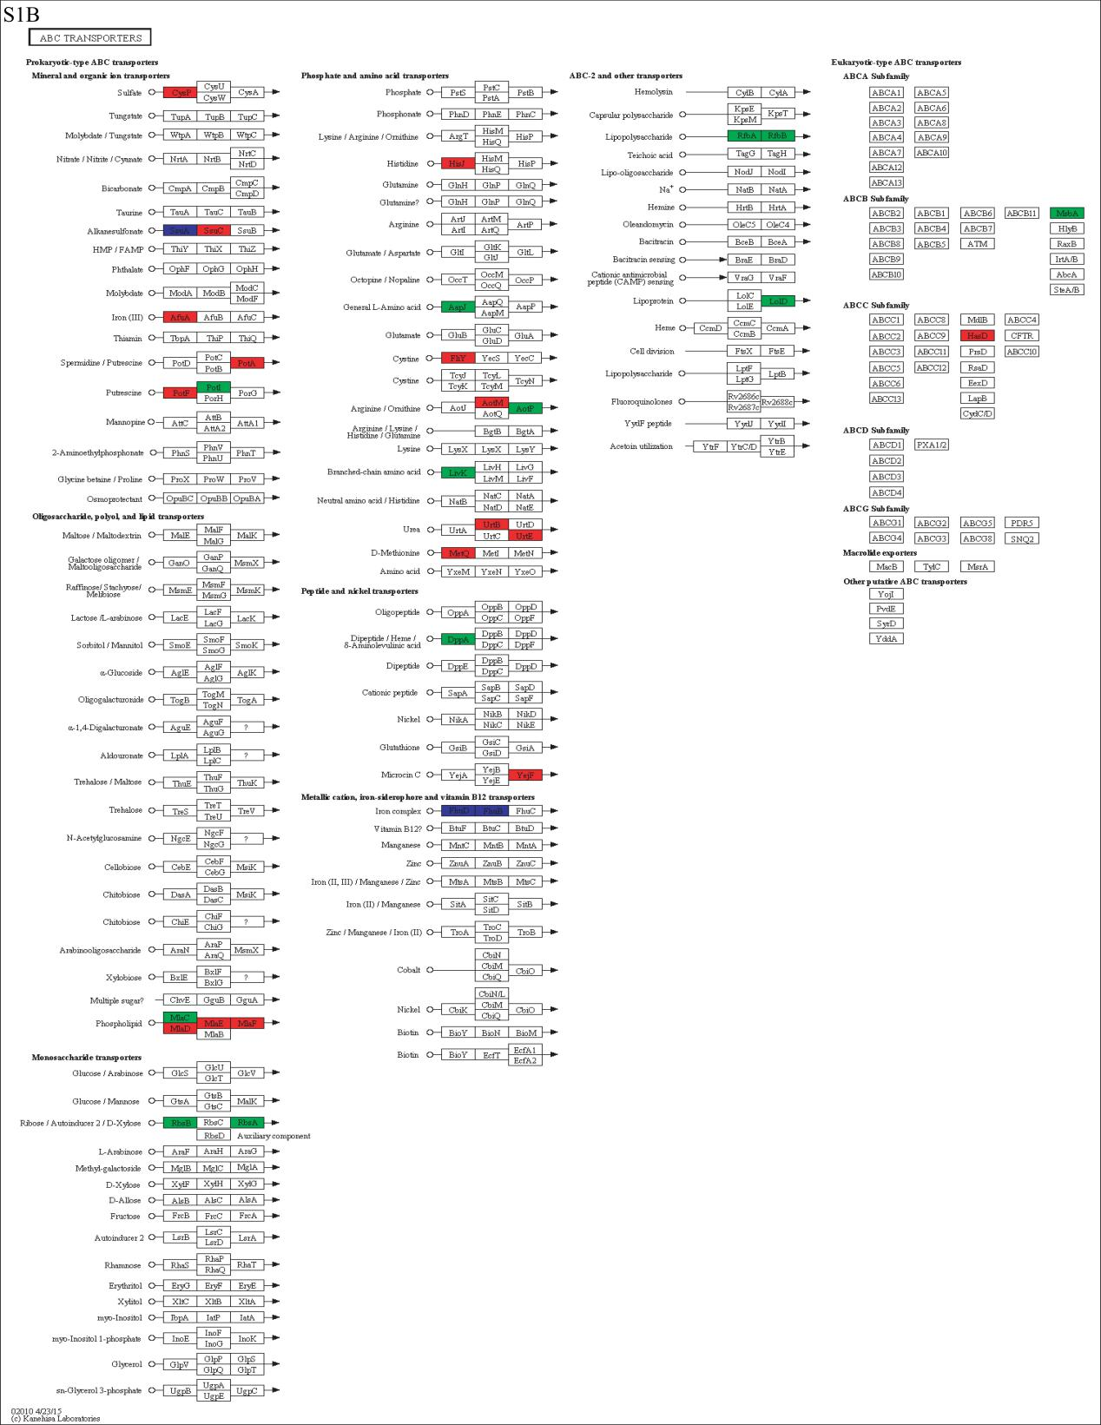
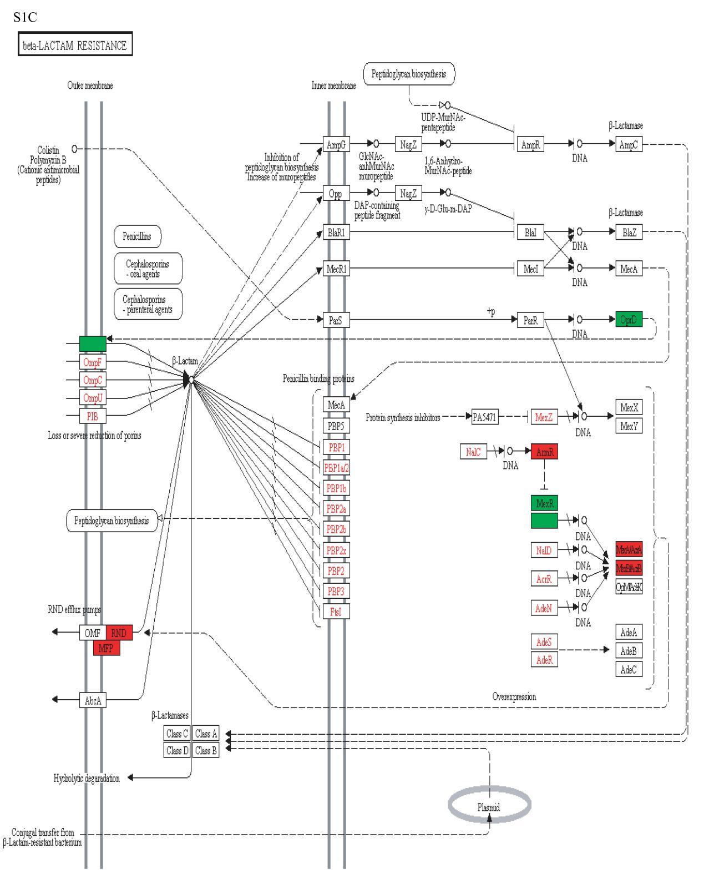

Supplementary Table S1-S5
Table S1. Specific primers of the genes
Symbol | primer F | primer R
16S rRNA | TAACTTCGTGCCAGCAGC | GGAAATTCCACCACCCTC
PA0156 | GCGCTTTTCATTCCAAAG | ACACGGACGTGTTCCTCG
PA1435 | CTGACCATCGACAACCAG | TAGACGAAATTGCCCTCC
mexC | AGGTGATGGTGGTGGGCG | CAGGTGACTGGGCTTGCG
PA2018 | GGTGGAGGGCGTGGGCAA | GGTGAGGCGGGCGTTGTG
mexB | GTCAAGCAATTGCCGAAA | CAGCGACAGCGCATACAG
PA4396 | GGCGGAGACCGACGATTT | CGACCAGGATGCTGAGAT
parR | CAGGCAGGGGAAATACTT | AGCGGGTTGAACAGGTAG
phoB | AGACAATCCTCATCGTTG | CTGCTGGGTATTTTCCGC
PA3573 | CATCGATTTCTACCTGCC | AAGATACTCACCCCCACC
motB | TGGCGTTCTTCCTGGTGC | CTGCGGATTGAGGGTCTT

Table S2. Statistical reads of Clean Data mapped to reference genome
#SampleID | Total reads | Mapped reads | Unmapped reads | Multiple mapped reads | Unique mapped reads
PA1.2620 (1) | 25588060 | 23568822  (92.11%) | 2019238 (7.89%) | 514967  (2.01%) | 23053855  (90.10%)
PA1.2620 (2) | 28884424 | 26610272  (92.13%) | 2274152 (7.87%) | 1596802  (5.53%) | 25013470  (86.60%)
PA1.2620 (3) | 24775104 | 22686017  (91.57%) | 2089087 (8.43%) | 891827  (3.60%) | 21794190  (87.97%)
PA- 99 (1) | 21049038 | 18448745  (87.65%) | 2600293 (12.35%) | 451663  (2.15%) | 17997082  (85.50%)
PA-99 (2) | 21204412 | 19832210  (93.53%) | 1372202 (6.47%) | 870487  (4.11%) | 18961723  (89.42%)
PA-99 (3) | 22675272 | 19875769  (87.65%) | 2799503 (12.35%) | 1060369  (4.68%) | 18815400  (82.98%)

Table S3. Correlation statistics of biological duplicate
sample1 | sample2 | R²
PA1.2620 (1) | PA1.2620 (2) | 0.4689
PA1.2620 (1) | PA1.2620 (3) | 0.4735
PA1.2620 (2) | PA1.2620 (3) | 0.9931
PA-99 (1) | PA-99 (2) | 0.9982
PA-99 (1) | PA-99 (3) | 0.9977
PA-99 (2) | PA-99 (3) | 0.997

Table S4. GO enrichment categorization of tachyplesin-resisitant responsive DEGs uinigenes vs. all uinigenes
#GO_classify1 | GO_classify2 | All Unigene | DEG Unigene
#Total_gene |  | 4761 | 1004
CCs | extracellular region | 29 | 6
CCs | cell | 1489 | 266
CCs | nucleoid | 6 | 1
CCs | membrane | 1149 | 238
CCs | virion | 5 | 0
CCs | membrane-enclosed lumen | 1 | 0
CCs | macromolecular complex | 226 | 38
CCs | organelle | 127 | 16
CCs | extracellular region part | 5 | 0
CCs | organelle part | 75 | 7
CCs | virion part | 5 | 0
CCs | membrane part | 738 | 165
CCs | cell part | 1489 | 266
MFs | protein binding transcription factor activity | 31 | 4
MFs | nucleic acid binding transcription factor activity | 345 | 76
MFs | catalytic activity | 2976 | 624
MFs | receptor activity | 116 | 15
MFs | structural molecule activity | 78 | 8
MFs | transporter activity | 604 | 114
MFs | binding | 2268 | 467
MFs | electron carrier activity | 143 | 25
MFs | antioxidant activity | 47 | 14
MFs | channel regulator activity | 1 | 0
MFs | metallochaperone activity | 1 | 1
MFs | enzyme regulator activity | 12 | 3
MFs | molecular transducer activity | 219 | 43
BPs | reproduction | 36 | 6
BPs | cell killing | 4 | 2
BPs | immune system process | 1 | 1
BPs | metabolic process | 3339 | 700
BPs | cellular process | 2834 | 585
BPs | biological adhesion | 14 | 0
BPs | signaling | 243 | 50
BPs | multicellular organismal process | 4 | 1
BPs | developmental process | 2 | 0
BPs | growth | 1 | 1
BPs | locomotion | 90 | 15
BPs | single-organism process | 2801 | 576
BPs | response to stimulus | 570 | 124
BPs | localization | 964 | 193
BPs | multi-organism process | 51 | 14
BPs | biological regulation | 828 | 181
BPs | cellular component organization or biogenesis | 173 | 30

Table S5. COG classification
#ID | Class_Name | Numbers
J | Translation, ribosomal structure and biogenesis | 57
A | RNA processing and modification | 0
K | Transcription | 130
L | Replication, recombination and repair | 32
B | Chromatin structure and dynamics | 1
D | Cell cycle control, cell division, chromosome partitioning | 9
Y | Nuclear structure | 0
V | Defense mechanisms | 17
T | Signal transduction mechanisms | 89
M | Cell wall/membrane/envelope biogenesis | 69
N | Cell motility | 27
Z | Cytoskeleton | 0
W | Extracellular structures | 0
U | Intracellular trafficking, secretion, and vesicular transport | 36
O | Posttranslational modification, protein turnover, chaperones | 64
C | Energy production and conversion | 85
G | Carbohydrate transport and metabolism | 64
E | Amino acid transport and metabolism | 145
F | Nucleotide transport and metabolism | 29
H | Coenzyme transport and metabolism | 50
I | Lipid transport and metabolism | 63
P | Inorganic ion transport and metabolism | 91
Q | Secondary metabolites biosynthesis, transport and catabolism | 53
R | General function prediction only | 194
S | Function unknown | 101

