Supplementary Information
- Supplementary Experimental Section

1.1 Release profile

Method:
A dialysis assay was utilized to evaluate the release of DOX from C-H/D/M. 19.8 μg of DOX and C-H/D/M were separately dispersed into 500μL of a PBS solution (pH 7.4 and pH 5.0) and placed in the dialysis bags (MWCO: 8,000–14,000) in order to investigate the release characteristics in different media. The flasks (n = 3) were shaken at 37 °C (130 times/min). Next, 5mL of the PBS dialysis solution was collected and replaced with fresh buffer (5 mL) at different time points. The absorbance was recorded at 480 nm. The cumulative release of DOX was calculated. All experiments were repeated in triplicate.
Result:
A dialysis assay was applied to evaluate the release of DOX from the C-H/D/M. The cumulative release of DOX at 216 hours at pH 7.4 and pH 5.0 was 59.37% ± 2.66% and 79.42% ± 0.16%, respectively. It was proven that, compared to the tumor environment (pH 5.0), the amount of C-H/D/M release reduced significantly. (Figure S1)

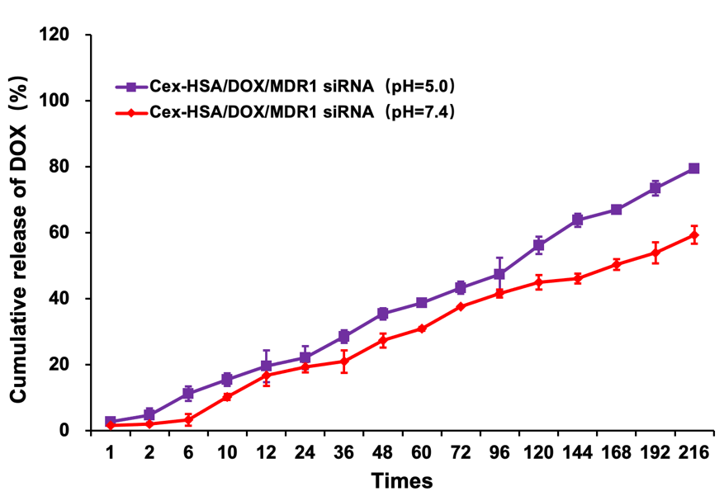
Figure S1: Release profiles of DOX at pH 7.4（physiological）and pH 5.0（tumor mimicking）from Cex-HSA/DOX/MDR1 siRNA in vitro (n=3)

1.2 Transwell assay

Method:
Migration was analyzed using Transwell filters. Control or treated cells (2*10⁵) with serum-free media were added to the top chamber and allowed to migrate through the filter for 6 hours. The cells on the bottom of the filter were then fixed in 4% paraformaldehyde. The cells were stained with crystal violet and washed 3 times with PBS. Invasion assays were performed as described by the migration assay procedure above; however, invasion was used to coat the filter. The cells were allowed to invade for 24 hours. Images were captured with an inverted microscope.
Result:
A transwell assay was performed to evaluate the effects of C-H/D/M on cell migration and invasion. The migration cell number of MCF-7/ADR cells treated with C-H/D/M (5 mg/mL for DOX) was 110.2 ± 5.5, which was lower than in the control group（158.8 ± 7.4） (P < 0.01). The invasion cell number of MCF-7/ADR cells treated with C-H/D/M (5 mg/mL for DOX) was 104.3 ± 3.8 which was significantly lower than that in the control group（160.7 ± 4.8）(P < 0.01). As the concentration increases, the effect increases. All of the results indicate that C-H/D/M inhibits the migration and invasion of MCF-7/ADR cells. (Figure S2)
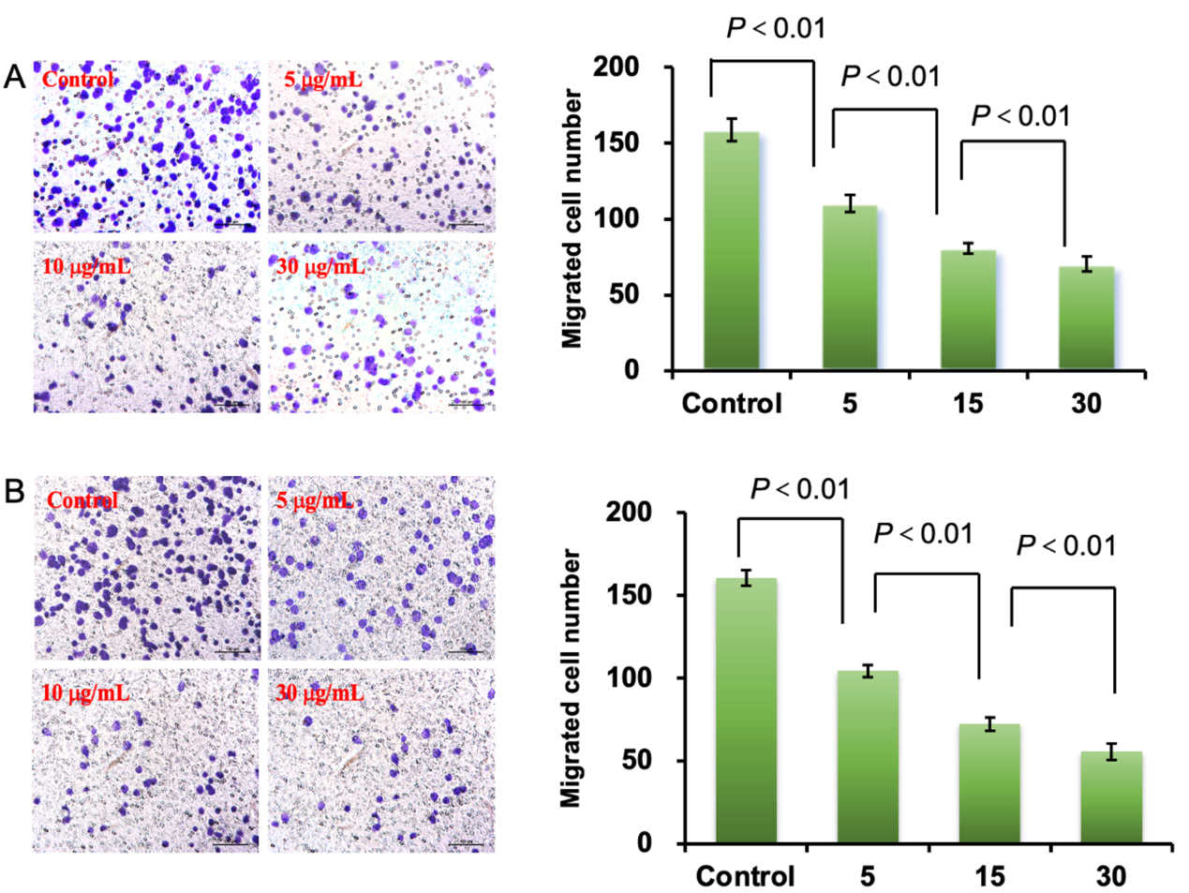
Figure S2: Migration and invasion inhibition effects of C-H/D/M on MCF-7/ADR cells. (A) Effect of C-H/D/M on MCF-7/ADR cells migration by transwell assays. (B) Effect of C-H/D/M on MCF-7/ADR cells invasion by transwell assays. The cells with no treatment were considered as a control. The data were presented as the mean ± SD, n=3.

