Supporting Information for
Albumin-encapsulated nanoparticles of naproxen platinum(IV) complexes with inflammation inhibitory competence displaying effective antitumor activities in vitro and in vivo
Linming Li^{1,}*
Yan Chen^{1,}*
Qingpeng Wang¹
Zuojie Li¹
Zhifang Liu¹
Xuewen Hua¹
Jun Han¹
Chunxiao Chang²
Zhengping Wang^{1,3}
Dacheng Li^{1,4}
¹Institute of Biopharmaceutical Research, Liaocheng University, Liaocheng 252059, P.R. China; ²Shandong Cancer Hospital and Institute, Shandong First Medical University and Shandong Academy of Medical Sciences, Jinan 250022, P.R. China; ³Liaocheng High-Tech Biotechnology Co., Ltd, Liaocheng 252059, PR China; ⁴Shandong Provincial Key Laboratory of Chemical Energy Storage and Novel Cell Technology, Liaocheng University, Liaocheng 252059, PR China.

Correspondence: Qingpeng Wang
Institute of Biopharmaceutical Research, Liaocheng University, Liaocheng 252059, P.R. China.
Tel +86 635 8239773
Fax +86 635 8239773
Email: lywqp@126.com;

Chunxiao Chang
Shandong Cancer Hospital and Institute, Shandong First Medical University and Shandong Academy of Medical Sciences, Jinan 250022, P.R. China.
changcx-111@163.com

* These authors contributed equally to this work.

Contents

1. Synthetic procedures S3
2. The particle size and zeta potential of nanoparticles S3
3. Organ weight indexes and biochemical indexes S10
4. NMR spectra S12
References S14

1. Synthetic procedures
Figure S1 Structures of naproxen platinum(IV) compounds 1−2, oxoplatins O1-O2.
1.1 Preparation of compound O1:
A suspension of oxaliplatin (1.0 g, 2.5 mmol) in distilled water 30 mL was stirred at room temperature. Then H₂O₂ (30%) 50 mL was added dropwise. The mixture was kept stirring for 4 h at 60 °C. Then the resultant mixture was recrystallized at 4 °C. Crude product as solid was obtained after filtration. Then recrystallization in water afforded pure oxoplatin O1 as white solid (0.82 g, 76%).
1.2 Preparation of compound O2:
A suspension of cisplatin (1.0 g, 3.3 mmol) in distilled water 30 mL was stirred at room temperature. Then H₂O₂ (30%) 50 mL was added drop wise. The mixture was kept stirring for 4 h at 60 °C. Then the resultant mixture was recrystallized at 4 °C. Crude product as yellow solid was obtained after filtration. Then recrystallization in water afforded pure compound O2 as yellow crystals (0.91 g, 82%).

2. The particle size and zeta potential of nanoparticles
Table S1 The effects of ratio for compound 1:BSA on the size, PDI and Zeta potential of the nanoparticles (pH = 7.4, T = 4 °C)
1:BSA | 1 | BSA | Size (nm) | PDI | Zeta Potential (mV)
2.0:1 | 5 mg, 5.85 μmol | 194.3 mg, 2.92 μmol | 368.4±15.0 | 0.46±0.04 | -25.1±0.5
3.5:1 | 5 mg, 5.85 μmol | 111.0 mg, 1.67 μmol | 278.6±6.5 | 0.32±0.03 | -29.5±0.3
5.0:1 | 5 mg, 5.85 μmol | 77.7 mg, 1.17 μmol | 299.7±15.2 | 0.49±0.04 | -23.7±0.3
7.5:1 | 5 mg, 5.85 μmol | 51.8 mg, 0.78 μmol | 319.6±4.1 | 0.40±0.01 | -19.4±0.8
Table S2 The effects of ratio for compound 2:BSA on the size, PDI and Zeta potential of the nanoparticles (pH = 7.4, T = 4 °C)
2:BSA | 2 | BSA | Size (nm) | PDI | Zeta Potential (mV)
2.0:1 | 5 mg, 6.60 μmol | 219.1 mg, 3.30 μmol | 392.9±25.6 | 0.42±0.03 | -10.8±0.3
3.5:1 | 5 mg, 6.60 μmol | 125.2 mg, 1.88 μmol | 356.3±2.4 | 0.41±0.01 | -25.4±0.6
5.0:1 | 5 mg, 6.60 μmol | 87.6 mg, 1.32 μmol | 270.2±1.5 | 0.30±0.02 | -22.8±0.8
7.5:1 | 5 mg, 6.60 μmol | 58.4 mg, 0.88 μmol | 345.1±4.2 | 0.51±0.02 | -16.8±0.7
Table S3. The particle size, PDI and the zeta potential of 1-NPs (3.5:1) during storage of 30 days under conditions pH = 7.4, T = 4 °C (n=3)
Time(Day) | Size(nm) |  | PDI |  | Zeta potential (mV)
 | Average | SD | Average | SD | Average | SD
1 | 280.2 | 6.5 | 0.44 | 0.04 | -23.7 | 0.3
3 | 278.1 | 7.2 | 0.38 | 0.05 | -25.7 | 0.8
5 | 287.2 | 5.6 | 0.42 | 0.05 | -24.7 | 0.2
7 | 296.6 | 14.0 | 0.59 | 0.02 | -26.5 | 0.3
16 | 264.9 | 3.5 | 0.38 | 0.02 | -28.1 | 0.1
22 | 299.7 | 15.2 | 0.49 | 0.04 | -29.5 | 0.3
27 | 238.3 | 0.9 | 0.35 | 0.02 | -30.5 | 0.9
30 | 266.0 | 16.7 | 0.37 | 0.01 | -31.1 | 1.2
Table S4. The particle size, PDI and the zeta potential of 1-NPs (3.5:1) during storage of 7 days under conditions pH = 7.4, T = 25 °C (n=3)
Time | Size(nm) |  | PDI |  | Zeta potential (mV)
 | Average | SD | Average | SD | Average | SD
0 h | 304.47 | 4.24 | 0.34 | 0.02 | -38.07 | 0.09
12 h | 330.53 | 5.12 | 0.36 | 0.02 | -37.30 | 0.45
1 d | 313.07 | 2.22 | 0.40 | 0.06 | -38.67 | 0.69
2 d | 304.03 | 4.10 | 0.39 | 0.00 | -32.77 | 1.26
3 d | 284.13 | 1.44 | 0.37 | 0.01 | -22.03 | 1.22
4 d | 311.87 | 22.06 | 0.62 | 0.08 | -13.97 | 0.53
5 d | 338.70 | 15.58 | 0.50 | 0.02 | -12.63 | 0.52
6 d | 540.10 | 8.64 | 0.59 | 0.03 | -9.81 | 0.71
7 d | 513.07 | 18.05 | 0.77 | 0.03 | -9.41 | 0.24
Table S5. The particle size, PDI and the zeta potential of 1-NPs (3.5:1) during storage of 7 days under conditions pH = 7.4, T = 37 °C (n=3)
Time | Size(nm) |  | PDI |  | Zeta potential (mV)
 | Average | SD | Average | SD | Average | SD
0 h | 268.80 | 1.98 | 0.38 | 0.01 | -24.90 | 1.23
2 h | 277.50 | 8.82 | 0.44 | 0.07 | -27.37 | 0.90
3 h | 268.97 | 7.36 | 0.42 | 0.03 | -27.20 | 0.57
4 h | 269.83 | 9.60 | 0.37 | 0.02 | -27.93 | 1.41
8 h | 267.13 | 5.38 | 0.43 | 0.03 | -28.10 | 0.64
12 h | 252.60 | 17.56 | 0.49 | 0.05 | -29.30 | 0.71
24 h | 273.50 | 4.53 | 0.39 | 0.03 | -28.13 | 0.12
2 d | 270.17 | 14.66 | 0.41 | 0.02 | -22.43 | 0.54
3 d | 268.43 | 33.49 | 0.45 | 0.01 | -24.13 | 0.46
4 d | 324.27 | 8.03 | 0.58 | 0.04 | -14.20 | 0.22
5 d | 678.47 | 83.48 | 0.62 | 0.07 | -5.22 | 1.27
6 d | 649.87 | 65.74 | 0.75 | 0.05 | -9.58 | 0.52
7 d | 680.73 | 66.51 | 0.73 | 0.20 | -8.47 | 0.96
Table S6. The particle size, PDI and the zeta potential of 1-NPs (3.5:1) during storage of 7 days under conditions pH = 6.4, T = 4 °C (n=3)
Time(Day) | Size(nm) |  | PDI |  | Zeta potential (mV)
 | Average | SD | Average | SD | Average | SD
1 d | 285.2 | 10.4 | 0.32 | 0.02 | -28.9 | 0.5
3 d | 280.1 | 5.8 | 0.37 | 0.03 | -29.7 | 0.6
5 d | 285.2 | 6.6 | 0.41 | 0.03 | -26.4 | 0.4
7 d | 273.6 | 7.9 | 0.49 | 0.05 | -22.0 | 0.8
Table S7. The particle size, PDI and the zeta potential of 1-NPs (3.5:1) during storage of 7 days under conditions pH = 6.4, T = 37 °C (n=3)
Time | Size(nm) |  | PDI |  | Zeta potential (mV)
 | Average | SD | Average | SD | Average | SD
0 h | 282.57 | 6.06 | 0.42 | 0.04 | -24.60 | 1.31
2 h | 282.97 | 10.20 | 0.41 | 0.01 | -28.30 | 0.45
3 h | 262.47 | 5.39 | 0.36 | 0.05 | -28.90 | 0.50
4 h | 267.97 | 6.86 | 0.39 | 0.02 | -28.93 | 0.45
8 h | 265.57 | 0.48 | 0.37 | 0.02 | -28.27 | 0.90
12 h | 269.13 | 10.58 | 0.38 | 0.01 | -30.13 | 0.97
24 h | 263.80 | 6.87 | 0.38 | 0.00 | -22.63 | 1.39
2 d | 2013.00 | 288.67 | 0.38 | 0.07 | -5.37 | 0.33
3 d | 2582.33 | 126.41 | 0.87 | 0.13 | -9.59 | 0.58
4 d | 1439.67 | 64.60 | 0.68 | 0.03 | -13.47 | 0.76
5 d | 1305.00 | 99.26 | 0.80 | 0.04 | -14.10 | 0.71
6 d | 1203.00 | 27.43 | 0.50 | 0.12 | -12.80 | 0.163299
7 d | 1270.00 | 69.46 | 0.50 | 0.08 | -10.53 | 0.980929
Table S8. The particle size, PDI and the zeta potential of 2-NPs (5.0:1) during storage of 30 days under conditions pH = 7.4, T = 4 °C (n=3)
Time(Day) | Size(nm) |  | PDI |  | Zeta potential (mV)
 | Average | SD | Average | SD | Average | SD
1 | 273.1 | 1.5 | 0.273 | 0.028 | -22.8 | 0.8
3 | 287.9 | 9.8 | 0.303 | 0.028 | -25.8 | 1.8
5 | 259.2 | 8.0 | 0.244 | 0.018 | -23.8 | 0.1
7 | 274.1 | 3.1 | 0.267 | 0.026 | -25.7 | 0.6
16 | 286.1 | 2.4 | 0.410 | 0.053 | -11.4 | 0.2
22 | 285.6 | 4.5 | 0.383 | 0.024 | -20.1 | 0.2
27 | 303.4 | 12.8 | 0.430 | 0.016 | -16.9 | 3.8
30 | 297.1 | 4.9 | 0.464 | 0.046 | -12.5 | 0.1
Table S9. The particle size, PDI and the zeta potential of 2-NPs (5.0:1) during storage of 7 days under conditions pH = 7.4, T = 25 °C (n=3)
Time | Size(nm) |  | PDI |  | Zeta potential (mV)
 | Average | SD | Average | SD | Average | SD
0 h | 292.10 | 8.41 | 0.58 | 0.01 | -38.70 | 1.51
12 h | 282.27 | 4.27 | 0.43 | 0.04 | -36.10 | 0.22
24 h | 287.53 | 3.27 | 0.42 | 0.02 | -36.37 | 0.45
2 d | 272.70 | 4.93 | 0.42 | 0.03 | -34.33 | 1.21
3 d | 275.50 | 5.80 | 0.42 | 0.05 | -32.67 | 0.93
4 d | 270.97 | 9.07 | 0.52 | 0.11 | -30.06 | 1.48
5 d | 223.60 | 11.79 | 0.51 | 0.07 | -36.60 | 0.33
6 d | 364.67 | 39.38 | 0.57 | 0.05 | -8.88 | 0.46
7 d | 395.10 | 20.22 | 0.51 | 0.02 | -7.44 | 0.27
Table S10. The particle size, PDI and the zeta potential of 2-NPs (5.0:1) during storage of 7 days under conditions pH = 7.4, T = 37 °C (n=3)
Time | Size(nm) |  | PDI |  | Zeta potential (mV)
 | Average | SD | Average | SD | Average | SD
0 h | 266.13 | 7.61 | 0.59 | 0.08 | -39.40 | 1.10
2 h | 230.00 | 1.39 | 0.43 | 0.05 | -42.17 | 1.44
3 h | 260.07 | 6.24 | 0.50 | 0.07 | -41.40 | 0.73
4 h | 268.30 | 10.71 | 0.53 | 0.06 | -42.13 | 1.58
8 h | 254.30 | 2.38 | 0.39 | 0.03 | -42.27 | 0.45
12 h | 259.27 | 6.46 | 0.35 | 0.02 | -40.70 | 0.67
24 h | 246.03 | 13.15 | 0.42 | 0.06 | -42.97 | 2.11
2 d | 278.73 | 11.45 | 0.41 | 0.06 | -42.93 | 0.90
3 d | 236.73 | 7.33 | 0.38 | 0.01 | -32.60 | 2.02
4 d | 274.27 | 17.08 | 0.65 | 0.04 | -33.70 | 1.08
5 d | 268.70 | 22.87 | 0.79 | 0.04 | -8.62 | 0.43
6 d | 365.33 | 10.60 | 0.84 | 0.11 | -8.09 | 1.57
7 d | 439.77 | 48.34 | 0.73 | 0.02 | -6.94 | 1.20
Table S11. The particle size, PDI and the zeta potential of 2-NPs (5.0:1) during storage of 7 days under conditions pH = 6.4, T = 4 °C (n=3)
Time(Day) | Size(nm) |  | PDI |  | Zeta potential (mV)
 | Average | SD | Average | SD | Average | SD
1 d | 257.1 | 3.6 | 0.320 | 0.013 | -28.9 | 0.5
3 d | 246.7 | 4.5 | 0.311 | 0.032 | -29.7 | 0.9
5 d | 234.5 | 7.3 | 0.256 | 0.024 | -32.3 | 0.3
7 d | 248.6 | 5.7 | 0.283 | 0.016 | -22.4 | 0.5
Table S12. The particle size, PDI and the zeta potential of 2-NPs (5.0:1) during storage of 7 days under conditions pH = 6.4, T = 37 °C (n=3)
Time | Size(nm) |  | PDI |  | Zeta potential (mV)
 | Average | SD | Average | SD | Average | SD
0 h | 242.43 | 5.90 | 0.39 | 0.04 | -31.60 | 1.15
2 h | 275.33 | 17.15 | 0.43 | 0.04 | -34.43 | 1.04
3 h | 254.57 | 50.78 | 0.46 | 0.02 | -36.40 | 0.80
4 h | 278.03 | 4.05 | 0.57 | 0.07 | -34.70 | 0.54
8 h | 251.47 | 4.25 | 0.43 | 0.02 | -33.70 | 0.37
12 h | 276.47 | 15.18 | 0.37 | 0.01 | -38.80 | 1.31
24 h | 264.47 | 12.41 | 0.47 | 0.02 | -36.43 | 0.74
2 d | 295.40 | 5.91 | 0.43 | 0.05 | -36.00 | 0.50
3 d | 467.47 | 6.11 | 0.45 | 0.07 | -17.67 | 0.61
4 d | 543.00 | 27.53 | 0.74 | 0.03 | -9.57 | 0.44
5 d | 683.30 | 38.37 | 0.80 | 0.08 | -6.34 | 0.55
6 d | 737.20 | 26.38 | 0.85 | 0.09 | -5.63 | 1.81
7 d | 1115.00 | 94.05 | 0.69 | 0.21 | -5.57 | 0.70

Figure S2 Fluorescence spectrum of BSA in the absence and presence of the platinum(IV) complexes (A) 1 and (B) 2 (λex = 280 nm, T = 298 K). a-d: c(BSA) = 4.0 μM, c(complex) = 0.0, 8.0, 14.0, 20.0 μM; e: fluorescence spectrum of free complex, c(complex) = 20.0 μM.
Figure S3 UV-vis spectra of BSA with and without compounds (A) 1 and (B) 2: (a) absorption spectrum of BSA, c(BSA) = 10 μM; (b) absorption spectrum of compound-BSA (2:1), c(BSA) = 10 μM, c(compound) = 20 μM; (c) absorption spectrum of compound, c(compound) = 20 μM; (d) subtraction spectrum of absorption spectrum of compound-BSA complex (a) and compound 1/2 (c). Inset: the curve (a) and (d) for the wavelength ranging from 250 to 300 nm.

3. Organ weight indexes and biochemical indexes
Figure S4 Organ weight indexes of heart (A), liver (B), spleen (C), lung (D) and kidney (E) (organ weight/body weight). Results are presented as the mean ± SD.
Figure S5 Serum ALT levels (A), AST levels (B), CRE levels (C) and BUN levels (D) in mice. Results are presented as the mean ± SD (n=6). *P < 0.05, **P < 0.01.

4. NMR spectra
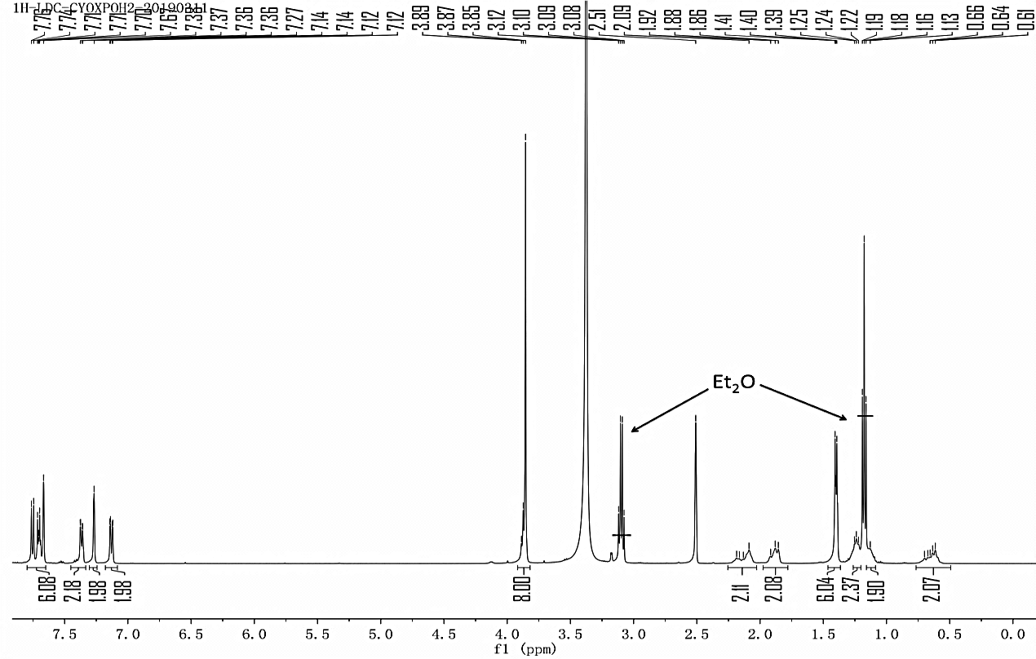
* Signals at 1.19 (t) and 3.08 ppm (q) were ascribed to the peaks of solvent Et₂O.
¹H NMR for Compound 1.^{[S1]}
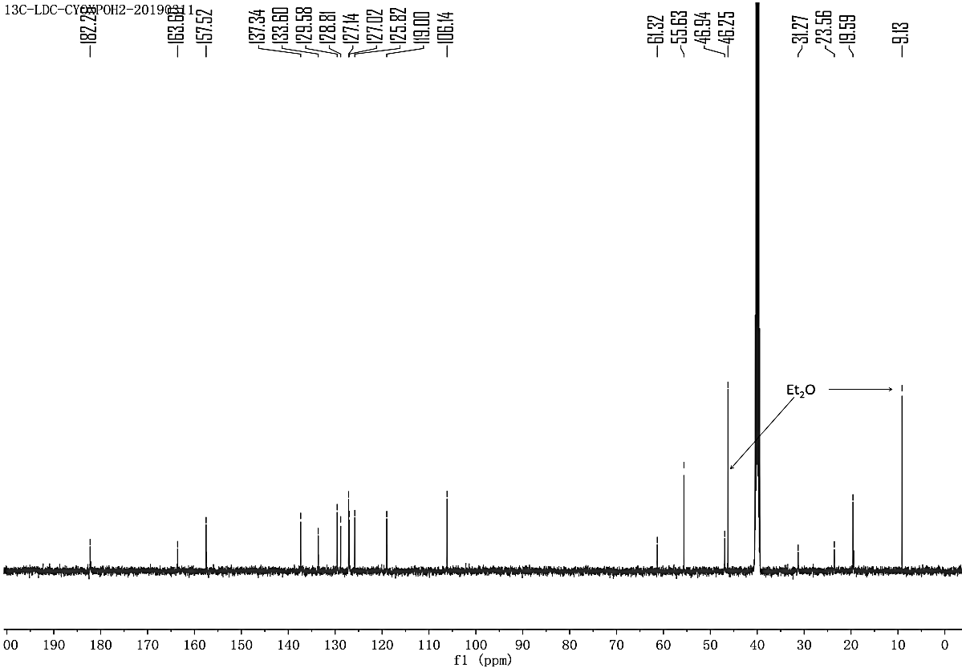
* Signals at 9 ppm and 46 ppm were ascribed to the peaks of solvent Et₂O.
¹³C NMR for Compound 1.^{[S1]}
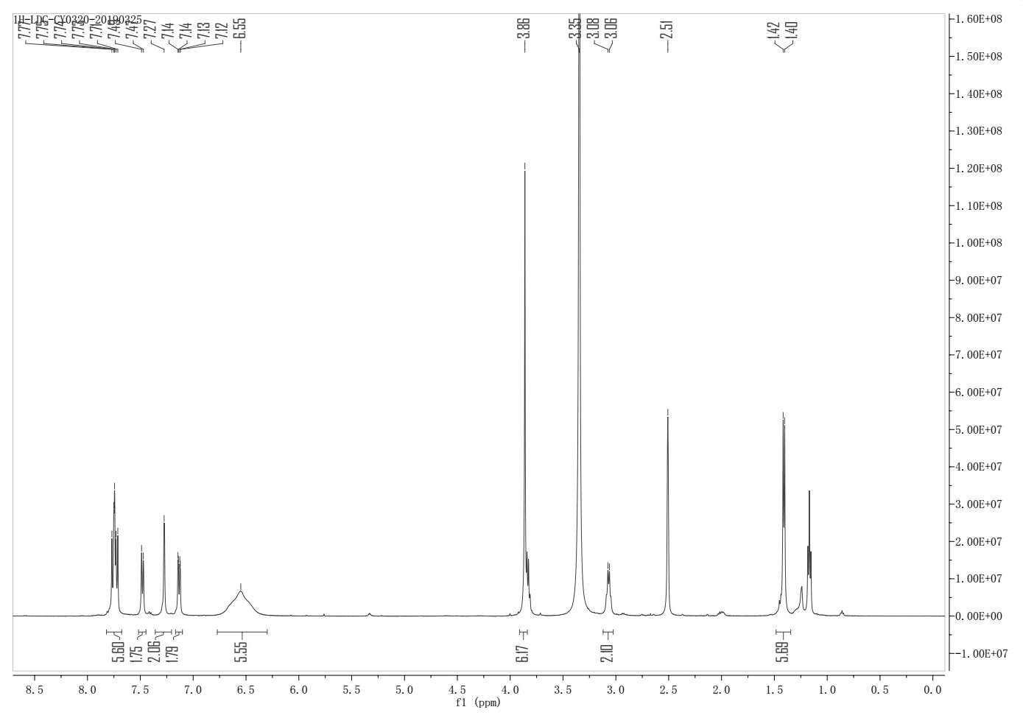
¹H NMR for Compound 2.

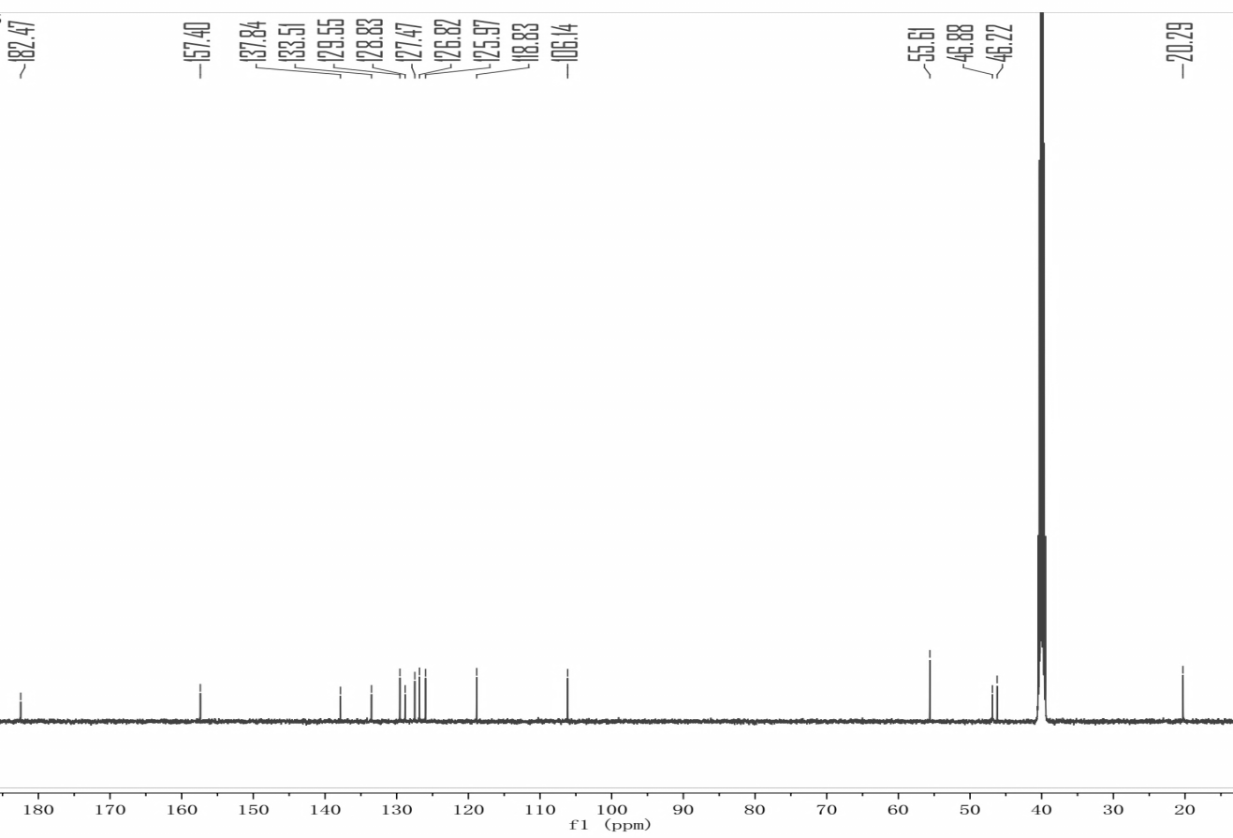
¹³C NMR for Compound 2.

References
[S1] Y. Chen, Q. Wang, Z. Li, Z. Liu, Y. Zhao, J. Zhang, M. Liu, Z. Wang, D. Li, J. Han, Naproxen platinum(IV) hybrids inhibiting cycloxygenases and matrix metalloproteinases and causing DNA damage: synthesis and biological evaluation as antitumor agents in vitro and in vivo. Dalton Trans. 49 (2020) 5192–5204.

