Supplemental Material
Multi-compartmental lung model
Alongside our single compartments model, a simulation-based optimisation model is also being developed to provide further indices of lung heterogeneity using IST data. The concepts of the multi-compartmental lung model have been discussed elsewhere¹⁻³ and it aims to examine lung heterogeneity by recovering lognormal distributions of ventilation (V̇) and pulmonary blood flow (Q̇_{P}) fractions and assessing V̇-Q̇_{P} mismatching. In brief, the fractions of V̇ and Q̇_{P} to each compartment are described by a lognormal distribution. After the simulation is developed, the IST (sinewave periods of 60 and 180 seconds) was applied to both the simulated lung and the participant’s lung. Bayesian optimisation methods were applied to match the simulated data to the measured data⁴. The V̇ and Q̇_{P} of each compartment are varied until the algorithm finds the optimal match. The output of the optimisation is the lognormal distribution of the participant’s V̇ and Q̇_{P} fractions. This analysis was applied to data collected in the current study (Figure 1S).
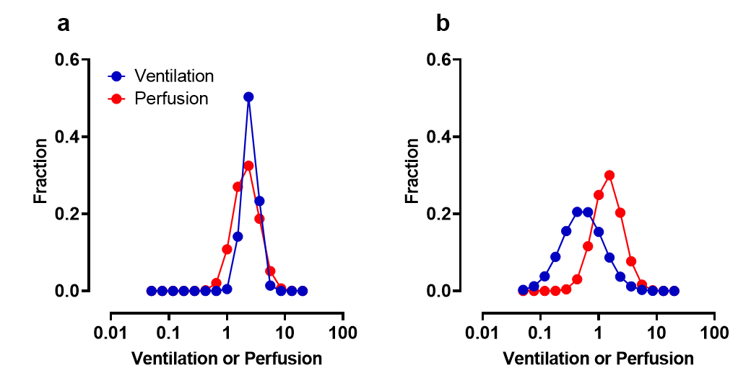
B
A

Figure 1S: Typical lognormal distributions of ventilation (V̇) and perfusion (Q̇_{P}) fractions from healthy (A) and COPD (B) participants, recovered by the multi-compartmental lung model. Note the wider distributions typically shown with COPD.
The single compartment lung model only provides basic indices of lung heterogeneity and was unable to discriminate between COPD patients and Healthy participants based solely upon the signal from the two sinewave periods (ELV₆₀/ELV₁₈₀; Figure 1C in the main article). However, the multi-compartment model can present a more detailed assessment of lung heterogeneity by estimating V̇ and Q̇_{P} heterogeneity in lognormal distributions using data from the two sinewave periods. Figure 1S shows a typical lung heterogeneity distribution output in health (A) and COPD (B) using the multi-compartmental lung model. The V̇ and Q̇_{P} distributions were wider in COPD vs. healthy participants, where the standard deviation of the of V̇ distribution was 1.0 vs. 0.4 and Q̇_{P} distribution was 0.8 vs 0.6 respectively.
Based upon these initial findings, this multicompartmental lung model is a promising method in the identification of COPD. V̇ and Q̇_{P} distributions are wider in COPD patients in comparison to healthy controls, and these differences are similar to those demonstrated using other experimental techniques². Our single compartment models provide useful indices of VH and are related to important clinical outcomes, but its utility seems dependent on additional tests such as whole-body plethysmography. Conversely, the multicompartmental model can discriminate between COPD and healthy participants using information from two different sinewave periods. This clearly shows the potential for using more complex multi-compartmental models in the assessment of COPD, but further work is required.

REFERENCES
1. Harrison C. Methods for determining lung function from tracer gas concentrations., University of Oxford; 2016.
2. Mountain JE, Santer P, O'Neill DP, et al. Potential for noninvasive assessment of lung inhomogeneity using highly precise, highly time-resolved measurements of gas exchange. Journal of applied physiology (Bethesda, Md : 1985). 2018;124(3):615-631.
3. Tran M, Crockett D, Phan PA, Payne S, Farmery A. A tidal lung simulation to quantify lung heterogeneity with the Inspired Sinewave test. 42nd Annual International Conference of the IEEE Engineering in Medicine and Biology Society 2020.
4. Nguyen V. Bayesian Optimization for Accelerating Hyper-Parameter Tuning. Paper presented at: 2019 IEEE Second International Conference on Artificial Intelligence and Knowledge Engineering (AIKE); 3-5 June 2019, 2019.

