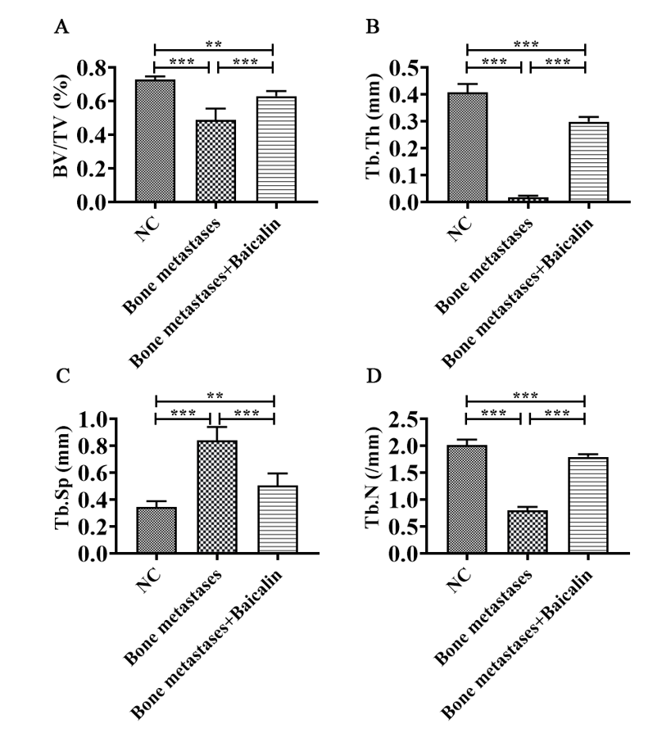

Supplementary Figure 1 CT was used to examine the bone volume fraction (BV/TV), trabecular thickness (Tb.Th), the number of trabeculae (Tb.N) and the mean spacing of trabecular bone (Tb.Sp) in the NC group, the Bone metastases group and the Bone metastases + Baicalin group. Compared with the control group, BV/TV, Tb.Th and Tb.N were downregulated in the Bone metastases group. Although the trend of Tb.Sp was opposite, BV/TV, Tb.Th and Tb.N were significantly increased after baicalin treatment. Data were shown as mean ± SD. **p﹤0.01, ***p﹤0.001.
Supplementary Table 1 The primers were used for this study
Genes | F(5’-3’) | R(5’-3’)
ALPP | GTGAACCGCAACTGGTACTC | GAGCTGCGTAGCGATGTCC
DUSP1 | AGTACCCCACTCTACGATCAGG | GAAGCGTGATACGCACTGC
CYR61 | CTCGCCTTAGTCGTCACCC | CGCCGAAGTTGCATTCCAG
ALPPL2 | CCCGCTTTAACCAGTGCAAC | CCCACGTCACCTCGTTTCTT
SPP1 | CTCCATTGACTCGAACGACTC | CAGGTCTGCGAAACTTCTTAGAT
GAPDH | AGCTTCGGCACATATTTCATCTG | CGTTCACTCCCATGACAAACA

