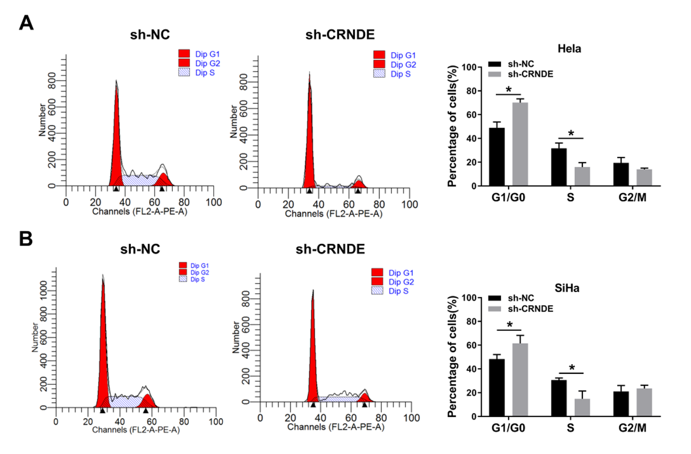
Supplement Fig. 1 CRNDE knockdown arrested cell cycle at G1/G0 in cervical cancer. (A-B) Hela and SiHa cells were transfected with sh-NC or sh-CRNDE, respectively. Cell cycle progression was detected by flow cytometry in transfected Hela (A) and SiHa (B) cells.

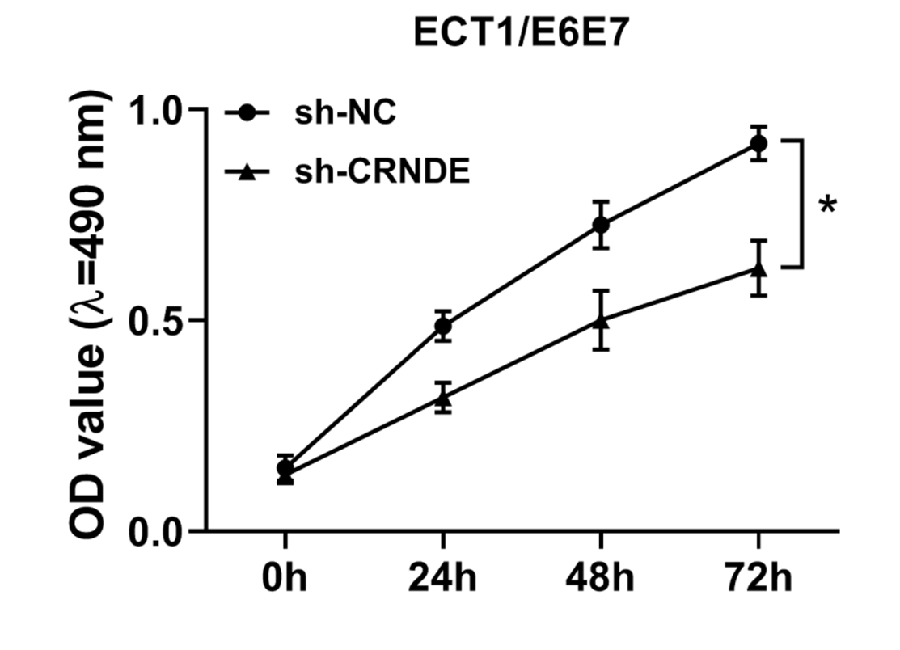
Supplement Fig. 2 CRNDE knockdown inhibited the proliferation of non-cancer ECT1/E6E7 cells. The OD value of ECT1/E6E7 cells with sh-NC or sh-CRNDE was detected by MTT assay.

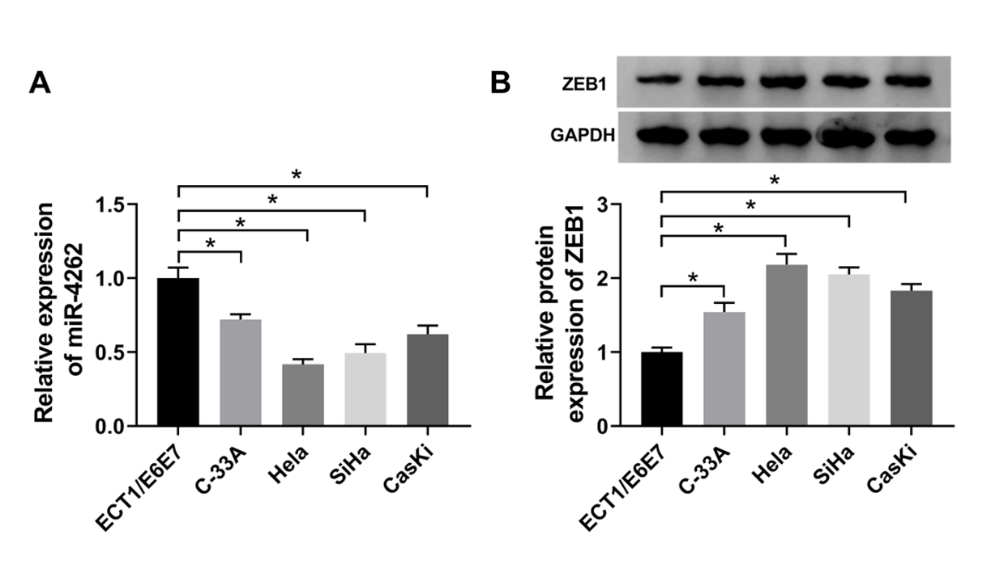
Supplement Fig. 3 MiR-4262 was downregulated and ZEB1 was upregulated in cervical cancer cells. (A) The expression of miR-4262 was detected by qRT-PCR in cervical cancer cell lines (C-33A, Hela, SiHa and CasKi) compared to normal cell line ECT1/E6E7. (B) The protein level of ZEB1 was detected by western blot in cervical cancer cell lines (C-33A, Hela, SiHa and CasKi) compared to normal cell line ECT1/E6E7.

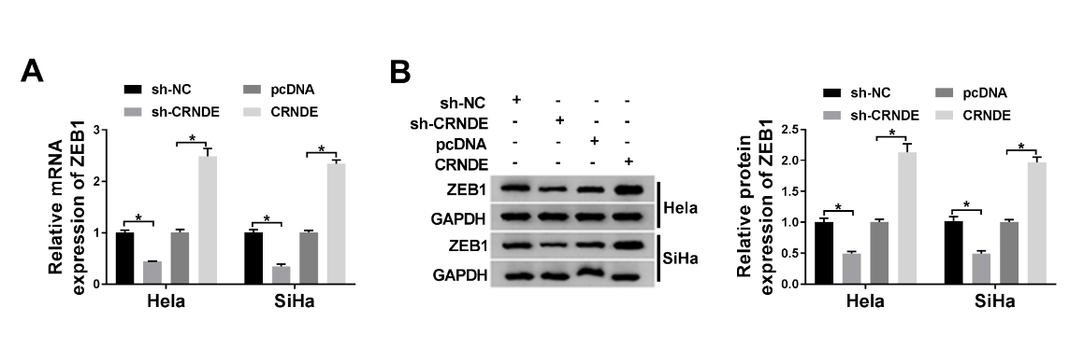
Supplement Fig. 4 CRNDE promoted the expression of ZEB1 in cervical cancer. (A-B) Hela and SiHa cells were transfected with sh-NC, sh-CRNDE, pcDNA or CRNDE, respectively. The mRNA (A) and protein level (B) of ZEB1 was detected by qRT-PCR or western blot.

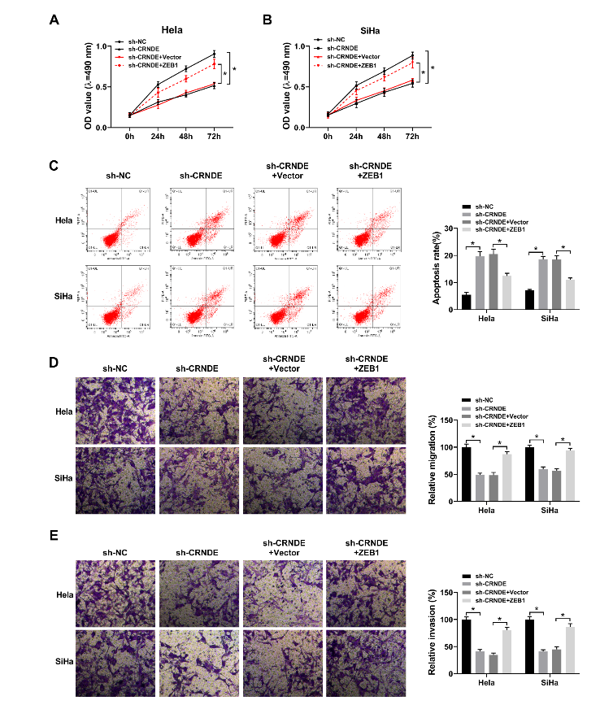
Supplement Fig. 5 ZEB1 overexpression reversed the effects of CRNDE deletion on cervical cancer cells. (A-E) Hela and SiHa cells were transfected with sh-NC, sh-CRNDE, sh-CRNDE + Vector, or sh-CRNDE + ZEB1, respectively. (A-B) Cell viability was evaluated by MTT assay. (C) Cell apoptosis was determined by flow cytometry. (D-E) Cell migration and invasion were detected by transwell migration and invasion assays. *P<0.05.

