Supplementary materials

Supplemental Table 1. Clinicopathological characteristics of patients with colon cancer.
 | n | %
Gender  Male  Female | 25  16 | 61  39
Location of primary lesion  Transverse colon  Right hemicolon  Left hemicolon  Missing | 5  13  15  8 | 12  32  37  20
TNM stage  I  II  III  IV  Missing | 5  7  17  4  8 | 12  17  41  10  20
Differentiation  Well  Moderately  Poorly and undifferentiated  Missing | 3  25  5  8 | 7  61  12  20
Tumor size  ≤ 5 cm  > 5 cm  Missing | 17  8  16 | 41  20  40
Lymph node status  Positive  Negative | 15  26 | 37  63

Supplemental Table 2. Sequences of the primers and TaqMan® probes.
Gene (GenBank accession) |  | Oligonucleotide sequence (5’-3’)
ADIPOQ (NM_001177800)
Forward |  | GGAGATCCAGGTCTTATTGGTCCTA
Reverse |  | CCTTGGATTCCCGGAAAGC
TaqMan® Probe |  | FAM-ACATCGGTGAAACCGGAGTACCCGG-TAMRA
ASC (NM_013258.4)
Forward |  | AGCCAGGCCTGCACTTTATAGA
Reverse |  | CAGCAGCCACTCAACGTTTG
TaqMan® Probe |  | FAM-CACCGGGCTGCGCTTATCGC-TAMRA
 | CCL2 (NM_002982)
 | Forward |  | GCTCATAGCAGCCACCTTCATT
 | Reverse |  | TCTGCACTGAGATCTTCCTATTGGT
 | TaqMan® Probe |  | FAM-TCGCTCAGCCAGATGCAATCAATGC-TAMRA
CLDN1 (NM_021101.5)
Forward |  | AAAGTCTTTGACTCCTTGCTGAATCT
Reverse |  | TTCCAAGCACTTCATACACTTCATG
TaqMan® Probe |  | FAM-AGCAGCCACATTGCAAGCAACCCGT-TAMRA
FGF21 (NM_019113)
Forward |  | CACCTGGAGATCAGGGAGGAT
Reverse |  | ATTTGAATAACTCCCGGCTTCA
TaqMan® Probe |  | FAM-CTGCTGACCAGAGCCCCGAAAGTCTC-TAMRA
GLP1 (NM_002054.5)
Forward |  | CCCTTCAAGACACAGAGGAGAAA
Reverse |  | GCGCTTGTCCTCGTTCATCT
TaqMan® Probe |  | FAM-CCAGATCATTCTCAGCTTCCCAGGCA-TAMRA
GSDMD (NM_001166237.1)
Forward |  | TGGCCCAGCTGGTTATTGAC
Reverse |  | CGCTCGTGGAACGCTTGT
TaqMan® Probe |  | FAM-GACTTGGACGTCCTTCTCTTCCCGG-TAMRA
HMGB1 (NM_001313893.1)
Forward |  | GAAGTTCAAGGATCCCAATGCA
Reverse |  | CTCCTTTGATTTTTGGGCGATAC
TaqMan® Probe |  | FAM-CTCCTTCGGCCTTCTTCCTCTTCTGCTC-TAMRA
IL1B (NM_000576)
Forward |  | CAGTGGCAATGAGGATGACTTG
Reverse |  | GTAGTGGTGGTCGGAGATTCGTA
TaqMan® Probe |  | FAM-TGGCCCTAAACAGATGAAGTGCTCCTTCC-TAMRA
IL18 (NM_001562)
Forward |  | CCAAGGAAATCGGCCTCTATT
Reverse |  | CCTCTAGGCTGGCTATCTTTATACATACT
TaqMan® Probe |  | FAM-TTCTGACTGTAGAGATAATGCACCCCGGAC-TAMRA
 | IL32 (NM_001012631)
 | Forward |  | GAGACAGTGGCGGCTTATTATGA
 | Reverse |  | GGCACCGTAATCCATCTCTTTCT
 | TaqMan® Probe |  | FAM-CAGCACCCAGAGCTCACTCCTCTACTTGAA-TAMRA
IL33 (NM_033439)
Forward |  | CACTGAAAACAGGTAGAAAGCACAAA
Reverse |  | CCCCTGATATACCAAAGGCAAAG
TaqMan® Probe |  | FAM-CTGGTACTCGCTGCCTGTCAACAGCAG-TAMRA
 | KLF4 (NM_001314052.1)
 | Forward |  | ACCTACACAAAGAGTTCCCATCTCA
 | Reverse |  | GTTTACGGTAGTGCCTGGTCAGTT
 | TaqMan® Probe |  | FAM-CCTGCGAACCCACACAGGTGAGAAA-TAMRA
MUC2 (NM_002457)
Forward |  | ACGGCCTGCAGAGCTATTCA
Reverse |  | TGATCTTCTGCATGTTCCCAAAC
TaqMan® Probe |  | FAM-ATTCCTCTCTGACGGCGTGCTCTTCAGT-TAMRA
 | NGAL (NM_005564)
 | Forward |  | CCCAGCCCCACCTCTGA
 | Reverse |  | CTTCCCCTGGAATTGGTTGTC
 | TaqMan® Probe |  | FAM-CAAGGTCCCTCTGCAGCAGAACTTCCA-TAMRA
NLRP1 (NM_033004.3)
Forward |  | CCCTGGAGCAGGAGAAACCT
Reverse |  | CGAGTCTCTGCCGCTTGAGT
TaqMan® Probe |  | FAM-CTCATCTTCAGCAGACGGAAACCAAGTGTG-TAMRA
NLRP3 (NM_001079821.2)
Forward |  | AAGCTTCAGGTGTTGGAATTAGACA
Reverse |  | GTTGCCCAGGCTCAGCTTT
TaqMan® Probe |  | FAM-CACACTGCTGCTGGGATCTTTCCACA-TAMRA
NLRP6 (NM_138329.2)
Forward |  | TCCCTTCTTCATCCACTCTTTCAG
Reverse |  | CAGACCGCGTCAGGGAGTT
TaqMan® Probe |  | FAM-CTGAGCAGCCTCACGCTGTCCCA-TAMRA
 | NOD2 (NM_001293557)
 | Forward |  | TTCAGGAATTACCAGTCCCATTG
 | Reverse |  | GGTCCTCAGCTTGGCCATATACT
 | TaqMan® Probe |  | FAM-CCCTGCCTTTGGAAGCTGCCACA-TAMRA
OCLN (NM_001205254.2)
Forward |  | TGGACTCTACGTGGATCAGTATTTGTA
Reverse |  | AGCAAAAGCCACAATAATCATGAAC
TaqMan® Probe |  | FAM-TCCCCAGGAGGCCATTGCCAT-TAMRA
 | S100A9 (NM_002965)
 | Forward |  | CTCAAGAAGGAGAATAAGAATGAAAAGG
 | Reverse |  | TCAGCTGCTTGTCTGCATTTG
 | TaqMan® Probe |  | FAM-CATAGAACACATCATGGAGGACCTGGAC-TAMRA
 | SPP1 (NM_000582)
 | Forward |  | CATCCAGTACCCTGATGCTACAGA
 | Reverse |  | GGCCTTGTATGCACCATTCAA
 | TaqMan® Probe |  | FAM-ACATCACCTCACACATGGAAAGCGAGGA-TAMRA
 | TGFB (NM_000660)
 | Forward |  | GCCCAGCATCTGCAAAGC
 | Reverse |  | TCCTTGCGGAAGTCAATGTACA
 | TaqMan® Probe |  | FAM-CACCAACTATTGCTTCAGCTCCACGGA-TAMRA
TJP1 (NM_003257.5)
Forward |  | GCACAGCAATGGAGGAAACAG
Reverse |  | TCTCGTCCACCAGATATTGCAAT
TaqMan® Probe |  | FAM-ACAACATACAGTGACGCTTCACAGGGCTC-TAMRA
 | TLR4 (NM_003266)
 | Forward |  | CTGCGTGGAGGTGGTTCCTA
 | Reverse |  | CAGGTCCAGGTTCTTGGTTGAG
 | TaqMan® Probe |  | FAM-TTTCTACAAAATCCCCGACAACCTCCCCT-TAMRA
 | TNFAIP9 (NM_024636)
 | Forward |  | TCTCCAGTCAGGAGCACTGGAT
 | Reverse |  | CAATTTCTTTGGCTGCCATGA
 | TaqMan® Probe |  | FAM- CAAGTCGGCAGGTGTTTGTGTGTGGA-TAMRA
ADIPOQ, adiponectin; ASC, apoptosis-associated speck-like protein containing a CARD; CCL2, monocyte chemoattractant protein-1; CLDN1, claudin 1; FGF21, fibroblast growth factor 21; GLP1, glucagon-like peptide-1; GSDMD, gasdermin D; HMGB1, high mobility group box 1; IL, interleukin; KLF4, kruppel like factor 4; MUC2, mucin 2; NGAL, lipocalin 2; NLRP, nucleotide-binding oligomerization domain, leucine rich repeat and pyrin; NOD2, nucleotide binding oligomerization domain containing 2; OCLN, occludin; S100A9, S100 calcium-binding A9; SPP1, osteopontin; TGFB1, transforming growth factor-β; TLR4, toll-like receptor-4; TJP1, tight junction protein 1; TNFAIP9, tumor necrosis factor-α induced protein 9.

Supplemental Table 3. Univariate analysis of the correlations between mRNA levels of different components of the inflammasome in VAT.
 | mRNA NLRP1 |  | mRNA NLRP3 |  | mRNA NLRP6
 | r | P | r | P | r | P
mRNA NLRP1 | - | - | 0.32 | 0.008 | 0.04 | 0.771
mRNA NLRP3 | 0.32 | 0.008 | - | - | 0.56 | <0.001
mRNA NLRP6 | 0.04 | 0.771 | 0.56 | <0.001 | - | -
mRNA IL1B | 0.04 | 0.784 | 0.59 | <0.001 | 0.50 | <0.001
mRNA IL18 | 0.25 | 0.041 | 0.41 | <0.001 | 0.09 | 0.448
mRNA ASC | 0.40 | <0.001 | 0.33 | 0.006 | 0.15 | 0.238
mRNA NOD2 | 0.50 | <0.001 | 0.40 | <0.001 | 0.28 | 0.025
CRP | 0.20 | 0.270 | 0.44 | 0.012 | 0.209 | 0.115
Monocyte (%) | 0.30 | 0.043 | 0.44 | 0.003 | 0.24 | 0.120
Eosinophil (%) | -0.06 | 0.669 | -0.30 | 0.044 | -0.44 | 0.002
ASC, apoptosis-associated speck-like protein containing a CARD; CRP, C-reactive protein; IL, interleukin; NLRP, nucleotide-binding oligomerization domain, leucine rich repeat and pyrin; NOD2, nucleotide binding oligomerization domain containing 2; VAT, visceral adipose tissue. Associations between variables were analyzed by Pearson’s correlation coefficients.

Supplemental Table 4. Analysis of gene expression levels of inflammation- and intestinal integrity-associated markers in colon cancer cells after the incubation with Akkermansia muciniphila.
Gen | CTL | A. muciniphila Heat-inactivated | A. muciniphila  Alive | CTL-BM  20% | BCM  20% | CTL-BM  40% | BCM  40%
NLRP1 | 1.00 ± 0.08 | 0.72 ± 0.12 | 0.43 ± 0.08 | 0.98 ± 0.12 | 3.15 ± 0.68**,††,§§,‡‡ | 1.09 ± 0.12 | 4.21 ± 0.57**,††,§§,‡‡
NLRP3 | 1.00 ± 0.22 | 1.12 ± 0.21 | 13.84 ± 1.20**,††,‡‡,## | 0.81 ± 0.02 | 0.21 ± 0.02 | 0.87 ± 0.07 | 0.39 ± 0.05
NLRP6 | 1.00 ± 0.13 | 0.61 ± 0.06 | 1.37 ± 0.20 | 0.51 ± 0.08 | 2.00 ± 0.44†,‡‡ | 0.92 ± 0.18 | 3.01 ± 0.34**,†,§,‡‡
ASC | 1.00 ± 0.08 | 0.96 ± 0.18 | 1.66 ± 0.18*,†,‡‡,# | 0.72 ± 0.05 | 0.92 ± 0.21 | 0.67 ± 0.05 | 0.74 ± 0.04
IL1B | 1.00 ± 0.17 | 1.40 ± 0.17## | 2.93 ± 0.28* | 1.26 ± 0.17 | 4.06 ± 0.94**,††,§,‡ | 1.89 ± 0.29 | 3.40 ± 0.45*,††,§,‡
IL6 | 1.00 ± 0.34 | 1.38 ± 0.30 | 1.32 ± 0.38 | 1.47 ± 0.29 | 1.00 ± 0.39 | 1.10 ± 1.14 | 0.59 ± 0.16
IL32 | 1.00 ± 0.12 | 7.96 ± 0.88** | 1.13 ± 0.17 | 0.83 ± 0.10 | 27.97 ± 3.75**,††,§§,‡‡ | 0.70 ± 0.10 | 22.01 ± 3.19**,††,§§,‡‡
TLR4 | 1.00 ± 0.11 | 0.99 ± 0.08 | 0.68 ± 0.03 | 0.98 ± 0.10 | 0.40 ± 0.04 | 1.12 ± 0.17 | 1.03 ± 0.06
HMGB1 | 1.00 ± 0.12 | 1.46 ± 0.22 | 1.97 ± 0.27* | 0.99 ± 0.07 | 0.52 ± 0.09 ††,§§,‡‡ | 0.92 ± 0.15 | 0.49 ± 0.07 ††,§§,‡‡
GSDMD | 1.00 ± 0.07 | 0.95 ± 0.11 | 0.84 ± 0.11 | 0.98 ± 0.08 | 0.77 ± 0.07 | 0.82 ± 0.08 | 1.00 ± 0.21
MUC2 | 1.00 ± 0.14 | 2.51 ± 0.30* | 3.38 ± 0.51** | 0.79 ± 0.02 | 2.29 ± 0.29*,‡ | 0.88 ± 0.01 | 2.49 ± 1.18*,‡
CLDN1 | 1.00 ± 0.12 | 1.73 ± 0.23 | 1.85 ± 0.20* | 0.87 ± 0.02 | 1.47 ± 0.32 | 0.83 ± 0.03 | 1.21 ± 0.23
OCLN1 | 1.00 ± 0.13 | 1.50 ± 0.70 | 1.13 ± 0.10 | 0.73 ± 0.03 | 1.30 ± 0.32 | 0.75 ± 0.05 | 1.38 ± 0.17
TJP1 | 1.00 ± 0.20 | 0.95 ± 0.18 | 1.17 ± 0.21 | 0.86 ± 0.03 | 0.79 ± 0.07 | 0.73 ± 0.04 | 0.85 ± 0.20
Analysis of mRNA levels in HT-29 colon cancer cells (n=6 per group). Data represent the mean ± SEM of the ratio between the gene expression to 18S rRNA. Differences between groups were analyzed by one-way ANOVA followed by Tukey’s post-hoc tests. *P<0.05 and **P<0.01 vs CTL. †P<0.05 and ††P<0.01 vs heat-inactivated A. muciniphila. §P<0.05 and §§P<0.01 vs A. muciniphila alive. ‡P<0.05 and ‡‡P<0.01 vs corresponding CTL-BCM. #P<0.05 and ##P<0.01 vs BCM. ASC, apoptosis-associated speck-like protein containing a CARD; CLDN1, claudin 1; GSDMD, gasdermin D; HMGB1, high mobility group box 1; IL, interleukin; MUC2, mucin 2; NLRP, nucleotide-binding oligomerization domain (NOD)-like receptors; OCLN, occludin; TJP1, tight junction protein 1; TLR4, toll-like receptor-4.CTL-BM, brain heart infusion medium diluted in McCoy’s 5a medium.

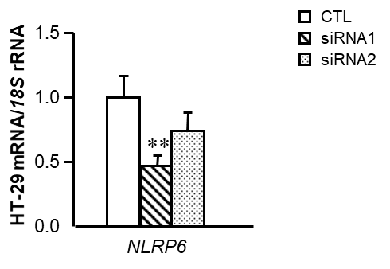
Supplemental Figure 1. mRNA expression levels of NLRP6 in HT-29 cells after transfection with two siRNAs (s128674 and s128675) at 100 pM siRNA NLRP6/2x10⁵ cells for 24 h. Gene expression levels in scrambled siRNA cells (CTL) were assumed to be 1. Values are the mean ± SEM (n=6 per group). Differences between groups were analyzed by one-way ANOVA followed by Dunnet’s tests. **P<0.01 vs CTL.

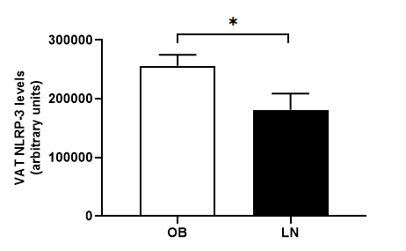
Supplemental Figure 2. Impact of obesity on protein expression levels of NLRP-3 in visceral active tissue (VAT). NLRP-3 levels in patients with obesity (OB) and lean volunteers (LN). Bars represent the mean ± SEM. Differences between groups were analyzed by unpaired two-tailed Student’s t test. *P<0.05.

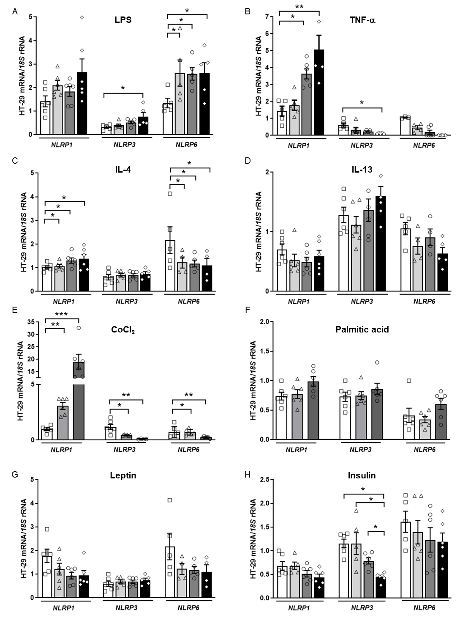
Supplemental Figure 3. Impact of hypoxia and inflammation-related factors in the gene expression levels of the main inflammasome components in HT-29 colon cancer cells. Bar graphs show the effect of (A) LPS, (B) TNF-α, (C) IL-4, (D) IL-13 (E) CoCl₂, (F) palmitic acid, (G) leptin and (H) insulin incubated for 24 h on the transcript levels of NLRP1, NLRP3 and NLRP6 in HT-29 cells. Values are the mean ± SEM (n=6 per group). Differences between groups were analyzed by one-way ANOVA followed by Dunnett’s tests. *P<0.05, **P<0.01 and ***P<0.001.
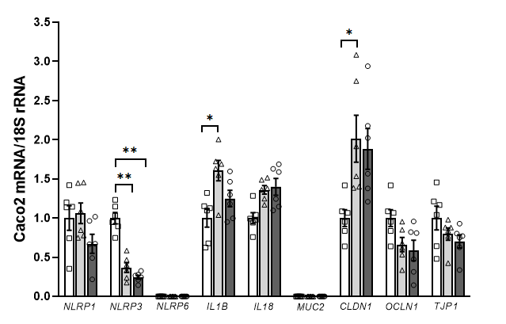
Supplemental Figure 4. Effect of adipocyte-conditioned media (ACM) on the gene expression levels of the inflammasome as well as on intestinal integrity markers in Caco-2 cells. Bar graphs show the effect of ACM (20 and 40%) from obese subjects incubated for 24 h on the transcript levels of inflammasome- and intestinal integrity-associated genes in Caco2 cells. Values are the mean ± SEM (n=6 per group). Differences between groups were analyzed by one-way ANOVA followed by Tukey’s tests. *P<0.05 and **P<0.01. CLDN1, claudin 1; IL, interleukin; NLRP, nucleotide-binding oligomerization domain, leucine rich repeat and pyrin; OCLN, occludin; TJP1, tight junction protein 1.

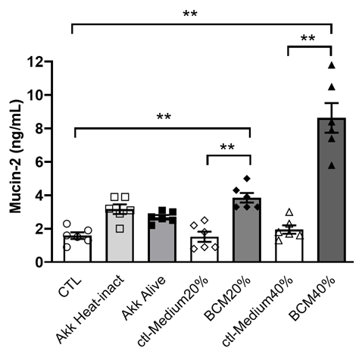
Supplemental Figure 5. Secreted levels of mucin-2 after Akkermansia muciniphila incubation in HT-29 colon cancer cells. Mucin-2 concentrations in the culture media of HT-29 cells incubated in the presence of A. muciniphila heat-inactivated (Akk Heat-inact), A. muciniphila alive (Akk Alive) and with the bacteria-conditioned medium (BCM) (20% and 40%) for 24 h. Values are the mean ± SEM (n=6 per group). Differences between groups were analyzed by one-way ANOVA followed by Tukey’s tests. **P<0.01.

