Electronic Supplementary Information
Selenium-Doped Carbon Quantum Dots Efficiently Ameliorate Secondary Spinal Cord Injury via Scavenging Reactive Oxygen Species

Wenqi Luo ^{1,2}, Yiming Wang ^{1,2}, Feng Lin ^{1,2}, Yixuan Liu ^{2,3}, Rui Gu ^{1*}, Wanguo Liu ^{1*}, Chunsheng Xiao ^{2,4}
¹ Department of Orthopaedic Surgery, China-Japan Union Hospital of Jilin University, Changchun 130033, P. R. China
² Key Laboratory of Polymer Ecomaterials, Changchun Institute of Applied Chemistry, Chinese Academy of Sciences, Changchun 130022, P. R. China
³ School of Applied Chemistry and Engineering, University of Science and Technology of China, Hefei 230026, P. R. China
⁴ Jilin Biomedical Polymers Engineering Laboratory, Changchun 130022, P. R. China

* Corresponding authors
E-mail addresses:
liuwanguo6016@jlu.edu.cn (Wanguo Liu); gurui@jlu.edu.cn (Rui Gu)

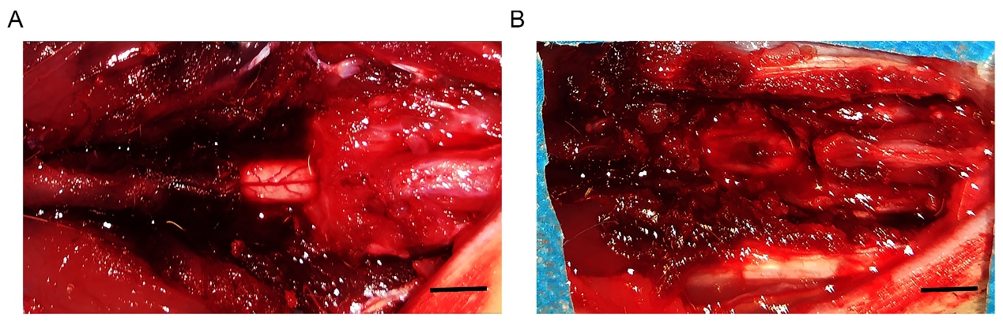
Figure S1. Images of the spinal cord. (A) Image of normal spinal cord. (B) Image of the injured spinal cord after the establishment of the spinal cord injury model. Scale bar = 4 mm.
Figure S2. ¹H NMR and ¹³C NMR spectra of L-selenocystine. (A) ¹H NMR spectra of l-selenocystine, (B) ¹³C NMR spectra of l-selenocystine.

Figure S3. NMR spectra of the Se-CQDs. (A) ¹H NMR spectra of the Se-CQDs. (B) ¹³C NMR spectra of the Se-CQDs.
Figure S4. FTIR spectra of the Se-CQDs and l-selenocystine.
Figure S5. UV-Vis absorption spectra of Se-CQDs in water at various concentrations.

Figure S6. Fluorescence spectra of Se-CQDs in water at a concentration of 1 mg mL⁻¹.

Figure S7. In vitro toxicity study of the Se-CQDs. (A) Viability of PC12 cells, astrocytes and N2a cells incubated with different concentrations of Se-CQDs for 24 h. (B) Viability of PC12 cells, astrocytes and N2a cells incubated with different concentrations of Se-CQDs for 48 h. Data are presented as the means ± SDs, with n = 3 for each group.
Figure S8. Se-CQDs scavenge ROS to protect N2a cells from ROS-induced oxidative damage. (A) Effect of H₂O₂ on the viability of N2a cells. (B) Protective effect of Se-CQDs against H₂O₂-induced oxidative damage in N2a cells. The concentration of H₂O₂ was 250 μM. (C) Intracellular ROS levels in N2a cells were measured by DCF staining, scale bar = 50 μm. (D) Live/dead straining of N2a cells under different conditions, scale bar = 50 μm.
Figure S9. Se-CQDs scavenge ROS to protect PC12 cells in vitro. (A) Intracellular ROS levels in PC12 cells were measured by DCFH-DA staining. (B) Quantitative analysis of the fluorescence intensity of DCF in the cells. (C) Live/dead staining of PC12 cells. Scale bar = 20 μm. (D) Quantitative analysis of the number of dead cells. **P < 0.01.

Figure S10. Body weights of the rats with spinal cord injury from the different groups (n=9) after treatment at different time intervals. No diﬀerence in body weight was observed between the rats from the three groups.

Figure S11. Quantitative analysis of Luxol fast blue (LFB) staining and G-ratio. (A) Quantitative analysis of relative LFB staining. (B) Quantitative analysis of the G-ratio. *P < 0.05 and **P < 0.01.

Table S1. Antibodies dilution information used in the immunofluorescent (IF) staining
Antibody | Application | Dilution
anti-GFAP | IF | 1:1000
anti-NF200 | IF | 1:200
anti-NeuN | IF | 1:500
anti-CS56 | IF | 1:200
Anti-CD68 | IF | 1:200
DAPI | IF | 1:1000
Anti-Mouse IgG (H+L) labeled with Alexa-488 | IF | 1:1000
Anti-Rabbit IgG (H+L) labeled with Alexa-546 | IF | 1:500
Anti-Rabbit IgG (H+L) labeled with Alexa-488 | IF | 1:1000
Anti-Mouse IgG (H+L) labeled with Alexa-546 | IF | 1:500

Table S2. Antibodies dilution information used in the western blotting (WB)
Antibody | Application | Dilution
anti-caspase-9 | WB | 1:1000
anti-cleaved caspase-3 | WB | 1:1000
anti-Bcl-2 | WB | 1:1000
anti-Bax | WB | 1:1000
anti-GAPDH | WB | 1:5000

