Supplementary Material
Supplementary Table 1. Diagnostic read codes for COPD
Read code | Description
222I.00 | Blue bloater
663K.00 | Airways obstruction irreversible
66YB000 | COPD 3 monthly review
66YB100 | COPD 6 monthly review
66YM.00 | COPD annual review
H061400 | Obliterating fibrous bronchiolitis
H3...00 | COPD
H3...11 | Chronic obstructive airways disease
H31..00 | Chronic bronchitis
H310.00 | Simple chronic bronchitis
H310000 | Chronic catarrhal bronchitis
H310z00 | Simple chronic bronchitis NOS
H311.00 | Mucopurulent chronic bronchitis
H311000 | Purulent chronic bronchitis
H311100 | Fetid chronic bronchitis
H311z00 | Mucopurulent chronic bronchitis NOS
H312.00 | Obstructive chronic bronchitis
H312100 | Emphysematous bronchitis
H312300 | Bronchiolitis obliterans
H312z00 | Obstructive chronic bronchitis NOS
H313.00 | Mixed simple and mucopurulent chronic bronchitis
H31y.00 | Other chronic bronchitis
H31y100 | Chronic tracheobronchitis
H31yz00 | Other chronic bronchitis NOS
H31z.00 | Chronic bronchitis NOS
H32..00 | Emphysema
H320.00 | Chronic bullous emphysema
H320000 | Segmental bullous emphysema
H320100 | Zonal bullous emphysema
H320200 | Giant bullous emphysema
H320300 | Bullous emphysema with collapse
H320z00 | Chronic bullous emphysema NOS
H321.00 | Panlobular emphysema
H322.00 | Centrilobular emphysema
H32y.00 | Other emphysema
H32y000 | Acute vesicular emphysema
H32y100 | Atrophic (senile) emphysema
H32y111 | Acute interstitial emphysema
H32y200 | MacLeod's unilateral emphysema
H32yz00 | Other emphysema NOS
H32z.00 | Emphysema NOS
H36..00 | Mild COPD
H37..00 | Moderate COPD
H38..00 | Severe COPD
H39..00 | Very severe COPD
H3A..00 | End stage chronic obstructive airways disease
H3y..00 | Other specified chronic obstructive airways disease
H3y..11 | Other specified COPD
H3z..00 | Chronic obstructive airways disease NOS
H3z..11 | COPD NOS
H464000 | Chronic emphysema due to chemical fumes
H464100 | Obliterative bronchiolitis due to chemical fumes
H564.00 | Bronchiolitis obliterans organizing pneumonia
H564.11 | Cryptogenic organizing pneumonia
H581.00 | Interstitial emphysema
H582.00 | Compensatory emphysema
H583200 | Eosinophilic bronchitis
Hyu3000 | [X]Other emphysema
Hyu3100 | [X]Other specified chronic obstructive pulmonary disease
663k.00 | Reversibility trial by steroids
66Ym.00 | Inhaler device in use
H310100 | Smokers' cough
H312000 | Chronic asthmatic bronchitis
H312011 | Chronic wheezy bronchitis
H312200 | Acute exacerbation of chronic obstructive airways disease
H31y000 | Chronic tracheitis
H320311 | Tension pneumatocoele
H3y0.00 | COPD with acute lower respiratory infection
H3y1.00 | COPD with acute exacerbation, unspecified
H440.00 | Byssinosis
H464.00 | Chronic respiratory conditions due to chemical fumes
H464200 | Chronic pulmonary fibrosis due to chemical fumes
H464z00 | Chronic respiratory conditions due to chemical fumes NOS
H581.11 | Pneumomediastinum
Hyu3.00 | [X]Chronic lower respiratory diseases

Abbreviations: COPD, chronic obstructive pulmonary disease; NOS, not otherwise specified.

Supplementary Table 2. Read codes for exclusion of COPD
Read code | Description
14S9.00 | H/O: lung recipient
23E5.00 | O/E - fibrosis of lung present
23E5.11 | O/E - fibrosis of lung
7448100 | Excision of cyst of bronchus
7450.00 | Transplantation of lung
7450000 | Double lung transplant
7450100 | Single lung transplant
7450y00 | Other specified transplantation of lung
7450z00 | Transplantation of lung NOS
7451.00 | Excision of lung
7451.11 | Pneumonectomy operations
7451000 | Total pneumonectomy
7451011 | Pneumonectomy
7451100 | Bilobectomy of lung
7451200 | Lobectomy of lung
7451211 | Pulmonary lobectomy
7451300 | Excision of segment of lung
7451311 | Pulmonary segmentectomy
7451400 | Partial lobectomy of lung NEC
7451y00 | Other specified excision of lung
7451z00 | Excision of lung NOS
7900.00 | Transplantation of heart and lung
7900000 | Allotransplantation of heart and lung
7900z00 | Transplantation of heart and lung NOS
A114.00 | Tuberculous fibrosis of lung
A115.00 | Tuberculous bronchiectasis
C10N100 | Cystic fibrosis related diabetes mellitus
C350300 | Idiopathic pulmonary hemosiderosis
C370.00 | Cystic fibrosis
C370.12 | Mucoviscidosis
C370000 | Cystic fibrosis with no meconium ileus
C370100 | Cystic fibrosis with meconium ileus
C370111 | Meconium ileus in cystic fibrosis
C370200 | Cystic fibrosis with pulmonary manifestations
C370300 | Cystic fibrosis with intestinal manifestations
C370400 | Arthropathy in cystic fibrosis
C370500 | Cystic fibrosis with distal intestinal obstruction syndrome
C370800 | Cystic fibrosis related cirrhosis
C370y00 | Cystic fibrosis with other manifestations
C370z00 | Cystic fibrosis NOS
H34..00 | Bronchiectasis
H340.00 | Recurrent bronchiectasis
H341.00 | Post-infective bronchiectasis
H34z.00 | Bronchiectasis NOS
H423.00 | Massive silicotic fibrosis
H431.00 | Bauxite fibrosis of lung
H433.00 | Graphite fibrosis of lung
H464200 | Chronic pulmonary fibrosis due to chemical fumes
H48..00 | Progressive massive fibrosis
H4y1.00 | Chronic pulmonary radiation disease
H4y1000 | Chronic pulmonary fibrosis following radiation
H4y1z00 | Chronic pulmonary radiation disease NOS
H4y2.00 | Drug-induced interstitial lung disorders
H4y2000 | Acute drug-induced interstitial lung disorders
H4y2100 | Chronic drug-induced interstitial lung disorders
H55..00 | Postinflammatory pulmonary fibrosis
H561.00 | Idiopathic pulmonary hemosiderosis
H563100 | Diffuse pulmonary fibrosis
H58y300 | Interstitial lung disease NEC
H58y500 | Respiratory bronchiolitis associated interstitial lung dis
H58y700 | Interstitial lung disease due to connective tissue disease
Hyu5000 | [X]Other interstitial pulmonary diseases with fibrosis
P84..00 | Congenital cystic lung
P840.00 | Congenital cystic lung disease, unspecified
P841.00 | Congenital polycystic lung
P841.11 | Multiple lung cysts
P841.12 | Multiple congenital bronchogenic cysts
P842.00 | Congenital honeycomb lung
P843.00 | Single lung cyst
P843.11 | Lung cyst
P843.12 | Congenital bronchogenic cyst
P844.00 | Congenital cystic adenomatoid malformation of the lung
P84y.00 | Other specified congenital cystic lung
P84z.00 | Congenital cystic lung NOS
P85..00 | Lung agenesis, hypoplasia and dysplasia
P850.00 | Aplasia of lung
P853.00 | Agenesis of lung
P853.11 | Congenital absence of lung
P853000 | Congenital absence of lung fissures
P853100 | Congenital absence of lobe of lung
P853z00 | Agenesis of lung NOS
P85y.00 | Other specified lung agenesis, hypoplasia or dysplasia
P85yz00 | Other lung agenesis, hypoplasia or dysplasia NOS
P85z.00 | Lung agenesis, hypoplasia or dysplasia NOS
P861.00 | Congenital bronchiectasis
Q317100 | Prematurity with interstitial pulmonary fibrosis
ZV42600 | [V]Lung transplanted
ZV6G200 | [V]Acquired absence of part of lung
7451500 | Reduction of lung volume
C370.11 | Fibrocystic disease
H43..00 | Pneumoconiosis due to other inorganic dust
H432.00 | Berylliosis
H434.00 | Siderosis
H435.00 | Stannosis
H43z.00 | Pneumoconiosis due to inorganic dust NOS
P731.00 | Pulmonary artery agenesis
P731.11 | Congenital absence of pulmonary artery
P851.00 | Hypoplasia of lung
P852.00 | Sequestration of lung
P85y000 | Fusion of lobes of lung

Abbreviations: COPD, chronic obstructive pulmonary disease; NES, not elsewhere classified; NOS, not otherwise specified.

Supplementary Table 3. Diagnostic read codes for COPD exacerbation
Read code | Description
Moderate exacerbations
H312200 | Acute exacerbation of chronic obstructive airways disease
H3y1.00 | COPD with acute exacerbation, unspecified
8BP8.00 | Antibiotic therapy for acute pulmonary exacerbation
H3y0.00 | COPD with acute lower respiratory infection
Severe exacerbations
8H2R.00 | Admit COPD emergency
66Ye.00 | Emergency COPD admission since last appointment
66Yd.00 | COPD accident and emergency attendance since last visit
66Yi.00 | Multiple COPD emergency hospital admissions

Abbreviations: COPD, chronic obstructive pulmonary disease.

Supplementary Figure 1. Diagram showing definition of continuous use of index treatment.

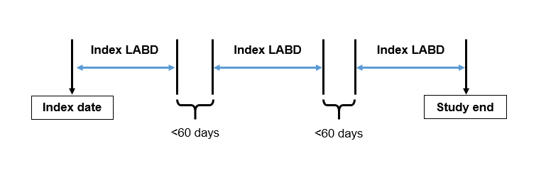
Abbreviations: LABD, long-acting bronchodilator.

Supplementary Figure 2. Diagrams showing definitions of first treatment modifications, which were categorized as either augmentation (A); direct switch (B); retreatment (C); or discontinuation/step down (D).
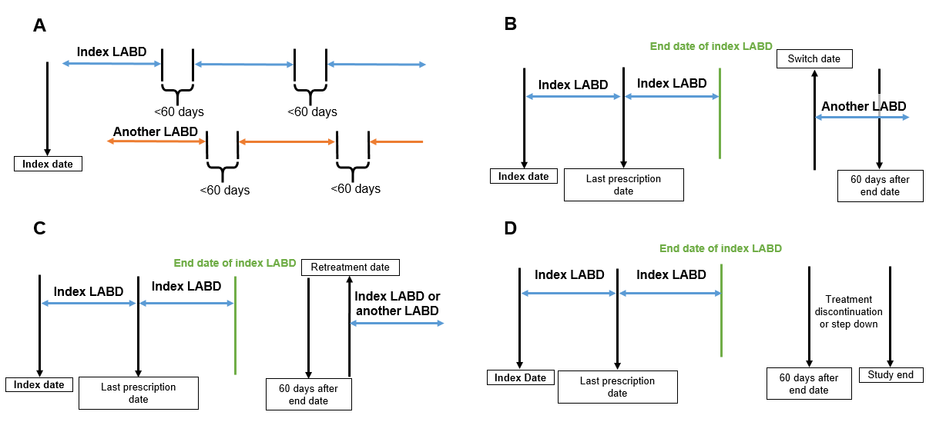
Abbreviations: LABD, long-acting bronchodilator.

