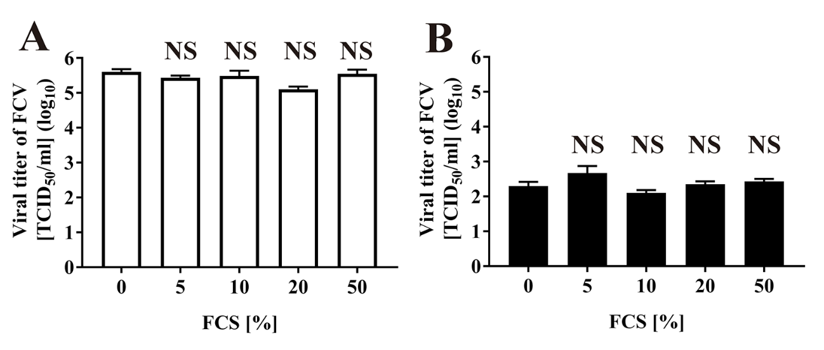
Fig. S1 Effect of the addition of FCS to CAC-717 on the reduction in viral titer of FCV during CAC-717 treatment
Fetal calf serum (FCS) was added to FCV-infected cell lysate at the indicated concentration. Samples were then mixed with PBS ((A), White bars) or CAC-717 ((B), Black bars) for 1 min at 25°C, and the viral titer of FCV (TCID₅₀) was determined. Zero log₁₀ TCID₅₀/ml of viral titer means below the detectable limit. Statistical differences were verified by the non-repeated measured ANOVA followed by the Bonferroni correction using GraphPad Prism7 software. NS: not significant difference compared with control (0%).

