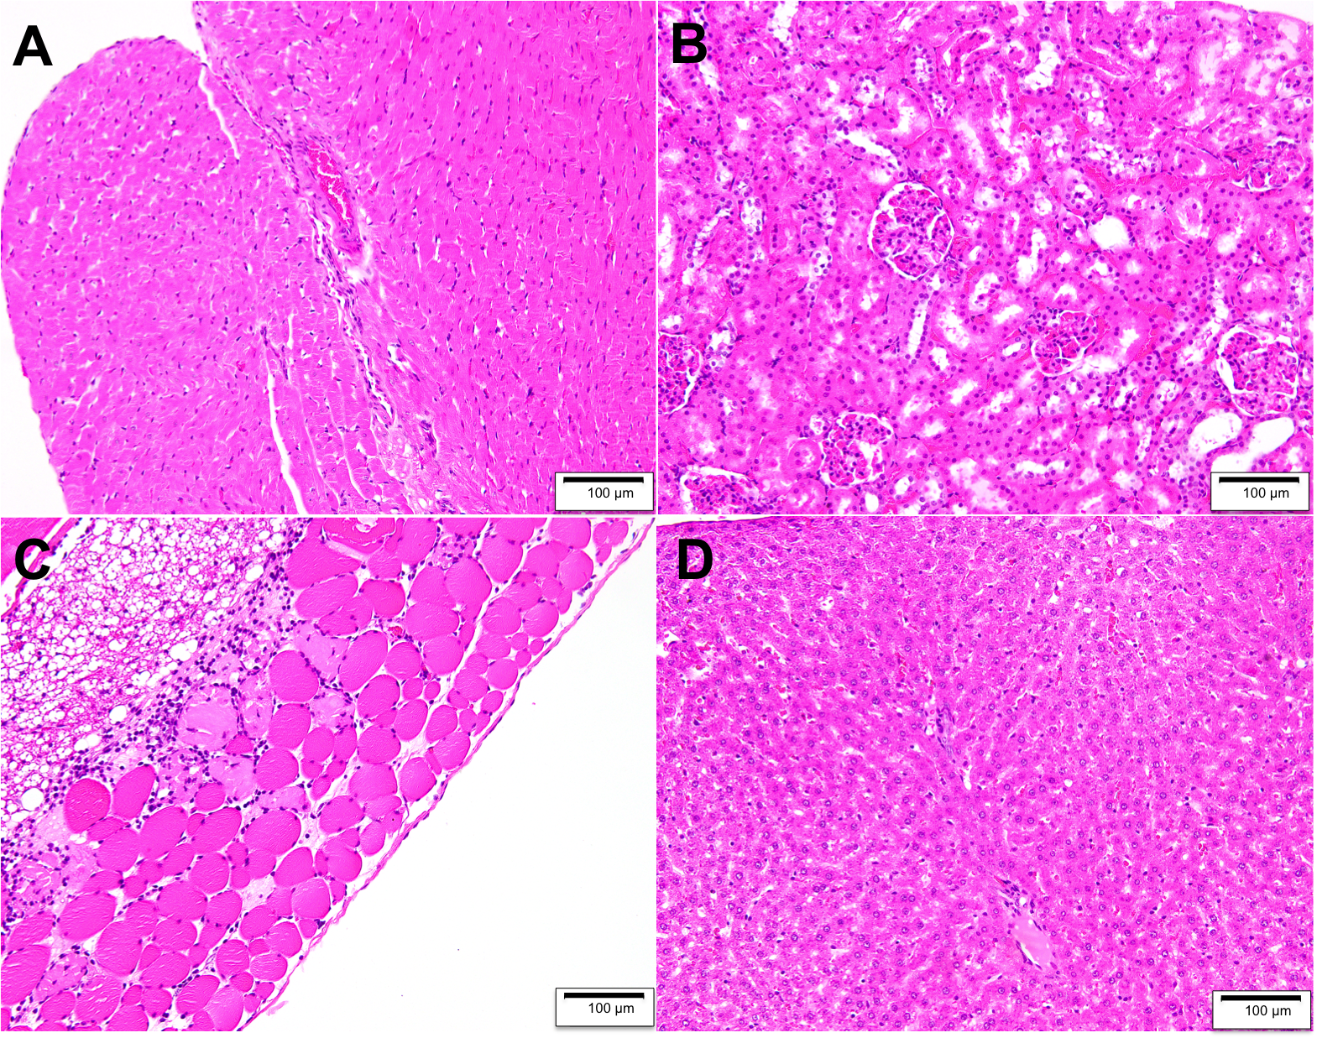
Supplementary Figure 1: Representative H&E stained sections of rat tissues 48 h after intrapleural administration of liposomal curcumin. A) heart, B) kidney, C) chest wall and D) liver

