SUPPLEMENTARY INFORMATION:

(A)
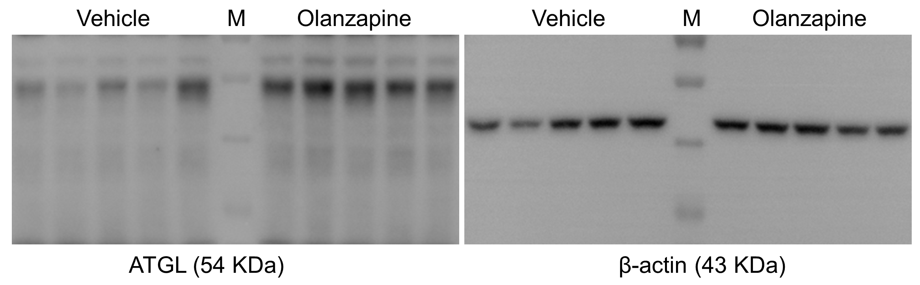

(B)
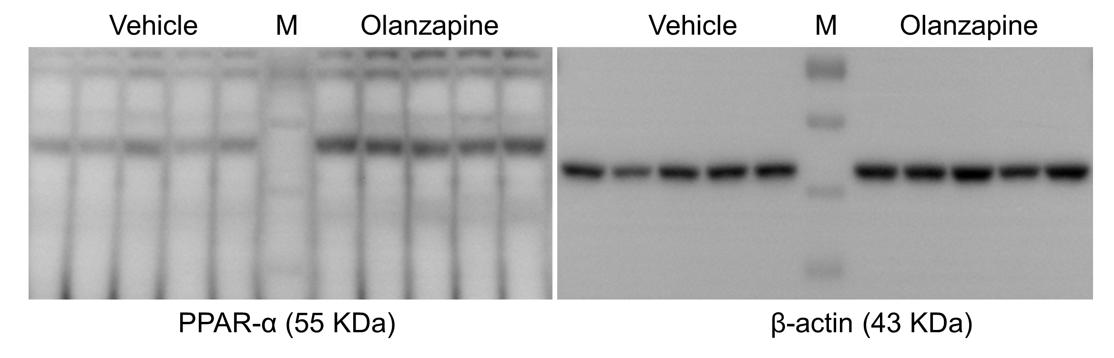

Supplementary Figure 1. Effect of olanzapine on relevant proteins regulated in the liver. Representative western blots of (A) ATGL and (B) PPAR-α in the liver of olanzapine-treated rats. The liver tissue lysates were subjected to SDS-PAGE and immunoprobed with antibodies against ATGL and PPAR-α.

