A non-lipolysis nanoemulsion improved oral bioavailability by reducing the first-pass metabolism of raloxifene, and related absorption mechanisms being studied

Supplementary data

Methods

Viability of MDCK cells
MDCK cells were cultured in EMEM supplemented with 1% (w/v) penicillin-streptomycin solution, and 10% (w/v) FBS at 37°C, 95% relative humidity, and a 5% CO₂ atmosphere.
The cells were seeded onto 96-well Transwell plates at a density of 2 × 10⁴ cell/mL for 24 h at 37°C after reaching 90% conﬂuence. The RAL-NNE or free RAL was diluted by EMEM to prepare a series of RAL-EMEM (0.47, 0.94, 1.88, 3.75, 7.50, 15.00, 30.00 and 60.00 μg/mL). For investigating cell toxicity of RAL-NNE, 200 μL of EMEM was added into plates (n = 6) and cultured at 37°C for 24 h. Thereafter, the RAL-EMEM was discarded. A 20 μL sample of MTT (5 mg/mL) and 200 μL sample of blank EMEM (without FBS) was added, then further cultured for 4 h. The reaction mixture was removed and 150 μL of dimethyl sulfoxide was added and then placed in a shaker at 37°C, 50 rpm for 10 min. Optical density (OD) was determined by an enzyme-labeled instrument at 490 nm and cell viability was calculated by Supplementary Equation (1).

Cell viability (%) = (OD_{drug} / OD_{blank}) × 100 (1)

Uptake and transport of RAL-NNE by MDCK cells
MDCK cells were seeded onto 24-well Transwell plates at a density of 6 × 10⁴ cell/mL for 48 h at 37°C to prepare the uptake experiment. The MDCK cells were rinsed 3× with PBS prior to uptake experiment. The EMEM (high glucose) containing RAL-NNE was added into 24-well Transwell plates at 37°C and incubated for 3 h. Then RAL-EMEM was pipetted out of the container and the cells were rinsed 3× with PBS to stop uptake. Trypsin-EDTA (200 μL) containing 1% (w/v) phenylmethylsulfonyl fluoride was added into plates to lyse cells and then centrifuged at 10,142 × g, 4°C, for 15 min. The supernatant was withdrawn and 3-fold acetonitrile was mixed to extract RAL and this process was performed twice. The supernatants were combined and dried then reconstituted with 100 μL mobile phase as samples. RAL content and the protein amount were determined by HPLC and BCA protein assay kit, respectively. The amount of cell uptake was calculated by the ratio of concentration of RAL and protein.
The inhibitors (nystatin (30 M), chlorpromazine (30 M), and amiloride (100 M)) were respectively added into the wells and incubated for 30 min prior to the uptake experiment for establishing the blocking model. The MDCK cells were rinsed 3× with PBS, EMEM containing RAL-NNE was added, and further cultured for 3 h. Then the uptake experiment was stopped and the following process was performed as previously described.
A density of 3 × 10⁴ cells/mL of MDCK cells were seeded onto 24-well Transwell plates for 48 h at 37°C for the transport experiment. When the transepithelial electrical resistance of MDCK cell was >180 Ω·cm², the cells were used for transport experiment. Prior to transport experiment, the cells at the apical side were rinsed 3× with PBS. The EMEM (high glucose) containing RAL-NNE was added into 24-well Transwell plates at 37°C and incubated for 3 h. Thereafter, the recipient solution was withdrawn from the basal well. The sample was centrifuged as described previously and filtered using a 0.22 μm filter; thereafter, the RAL content was determined by HPLC. The cumulative transport amount (Q) was calculated by Supplementary Equation (2). The endocytosis inhibitors used in the uptake experiment were applied to block the transport of RAL-NNE, the cells were rinsed, and EMEM (containing RAL-NNE) was added as described above.

$Q=C_{n}∙V_{1}+\sum_{m=1}^{n-1}{C_{m}∙V_{2}}$ (2)

where C_{n} is the RAL concentration at the time point of n (μg/mL); $\sum_{m=1}^{n-1}{C_{m}}$ is the cumulative concentration of RAL from time point of 1 to n-1 (μg/mL); C₀ is the initial concentration of RAL; V₁ is the volume of recipient solution (mL), and the V₂ is the volume of sample.

Results

Cell viability as well as uptake and transport of RAL-NNE in MDCK cells
Cell viability of free RAL and RAL-NNE was compared in Supplementary Figure 1 (A) and cell viability was >80% when the concentration of RAL below 3.75 μg/mL. In Supplementary Figure 1 (B), the uptake amounts of RAL were significantly inhibited by nytstatin and amiloride (p < 0.05). The cumulative transport amount of RAL-NNE was decreased but there were no significant differences compared with that of the absence of inhibitors.

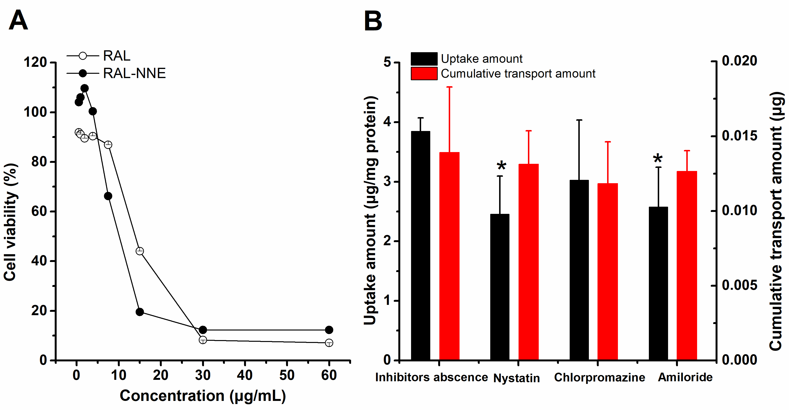
Supplementary Figure 1 Cell viability of RAL-NNE in MDCK cells (A); uptake and cumulative transport amounts of RAL-NNE when inhibitors were added (B) or absent.
Note: *, p < 0.05 compared with the group of inhibitors absent.

