Supplementary Figure S1
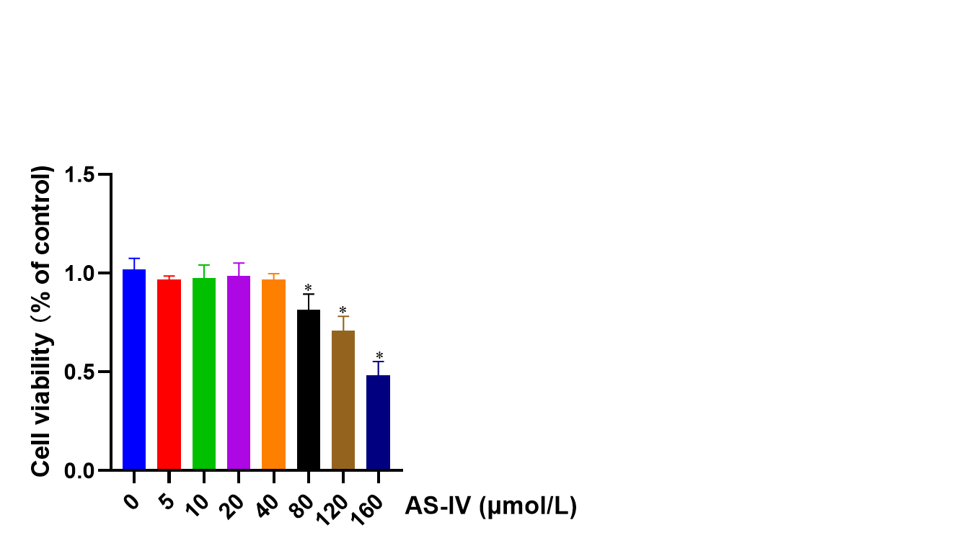
Figure S1: Cell viability of HK-2 cells treated with different concentrations of AS-IV. Data are expressed as the mean ± SD. *P < 0.05 vs. the 0 μmol /L AS-IV control group (n=6).

