Supplementary Material
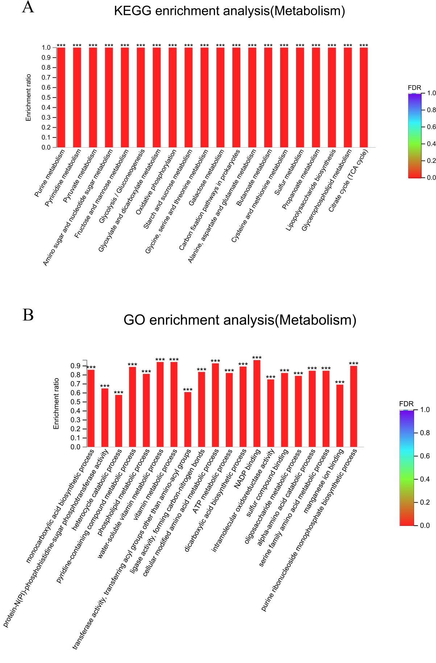
Supplementary Figure 1. Go analysis and KEGG analysis of metabolic gene demeanor

Table S1. Drug sensitivity of clinical drug-resistant S. flexneri R2448
Antimicrobial agents | MIC (μg/mL) |  | Sensitivity | Antimicrobial agents | MIC (μg/mL) | Sensitivity
Doxycycline | ≥16 |  | R | Cefuroxime | ≥64 | R
Amoxicillin-clavulanic acid | 16 |  | I | Minocycline | ≥16 | R
Cefalotin | ≥64 |  | R | Amikacin | ≤2 | R
Cefepime | 16 |  | R | Cefotetan | ≤4 | R
Cefotaxime | ≥64 |  | R | Cefpodoxime | ≥8 | R
Ceftazidine | 32 |  | R | Ceftizoxime | 4 | R
Cefuroxime | ≥64 |  | R | Ciprofloxacin | ≥4 | R
Imipenem | ≤0.25 |  | S | Levofloxacin | ≥8 | R
Meropenem | ≤0.25 |  | S | Moxifloxacin | ≥8 | R
Nadine | ≥32 |  | R | Norfloxacin | ≥16 | R
Piperacillin | ≥128 |  | R | Piperacillin/Tazobactam | 8 | S
tetracycline | ≥16 |  | R | Ticarcillin | ≥128 | R
Ticarcillin/Clavulanic Acid | ≥128 |  | R | Tobramycin | 8 | R
Compound trimethoprim | ≥320 |  | R | Aztreonam | ≥64 | R
Cefoperazone/Sulbactam | 32 |  | I | Polymyxin | ≤0.5 | S
Tigecycline | 1 |  | S | Donipenem | ≤0.12 | S
Table S2. Drug sensitivity of clinical drug-resistant S. flexneri RII-1
Antimicrobial agents | MIC (μg/mL) | Sensitivity | Antimicrobial agents | MIC (μg/mL) | Sensitivity
Doxycycline | ≥16 | R | Cefuroxime | ≥64 | R
Amoxicillin-clavulanic acid | 16 | I | Minocycline | 8 | I
Cefalotin | ≥64 | R | Amikacin | ≤2 | R
Cefepime | ≥32 | R | Cefotetan | ≤4 | R
Cefotaxime | ≥64 | R | Cefpodoxime | ≥8 | R
Ceftazidine | ≥64 | R | Ceftizoxime | 4 | R
Cefuroxime | ≥64 | R | Ciprofloxacin | ≥4 | R
Imipenem | ≤0.25 | S | Levofloxacin | ≥8 | R
Meropenem | ≤0.25 | S | Moxifloxacin | ≥8 | R
Nadine | ≥32 | R | Norfloxacin | ≥16 | R
Piperacillin | ≥128 | R | Piperacillin/Tazobactam | 64 | I
tetracycline | ≥16 | R | Ticarcillin | ≥128 | R
Ticarcillin/Clavulanic Acid | ≥128 | R | Tobramycin | 8 | R
Compound trimethoprim | ≥320 | R | Aztreonam | ≥64 | R
Cefoperazone/Sulbactam | 32 | I | Polymyxin | ≤0.5 | S
Tigecycline | ≤0.5 | S | Donipenem | ≤0.12 | S
Table S3. The criterion for judging the histological injury score.
Score | Inflammatory cell infiltration | Crypt damage | The absence of oedema
0 | None | None | None
1 | Infiltration around the crypt base | Basal 1/3 damaged | Oedema
2 | Infiltration reaching the muscularis mucosae | Basal 2/3 damaged
3 | Extensive infiltration reaching the muscularis mucosae and thickening of the mucosa with severe oedema | Only surface epithelium intact
4 | Infiltration of the submucosa | Entire crypt and epithelium lost
Table S4. Abbreviations of ROS-related genes analysed using transcriptome sequencing
ompA | outer membrane protein A
gshA | glutamate-cysteine ligase
bssR | regulator of biofilm formation
elaB | tail anchored inner membrane protein
alkB | DNA oxidative demethylase
grxA | reduced glutaredoxin 1
nth | endonuclease III
relB | DNA-binding transcriptional repressor
nuoF | NADH:quinone oxidoreductase subunit F
copA | Cu(+) exporting P-type ATPase
htrA | serine protease
soxS | DNA-binding transcriptional dual regulator
hha | haemolysin expression modulating protein

