Supplementary data

Figure S1 A-C Pairwise scatterplots of ESSENCE-Q summary scores

A.
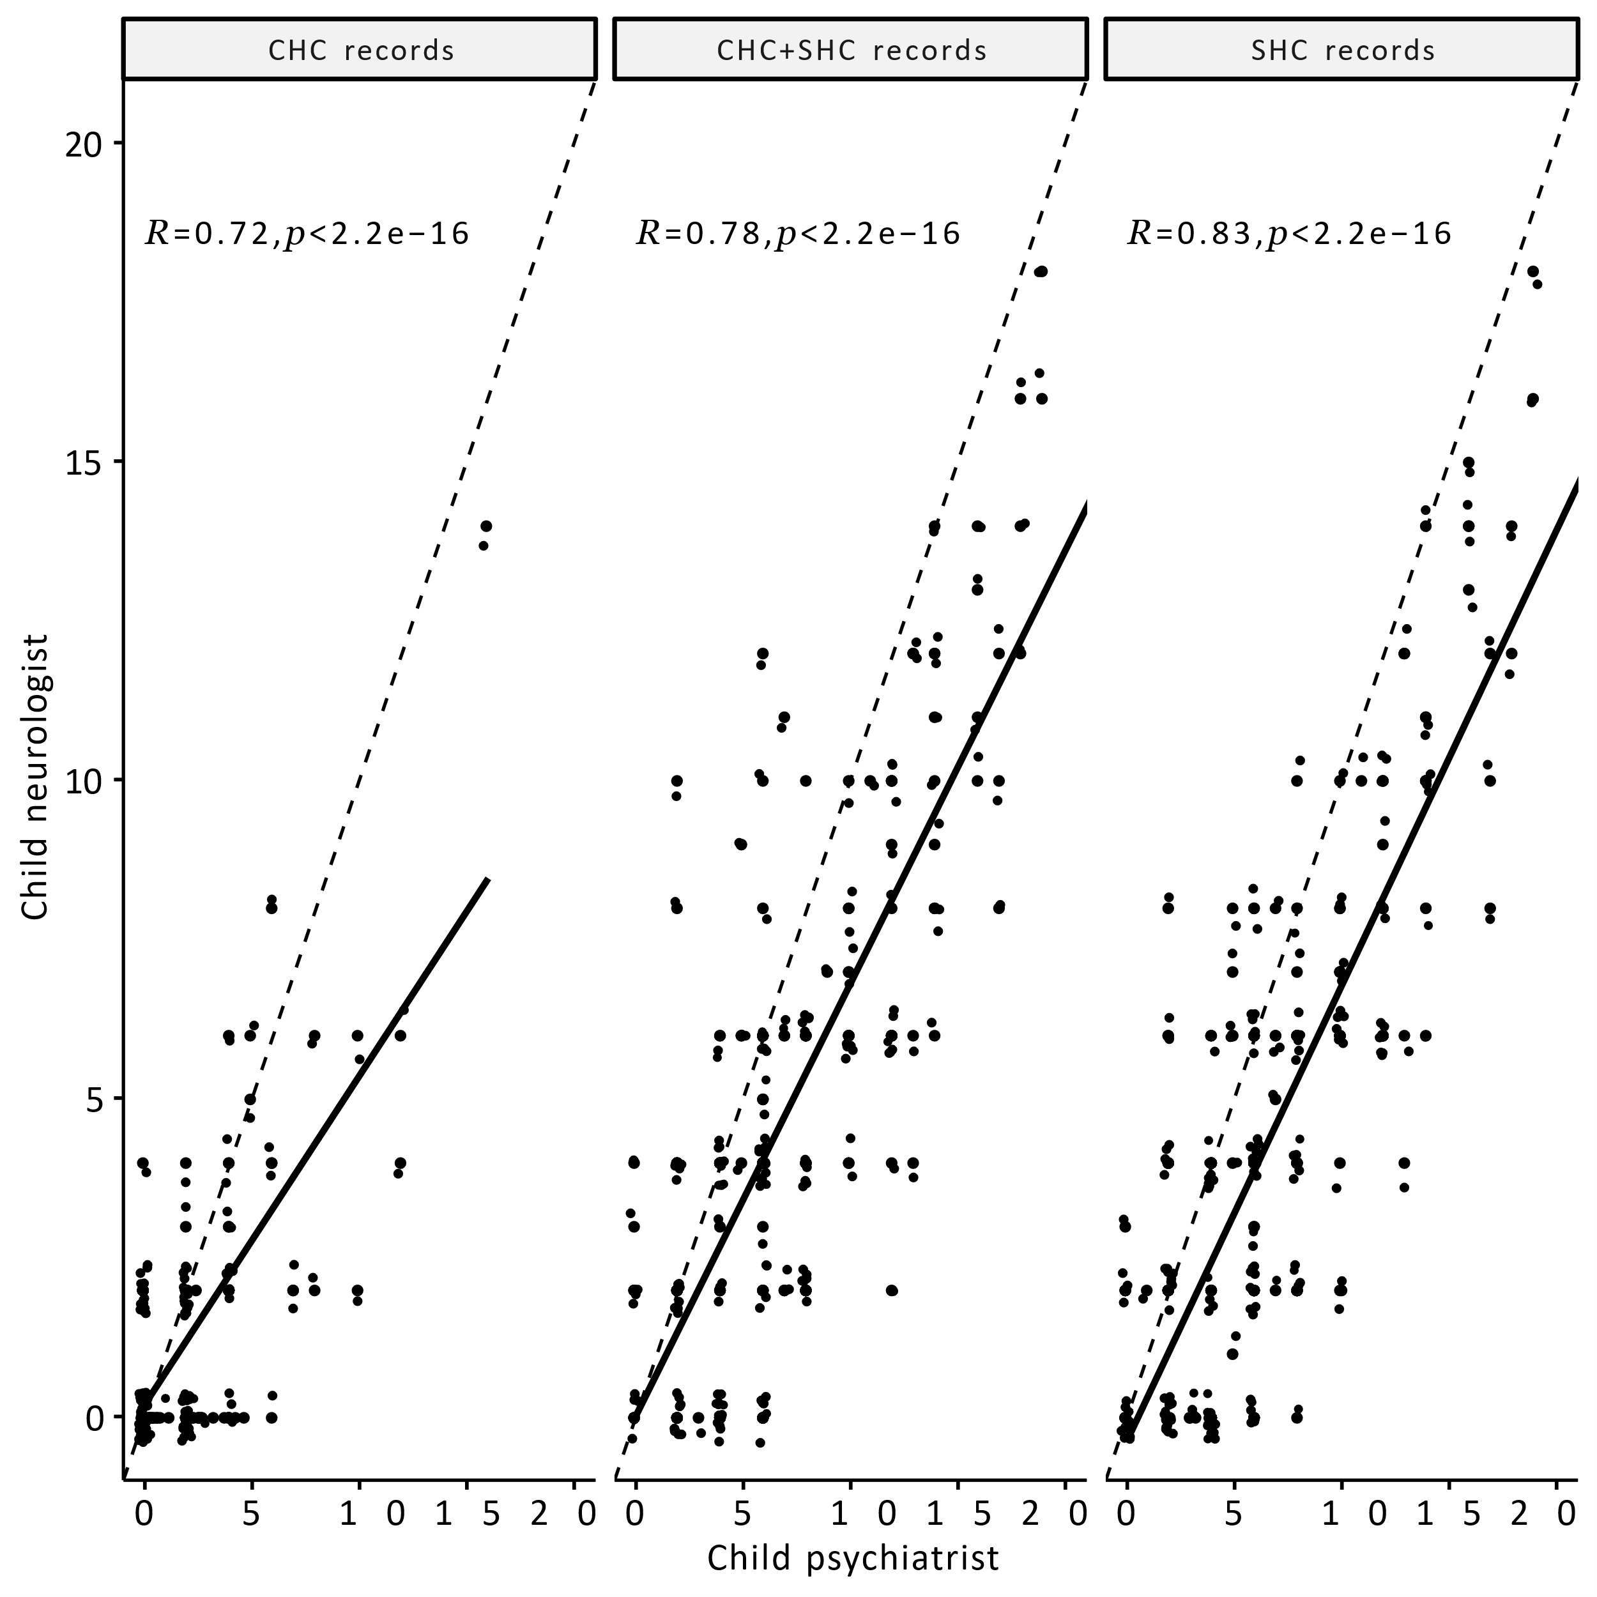

B.
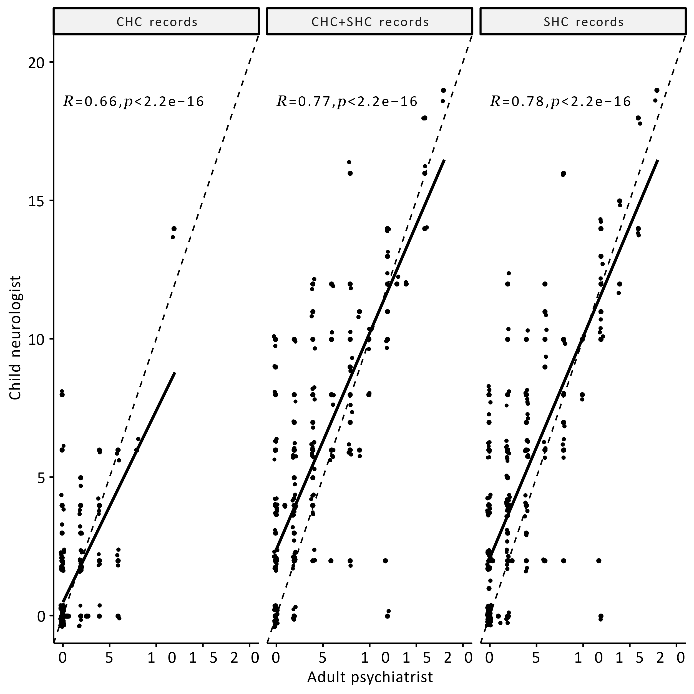

C.
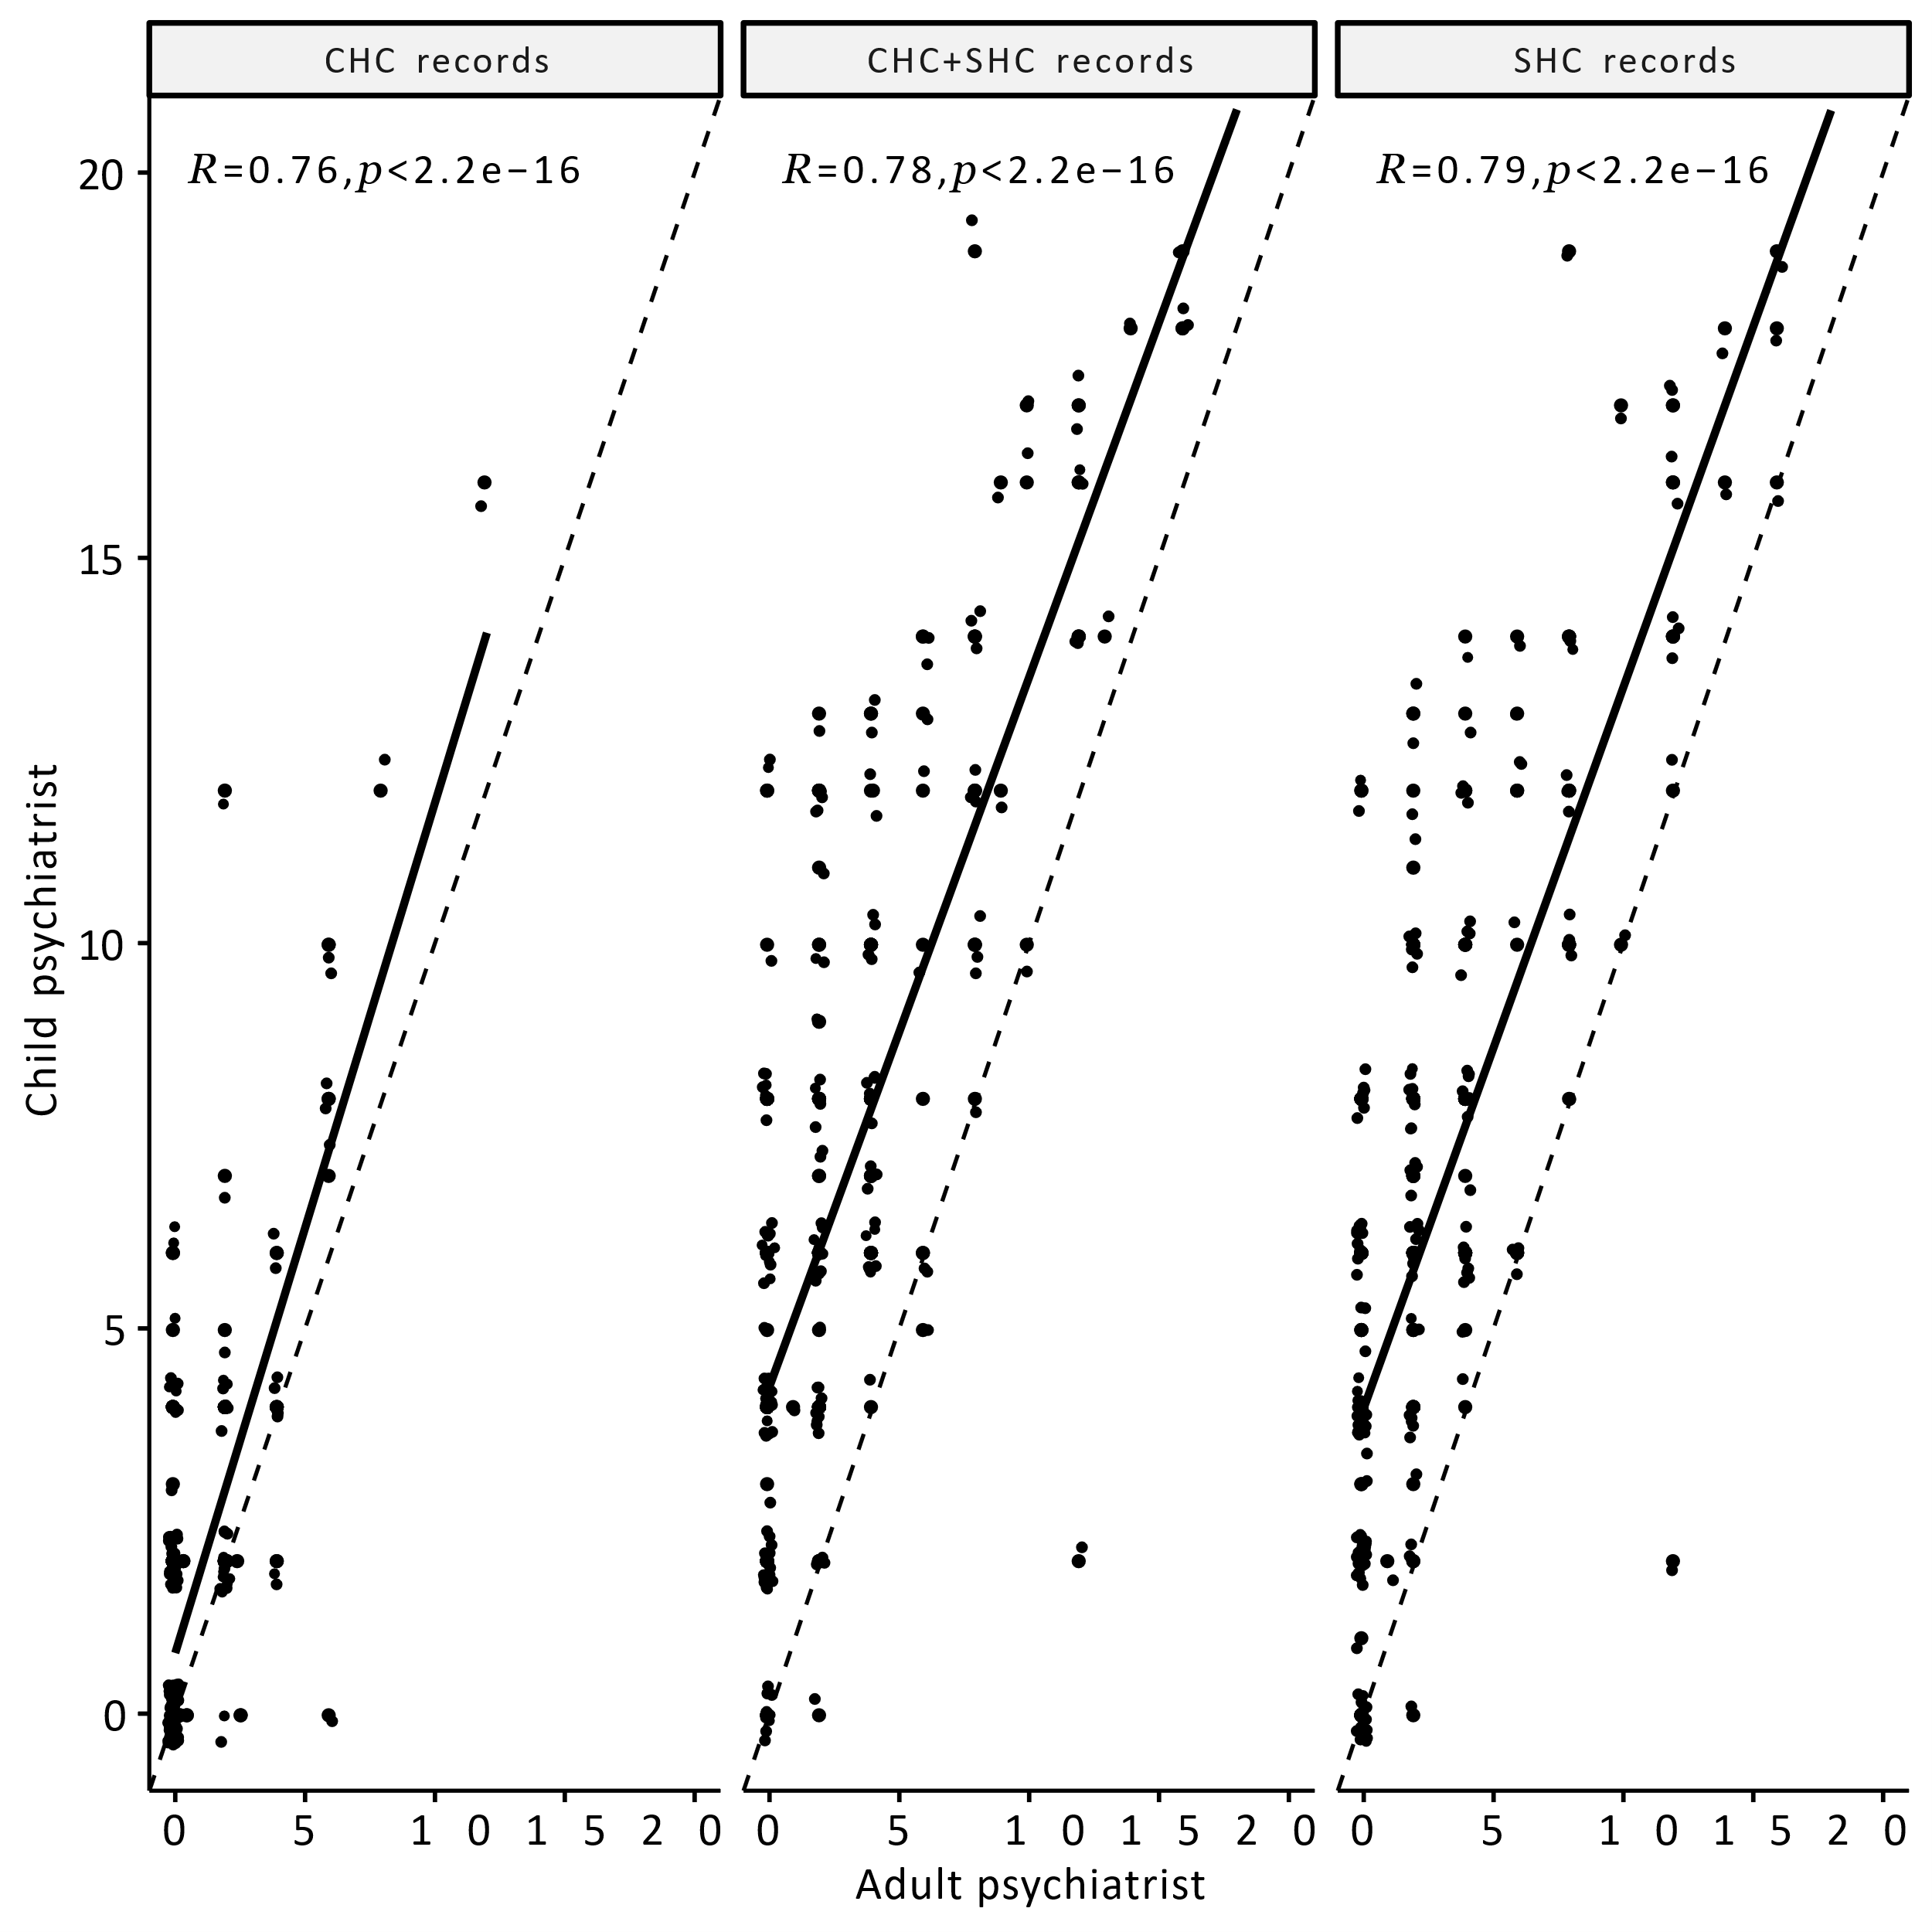
Notes: Thick line depicts Pearson correlation between raters, dashed line depicts perfect linear correlation for reference. Abbreviations: CHC = Child health care, SHC = School health care.

Figure S2 Test-retest reliability of the ESSENCE-Q summary score for the Child psychiatrist
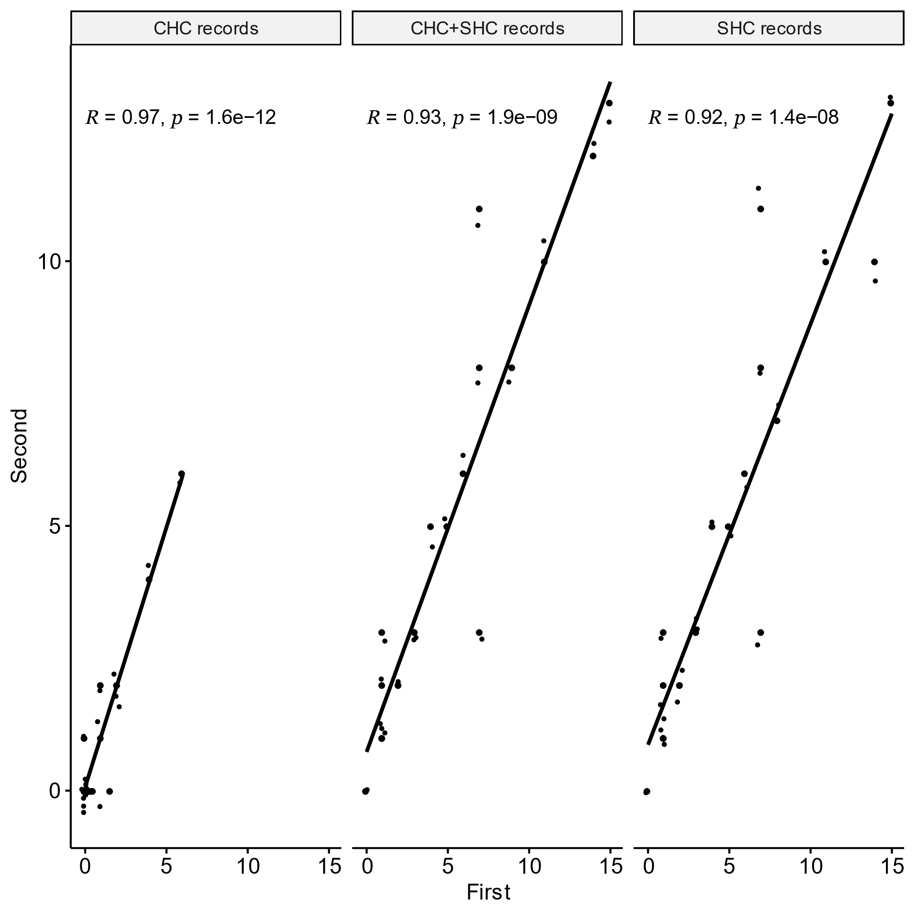
Notes: Thick line depicts Pearson correlation between ratings, dashed line depicts perfect linear correlation for reference. Abbreviations: CHC = Child health care, SHC = School health care.

Table S1 A-C. Classification tables of the capacity of medical records-rated ESSENCE-Q in predicting clinically relevant NDPs (CGI-S of 4-7)
- Child psychiatrist
Threshold | Specificity | Sensitivity | Accuracy | NPV | PPV | Youden index | Positive LR | Negative LR
-Inf | 0% | 100% | 38% |  | 38% | 0 | 1,0
0,5 | 8% | 99% | 43% | 90% | 40% | 0,07 | 1,1 | 0,2
1,5 | 23% | 96% | 51% | 89% | 43% | 0,18 | 1,2 | 0,2
2,5 | 38% | 91% | 58% | 87% | 47% | 0,29 | 1,5 | 0,2
3,5 | 51% | 91% | 66% | 90% | 54% | 0,42 | 1,9 | 0,2
4,5 | 66% | 87% | 74% | 89% | 61% | 0,53 | 2,6 | 0,2
5,5 | 75% | 78% | 76% | 85% | 66% | 0,53 | 3,1 | 0,3
6,5 | 83% | 70% | 78% | 82% | 72% | 0,54 | 4,3 | 0,4
7,5 | 89% | 64% | 80% | 80% | 78% | 0,53 | 5,8 | 0,4
8,5 | 94% | 61% | 81% | 80% | 85% | 0,55 | 9,5 | 0,4
9,5 | 95% | 52% | 79% | 76% | 88% | 0,48 | 11,4 | 0,5
10,5 | 96% | 45% | 77% | 74% | 88% | 0,41 | 12,2 | 0,6
11,5 | 97% | 36% | 74% | 71% | 89% | 0,33 | 13,0 | 0,7
12,5 | 98% | 33% | 73% | 70% | 92% | 0,31 | 17,9 | 0,7
13,5 | 98% | 25% | 70% | 68% | 89% | 0,24 | 13,8 | 0,8
14,5 | 99% | 19% | 69% | 67% | 93% | 0,18 | 21,2 | 0,8
15,5 | 99% | 12% | 66% | 65% | 89% | 0,11 | 13,0 | 0,9
16,5 | 99% | 7% | 64% | 64% | 83% | 0,07 | 8,1 | 0,9
17,5 | 100% | 6% | 64% | 63% | 100% | 0,06 | Inf | 0,9
19 | 100% | 3% | 63% | 63% | 100% | 0,03 | Inf | 1,0
20,5 | 100% | 1% | 62% | 62% | 100% | 0,01 | Inf | 1,0
Inf | 100% | 0% | 62% | 62% |  | 0 |  | 1,0

- Child neurologist
Threshold | Specificity | Sensitivity | Accuracy | NPV | PPV | Youden index | Positive LR | Negative LR
-Inf | 0% | 100% | 38% |  | 38% | 0 | 1,0
0,5 | 29% | 94% | 54% | 89% | 45% | 0,23 | 1,3 | 0,2
1,5 | 48% | 85% | 62% | 84% | 50% | 0,33 | 1,6 | 0,3
2,5 | 74% | 77% | 75% | 84% | 65% | 0,52 | 3,0 | 0,3
3,5 | 86% | 68% | 79% | 82% | 75% | 0,54 | 5,0 | 0,4
4,5 | 93% | 52% | 77% | 76% | 81% | 0,44 | 7,0 | 0,5
5,5 | 95% | 35% | 73% | 71% | 82% | 0,3 | 7,6 | 0,7
6,5 | 96% | 26% | 70% | 68% | 81% | 0,22 | 7,0 | 0,8
7,5 | 97% | 15% | 66% | 65% | 77% | 0,12 | 5,5 | 0,9
8,5 | 99% | 15% | 67% | 66% | 91% | 0,14 | 16,5 | 0,9
10 | 99% | 9% | 65% | 64% | 86% | 0,08 | 9,9 | 0,9
11,5 | 99% | 6% | 64% | 64% | 80% | 0,05 | 6,6 | 1,0
13 | 100% | 5% | 64% | 63% | 100% | 0,05 | Inf | 1,0
14,5 | 100% | 2% | 63% | 63% | 100% | 0,02 | Inf | 1,0
Inf | 100% | 0% | 62% | 62% |  | 0 |  | 1,0

- Adult psychiatrist
Threshold | Specificity | Sensitivity | Accuracy | NPV | PPV | Youden index | Positive LR | Negative LR
-Inf | 0% | 100% | 36% |  | 36% | 0 | 1,0
0,5 | 61% | 88% | 71% | 90% | 56% | 0,49 | 2,2 | 0,2
1,5 | 70% | 84% | 75% | 89% | 61% | 0,54 | 2,8 | 0,2
2,5 | 88% | 65% | 79% | 82% | 75% | 0,52 | 5,3 | 0,4
3,5 | 89% | 59% | 78% | 80% | 75% | 0,48 | 5,5 | 0,5
4,5 | 93% | 47% | 77% | 76% | 80% | 0,41 | 7,2 | 0,6
5,5 | 94% | 44% | 76% | 75% | 81% | 0,38 | 7,7 | 0,6
6,5 | 97% | 38% | 76% | 74% | 87% | 0,35 | 11,7 | 0,6
7,5 | 97% | 34% | 74% | 72% | 85% | 0,31 | 10,3 | 0,7
8,5 | 98% | 25% | 72% | 70% | 85% | 0,23 | 10,2 | 0,8
9,5 | 99% | 22% | 72% | 70% | 94% | 0,21 | 26,9 | 0,8
10,5 | 100% | 18% | 71% | 69% | 100% | 0,18 | Inf | 0,8
11,5 | 100% | 15% | 69% | 68% | 100% | 0,15 | Inf | 0,9
12,5 | 100% | 9% | 67% | 66% | 100% | 0,09 | Inf | 0,9
13,5 | 100% | 7% | 67% | 66% | 100% | 0,07 | Inf | 0,9
15 | 100% | 6% | 66% | 66% | 100% | 0,06 | Inf | 0,9
16,5 | 100% | 3% | 65% | 65% | 100% | 0,03 | Inf | 1,0
18,5 | 100% | 1% | 65% | 65% | 100% | 0,01 | Inf | 1,0
Inf | 100% | 0% | 64% | 64% |  | 0 |  | 1,0

Notes: Accuracy (proportion accurately classified, [true positive + true negative / all positive and negative]), negative predictive value (NPV=true negative/all negative), positive predictive value (PPV= true positive/all positive), Youden index (sensitivity + specificity -1), positive (LR+) and negative likelihood ratio (LR-) (LR+ = True positive/False positive, LR- = True negative / False negative).

