Supplemental figure 1 MAFG-AS1 promoted the expression of DICER and Drosha in U87 and U-188 cells. *,p<0.05.

Supplemental figure 2 MAFG-AS1 overexpression did not affect the apoptosis and cell cycle of GBM cells
Flow cytometry was performed to analyze the roles of MAFG-AS1 and miR-34a in regulating the apoptosis (A) and cell cycle (B) of U87 and U-118 cells.

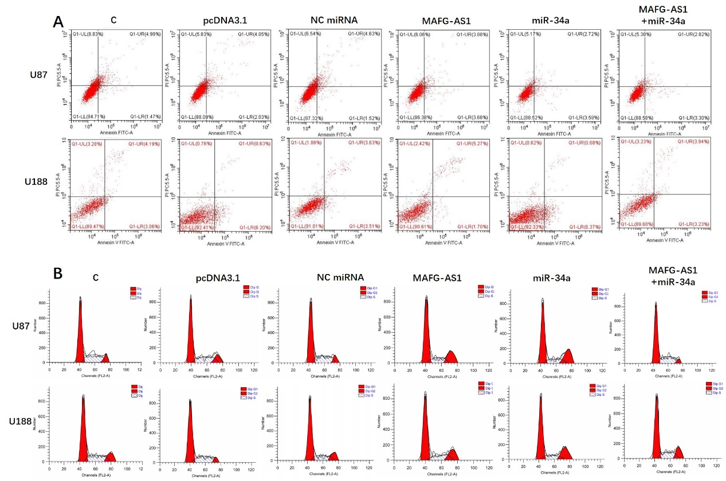

Supplemental figure 3 MAFG-AS1 overexpression did not affect the migration of GBM cells
A cell scratch experiment was performed to analyze the roles of MAFG-AS1 and miR-34a in regulating the migration of U87 and U-118 cells.

