Figure S1. Stability evaluation of PTX-A NPs and FKA-A NPs . (A) Particle size and (B) PDI with different media for 24 h at 37 ± 0.5◦C.

Figure S2. The lowest energy conformation of molecule Aes afer geomoetry optimization at PBE0/def2-SVP level with consideration of solvent environment using SMD model of water.
Figure S3. The lowest energy conformation of molecule FKA afer geomoetry optimization at PBE0/def2-SVP level with consideration of solvent environment using SMD model of water.
Figure S4. The lowest energy conformation of molecule PTX afer geomoetry optimization at PBE0/def2-SVP level with consideration of solvent environment using SMD model of water.
Figure S5. Averaged inter-molecular radial distribution functions for FKA (A) in Aes: FKA = 5:17 and PTX (B) in Aes:PTX= 6:8 system.

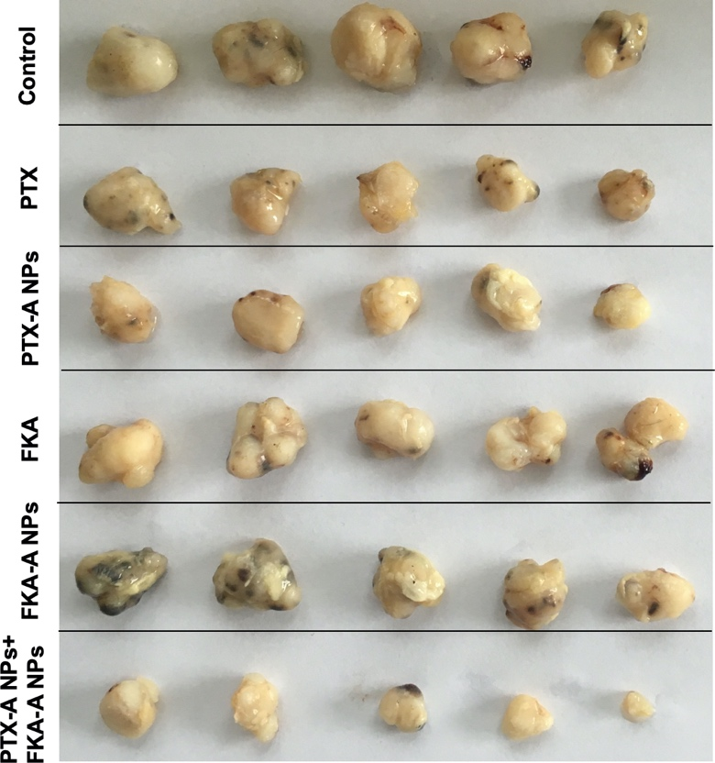
Figure S6. Photographs of tumors isolated from different groups.

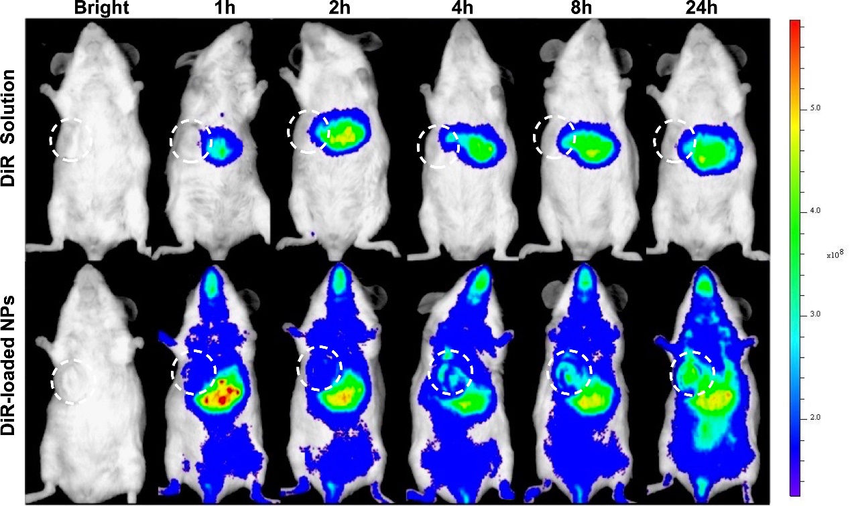
Figure S7. Real time fluorescence images of tumor-bearing mice post-injection of DiR solutions and DiR-loaded NPs. Tumors were marked with white circles.

Figure S8. In vivo biodistribution of DiR-loaded NPs. Ex vivo fluorescence images of main organs and tumors after administration with DiR solutions and DiR-loaded NPs at different time points.

