Supplementary Materials

Real-World Reductions in Oral Corticosteroid Use Following Mepolizumab Therapy for Asthma

Silver J et al.

Contents
Figure S1. Annualized exacerbation rates during the baseline and follow-up periods.
Figure S2. Mean asthma exacerbation-related costs per patient* during the baseline and follow-up periods.

Figure S1. Annualized exacerbation rates during the baseline and follow-up periods. (A) Mean annualized rate of any exacerbations/year* and (B) mean annualized rate of exacerbations resulting in hospitalization/year† (N=527).
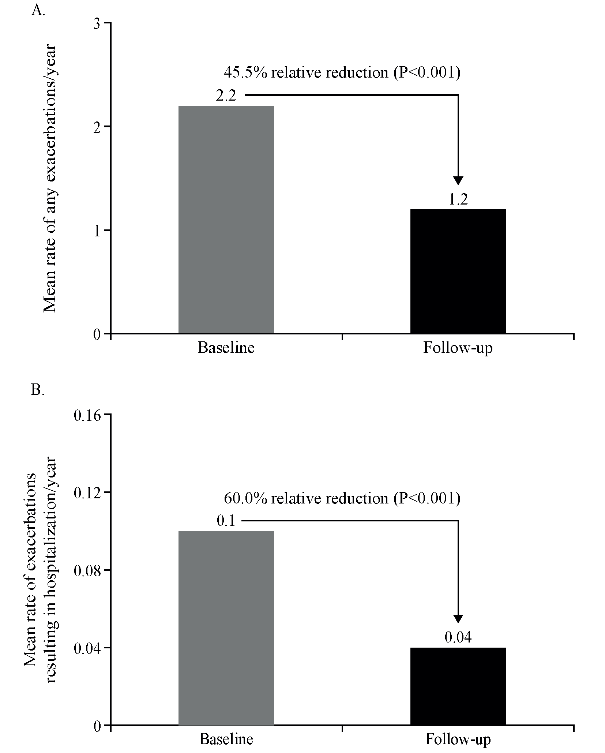
*Any exacerbation was identified as either an outpatient or ER visit with a diagnosis of asthma and ≥1 dispensing of systemic corticosteroids within five days of the encounter, or an exacerbation resulting in a hospitalization. Outpatient encounters with a HCPCS code for administration of mepolizumab and the first outpatient encounter with CPT administration codes 96372 and 96401 in the 28 days following an NDC claim of mepolizumab or prior to the next NDC claim were excluded from the definition of exacerbations; †Exacerbations resulting in a hospitalization were defined as inpatient hospital admissions with a primary diagnosis of asthma.
CPT, current procedural terminology; ER, emergency room; HCPCS, healthcare common procedure coding system; NDC, national drug code.

Figure S2. Mean asthma exacerbation-related costs per patient* during the baseline and follow-up periods.
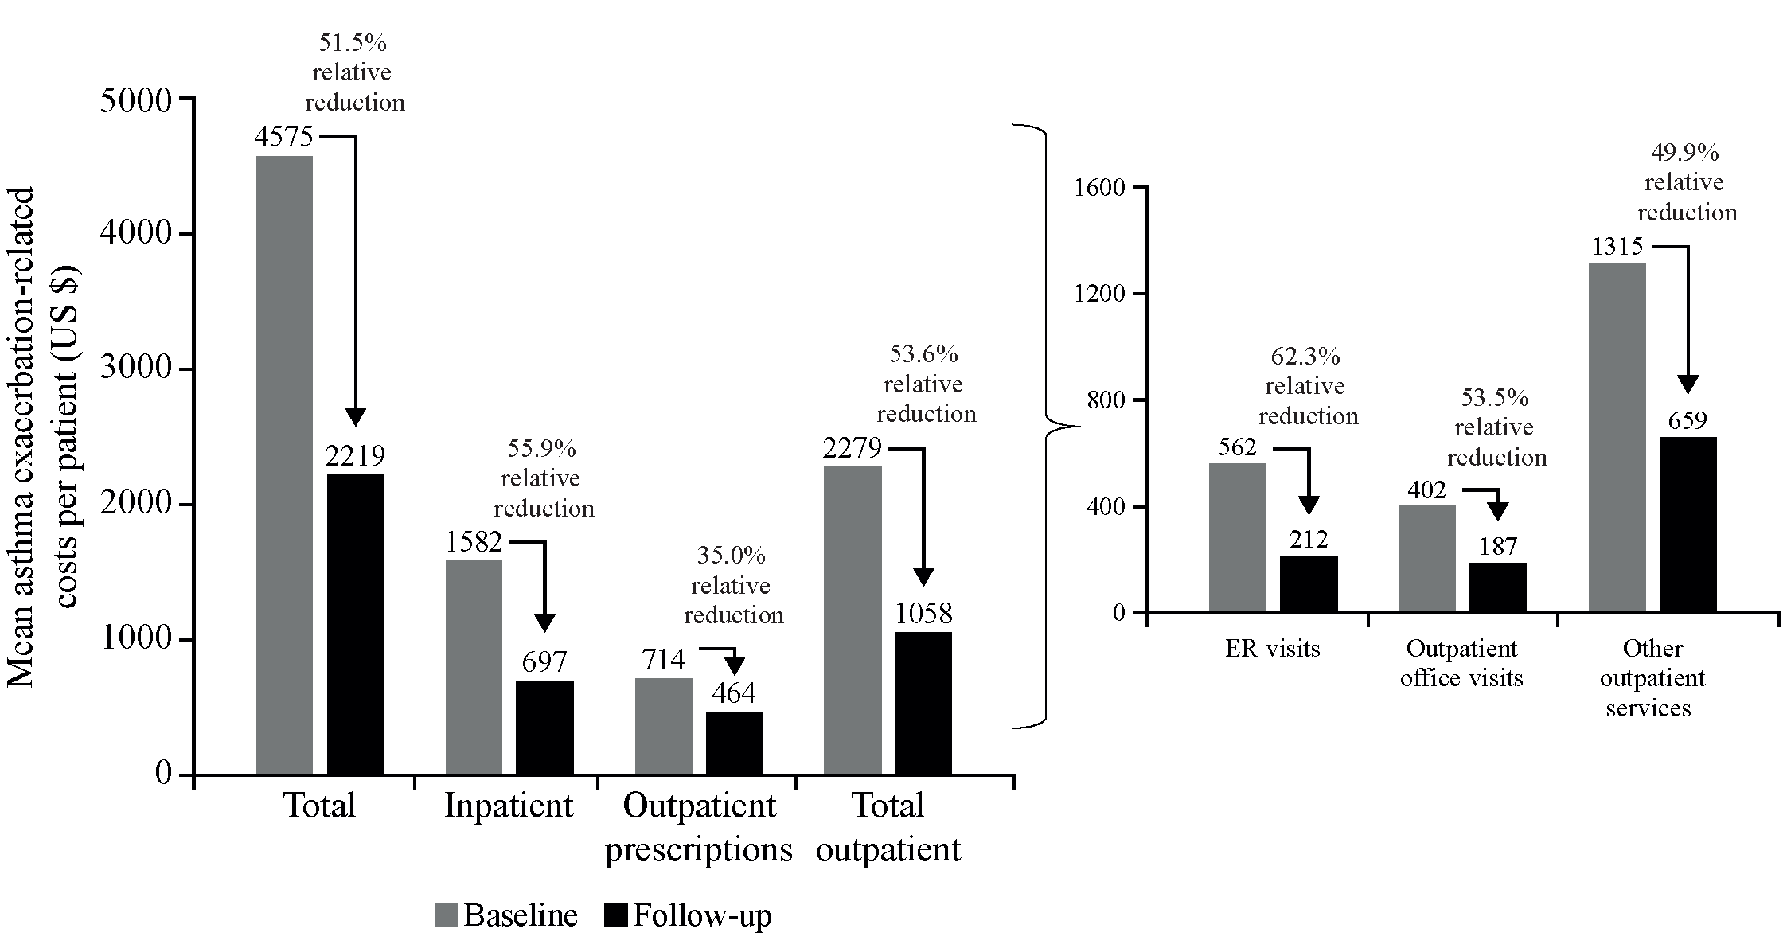
*Excluding mepolizumab acquisition and administration costs. Claims with asthma exacerbation-related costs were identified as inpatient claims with a primary diagnosis of asthma, outpatient claims with an asthma diagnosis in any position, or medical or pharmacy claims for asthma medications during the exacerbation episode. Costs for prophylactic biologics (mepolizumab) were excluded. All costs were adjusted for inflation using the Consumer Price Index and standardized to 2018 US dollars; †Other outpatient services were defined as services performed in an outpatient setting that were not specifically reported separately (including laboratory and radiology services).
P<0.01 for all baseline to follow-up comparisons.
ER, emergency room.

