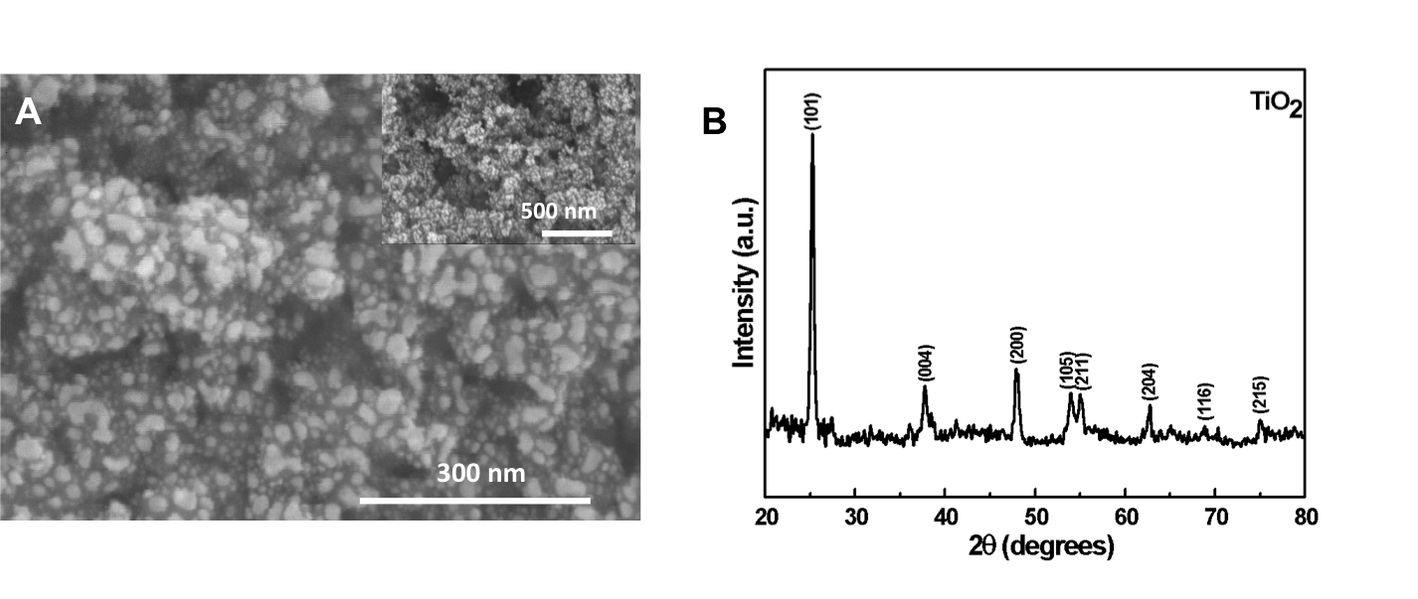
Supplementary Figure S1. TiO₂ nanoparticle characterization (A) SEM micrographs of TiO₂ nanoparticles at different magnifications. The inset shows the low magnification image of TiO₂ nanoparticle. (B) XRD patterns of commercially procured TiO₂ nanoparticles.

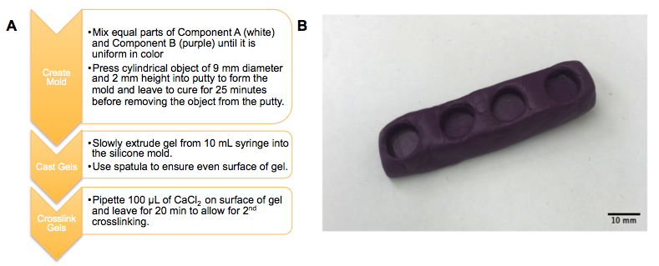
Supplementary Figure S2. A. Process for casting gels using EasyMold Silicone Putty. B. Silicone mold for cast gels.

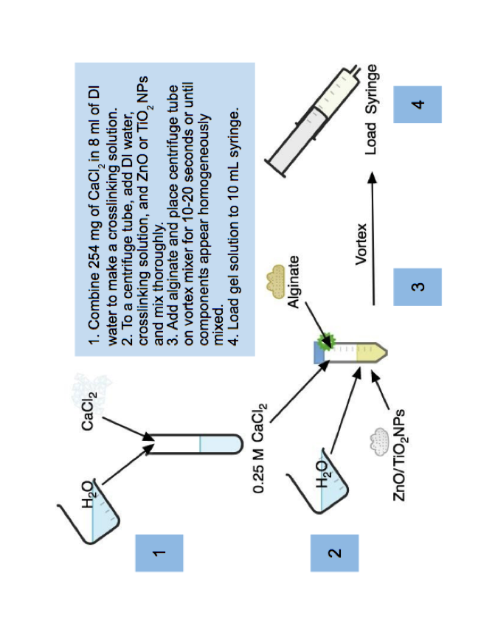Supplementary Figure S3. Schematic depicting the steps for gel formulation.

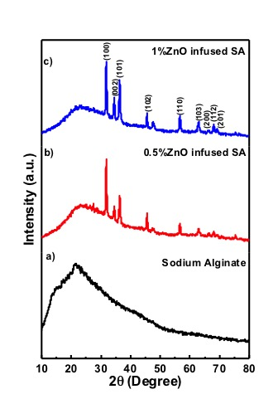

Supplementary Figure S4. XRD patterns of a) pure sodium alginate b) 0.5% and c) 1% ZnO nanoparticle infused sodium alginate.

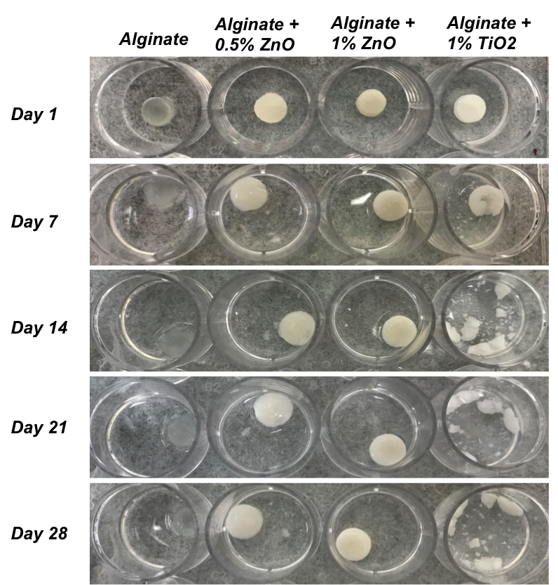
Supplementary Figure S5. Images of samples in 1X PBS visually tracked over time.

