Supplementary data
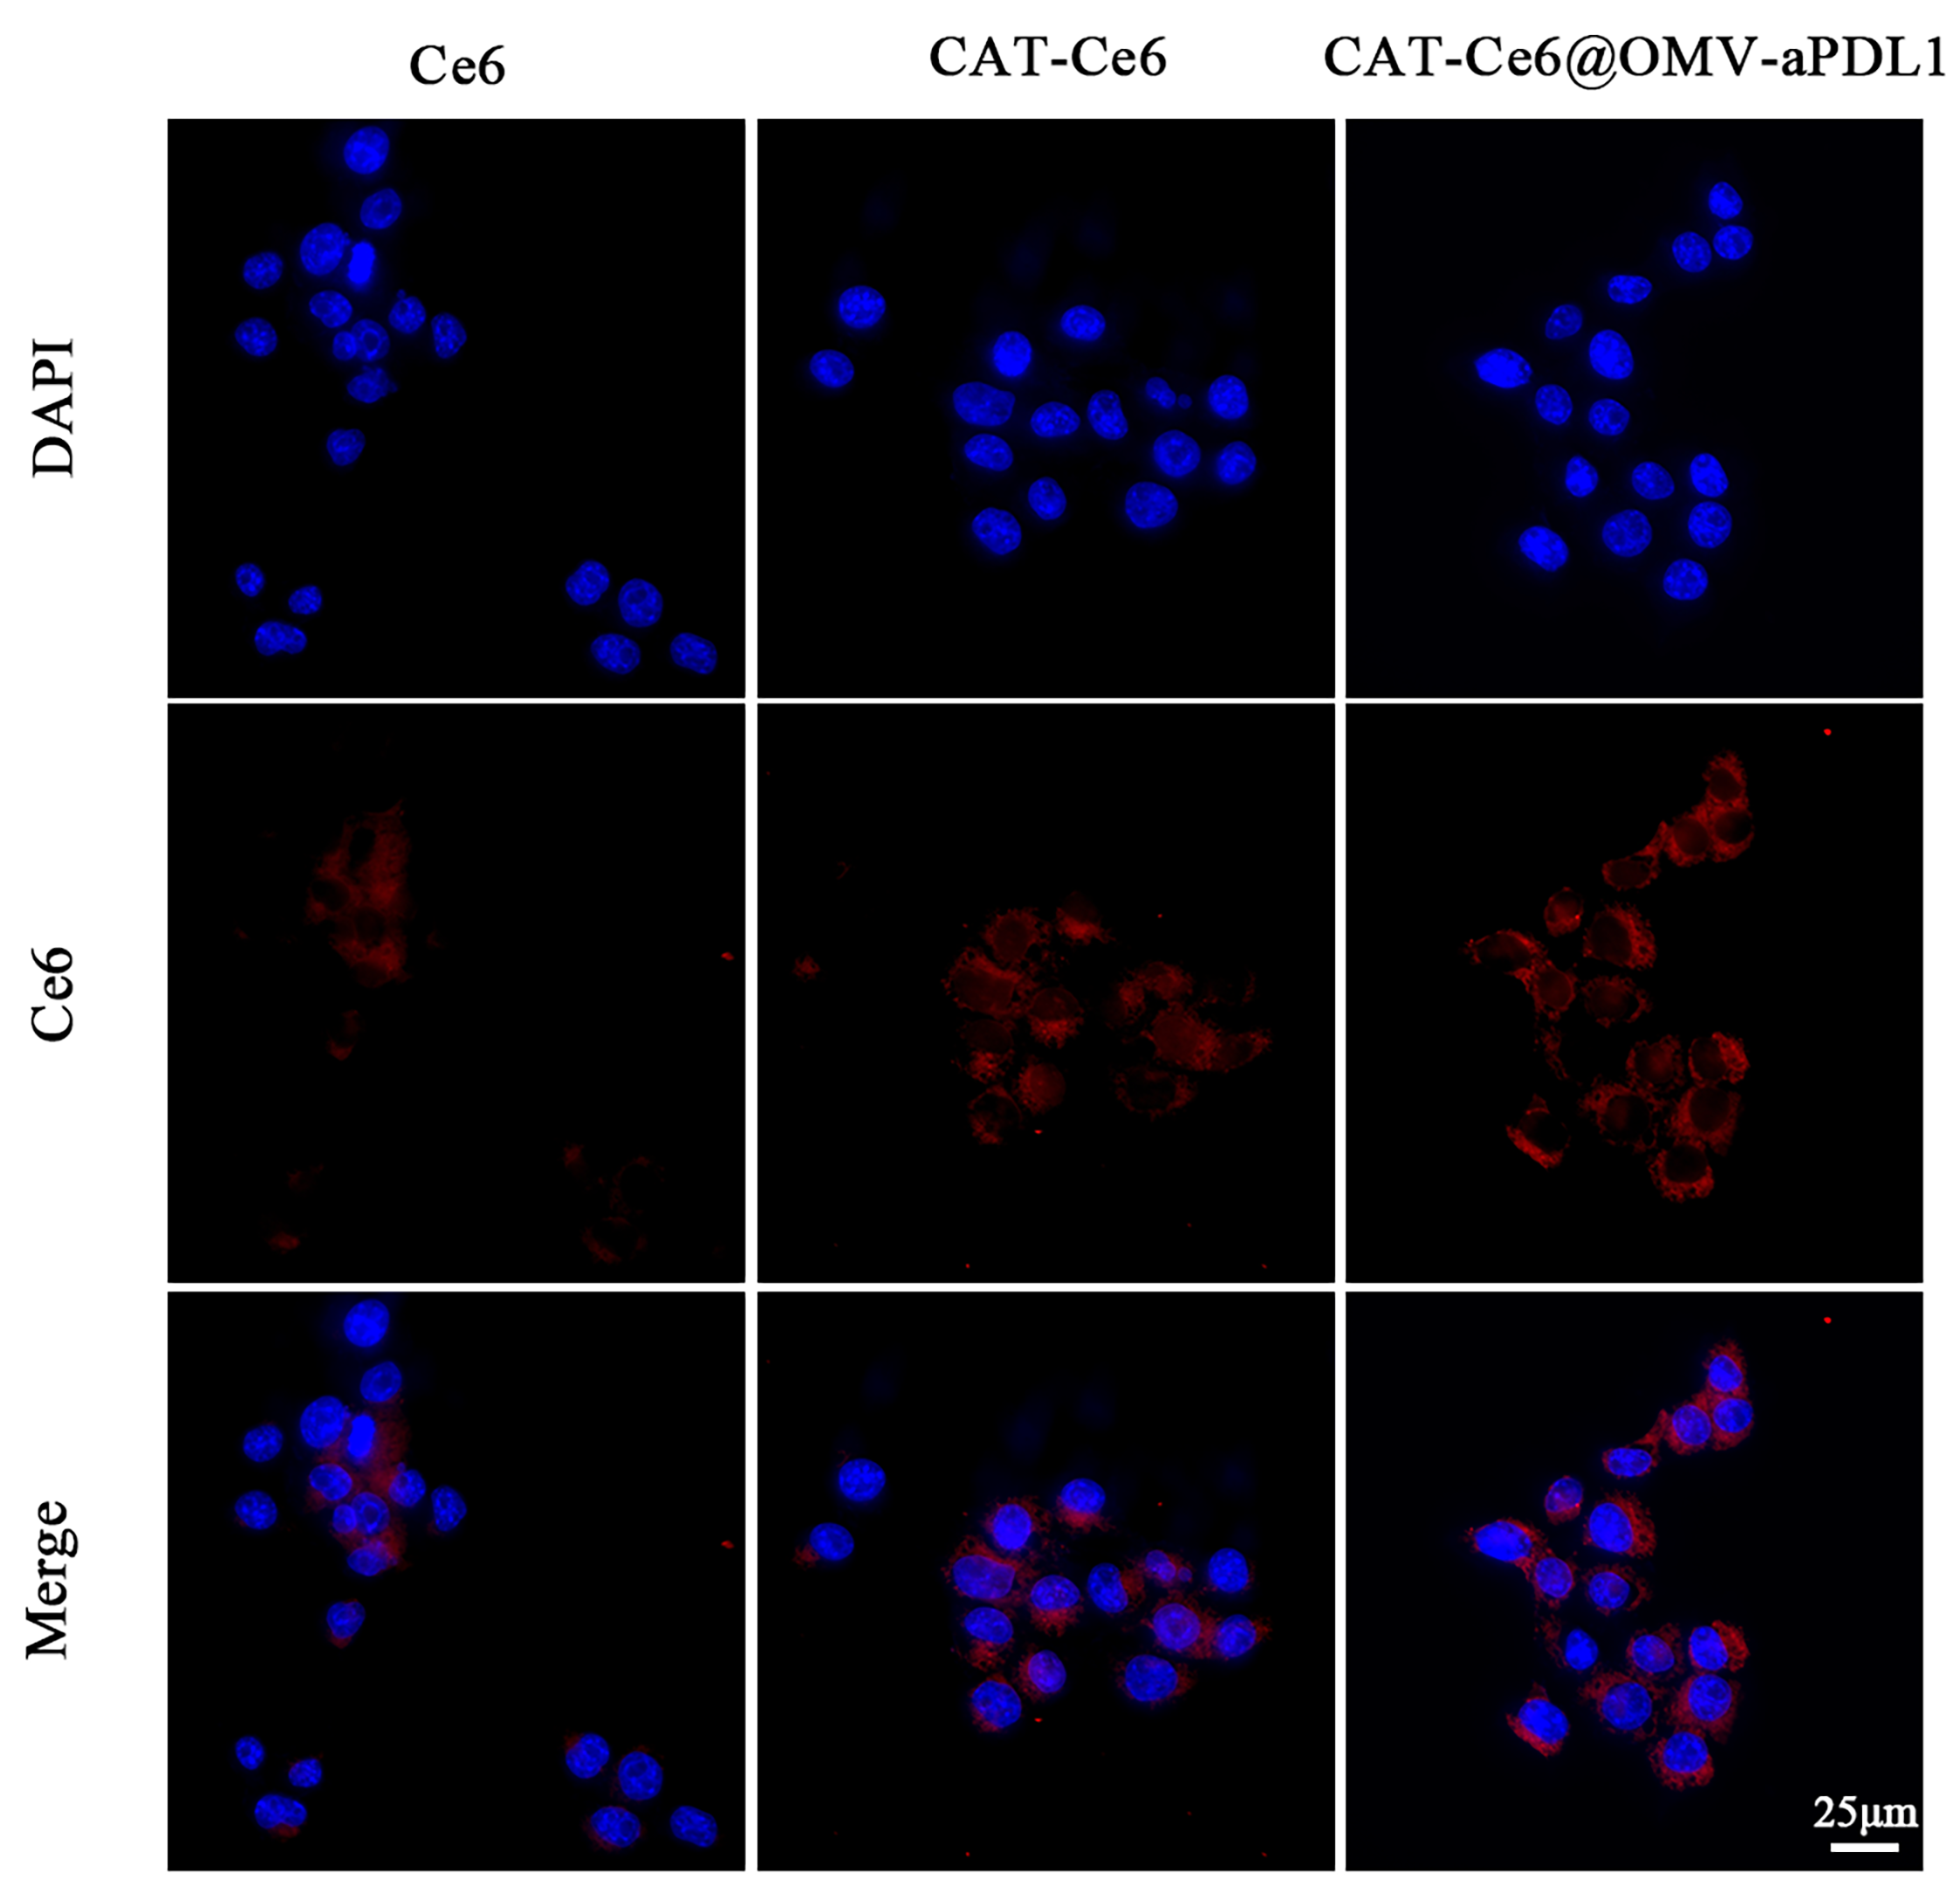
Figure. S1 The cellular uptake of Ce6, CAT-Ce6, CAT-Ce6@OMV-aPDL1 after incubation with 4T1 cells for 2 h. Scan bar, 25 μm.

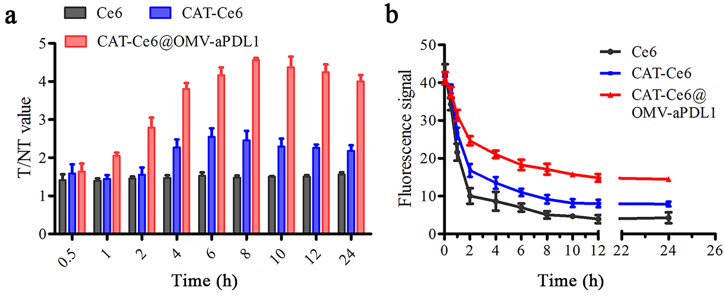
Figure. S2 The ratio of drug fluorescence signal between tumor and normal tissue (T/NT) of different formulations (a) and the metabolic time of different formulations in blood (b) anlong with time.

