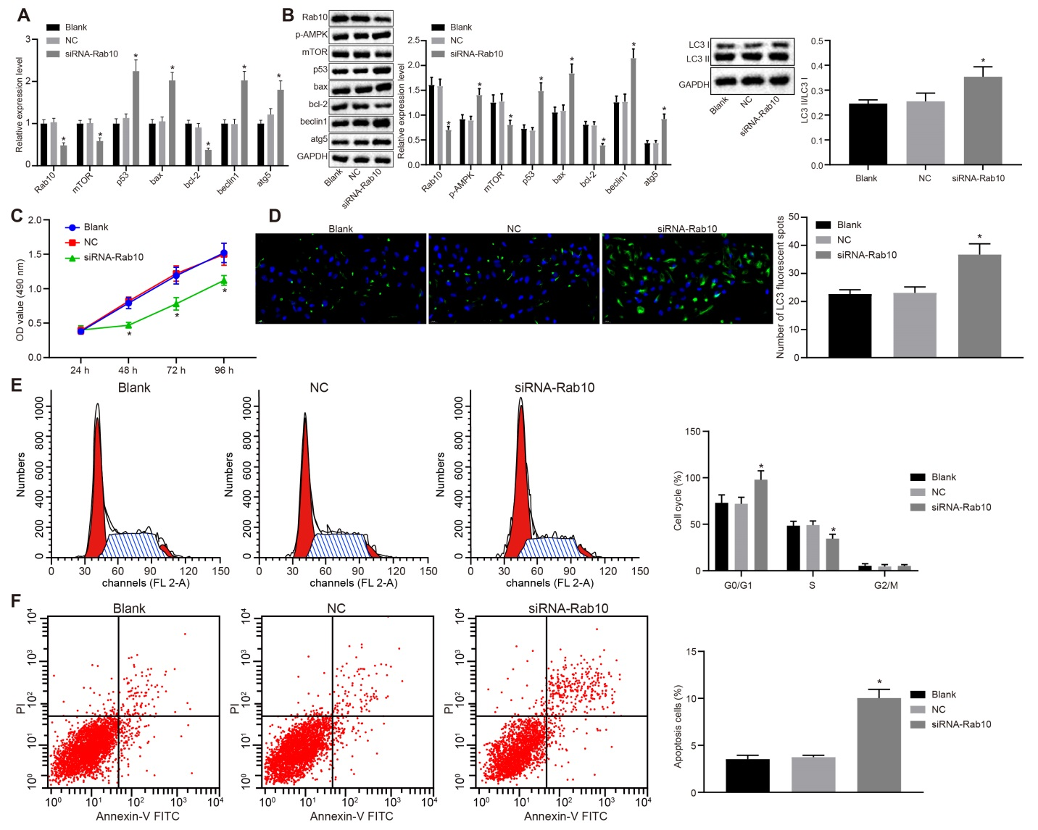
Supplementary Figure 1 Silencing of Rab10 inhibits the proliferation and promotes apoptosis and autophagy of HCC9724 cells. The HCC9724 cells were treated with siRNA-Rab10 and NC. A, mRNA expression of Rab10, Bax, Beclin1, Atg5, p53, mTOR and Bcl-2 detected by RT-qPCR; B, protein expression of Bax, Beclin1, Atg5, p53, Rab10, mTOR, and Bcl-2 and the extent of AMPK phosphorylation normalized to GAPDH detected by Western blot analysis; C, OD value of HCC9724 cells at the 24th, 48th, 72, ^{nd} and 96th h assessed by MTT assay; D, HCC9724 cell autophagy observed by immunofluorescence; E, cell cycle of HCC9724 cells detected by flow cytometry analysis; F, the apoptosis of HCC9724 cells as indicated using flow cytometry analysis. Data are represented as the mean ± standard deviation. Variation analysis was performed using unpaired t-test. *, p < 0.05 vs. the blank and NC groups; The experiment was repeated 3 times independently. HCC, hepatocellular carcinoma; RT-qPCR, reverse transcription-quantitative polymerase chain reaction; miR-519d, microRNA-519d; mTOR, mammalian target of rapamycin; Bax, Bcl-2 associated X protein; Bcl-2, b-cell lymphoma-2; Atg5, autophagy-related gene 5; GAPDH, glyceraldehyde-3-phosphate dehydrogenase; p-AMPK, phosphorylated-adenosine 5’-monophosphate-activated protein.

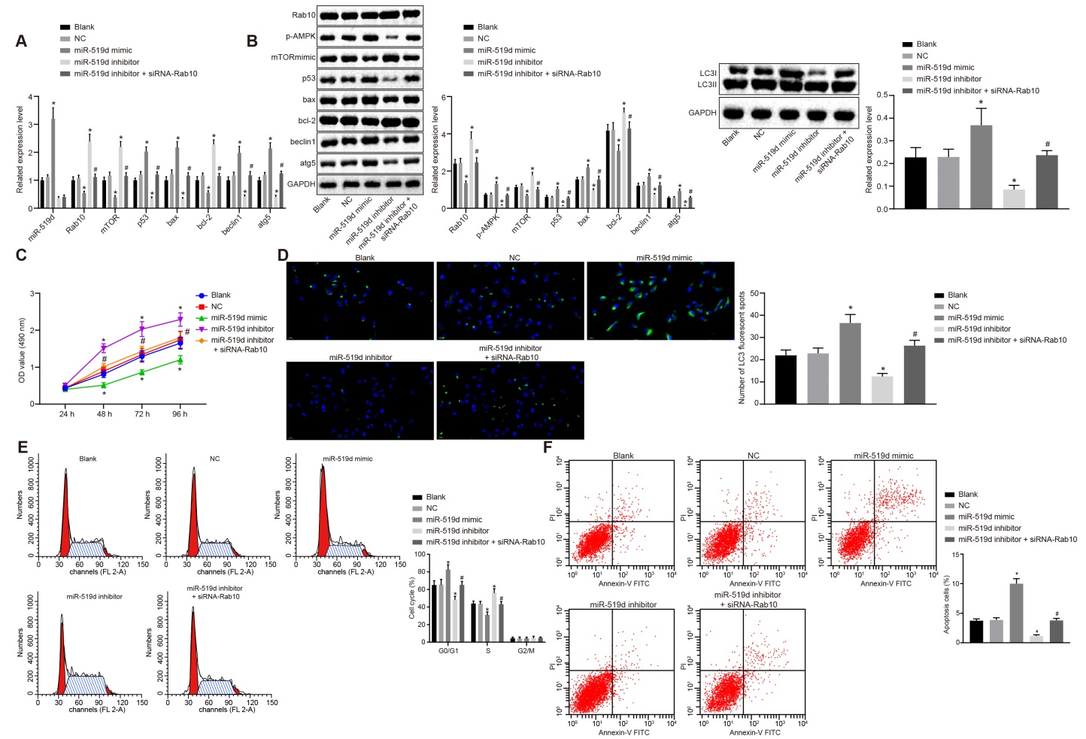
Supplementary Figure 2 miR-519d overexpression and Rab10 gene silencing inhibit cell proliferation and promote HCC9724 cell autophagy and apoptosis. The HCC9724 cells were treated with miR-519d mimic, miR-519d inhibitor alone, or siRNA-Rab10. A, miR-519d expression and mRNA expression of Rab10, Bax, Beclin1, Atg5, p53, mTOR and Bcl-2 in HCC9724 cells detected by RT-qPCR; B, protein expression of Bax, Beclin1, Atg5, p53, Rab10, mTOR, and Bcl-2 and the extent of AMPK phosphorylation normalized to GAPDH, as well as the ratio of LC3II/LC3I in HCC9724 cells detected by Western blot analysis; C, OD value of HCC9724 cells at the 24th, 48th, 72,^{nd} and 96th h assessed by MTT assay; D, HCC9724 cell autophagy observed by immunofluorescence; E, cell cycle of HCC9724 cells detected by flow cytometry analysis; F, the apoptosis levels of HCC9724 cells treated as indicated using flow cytometry analysis. Data are represented as the mean ± standard deviation. Variation analysis was performed using an unpaired t-test. *, p < 0.05 vs. the blank and NC groups; The experiment was repeated 3 times independently. *, p < 0.05 vs. the blank and NC groups; #, p < 0.05 vs. the miR-519d inhibitorr group; HCC, hepatocellular carcinoma; MTT, 3-(4,5-dimethylthiazol-2-yl)-2,5-diphenyltetrazolium bromide; miR-519d, microRNA-519d; NC, negative control; p-AMPK, phosphorylated-adenosine 5’-monophosphate-activated protein; mTOR, mammalian target of rapamycin; Bax, Bcl-2 associated X protein; Bcl-2, b-cell lymphoma-2; Atg5, autophagy-related gene 5; GAPDH, glyceraldehyde-3-phosphate dehydrogenase.

