Supplementary table and figure legends

Table S1 Main effect of group in typical frequency band (0.01–0.1 Hz)
Brain area | BA | MNI | Peak | Voxel size
 |  | X, Y, Z
Cerebellum posterior lobe | / | ±30, -81, -33 | -4.502 | 227
Inferior temporal gyrus | 20 | ±57, -9, -24 | -4.227 | 94
Middle frontal gyrus | 10 | ±36, 42, 3 | 4.325 | 123
Notes: GRF correction was performed at voxel-level p < 0.01 and cluster-level p < 0.05.
Abbreviations: BA, Brodmann’s area; MNI, Montreal Neurological Institute; GRF, Gaussian random field.

Table S2 Main effect of AD or AND in slow-4 and slow-5 frequency band
Brain area | BA | MNI | Peak | Voxel size
 |  | X, Y, Z
AD
Cerebellum posterior lobe | / | ±30, -81, -33 | -5.504 | 277
Inferior temporal gyrus | 21 | ±69,-12, -21 | -3.937 | 112
Middle frontal gyrus | 10 | ±42, 51, 0 | 5.845 | 147
Parahippocampa gyrus | 30 | ±12, -39, 0 | -5.003 | 95
Middle temporal gyrus | 39 | ±33, -69, 24 | -4.465 | 99
AND
Cerebellum posterior lobe | / | ±30, -81, -33 | -4.453 | 227
Inferior temporal gyrus | 20 | ±57, -9, -24 | -4.227 | 94
Middle frontal gyrus | 10 | ±36, 42, 3 | 4.325 | 123
Notes: GRF correction was performed at voxel-level p < 0.01 and cluster-level p < 0.05.
Abbreviations: AD, alcohol dependence; AND, alcohol and nicotine co-dependence; BA, Brodmann’s area; MNI, Montreal Neurological Institute; GRF, Gaussian random field.

Table S3 Interaction between AND and frequency band (p<0.01, uncorrected)
Brain area | BA | MNI | Peak | Voxel size
 |  | X, Y, Z
Inferior occipital gyrus | 18 | ±33, -87, -12 | -3.036 | 13
Abbreviations: AND, alcohol and nicotine co-dependence; BA, Brodmann’s area; MNI, Montreal Neurological Institute.

Table S4 Significant group differences in seed-based FC between AD and HC groups in typical and slow-4 frequency band
seeds | regions | BA | MNI | Peak | Voxel size
 |  |  | X, Y, Z
In the typical band
Right CPL | left CPL | / | -33, -84, -30 | -4.929 | 336
Left CPL | right CPL | / | 33, -84, -30 | -5.519 | 440
Right MFG | left MFG | 10 | -39, 54, 0 | 4.798 | 135
Left MFG | right MFG | 10 | 45, 51, 0 | 4.233 | 158
In slow-4 frequency band
Right CPL | left CPL | / | -15, -93, -30 | -3.614 | 133
Left CPL | right CPL | / | 27, -81, -33 | -3.257 | 102
Right MFG | left MFG | 10 | -39, 54, 0 | 4.794 | 141
Left MFG | right MFG | 10 | 45, 45, 0 | 4.253 | 144
Notes: GRF correction was performed at voxel-level p < 0.01 and cluster-level p < 0.05.
Abbreviations: FC, functional connectivity; AD, alcohol dependence; HC, healthy control; BA, Brodmann’s area; MNI, Montreal Neurological Institute; CPL, cerebellum posterior lobe; MFG, middle frontal gyrus; GRF, Gaussian random field.

Table S5 Correlations between functional results (VMHC and FC) and clinical variables in AD group
 | Years of drinking |  | Daily drinking |  | AUDIT |  | SADQ
Variables | p | ρ | p | ρ | p | ρ | p | ρ
VMHC values
Bilateral CPLª | 0.207 | -0.280 | 0.482 | -0.158 | 0.529 | 0.142 | 0.839 | -0.046
Bilateral MFGª | 0.824 | -0.050 | 0.685 | -0.092 | 0.008 | 0.553 | 0.536 | 0.140
Bilateral CPL^{b} | 0.485 | -0.167 | 0.162 | -0.309 | 0.966 | -0.010 | 0.645 | -0.101
Bilateral MFG^{b} | 0.902 | 0.028 | 0.513 | -0.147 | 0.019 | 0.497 | 0.841 | 0.045
FC values
Right CPL seed^{c} | 0.566 | -0.129 | 0.044 | -0.433 | 0.775 | 0.065 | 0.645 | -0.104
Left CPL seed^{c} | 0.300 | -0.231 | 0.671 | -0.096 | 0.713 | 0.083 | 0.631 | -0.108
Right MFG seed^{c} | 0.582 | -0.124 | 0.770 | -0.066 | 0.175 | 0.300 | 0.880 | 0.034
Left MFG seed^{c} | 0.704 | 0.086 | 0.691 | -0.090 | 0.290 | 0.236 | 0.906 | 0.027
Right CPL seed^{d} | 0.652 | -0.102 | 0.035 | -0.450 | 0.347 | -0.211 | 0.230 | -0.267
Left CPL seed^{d} | 0.521 | -0.145 | 0.104 | -0.356 | 0.796 | -0.058 | 0.401 | -0.189
Right MFG seed^{d} | 0.970 | 0.008 | 0.926 | 0.021 | 0.105 | 0.355 | 0.853 | 0.047
Left MFG seed^{d} | 0.906 | 0.027 | 0.483 | -0.158 | 0.508 | 0.149 | 0.997 | 0.001
Notes: a, alteration of VMHC in the typical frequency band; b, alteration of VMHC in the slow-4 frequency band; c, the seeds in the typical frequency band; d, the seeds in the slow-4 frequency band.
Abbreviations: VMHC, voxel-mirrored homotopic connectivity; FC, functional connectivity; AD, alcohol dependence; AUDIT, alcohol use disorders identification test; SADQ, severity of alcohol dependence questionnaire; CPL, cerebellum posterior lobe; MFG, middle frontal gyrus.

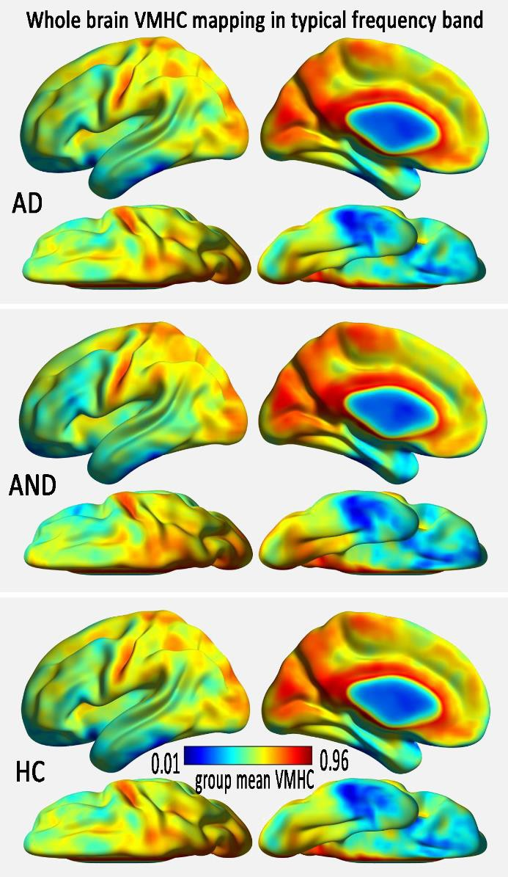

Figure S1 The spatial distributions of the whole brain mean VMHC for AD, AND, and HC groups in typical frequency band. The warm color indicates higher VMHC value than the global mean, while the cool color indicates lower VMHC value. Regions with stronger VMHC than the global mean values mainly distributed in DMN in all the three groups.
Abbreviations: VMHC, voxel-mirrored homotopic connectivity; AD, alcohol dependence; AND, alcohol and nicotine co-dependence; HC, healthy control.

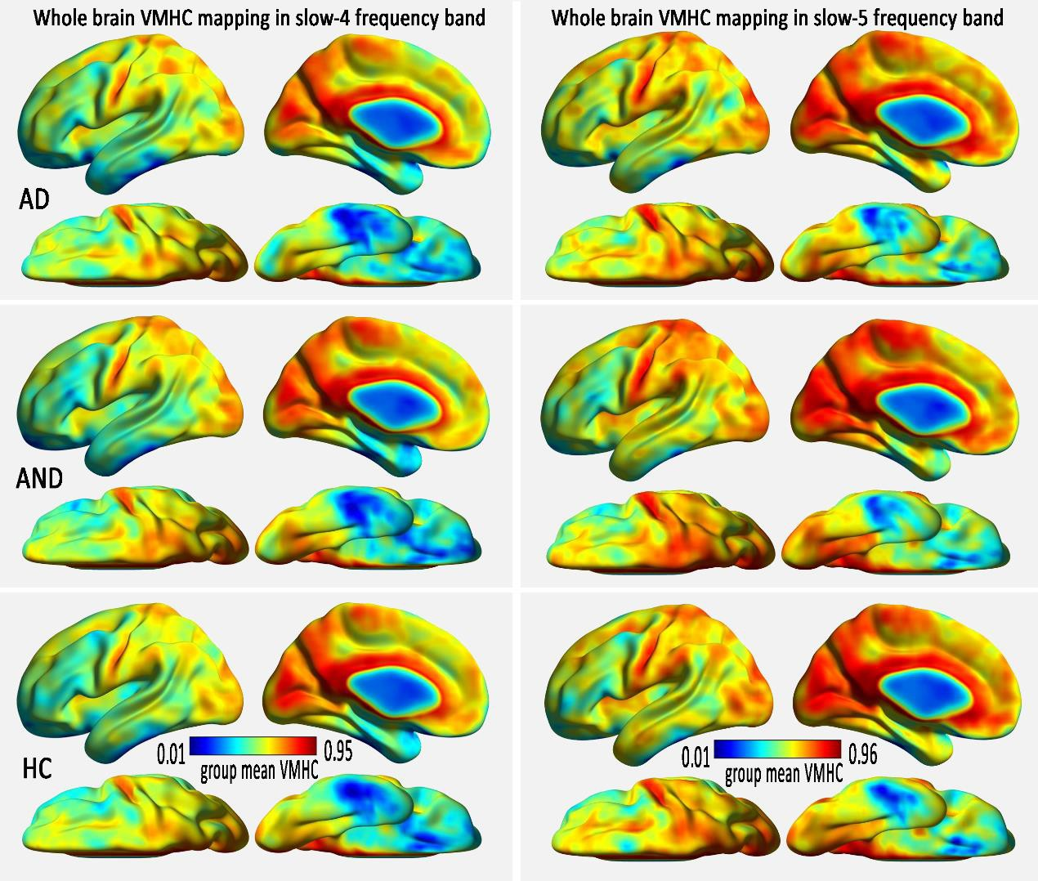
Figure S2 The spatial distributions of the whole brain mean VMHC for AD, AND, and HC groups in slow-4 and the slow-5 frequency band. The warm color indicates higher VMHC value than the global mean, while the cool color indicates lower VMHC value. The distributions of whole brain mean VMHC were similar in the slow-4 and slow-5 band among the three groups.
Abbreviations: VMHC, voxel-mirrored homotopic connectivity; AD, alcohol dependence; AND, alcohol and nicotine co-dependence; HC, healthy control.

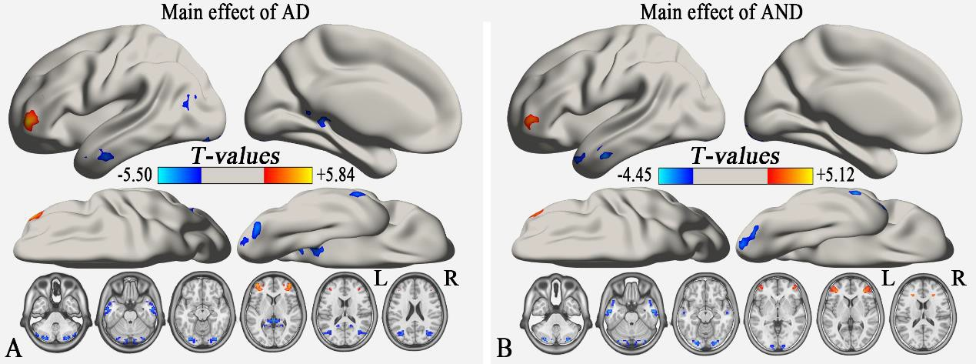
Figure S3 (A) the main effect of AD based on two way ANOVA analysis (GRF correction, voxel level p < 0.01 and cluster level p < 0.05). (B) the main effect of AND based on two way ANOVA analysis (GRF correction, voxel level p < 0.01 and cluster level p < 0.05). The cool color indicates the brain regions with decreased VMHC, and the warm color indicates the brain regions with increased VMHC on the comparison between AD (or AND) and HC group.
Abbreviations: AD, alcohol dependence; AND, alcohol and nicotine co-dependence; L, left; R, right; GRF, Gaussian random field; VMHC, voxel-mirrored homotopic connectivity.

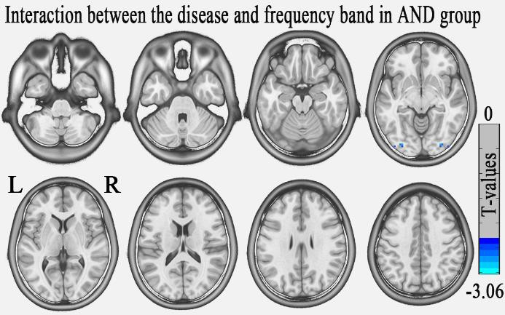
Figure S4 Interaction between AND and frequency band (p < 0.01, uncorrected). The cool color exhibits the brain regions of the decreased VMHC on the comparison between AND and HC group.
Abbreviations: AND, alcohol and nicotine co-dependence; L, left; R, right; VMHC, voxel-mirrored homotopic connectivity; HC, healthy control.

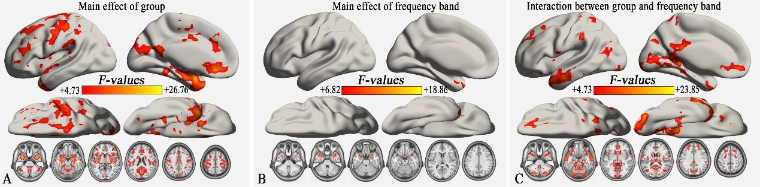
Figure S5 Main effect of group, frequency band and their interaction in the 3×2 ANOVA analysis (GRF correction, voxel level p < 0.01 and cluster level p < 0.05). The main effect of group (A) and interaction between group and frequency band (C) distributed in a wide range of brain areas, while the main effect of frequency band (B) largely distributed in bilateral middle temporal gyrus.

