Supplementary Information

Three animals: two males (WC#1701 and WC#1741) and one female (WC#11857) were scanned with ZD2-[⁶⁸Ga-NOTA] in this study.

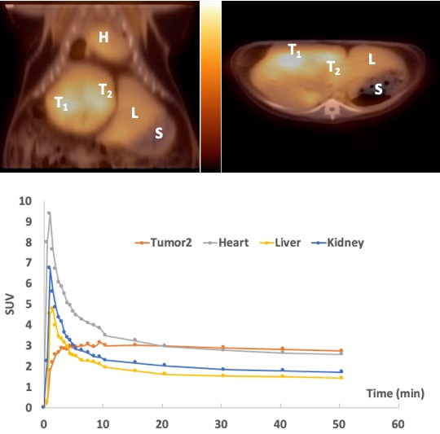
Figure S1 PET imaging of ZD2-[⁶⁸Ga-NOTA] with woodchuck (#1701). Upper: PET/CT overlays of coronal (left) and axial (right) cuts showing uptake in the other HCC (T₂ for tumor2) with L for liver, S for stomach, and H for heart; Lower: region-based uptake (in SUVs) as time activity curves for these organs.

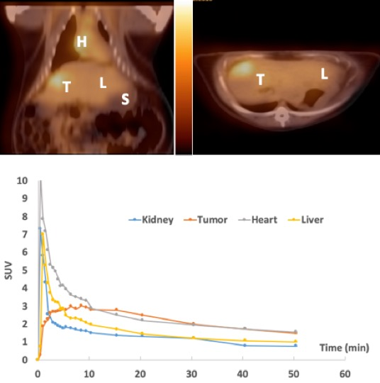
Figure S2 PET imaging of ZD2-[⁶⁸Ga-NOTA] with woodchuck (#1741). Upper: PET/CT overlays of coronal (left) and axial (right) cuts showing uptake in HCC (T for tumor) with L for liver, S for stomach, and H for heart; Lower: region-based uptake (in SUVs) as time activity curves for these organs.

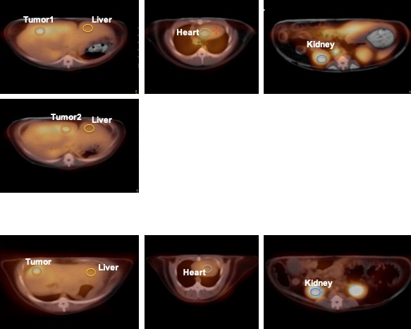
Figure S3 Regions of Interest (ROIs) used to generate time activity curves for region-based quantification in all the figures. Upper: ROIs for WC#1701; Lower: ROIs for WC#1741. These ROIs were draw on axial cuts due to the software used to generated the time activity curves.

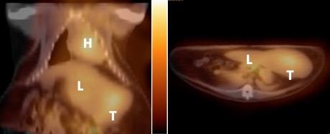
Figure S4 PET/CT overlay of WC#1857 at 60 min post-injection of ZD2-[⁶⁸Ga-NOTA]. The animal moved during the dynamic PET scan, and the PET and CT images were realigned for display.

