Supplementary Figure 1 Heatmap distribution of virulent factor genes in smart watches and mobile phones
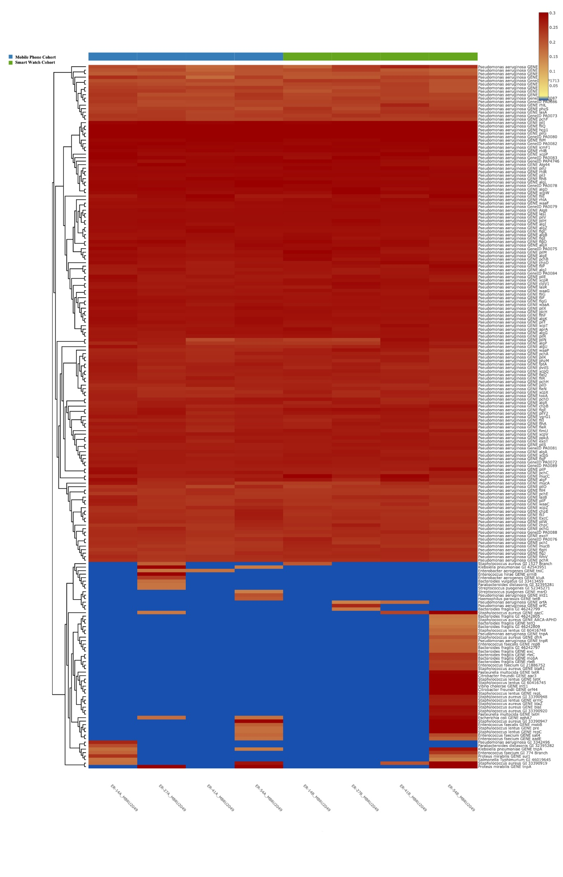
Supplementary Figure 2 Heatmap map distribution of antibiotic resistant genes in smart watches and mobile phones
