Supplementary Information
Regulating Interactions between Targeted Nanocarriers and Mononuclear Phagocyte System via an Esomeprazole-Based Preconditioning Strategy

Zakia Belhadj¹, Bing He¹, Jijun Fu², Hua Zhang¹, Xueqing Wang¹, Wenbing Dai*¹, Qiang Zhang*¹

¹Beijing Key Laboratory of Molecular Pharmaceutics and New Drug Delivery Systems, State Key Laboratory of Natural and Biomimetic Drugs, School of Pharmaceutical Sciences, Peking University, Beijing 100191, China
² School of Pharmaceutical Sciences, Guangzhou Medical University, Guangzhou 511436, China

Correspondence: Qiang Zhang; Wenbing Dai
Beijing Key Laboratory of Molecular Pharmaceutics and New Drug Delivery Systems, State Key Laboratory of Natural and Biomimetic Drugs, School of Pharmaceutical Sciences, Peking University, Beijing 100191, China
E-mail: zqdodo@bjmu.edu.cn; phone: +86-10-82802791
E-mail: daiwb@bjmu.edu.cn ; phone: +86-10-82805724

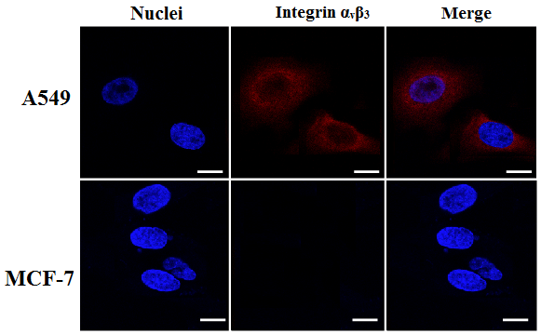
Figure S1 Integrin α_{v}β₃ expression in A549 and MCF-7 cells. Red represents Integrin α_{v}β₃ staining, and blue represents Hoechst fluorescence. (Scale bar = 10 μm).

Figure S2 MALDI-TOF-MS analysis of NHS-PEG-DSPE and c(RGDm7)-PEG-DSPE.
Figure S3 Distribution of DiO-loaded lipid vesicles in the tumors of nude mice bearing A549 xenografts. Blue: Hoechst stained cell nuclei. Green: DiO-loaded lipid vesicles. Bars represent 100 μm.
Figure S4 In vivo biocompatibility evaluation. (A) Histological analysis of the main organs of A549 tumor-bearing nude mice. Bars represent 200 μm. (B) Serum biochemical analysis of heart, liver, and kidney function markers of normal mice (mean ± SD, n = 3).

Table S1 DOX pharmacokinetic parameters following i.v. injection of various nanocarrier groups to SD rats
Group | AUC₀₋₇₂ (µg.h/mL) | MRT(h) | t_{1/2} (h)
LS-GE/DOX | 1591.01 ± 119.15 | 26.67 ± 4.56 | 21.27 ± 4.37
c(RGDm7)-LS-GE/DOX | 1086.33 ± 65.64 | 24.56 ± 3.08 | 18.23 ± 1.62
ESO+LS-GE/DOX | 2352.18 ± 257.02 | 32.24 ± 7.92 | 25.65 ± 8.80
ESO+c(RGDm7)-LS-GE/DOX | 2021.16 ± 210.97 | 29.72 ± 4.67 | 22.42 ± 2.56

Table S2 GE pharmacokinetic parameters following i.v. injection of various nanocarrier groups to SD rats
Group | AUC₀₋₂₄ (µg.h/mL) | MRT(h) | t_{1/2} (h)
LS-GE/DOX | 224.11 ± 36.12 | 7.04 ± 1.38 | 6.44 ± 2.53
c(RGDm7)-LS-GE/DOX | 174.77 ± 31.02 | 4.45 ± 1.43 | 3.97 ± 0.82
ESO+LS-GE/DOX | 431.25 ± 34.66 | 8.56 ± 1.85 | 8.40 ± 1.93
ESO+c(RGDm7)-LS-GE/DOX | 370.56 ± 68.31 | 8.80 ± 1.94 | 7.57 ± 2.52

