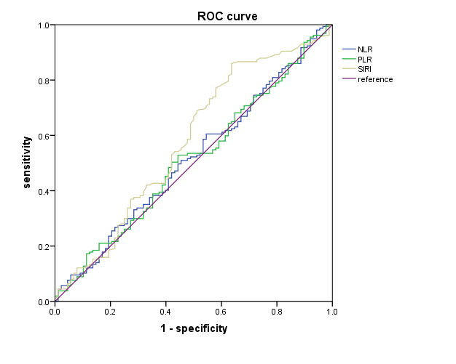
Figure S1: Receiver operating characteristic curve analysis for optimal cut-off value of NLR, PLR, and SII for PFS. NLR: Neutrophil to Lymphocyte Ratio, PLR: Platelet to Lymphocyte Ratio, SIRI: Systemic Immune Response Index, PFS: Progression Free Survival.

