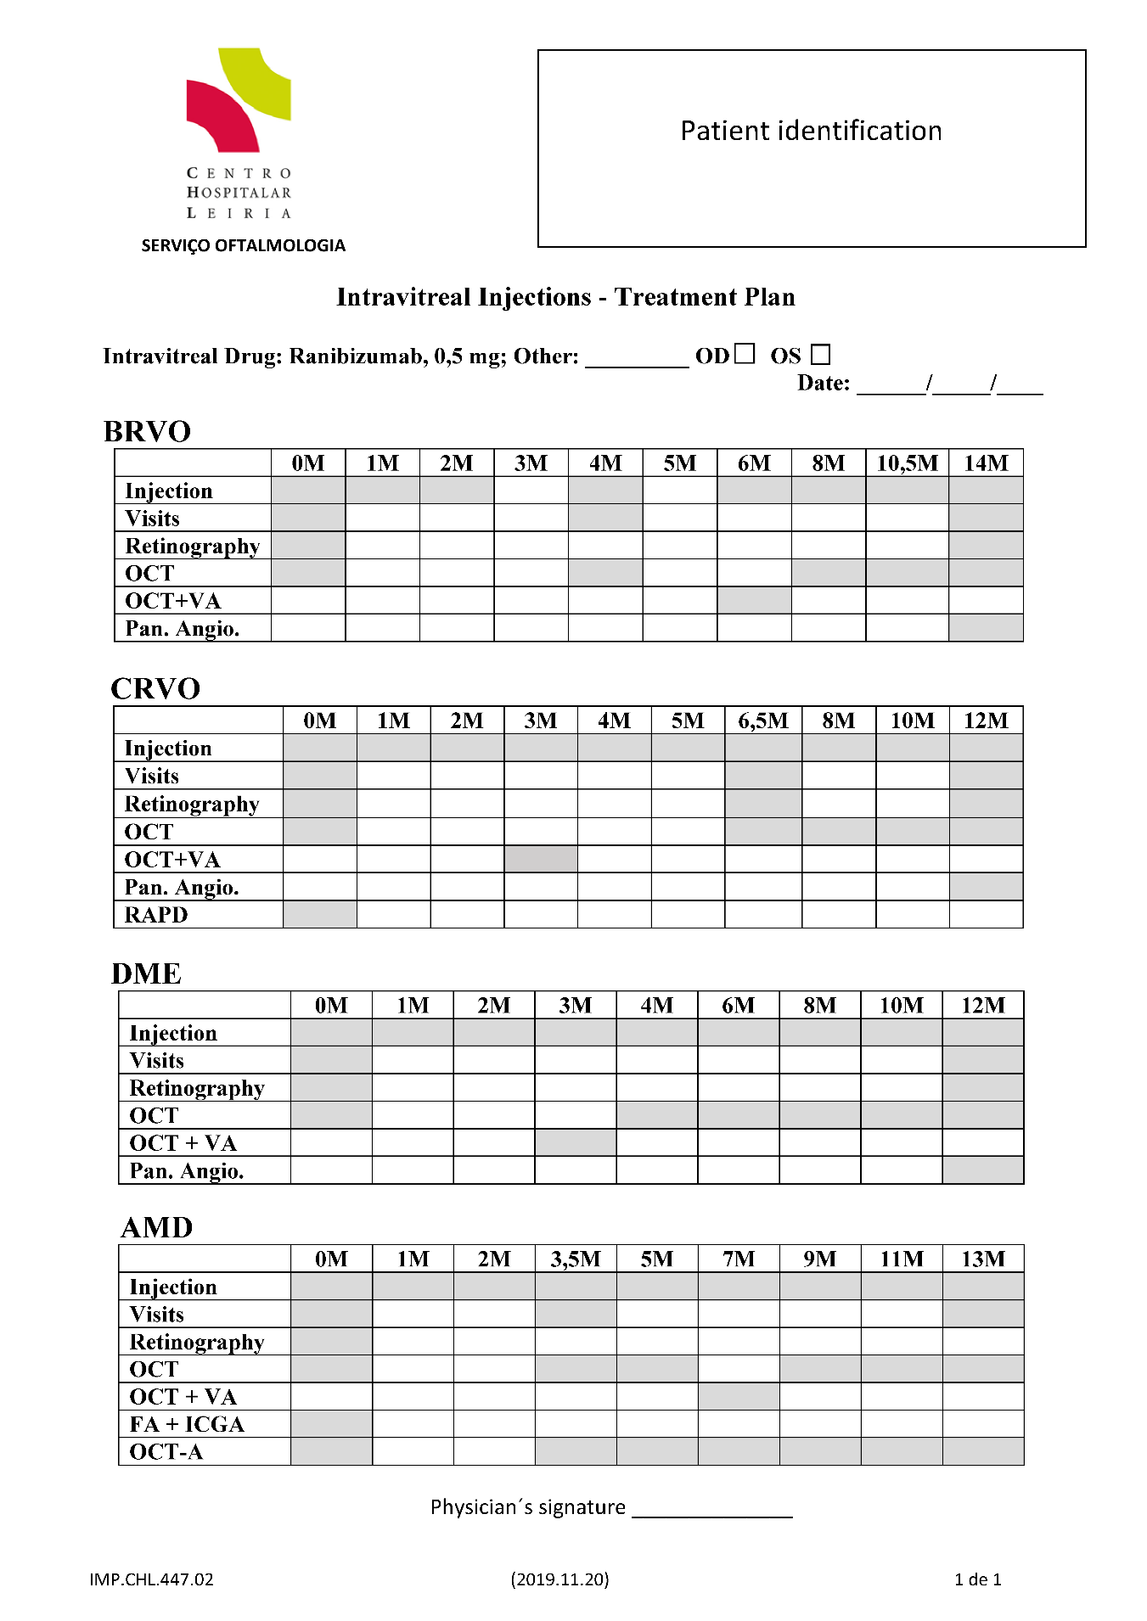

Supplementary Figure 1. Approved protocol of a fixed regimen of intra-vitreal injections that became an institutional guide of good clinical practice.
OD: oculus dextrus, right eye. OS: oculus sinister, left eye. BRVO: branch retinal vein occlusion. CRVO: central retinal vein occlusion. DME: diabetic macular edema. AMD: age-related macular degeneration. OCT: optical coherence tomography. OCT+VA: optical coherence tomography scans and assessment of visual acuity using the ETDRS scale. Pan. Angio.: wide field (panoramic) fluorescein angiography. FA+ICG: fluorescein angiography and indocyanin green angiography. OCT-A: optical coherence tomography angiography. M: month of administration designed by numerals where 0M is baseline.

