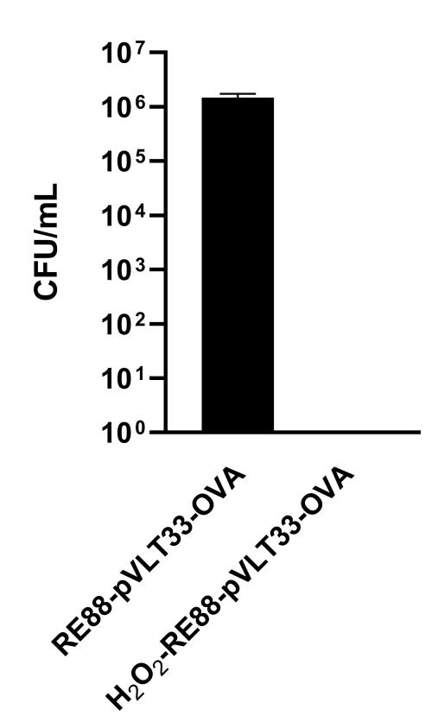

Fig. S1. The effect of hydrogen peroxide (H₂O₂) in killing RE88-pVLT33-OVA. RE88 were treated with 3% H₂O₂ at 37 °C after 1 h and then cultured on LB plates to allow bacterial growth was observed.

Fig. S2. The inducible expression of OVA by RE88-pVLT33-OVA. OVA was engineered into a bacterial expression plasmid (pVLT33), and RE88 cells bearing recombinant pVLT33-OVA were induced to express OVA by IPTG. The RE88 cells were treated with 1 mM IPTG for 0, 1, 3, 5, 7, 9 or 13 hours, and OVA expression in the bacterial lysate was measured by ELISA.

Fig. S3. Evaluation of anti-OVA IgG subtypes after subcutaneous vaccination with non-inactivated or H₂O₂-inactivated RE88-pVLT33-OVA. Anti-OVA IgG subtypes in mouse serum were measured at 42 days after the first immunization (6 independent experiments). SC: subcutaneous vaccination with non-inactivated RE88-pVLT33-OVA; H-SC: subcutaneous vaccination with H₂O₂-inactivated RE88-pVLT33-OVA.

Fig. S4. Ability of the neutralizing antibody in mouse serum to bind to the target tumor cells. The mice had been vaccinated intragastrically (H-IG) or subcutaneously (H-SC) with H₂O₂-inactivated RE88-pVLT33-OVA. Serum dilution: 1:400.

Fig. S5. Effects of prophylactic subcutaneous vaccination with H₂O₂-inactivated RE88-pVLT33-OVA on tumor growth in mice. The length and width of the subcutaneous tumor (if detectable) was measured every 3 days following challenge with the tumor, and tumor volume was calculated as: tumor volume = 0.5 × length (mm) × [width (mm)]². CFU: colony-forming units; NS: normal saline (negative control); RE88: unmodified strain; RE88OVA: H₂O₂-inactivated RE88-pVLT33-OVA; OVA-10 µg (positive control).

