Supplementary material
Supplementary Table 1 Full Eligibility Criteria
Inclusion criteria
- Non-smokers, 12–80 years old, body weight ≥40 kg and documented physician-diagnosed asthma for at least 12 months before screening
- Evidence of asthma as documented by post-bronchodilator (albuterol/salbutamol) reversibility of FEV₁ ≥12% AND ≥200 mL in the 12 months before screening or at week 0
- Documented history of current treatment with medium- or high-dose ICS for at least 6 months before screening, according to GINA 2018 guidelines,¹¹ and at least one additional asthma controller medication according to standard practice of care. Documented use of additional asthma controller medications for at least 3 months before screening
- A daily ICS dose ≥500 μg/day fluticasone propionate dry powder formulation or equivalent
- A morning pre-bronchodilator FEV₁ >50% predicted normal at screening
- Asthma that was not well controlled, documented by either:
  - an ACQ-6 ≥1.5 at screening or randomization, OR
  - one or more exacerbations that required oral or systemic corticosteroids within 12 months of screening, or an exacerbation that resulted in inpatient hospitalization for ≥24 hours within 12 months of screening
- The patient or caregiver must have been willing and able to administer the study drug and the caregiver must be have been at least 21 years old at screening.
Exclusion criteria
- Any disorder that could, in the opinion of the investigator, affect the safety of the patient or influence study findings
- Any clinically relevant abnormal findings in physical examination results, electrocardiogram, vital signs, hematology, clinical chemistry or urinalysis during screening that could, in the opinion of the investigator, affect the safety of the patient or influence study findings
- Hypersensitivity to tezepelumab or any excipients of tezepelumab
- History of anaphylactic reaction to any biologic therapy
- Helminth or parasitic infection diagnosed in the 6 months before screening that had not been treated with, or was unresponsive to, standard-of-care therapy
- An acute upper or lower respiratory tract infection requiring antibiotics or antiviral medication in the 2 weeks before screening
- History of cancer, Guillain–Barré syndrome, hepatitis B or C, immunodeficiency disorder, thrombocytopenia, use of anticoagulants or tuberculosis
- History of chronic alcohol or drug abuse ≤12 months before screening or positive screen for drug abuse at screening or on the day before dosing
- Evidence of active liver disease
- Receipt of any marketed or investigational biologic agent in the 4 months or 5 half-lives (whichever is longer) before screening
- Use of drugs with enzyme-inducing properties (eg, St John’s Wort) in the 3 weeks before day 1, or use of any prescribed or non-prescribed medication (eg, antacids, analgesics, herbal remedies, mega-dose vitamins and minerals) during the 2 weeks before administration of tezepelumab
- Individuals who had previously received tezepelumab
- Current smokers or those who had smoked or used nicotine products including e-cigarettes in the 3 months before screening, as judged by the investigator
- Pregnant, breastfeeding or lactating women
Abbreviations: ACQ-6, Asthma Control Questionnaire; FEV₁, forced expiratory volume in 1 second; GINA, Global Initiative for Asthma; ICS, inhaled corticosteroids.
Supplementary Table 2 Questions Provided to HCPs, Patients and Caregivers on Use of the APFS and AI to Administer Tezepelumab
Question | Response |  | If the answer was no, please explain
 | Yes | No
Were you able to inspect the syringe contents?
Were you able to perform the injection?
Were you able to fully depress the plunger during injection?
Were you able to administer the full dose?
Were you able to activate the needle safety guard?
Abbreviations: AI, autoinjector; APFS, accessorized pre-filled syringe; HCP, healthcare professional.
Supplementary Table 3 Serum Concentrations of Tezepelumab Administered Via APFS and AI
Time Point | Parameter | Tezepelumab 210 mg Q4W  Via APFS  (n=111) | Tezepelumab 210 mg Q4W  Via AI  (n=105)
Week 4 | n  Geometric mean (CV, %)ª, µg/mL  Mean (SD), µg/mL  Median (min, max), µg/mL | 109  11.0 (48.4)  12.0 (4.6)  11.4 (3.1, 23.2) | 105  10.6 (57.0)  11.8 (5.0)  11.5 (0.7, 30.4)
Week 20 | n  Geometric mean (CV, %)ª, µg/mL  Mean (SD), µg/mL  Median (min, max), µg/mL | 108  19.0 (69.1)  21.9 (10.1)  22.0 (0.7, 51.8) | 105  20.3 (56.6)  23.0 (10.7)  22.2 (4.0, 56.4)
Week 24 (end of treatment) | n  Geometric mean (CV, %)ª, µg/mL  Mean (SD), µg/mL  Median (min, max), µg/mL | 109  19.6 (58.3)  22.2 (9.9)  22.4 (4.3, 49.0) | 105  19.9 (54.3)  22.3 (9.7)  21.4 (3.0, 46.9)
Week 36 (final week of  follow-up) | n  Geometric mean (CV, %)ª, µg/mL  Mean (SD), µg/mL  Median (min, max), µg/mL | 103  1.8 (132.3)  2.7 (2.2)  2.2 (0.05, 11.8) | 98  2.1 (115.3)  2.9 (2.4)  2.2 (0.09, 15.9)
ªCalculated using log-transformed data.
Abbreviations: AI, autoinjector; APFS accessorized pre-filled syringe; CV, coefficient of variation; max, maximum; min, minimum; Q4W, every 4 weeks; SD, standard deviation.

Supplementary Table 4 ADA Responses to Tezepelumab Administration Via APFS or AI
 | APFS  (n=111) | AI  (n=105)
Any ADA-positive (ADA prevalence)ª
n/N (%) | 2/111 (1.8) | 11/105 (10.5)
Maximum titer, median  (min, max)^{b} | 67.2 (67.2, 67.2) | 67.2 (67.2, 537.6)
Treatment-emergent ADA-positive (ADA incidence)^{c}
n/N (%) | 2/111 (1.8) | 8/105 (7.6)
Maximum titer, median (min, max)^{b} | 67.2 (67.2, 67.2) | 67.2 (67.2, 268.8)
Treatment-induced ADA-positive^{d}
n/N (%) | 2/111 (1.8) | 8/105 (7.6)
Maximum titer, median (min, max)^{b} | 67.2 (67.2, 67.2) | 67.2 (67.2, 268.8)
Treatment-boosted ADA-positive^{e}
n/N (%) | 0 | 0
ªDefined as ADA positive at baseline and/or post-baseline. ADA prevalence was the proportion of participants testing positive for ADAs at any time.
^{b}Titers of ADA-positive samples ≤67.2 (limit of detection) are reported as 67.2.
^{c}Defined as either treatment-induced ADA positive or treatment-boosted ADA positive. ADA incidence was the proportion of treatment-emergent ADA-positive patients.
^{d}Defined as ADA negative at baseline and ADA positive post-baseline.
^{e}Defined as ADA positive at baseline and the baseline ADA titer was boosted to fourfold or greater after tezepelumab administration.
Abbreviations: ADA, antidrug antibody; AI, autoinjector; APFS, accessorized pre-filled syringe.

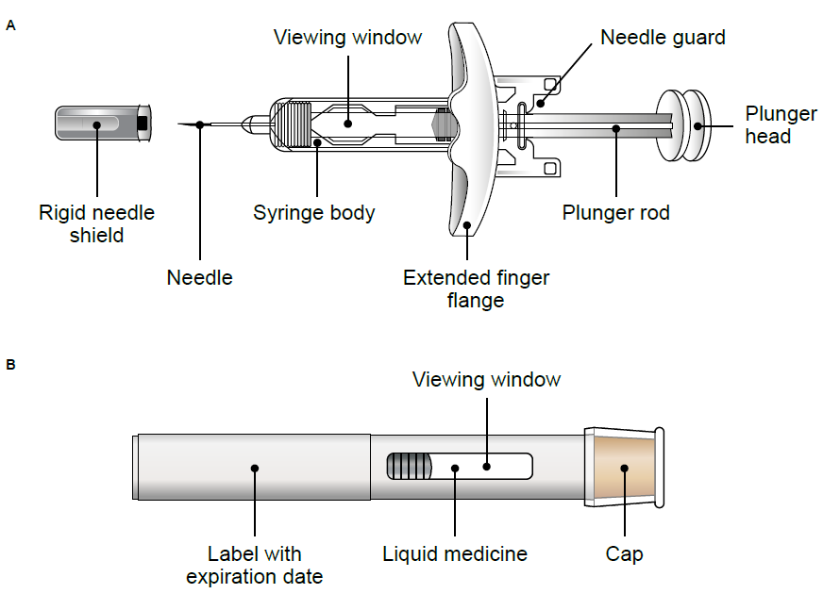

Supplementary Figure 1 Schematic drawing of (A) accessorized pre-filled syringe and (B) autoinjector.

