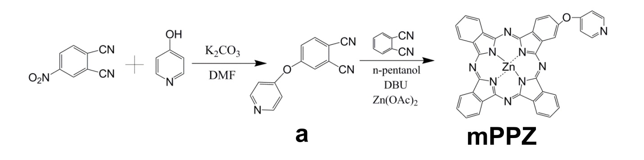
Scheme S1 The synthesis procedure of mPPZ
Synthesis of compound a and mPPZ
4-nitrophthalonitrile (300mg) and potassium carbonate (1.5g) was mixed into DMF (15ml). After the stirring for 30min, 15ml DMF solution of 4-Hydroxypyridine (412mg) was added into the mixed solution and following a reaction for 12h. Solvent was evaporated under reduced pressure and then the residue was purified to silica gel column chromatography using CH₂Cl₂/CH₃OH (10:1) as the eluent to afford the product a (yield: 66%). a: ¹H NMR (500 MHz, DMSO) δ 7.63 (d, J = 2.1 Hz, 1H), 7.46 (d, J = 8.6 Hz, 1H), 7.31-7.26 (m, 3H), 5.43 (d, J = 7.8 Hz, 2H).
Phthalonitrile (300mg), a (58mg), zinc acetate (480mg) and 1-pentanol (30ml) was mixed together and then was heated to 110 °C under an atmosphere of nitrogen. After the reactant was dissolved, DBU (0.5ml) was added into them and then the mixture was stirred at 150 °C for 12 h in the nitrogen atmosphere. The volatiles were evaporated under reduced pressure and the residue was dissolved by CH₂Cl₂ to be purified by alkaline alumina column using CH₂Cl₂/CH₃OH (20:1) as the eluent to obtain the crude product. The crude product was further purified by silica gel thin layer chromatography which developing solvent was CH₂Cl₂/CH₃OH (10:1) to get the final product mPPZ. mPPZ: ¹H NMR (600 MHz, DMSO) δ 9.32-8.98 (m, 8H), 8.62 (d, J = 7.8 Hz, 2H), 8.32-8.16 (m, 7H), 6.59 (d, J = 6.6 Hz, 2H).

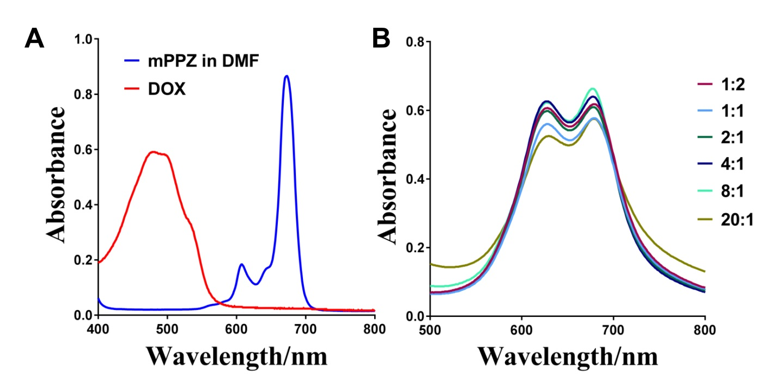
Figure S1 A. The ultraviolet-visible spectrum of mPPZ in DMF and DOX in PBS sulution. DOX had a characteristic absorption peak at 490nm. The maximum absorption peak at 670nm indicated mPPZ was in a monomer state in DMF solution. B. The ultraviolet-visible spectrum of mPPZ incubated with HSA molecules at different molar ratios (HSA:mPPZ). The strong absorption at 630nm indicated mPPZ was still in a state of aggregation in spite of any molar ratios with HSA. This showed that the simple mixing and incubation could not make mPPZ be disaggregated.
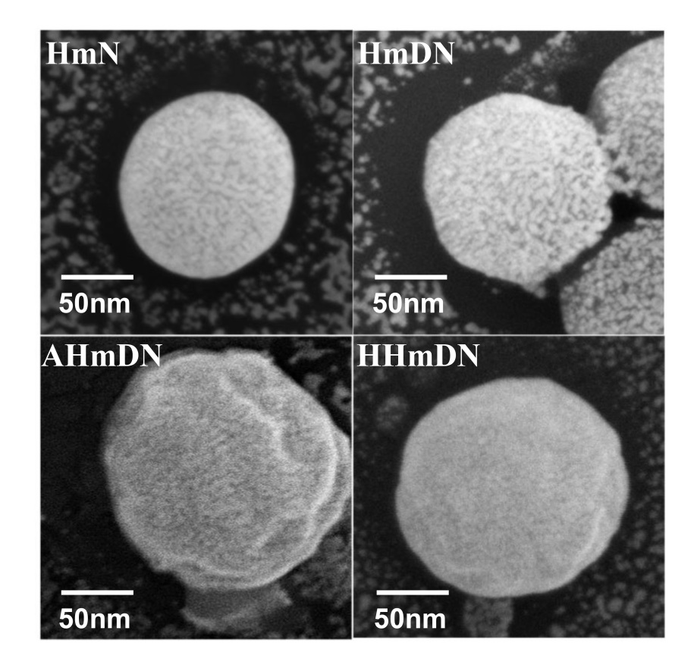
Figure S2 FESEM images of HmN, HmDN, HHmDN, AHmDN with enlarged scale. The detail showed that HmN and HmDN was sphere with smooth surface while HHmDN and AHmDN with rough surface, suggesting the surface coating of HSA or ATF-HSA.
Table S1 The fluorescence quantum yield Φ_{F} of prepared nanoparticles in PBS and free mPPZ in DMF and PBS.
 | HmN | HmDN | HHmDN | AHmDN | mPPZ in PBS | mPPZ in DMF
Φ_{F} | 0.23±0.01 | 0.22±0.02 | 0.22±0.01 | 0.22±0.01 | 0.10±0.02 | 0.26±0.01

Table S2 The key properties of prepared nanoparticles by average size, PDI, zeta potential, EE%, RE% (72 hours) and LE%.
 | average size | PDI | Z-potential | EE% for  DOX/mPPZ | RE% for  DOX/mPPZ | LE% for  DOX/mPPZ
HmN | 97.6±3.8 | 0.10±0.03 | -22.3±1.2 | (N/A)/  13.1±0.4 | (N/A)/  1.6±0.2 | (N/A)/  0.8±0.4
HmDN | 104.9±4.0 | 0.14±0.01 | -25.3±1.5 | 62.3±3.4/  12.8±2.7 | 3.8±0.4/  1.8±0.3 | 3.9±0.2/  0.8±0.2
HHmDN | 166.0±6.1 | 0.23±0.05 | -30.0±1.8 | 59.6±3.9/  12.5±1.3 | 1.6±0.2/  1.3±0.5 | 2.8±0.4/  0.5±0.3
AHmDN | 179.4±7.2 | 0.21±0.04 | -32.6±2.0 | 60.5±5.6/  12.6±1.1 | 1.6±0.3/  1.4±0.4 | 2.2±0.3/  0.4±0.1

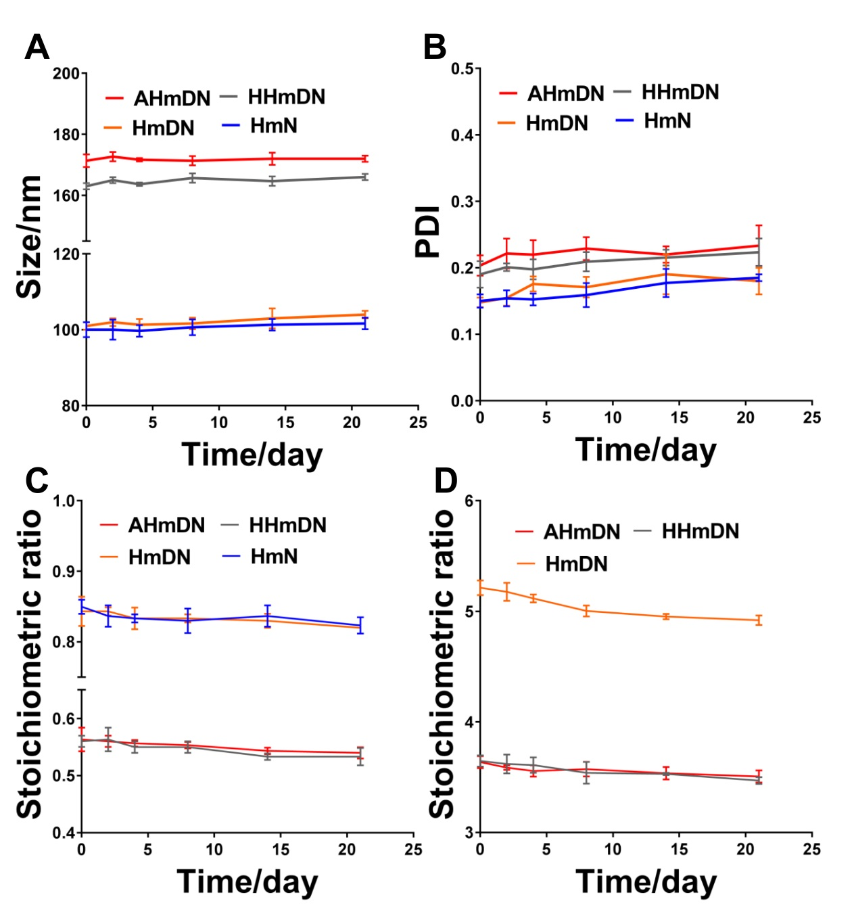
Figure S3 The stability of HmN, HmDN, HHmDN and AHmDN. During the period of three weeks, there was barely change in the size (A) and PDI (B) of HmN, HmDN, HHmDN and AHmDN. C. The stoichiometric ratio (mPPZ:HSA) was used to monitor the release of mPPZ from nanoparticles. In the three weeks, there was hardly any mPPZ being released from the four nanoparticles, which indicated the well stability. D. The change of stoichiometric ratio (DOX:HSA) showed DOX was barely released from HHmDN and AHmDN during three weeks while a small quantity of DOX was escaped from HmDN at the first week, which suggested the enhanced stability of HHmDN and AHmDN through the surface modification.
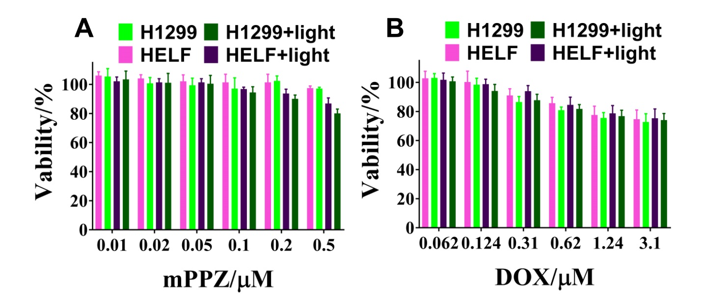Figure S4 The cytotoxicity of free mPPZ and DOX to H1299 and HELF with or without the illumination was detected by MTT method. The concentration of free mPPZ or DOX was the same as that encapsulated in nanoparticles shown in Figure 2.
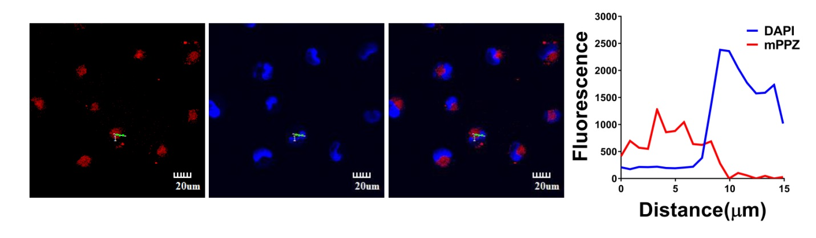
Figure S5 Cellular localization of HmN and the fluorescence intensity profile. HmN could be absorbed into H1299 cells after the incubation for 12h at the concentration of mPPZ 0.5μM. mPPZ was mainly distributed in cytoplasm but not in nucleus.
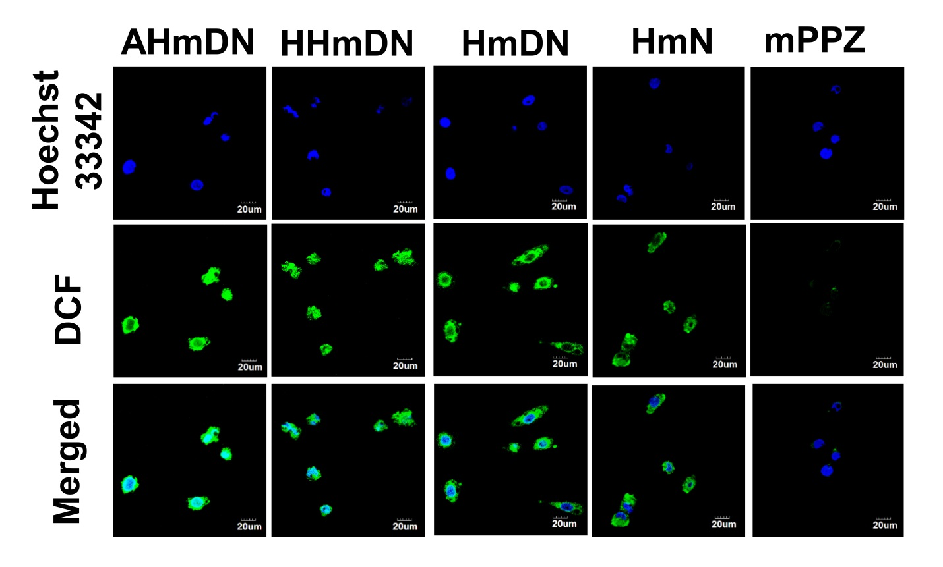
Figure S6 Intracellular ROS detection after AHmDN, HHmDN, HmDN, HmN or mPPZ treatment. Cell nucleus localization was determined by the fluorescence of Hoechst 33342 and ROS was detected using DCF fluorescence (green). The cells treated with AHmDN, HHmDN, HmDN or HmN showed brighter fluorescence of DCF than that with mPPZ demonstrating higher ROS production efficiency by albumin packaging using DIP method.
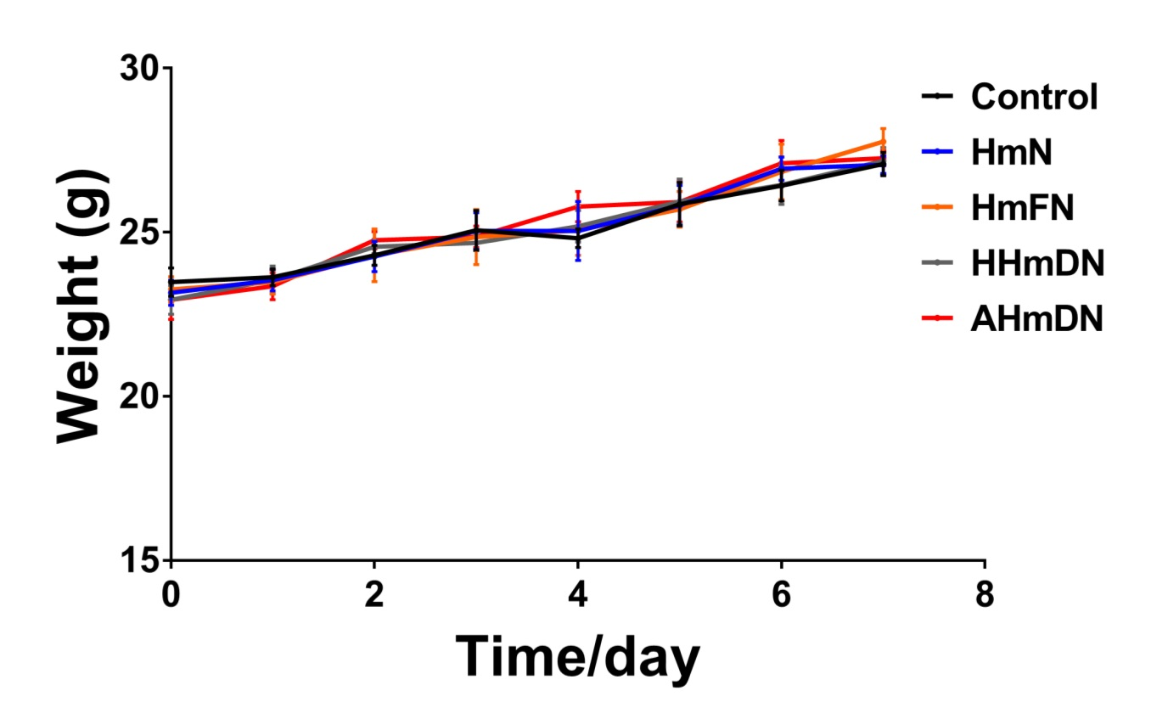
Figure S7 The weight change of mice during the process of treatment. The weight of all the mice in treatment group showed a steady growth trend and there was no significant difference between HmN, HmDN, HHmDN and AHmDN groups.
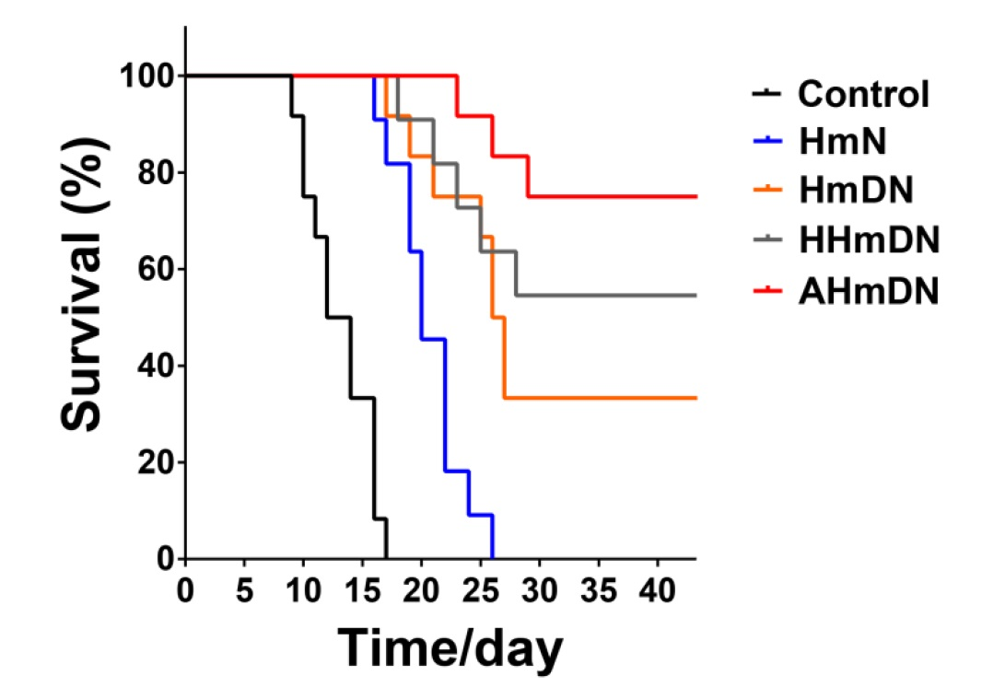
Figure S8 Survival curves of mice bearing H22 tumors after the injection with HmN, HmDN, HHmDN or AHmDN. Through the treatment of 7 days (daily illumination at the light dose 50J/cm²), the survival rate was significantly enhanced and AHmDN showed the best therapeutic effect than HmN, HmDN or HHmDN.
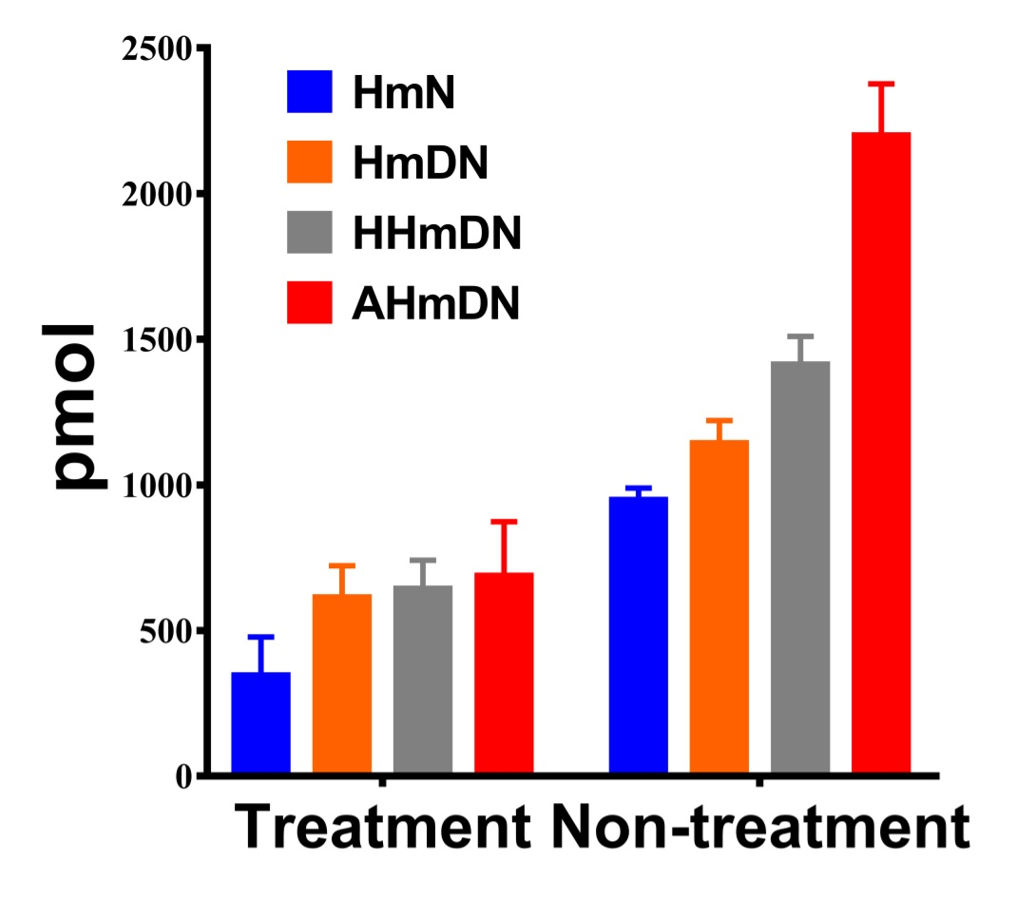
Figure S9 The quantitative analysis of mPPZ at tumor site of mice with or without PDT. After the injection with HmN, HmDN, HHmDN or AHmDN at the dose of mPPZ 0.2μmol/kg, the mice were treated with PDT by daily illumination (50 J/cm²) while other mice in non-treatment group were raised in darkroom. After 7 days, the mPPZ content in treatment group at tumor site was about 2-3 fold lower than non-treatment group suggesting the depletion of mPPZ in the course of PDT.

