Supplementary materials
Exercise Protocol. Patients in the transcutaneous neuromuscular electrical stimulation group (NMES; n = 13) performed a NMES protocol delivered using a hand-held, battery powered device (Empi 300PV, Minnesota, USA) linked to two skin surface gel electrodes (7 x 4 cm). The negative electrode was positioned proximal to the patella so as to cover the motor points of the vastus lateralis and vastus medialis muscles with the positive electrode placed longitudinally over the rectus femoris motor point. The 30 min stimulation protocol consisted of repetitions of 15 s stimulation (including 2 s ramp-up and 2 s ramp-down of current) and 5 s rest. Stimulation was a biphasic pulse at 50 Hz with a pulse duration of 300 µs. During stimulation patients were seated with knees extended and supported on a physiotherapists couch.
RNA Extraction. Previously frozen muscle samples were homogenised in TRI Reagent Solution (Applied Biosystems / Life Technologies, Paisley, UK). Chloroform was used to separate the homogenate into aqueous-, inter- and organic-phases. RNA was precipitated from the aqueous phase with isopropanol, the resulting pellet washed in ethanol and then re-suspended in nuclease free water.
Extracted RNA was quantified according to its absorbance of 260nm light (Nanodrop 2000 Spectrophotometer, Thermoscientific, Waltham, MA, USA) before reverse transcription to cDNA. One micro-gram of RNA per sample was incubated with random hexamer primers, dNTPs (deoxynucleotide triphosphates) and reverse transcriptase (SuperScript III, Life Technologies / Invitrogen) in order to synthesise complimentary DNA.
Change in abundance of mRNA is expressed using the widely accepted ΔΔCT method ( Livak & Schmittgen, Methods; 2001). In this term, the first Δ refers to the relative difference between target and housekeeping gene within a sample (ΔCT), the second Δ refers to the relative difference between ΔCT in the baseline and 24 hr samples. The value of ΔΔCT equates to fold change from baseline in the target gene.
Table S1. Transcript name abbreviations
Abbreviation | Transcript name
AQP4 | aquaporin 4
ASPA | aspartoacylase
ATP2B2 | ATPase, Ca++ transporting, plasma membrane 2
ATP5G3 | ATP synthase, H+ transporting, mitochondrial Fo complex, subunit C3 (subunit 9)
BCHE | butyrylcholinesterase
CCL19 | chemokine (C-C motif) ligand 19
CCNG1 | cyclin G1
CCNG2 | cyclin G2
CD38 | CD38 molecule
CDK2 | cyclin-dependent kinase 2
CDKN2C | cyclin-dependent kinase inhibitor 2C (p18, inhibits CDK4)
CES2 | carboxylesterase 2
CHI3L1 | chitinase 3-like 1 (cartilage glycoprotein-39)
CLCN1 | chloride channel, voltage-sensitive 1
CSDE1 | cold shock domain containing E1, RNA-binding
CTSL | cathepsin L
CYBA | cytochrome b-245, alpha polypeptide
DYSF | dysferlin
EIF2B4 | eukaryotic translation initiation factor 2B, subunit 4 delta, 67kDa
EIF4H | eukaryotic translation initiation factor 4H
ETFB | electron-transfer-flavoprotein, beta polypeptide
FADS3 | fatty acid desaturase 3
FANCA | Fanconi anemia, complementation group A
FOS | FBJ murine osteosarcoma viral oncogene homolog
GLRX2 | glutaredoxin 2
HSPA5 | heat shock 70kDa protein 5 (glucose-regulated protein, 78kDa)
IL10 | interleukin 10
IL6 | interleukin 6
IRS1 | insulin receptor substrate 1
ITGB6 | integrin, beta 6
JUN | jun proto-oncogene
LTC4S | leukotriene C4 synthase
MDH1 | malate dehydrogenase 1, NAD (soluble)
MFAP4 | microfibrillar-associated protein 4
MGST2 | microsomal glutathione S-transferase 2
MN1 | meningioma (disrupted in balanced translocation) 1
MSTN | myostatin
MYC | v-myc avian myelocytomatosis viral oncogene homolog
MYLPF | myosin light chain, phosphorylatable, fast skeletal muscle
NDUFS3 | NADH dehydrogenase (ubiquinone) Fe-S protein 3, 30kDa (NADH-coenzyme Q reductase)
NFKB1 | nuclear factor of kappa light polypeptide gene enhancer in B-cells 1
NPY6R | neuropeptide Y receptor Y6 (pseudogene)
OSTM1 | osteopetrosis associated transmembrane protein 1
P2RX5 | purinergic receptor P2X, ligand gated ion channel, 5
PCCB | propionyl CoA carboxylase, beta polypeptide
PLA2G4C | phospholipase A2, group IVC (cytosolic, calcium-independent)
PPARD | peroxisome proliferator-activated receptor delta
PPIA | peptidylprolyl isomerase A (cyclophilin A)
PXMP4 | peroxisomal membrane protein 4, 24kDa
RASGRP3 | RAS guanyl releasing protein 3 (calcium and DAG-regulated)
RELA | v-rel avian reticuloendotheliosis viral oncogene homolog A
RELB | v-rel avian reticuloendotheliosis viral oncogene homolog B
RRAD | Ras-related associated with diabetes
RUNX1 | runt related transcription factor 1
SERPINB1 | serpin peptidase inhibitor, clade B (ovalbumin), member 1
SIRT2 | sirtuin 2
SLC25A11 | solute carrier family 25 (mitochondrial carrier; oxoglutarate carrier), member 11
SLC25A12 | solute carrier family 25 (aspartate/glutamate carrier), member 12
SLC25A36 | solute carrier family 25 (pyrimidine nucleotide carrier), member 36
SOAT1 | sterol O-acyltransferase 1
SOD2 | superoxide dismutase 2, mitochondrial
SORCS1 | sortilin-related VPS10 domain containing receptor 1
SPAG7 | sperm associated antigen 7
TIMP1 | TIMP metallopeptidase inhibitor 1
TNFRSF11A | tumor necrosis factor receptor superfamily, member 11a, NFKB activator
TP53 | tumor protein p53
TPM1 | tropomyosin 1 (alpha)
UCRC | ubiquinol-cytochrome c reductase, complex III subunit X
UQCRC1 | ubiquinol-cytochrome c reductase core protein I
UQCRFS1 | ubiquinol-cytochrome c reductase, Rieske iron-sulfur polypeptide 1
VDAC3 | voltage-dependent anion channel 3
YWHAZ | tyrosine 3-monooxygenase/tryptophan 5-monooxygenase activation protein, zeta

Results.
In order to further investigate the function of the 14 genes commonly regulated by both RE and NMES, targets and expression values were interrogated using Ingenuity Pathway Analysis (IPA; QIAGEN Redwood City, USA www.qiagen.com/ingenuity).
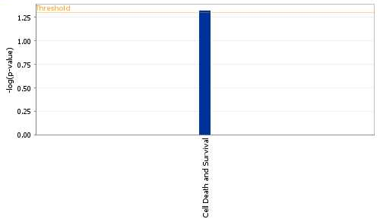
Figure S1. Probability of influence on the cellular function (Cell Death and Survival) identified by IPA.

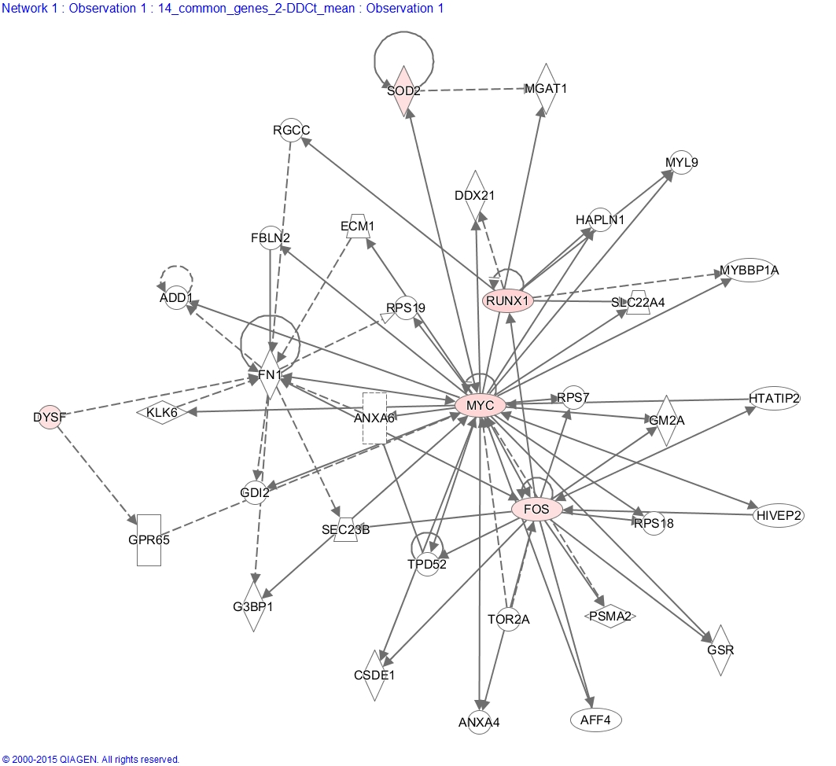
Figure S2. Network of gene interactions within the Cell Death and Survival function. Targets coloured pink were significantly changed in abundance following both RE and NMES.

Table S2. Mean Fold Change (2^-DDCt) between baseline and sample obtained 24 h after either resistance exercise (RE) or transcutaneous neuromuscular electrical stimulation (NMES).

RE
Gene | Mean 2^-DD Ct
NFKBIA | 0.97
RELA | 1.95
TP53 | 2.40
MYC | 11.55
CFLAR | 0.68
E2F1 | 1.57
ACTN3 | 6.16
SLC25A4 | 0.71
DAXX | 1.55
DECR1 | 0.76
FLNC | 1.76
HSPB2 | 1.31
IL18 | 0.81
ACAA1 | 0.83
APOA2 | Undetected
APOC1 | 1.38
BPGM | 1.09
CAST | 1.72
DCI | 1.11
FLII | 0.93
GLP1R | 0.09
GOT1 | 0.89
GPX4 | 0.89
KCNN3 | 2.44
KCNN4 | 6.13
LAMB1 | 1.43
MN1 | 0.58
MYOD1 | 1.53
NDUFB5 | 0.79
NDUFC1 | 0.70
NDUFS8 | 0.88
PGM1 | 0.51
PSMB10 | 1.43
PSMD3 | 1.06
PTPN3 | 0.98
ST3GAL1 | 0.81
SOAT1 | 2.51
TFR2 | 1.45
UQCRC1 | 0.69
ASPA | 0.51
GAMT | 0.62
NCF1C;NCF1;NCF1B | 2.51
PGAM2 | 0.65
TPM1 | 0.66
PCCB | 0.69
RYR1 | 0.66
SOD2 | 3.62
ACACA | 2.06
HPGD | 1.34
ITGB6 | 0.55
LTC4S | 0.59
INSR | 0.79
CDH13 | 0.76
DPT | 0.72
FOS | 8.72
CCL22 | 4.71
CCNG1 | 0.70
CCNG2 | 0.58
CCL19 | 21.65
TIMP1 | 11.17
MRAS | 1.97
MGMT | 0.90
ENDOG | 0.84
BRCA1 | 1.07
ANKRD1 | 8.77
IL10 | 17.10
IL1A | 1.00
TNF | 4.43
IL6 | 51.26
ITGA7 | 0.79
NFKB2 | 2.11
AK1 | 0.75
CDKN2C | 0.65
CKMT2 | 0.97
PDK2 | 0.67
PDK4 | 2.73
PI4KAP2;PI4KA;PI4KAP1 | 1.08
MAP2K3 | 1.40
SQSTM1 | 1.07
AKT1 | 1.45
IRS1 | 0.51
MAP3K12 | 1.32
FASTK | 11.90
CHRNE | 1.88
FASLG | 1.90
CHRNB1 | 0.75
CHRND | 2.71
MGST2 | 0.72
SRF | 1.04
ATP5D | 0.85
IRF7 | 0.16
MFAP5 | 1.00
ACOX2 | 1.26
SLC25A11 | 0.65
SLC25A12 | 0.65
TNFRSF11A | 5.01
CES2 | 2.47
MYOM2 | 0.75
EIF2S1 | 1.65
RRAD | 11.29
SDHA | 0.67
BAD | 38.13
CLCN2 | 1.72
CHKB;CPT1B | 0.63
CTSH | 0.96
FHL3 | 0.57
NDUFA10 | 0.83
NDUFS3 | 0.84
POLR1C | 2.18
SPAG7 | 0.75
MYBPH | 5.29
NDUFS1 | 0.75
RPL3L | 0.55
GNG7 | 0.67
COX6A2 | 0.66
MSTN | 0.39
GRB10 | 1.44
MAF | 0.67
PDLIM7 | 0.78
ARPC4 | 1.81
PPIF | 1.67
FARP1 | 1.68
MDH1 | 0.67
S100A13 | 1.05
CCT3 | 1.50
AKR1A1 | 1.47
PECI | 0.72
GMPR | 0.66
UPK3A | 0.54
ADRM1 | 1.13
RPP14 | 1.83
NDUFV1 | 0.79
CSDE1 | 0.74
ADAT1 | 1.28
CA14 | 1.05
GRHPR | 0.77
MORF4L2 | 1.96
ICMT | 3.17
MYLPF | 0.57
UCRC | 0.75
OSTM1 | 1.59
BZW2 | 1.06
PKD2L2 | Undetected
ZNF330 | 1.07
CDC42BPA | 1.20
RASGRP3 | 0.61
NPDC1 | 1.34
GSTK1 | 0.87
CYLD | 1.53
MRPS33 | 0.81
BRP44L | 1.63
PPME1 | 0.92
HP1BP3 | 0.93
SLC25A36 | 0.62
ZC3H15 | 1.37
ZMAT5 | 0.71
TNXB | Undetected
NT5M | 1.28
ANK1 | 2.37
NDUFV2 | 0.87
XRCC5 | 1.23
RRAGD | 0.90
FADS3 | 3.36
SIGIRR | 1.55
UCP1 | Undetected
TSPYL2 | 2.34
GNB1L | 1.08
UBE2Z | 1.75
PSTPIP2 | 1.22
CARS2 | 1.23
VCPIP1 | 1.06
SERPINB1 | 13.35
MRPS15 | 0.82
RUNX1 | 12.59
LMO1 | 0.91
MEF2C | 0.64
MYOG | 0.92
SMARCA4 | 1.76
CNBP | 0.80
RUNX3 | 2.39
CREB1 | 1.09
PPARA | 0.71
RELB | 4.36
IL12B | Undetected
PLA2G4C | 0.59
MMP2 | 1.02
DAPK1 | 3.52
FRAP1 | 1.01
YWHAZ | 3.01
ACTN1 | 2.33
ANXA6 | 1.04
AQP4 | 0.42
CBFB | 2.60
MRPL12 | 1.11
DYSF | 4.18
ACCN3 | 0.81
NDUFA9 | 0.70
NPY6R | 0.50
SIRT2 | 0.67
TOR1B | 1.60
EIF2B4 | 1.74
ABR | 2.87
EIF4H | 3.14
GNRHR2;RBM8A | 1.03
OLFM1 | 1.56
FARS2 | 1.11
RABL2A;RABL2B | 2.00
WBP11 | 1.10
NDUFS7 | 1.36
SLC37A4 | 1.27
TRIM63 | 2.56
MYL3 | 0.64
DNAJA1 | 1.53
ATP5G3 | 0.79
COX6B1 | 0.81
PRKAR1A | 1.50
SMARCC1 | 1.74
TBCC | 0.98
TNNI2 | 0.75
PKP4 | 1.25
IDH1 | 0.74
PRMT5 | 1.56
CCT4 | 1.26
MRCL3 | 0.89
ATP5I | 1.16
DNAJB5 | Undetected
RPS27L | 2.04
TPRKB | 1.10
GSK3B | 1.19
SIVA1 | 0.79
CCND1 | 1.12
CD38 | 0.61
JUN | 0.64
C22orf9 | 1.26
LGALS1 | 1.08
INS | Undetected
ALDH2 | 0.72
SFN | Undetected
HSPB1 | 0.89
CYC1 | 0.73
FNTA | 1.39
NOL3 | 0.81
SLC16A3 | 1.02
DEXI | 0.88
SORCS1 | 0.51
MYL1 | 0.66
TCAP | 0.60
VDAC3 | 0.69
ARS2 | 1.66
PACSIN3 | 0.74
FBXO32 | 1.05
COX7B | 0.79
GLRX2 | 1.47
SYNGR1 | 0.78
CTSL1 | 5.35
TBC1D22A | 1.19
KIAA0368 | 0.95
DYNC1H1 | 0.87
CTNNA3 | 0.80
PREPL | 1.77
OSBP | 0.88
PSME1 | 1.07
LRP4 | 1.28
CCPG1 | 1.09
IKBKB | 1.36
LIAS | 0.91
MFAP4 | 0.53
AKR1C2;AKR1C1 | 1.03
CDC2L1;CDC2L2 | 1.02
CALCOCO2 | 1.22
ADK | 1.00
CLIP1 | 0.66
ACO2 | 0.94
CTSL2 | Undetected
ATP5O | 0.75
COX5B | 0.75
PSMB1 | 1.13
PSMD7 | 1.18
SFRS2 | 6.11
FBP2 | 0.74
NDUFB8 | 0.84
RTN3 | 12.97
MAN2C1 | 1.06
TXN2 | 0.83
ARTS | 1.52
P2RX5 | 4.20
MARS2 | 1.48
FADD | 2.59
CAPN3 | 0.77
ACTA1 | 0.75
ANXA7 | 1.00
UQCRB | 0.75
CHAF1B | 0.67
PRDX1 | 1.09
PPARD | 2.48
PPP2R4 | 1.25
GPSN2 | 0.73
ALDOA | 0.78
RPL38 | 0.92
EIF4EBP1 | 1.02
CDK2 | 3.08
CYBA | 2.06
HMBS | 1.00
CHI3L1 | 59.28
AARS | 1.04
KALRN | 1.37
DLG5 | 2.32
MLL | 0.96
UQCRFS1 | 0.71
TOX4 | 1.18
CCR10 | 1.06
CDK2AP2 | 2.26
ANP32B | 1.35
NAP1L1 | 1.20
PRPS1 | 1.29
MYH4 | 3.60
PKM2 | 1.06
NFKB1 | 1.62
EIF3K | 0.87
FOXO3 | 0.87
NSFL1C | 1.02
ZFAND5 | 1.79
ATP5G1 | 1.02
EIF2S2 | Undetected
PLA2G12A | 2.15
MKRN1 | 1.09
SYNGR2 | 1.82
LDHA | 1.51
POLRMT | 2.90
GPC1 | 0.88
CLCN1 | 0.50
LARGE | 2.04
GBP2 | 1.89
DLAT | 0.75
MAPT | 0.81
ATF4 | 1.30
SOCS2 | 2.44
SVIL | 0.61
MDH2 | 2.05
CTSB | 2.14
ADARB1 | 0.76
REL | 1.13
DUSP13 | 0.71
ATP5B | 0.80
COX4I1 | 0.81
GPI | 1.01
AMPD3 | 2.92
PYGM | 0.66
BCHE | 0.45
UQCRC2 | 0.76
VCP | 1.13
COL4A1 | 2.47
PMVK | 2.33
CASP10 | 1.19
KCNN2 | 1.67
HSPA1B | 1.63
FOXO1 | 0.80
IKBKE | 3.82
RXRA | 0.84
HRASLS | 0.82
ETFB | 0.69
ATP2B2 | 0.38
RUVBL2 | 1.09
ATP2A1 | 0.53
RFX2 | 2.13
DGKD | 2.69
FANCA | 5.81
TRIB2 | 1.44
PSAP | 1.01
DBI | 1.02
PXMP4 | 0.74
TPI1 | 0.83
COX7C | 1.68
LOC654007;EEF1G | 0.79
PSME2 | 1.94
CDC2L2 | 2.15
HSPA5 | 3.17
PPIA | 3.87
HPRT1 | 1.80
TGFB1 | 1.76

NMES
Detector | Mean Fold Change (2^-DDCt)
NFKBIA | 1.09
RELA | 3.13
TP53 | 4.42
MYC | 10.35
CFLAR | 0.77
E2F1 | 1.11
ACTN3 | 0.94
SLC25A4 | 0.62
DAXX | 1.75
DECR1 | 0.79
18S | 0.75
18S | 0.79
FLNC | 2.65
HSPB2 | 0.74
IL18 | 0.75
ACAA1 | 0.80
APOA2 | Undetected
APOC1 | 1.39
BPGM | 1.07
CAST | 1.99
ECI1 | 0.98
FLII | 1.23
GLP1R | Undetected
GOT1 | 0.79
GPX4 | 0.87
KCNN3 | 4.83
KCNN4 | 4.00
LAMB1 | 1.30
MN1 | 0.43
MYOD1 | 1.36
NDUFB5 | 0.75
NDUFC1 | 0.74
NDUFS8 | 0.94
PGM1 | 0.74
18S | 0.84
18S | 0.83
PSMB10 | 0.91
PSMD3 | 1.53
PTPN3 | 1.38
ST3GAL1 | 0.89
SOAT1 | 3.05
TFR2 | 1.00
UQCRC1 | 0.62
ASPA | 0.64
GAMT | 0.70
NCF1C;NCF1B;NCF1 | 1.81
PGAM2 | 0.73
TPM1 | 0.61
PCCB | 0.72
RYR1 | 0.94
SERPINE1 | 15.74
SOD2 | 3.64
ACACA | 2.55
HPGD | 1.21
ITGB6 | 0.69
LTC4S | 0.46
INSR | 1.20
CDH13 | 1.09
DPT | 0.53
FOS | 17.63
CCL22 | 12.94
CCNG1 | 0.88
CCNG2 | 0.53
CCL19 | 9.76
TIMP1 | 16.67
MRAS | 2.60
MGMT | 0.84
ENDOG | 0.83
BRCA1 | 0.78
ANKRD1 | 7.22
IL10 | 5.20
IL1A | 2.03
TNF | 3.01
IL6 | 25.79
ITGA7 | 0.89
NFKB2 | 2.54
AK1 | 0.76
CDKN2C | 0.77
CKMT2 | 0.92
PDK2 | 0.84
PDK4 | 3.12
PI4KA;PI4KAP1;PI4KAP2 | 1.40
MAP2K3 | 1.37
SQSTM1 | 1.29
AKT1 | 1.42
IRS1 | 0.63
MAP3K12 | 1.18
FASTK | 1.27
CHRNE | 1.09
FASLG | 2.29
CHRNB1 | 0.98
CHRND | 4.13
MGST2 | 0.82
SRF | 1.42
ATP5D | 0.68
IRF7 | 2.09
MFAP5 | 0.75
ACOX2 | 0.63
SLC25A11 | 0.71
SLC25A12 | 0.74
TNFRSF11A | 5.92
CES2 | 4.91
MYOM2 | 0.88
EIF2S1 | 1.77
RRAD | 10.29
SDHA | 0.82
BAD | 1.08
CLCN2 | 0.83
CPT1B;CHKB | 0.80
CTSH | 1.08
FHL3 | 0.84
NDUFA10 | 0.76
NDUFS3 | 0.64
POLR1C | 2.70
SPAG7 | 0.96
MYBPH | 10.83
NDUFS1 | 0.82
RPL3L | 0.71
GNG7 | 0.75
COX6A2 | 0.92
MSTN | 0.53
GRB10 | 1.73
MAF | 0.79
PDLIM7 | 0.98
ARPC4 | 1.85
PPIF | 1.76
FARP1 | 2.10
MDH1 | 0.87
S100A13 | 1.53
CCT3 | 1.74
AKR1A1 | 1.30
ECI2 | 0.93
GMPR | 0.78
UPK3A | 0.78
ADRM1 | 1.19
RPP14 | 1.51
NDUFV1 | 0.79
CSDE1 | 1.06
ADAT1 | 1.49
CA14 | 0.58
GRHPR | 0.71
MORF4L2 | 3.97
ICMT | 3.36
MYLPF | 0.62
UQCR10 | 0.86
OSTM1 | 1.41
BZW2 | 1.41
PKD2L2 | Undetected
ZNF330 | 1.57
CDC42BPA | 1.06
RASGRP3 | 0.62
NPDC1 | 4.29
GSTK1 | 0.85
CYLD | 1.54
MRPS33 | 0.68
MPC1 | 1.11
PPME1 | 1.07
HP1BP3 | 1.05
SLC25A36 | 0.85
ZC3H15 | 1.90
ZMAT5 | 0.86
 | Undetected
NT5M | 1.08
ANK1 | 2.84
NDUFV2 | 1.14
XRCC5 | 1.37
RRAGD | 1.41
FADS3 | 3.68
SIGIRR | 1.04
UCP1 | Undetected
TSPYL2 | 1.00
GNB1L | 1.44
UBE2Z | 1.72
PSTPIP2 | 1.26
CARS2 | 1.03
VCPIP1 | 2.20
MRPS15 | 0.89
RUNX1 | 15.74
LMO1 | 1.37
MEF2C | 0.85
MYOG | 1.66
SMARCA4 | 2.21
CNBP | 1.01
RUNX3 | 3.49
CREB1 | 1.11
PPARA | 0.73
RELB | 5.84
IL12B | Undetected
PLA2G4C | 0.65
MMP2 | 0.99
DAPK1 | 1.51
MTOR | 1.21
YWHAZ | 5.03
ACTN1 | 1.70
ANXA6 | 1.05
AQP4 | 0.42
CBFB | 2.77
MRPL12 | 1.26
DYSF | 6.19
ASIC3 | 1.06
NDUFA9 | 1.02
NPY6R | 0.67
SIRT2 | 2.89
TOR1B | 1.83
EIF2B4 | 2.10
ABR | 1.48
EIF4H | 3.21
GNRHR2;RBM8A | 1.03
OLFM1 | 1.37
FARS2 | 0.99
RABL2B;RABL2A | 2.04
WBP11 | 1.43
NDUFS7 | 0.73
SLC37A4 | 0.63
TRIM63 | 2.88
MYL3 | 1.55
DNAJA1 | 1.53
ATP5G3 | 0.64
COX6B1 | 1.02
PRKAR1A | 1.64
SMARCC1 | 1.76
TBCC | 0.87
TNNI2 | 0.91
PKP4 | 1.33
IDH1 | 0.83
PRMT5 | 1.88
CCT4 | 1.57
MYL12A | 1.28
ATP5I | 0.75
DNAJB5 | 4.09
TPRKB | 1.17
GSK3B | 1.25
SIVA1 | 1.00
CCND1 | 1.25
CD38 | 0.62
JUN | 1.07
KIAA0930 | 1.31
LGALS1 | 0.90
INS | Undetected
ALDH2 | 0.68
 | Undetected
HSPB1 | 1.22
CYC1 | 0.86
FNTA | 2.10
NOL3 | 0.83
SLC16A3 | 0.72
DEXI | 1.02
SORCS1 | 0.85
MYL1 | 0.84
TCAP | 1.01
VDAC3 | 1.18
SRRT | 2.22
PACSIN3 | 0.80
FBXO32 | 0.87
COX7B | 1.20
GLRX2 | 1.38
SYNGR1 | 0.79
CTSL | 5.23
TBC1D22A | 1.32
KIAA0368 | 1.10
DYNC1H1 | 0.88
CTNNA3 | 0.62
PREPL | 1.73
OSBP | 1.08
PSME1 | 1.41
LRP4 | 0.79
DYX1C1 | 1.14
IKBKB | 1.64
LIAS | 0.86
MFAP4 | 0.59
AKR1C2;AKR1C1 | 1.15
CDK11B;CDK11A | 1.17
CALCOCO2 | 0.80
ADK | 1.39
CLIP1 | 0.99
ACO2 | 0.84
CTSV | Undetected
ATP5O | 0.85
COX5B | 0.90
PSMB1 | 1.48
PSMD7 | 1.28
SRSF2 | 2.27
FBP2 | 0.59
NDUFB8 | 0.81
RTN3 | 1.14
MAN2C1 | 1.13
TXN2 | 0.79
ERAP1 | 1.16
P2RX5;P2RX5 | 4.94
MARS2 | 1.82
FADD | 1.81
CAPN3 | 1.09
ACTA1 | 1.11
ANXA7 | 1.20
UQCRB | 0.85
CHAF1B | 0.96
PRDX1 | 1.29
PPARD | 2.29
PPP2R4 | 1.19
TECR | 0.73
ALDOA | 0.79
RPL38 | 1.06
EIF4EBP1 | 1.06
CDK2 | 3.19
CYBA | 1.51
HMBS | 1.00
CHI3L1 | 84.44
AARS | 1.13
KALRN | 1.60
DLG5 | 2.65
KMT2A | 1.26
UQCRFS1 | 0.67
TOX4 | 1.33
CCR10 | 1.52
CDK2AP2 | 2.71
ANP32B | 1.81
NAP1L1 | 1.51
PRPS1 | 1.84
MYH4 | 0.69
PKM | 1.06
NFKB1 | 1.79
EIF3K | 1.35
FOXO3 | 1.18
NSFL1C | 1.13
ZFAND5 | 2.24
ATP5G1 | 0.89
EIF2S2 | Undetected
PLA2G12A | 0.76
MKRN1 | 1.35
SYNGR2 | 1.77
LDHA | 1.66
POLRMT | 1.07
GPC1 | 1.12
CLCN1 | 0.62
LARGE | 1.31
GBP2 | 1.91
DLAT | 0.93
MAPT | 0.80
ATF4 | 1.49
SOCS2 | 2.15
SVIL | 0.73
MDH2 | 1.34
CTSB | 3.26
ADARB1 | 0.70
REL | 2.07
DUSP13 | 0.80
ATP5B | 1.35
COX4I1 | 0.93
GPI | 1.02
AMPD3 | 5.57
PYGM | 0.64
BCHE | 0.69
UQCRC2 | 0.83
VCP | 1.40
COL4A1 | 2.41
PMVK | 0.75
CASP10 | 1.11
KCNN2 | 0.71
HSPA1B | 2.33
FOXO1 | 0.79
IKBKE | 2.08
RXRA | 0.78
HRASLS | 0.83
ETFB | 0.72
ATP2B2 | 0.37
RUVBL2 | 1.57
ATP2A1 | 0.51
RFX2 | 1.28
DGKD | 3.06
FANCA | 3.49
TRIB2 | 1.32
PSAP | 1.03
DBI | 1.37
PXMP4 | 0.75
TPI1 | 0.84
COX7C | 0.99
RPL12 | 1.27
EEF1G | 0.92
PSME2 | 1.34
CDK11B;CDK11A | 1.39
HSPA5 | 3.72
PPIA | 4.11
HPRT1 | 2.62
TGFB1 | 2.59

