Supplementary information
Results
- Frequency of genotypes with clinical findings
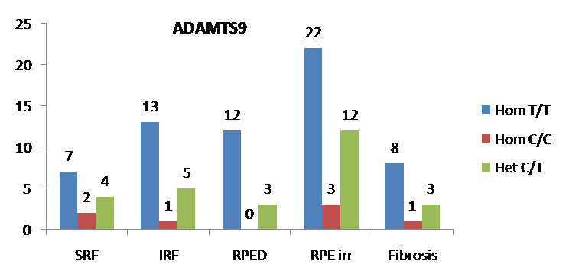
Fig S1. Showing association of ADAMTS9 genotypes in different clinical findings. X-axis represents clinical findings y axis represents number of individuals. Blue bar represents Hom T/T Genotype, Red bar represents Hom C/C and green bar represent Het C/T genotype respectively Statistical analysis was done by SPSS’s Pearson’s Chi Square test, (p≤0.05) was considered statistically significant.
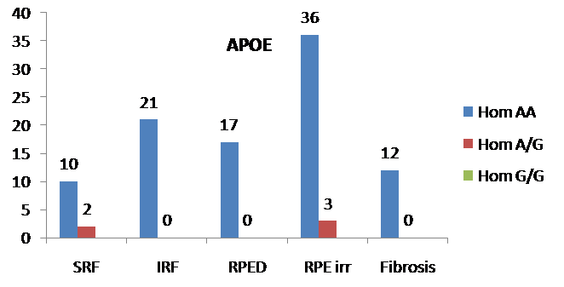
Fig S2. Showing Association of APOE genotypes in different clinical findings. X-axis represents clinical findings and y axis represents number of individuals. Blue bar represents Hom AA Genotype and Red bar represents Hom A/G genotype and green bar represents G/G genotype respectively. Statistical analysis was done by SPSS’s Pearson’s Chi Square test, (p≤0.05) was considered statistically significant.
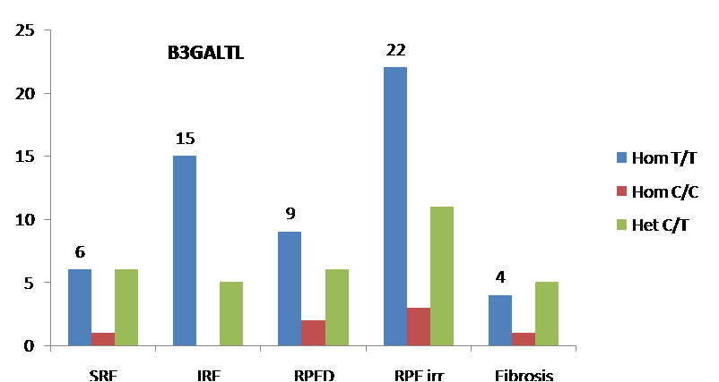
Fig S3. Showing Association of B3GALTL genotypes in different clinical findings. X-axis represents clinical findings and y axis represents number of individuals. Blue bar represents Hom T/T Genotype, Red bar represents Hom C/C and green bar represent Het C/T genotype respectively Statistical analysis was done by SPSS’s Pearson’s Chi Square test, (p≤0.05) was considered statistically significant
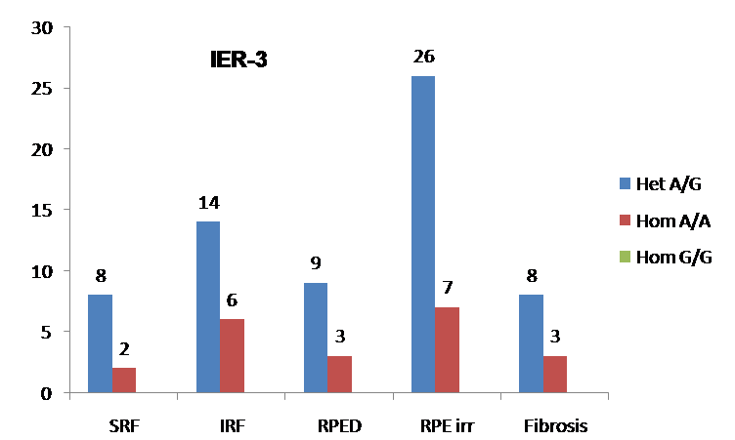
Fig S4. IER-3 genotypes in different clinical findings. X-axis represents clinical findings and y axis represents number of individuals. Blue bar represents Het A/G Genotype, Red bar represents Hom A/A and green bar represent Het G/G genotype respectively Statistical analysis was done by SPSS’s Pearson’s Chi Square test, (p≤0.05) was considered statistically significant.
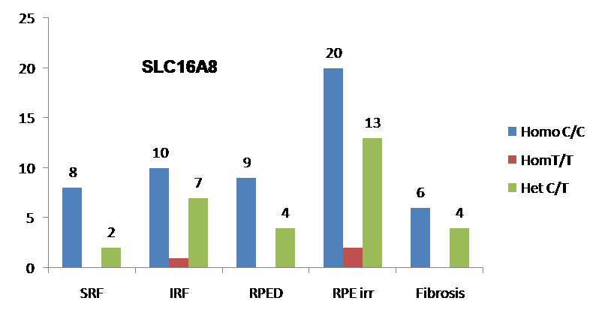
Fig. S5. SLC16A8 genotypes in different clinical findings. X axis represents clinical findings Blue bar represents Hom C/C Genotype, Red bar represents Hom T/T and green bar represent Het C/T genotype respectively Statistical analysis was done by SPSS’s Pearson’s Chi Square test, (p≤0.05) was considered statistically significant.

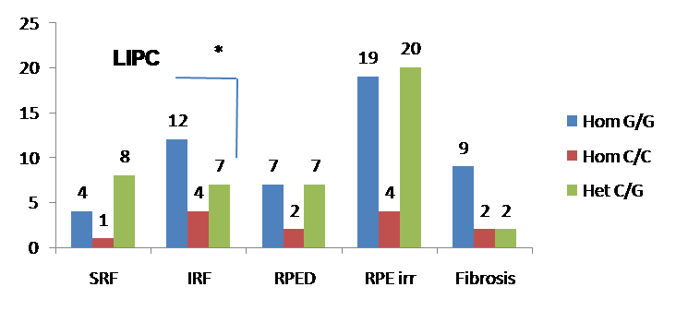
Fig. S6. LIPC genotypes in different clinical findings. X axis represents clinical findings and y axis represents number of individuals. Blue bar represents Hom G/G Genotype, Red bar represents Hom C/C and green bar represent Het C/G genotype respectively. Statistical analysis was done by SPSS’s Pearson’s Chi Square test, (p≤0.05) was considered statistically significant
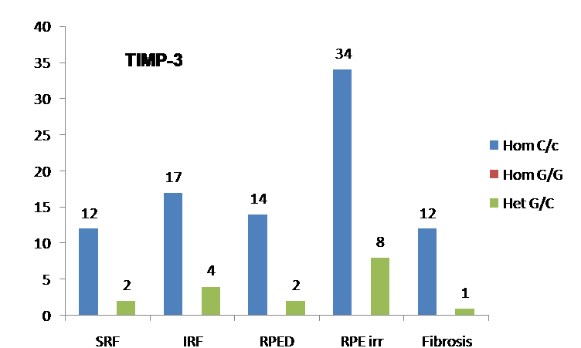
Fig.S 7: TIMP3 genotypes in different clinical findings. X-axis represents clinical findings and y axis represents number of individuals. Blue bar represents Hom C/C Genotype, Red bar represents Hom G/G and green bar represent Het G/C genotype respectively. Statistical analysis was done by SPSS’s Pearson’s Chi Square test, (p≤0.05) was considered statistically significant.
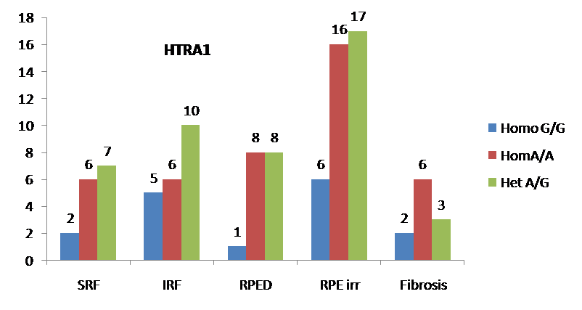
Fig. S8. HTRA 1 genotypes in different clinical findings. X-axis represents clinical findings and y axis represents number of individuals. Blue bar represents Hom G/G Genotype, Red bar represents Hom A/A and green bar represent Het A/G genotype respectively. Statistical analysis was done by SPSS’s Pearson’s Chi Square test, (p≤0.05) was considered statistically significant
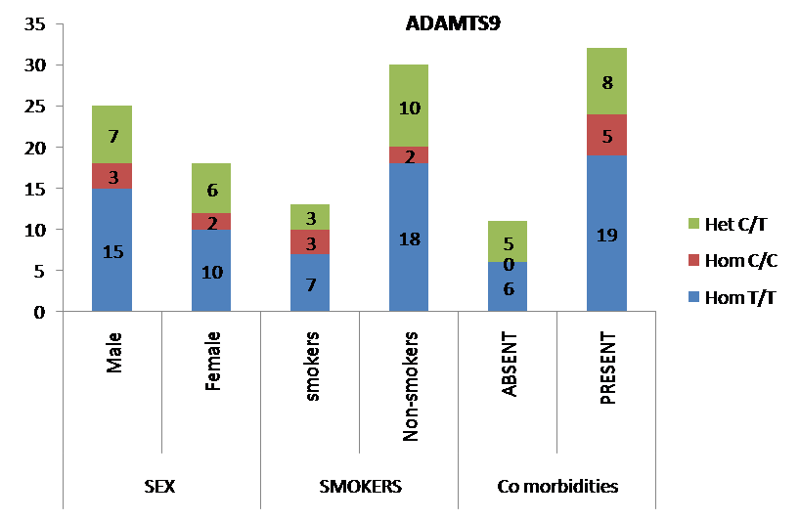
Fig S 9: ADAMTS9 genotypes with socio-demographic variables. X-axis represents sociodemographic variables and y axis represents number of individuals .Green bar represents Het C/T red represents Hom C/C and Blue bar represents Hom T/T genotype respectively. Statistical analysis was done by SPSS’s Pearson’s Chi Square test, (p≤0.05) was considered statistically significant
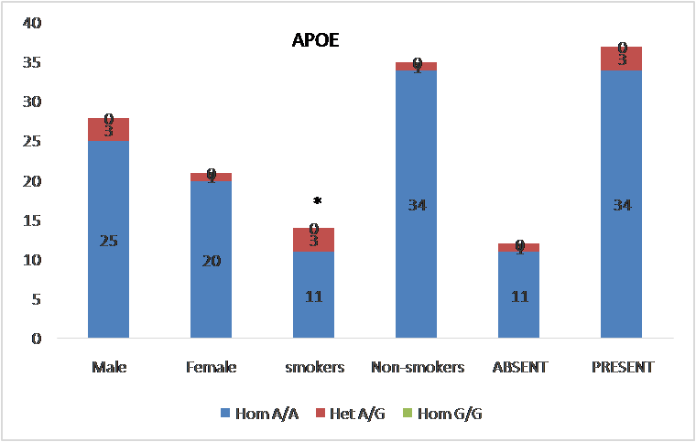
Fig S10: APOE genotypes with sociodemographic variables. X-axis represents sociodemographic variables and y axis represents number of individuals. Green bar represents Hom G/G red bar represents Het A/G , and Blue bar represents Hom A/A genotype respectively. Statistical analysis was done by SPSS’s Pearson’s Chi Square test, (p≤0.05) was considered statistically significant.
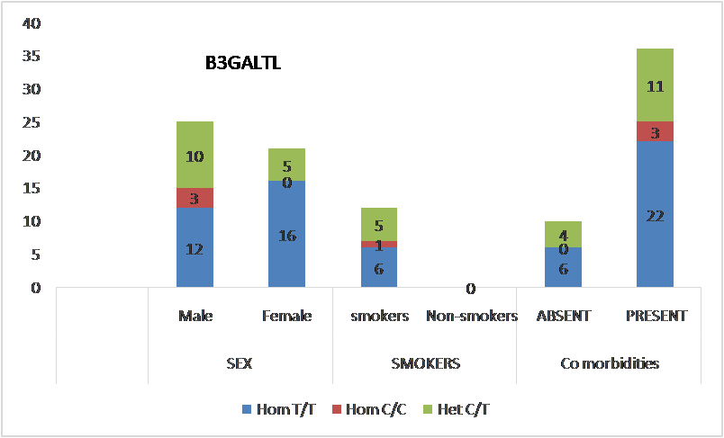
Fig S11: B3GALTL genotypes with sociodemographic variables. x axis represents sociodemographic variables and y axis represents number of individuals. Green bar represents Het C/T red bar represents Hom C/C , and Blue bar represents Hom T/T genotype respectively. Statistical analysis was done by SPSS’s Pearson’s Chi Square test, (p≤0.05) was considered statistically significant.
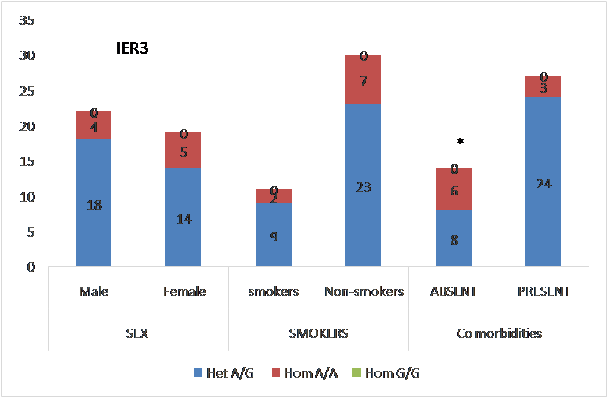
Fig S12 :Association of IER-3 genotypes with sociodemographic variables. X-axis represents sociodemographic variables and y axis represents number of individuals. Green bar represents Hom G/G red bar represents Hom A/A , and Blue bar represents Hom A/G genotype respectively. Statistical analysis was done by SPSS’s Pearson’s Chi Square test, (p≤0.05) was considered statistically significant.
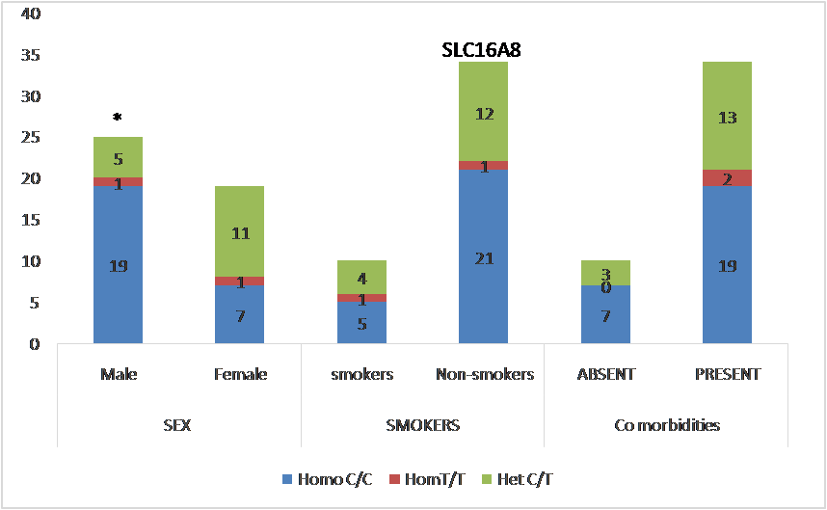
Fig S13: Association of SLC16A8 genotypes with sociodemographic variables. X-axis represents sociodemographic variables and y axis represents number of individuals. Green bar represents Het C/T red bar represents Hom T/T , and Blue bar represents Hom C/C genotype respectively. Statistical analysis was done by SPSS’s Pearson’s Chi Square test, (p≤0.05) was considered statistically significant.
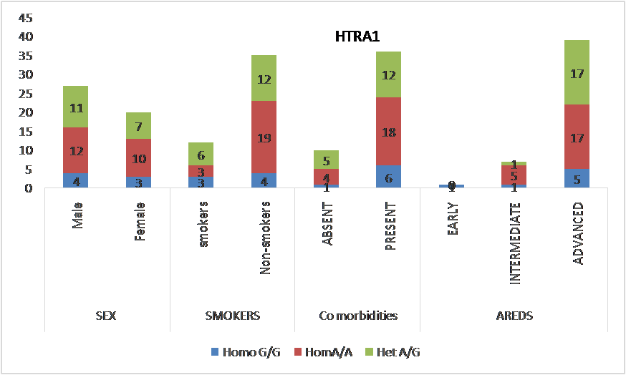
Fig. S14: Association of HTRA1 genotypes with sociodemographic variables. X-axis represents socio-demographic variables and y axis represents number of individuals. Green bar represents Het A/G genotype red bar represents Hom A/A , and Blue bar represents Hom G/G genotype respectively. Statistical analysis was done by SPSS’s Pearson’s Chi Square test, (p≤0.05) was considered statistically significant.
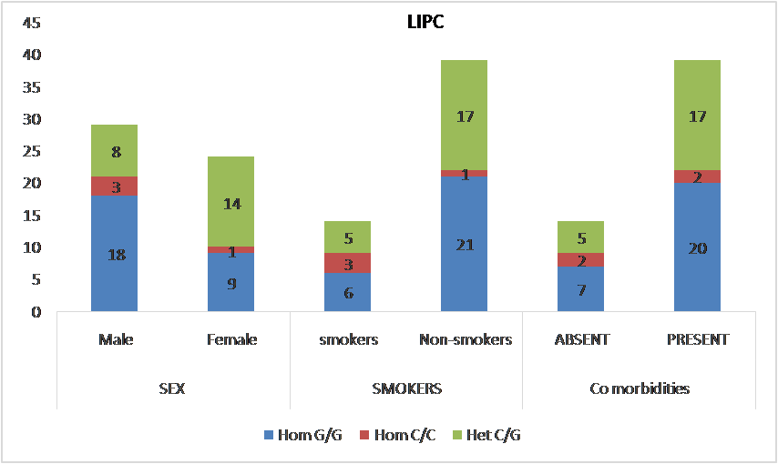
Fig. S15: Association of LIPC genotypes with sociodemographic variables. X-axis represents sociodemographic variables and y axis represents number of individuals. Green bar represents Het C/G genotype, red bar represents Hom C/C , and Blue bar represents Hom G/G genotype respectively. Statistical analysis was done by SPSS’s Pearson’s Chi Square test, (p≤0.05) was considered statistically significant.
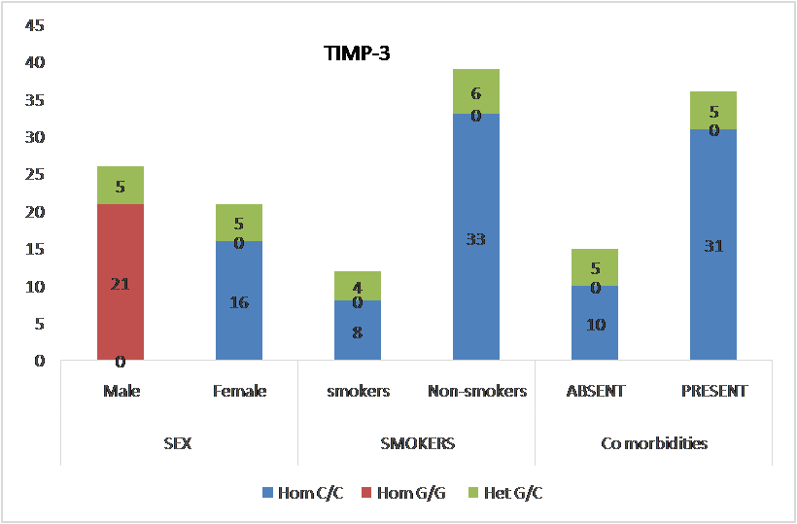
Fig. S16: Association of TIMP3 genotypes with sociodemographic variables. X-axis represents sociodemographic variables and y axis represents number of individuals. Green bar represents Het G/C genotype, red bar represents Hom G/G , and Blue bar represents Hom C/C genotype respectively. Statistical analysis was done by SPSS’s Pearson’s Chi Square test, (p≤0.05) was considered statistically significant.
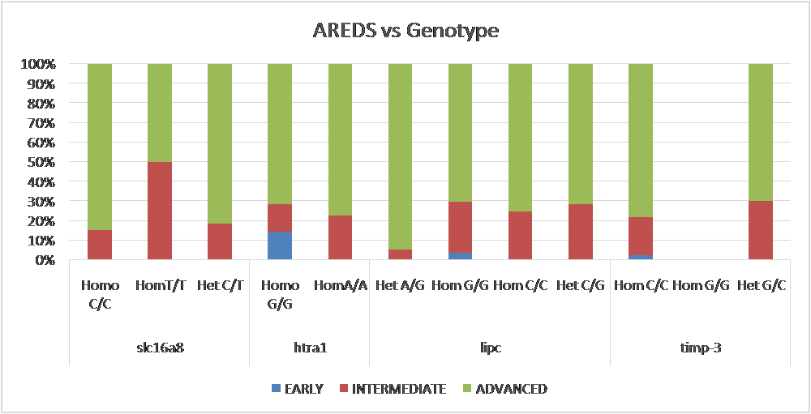
Fig S17: Frequency distribution genotypes of SLC16A8, HTRA1, LIPC and TIMP-3 variants among AMD subtypes.
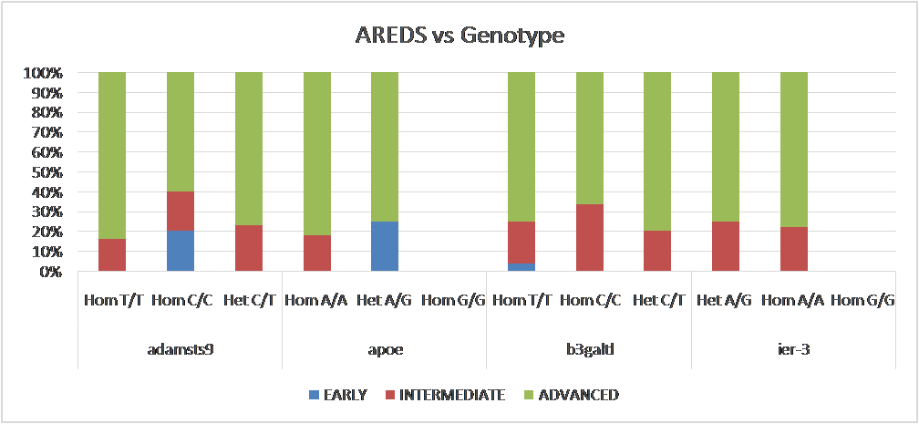
Figure S18: Frequency distribution of genotypes of SNP variants of ADAMTS9, APOE, B3GALTL and IER3 among AMD subtypes

Table S1.Describing association of Genotypes (B3GALTL, IER3, SLC16A8, TIMP3) and clinical findings.
Gene | B3GALTL  N=46 |  |  |  | IER3  N=41 |  |  |  | SLC16A8  N=44 |  |  |  | TIMP3  N=51
Oct findings | TT  N=28 | CC  N=3 | CT  N=15 | p | AG  N=32 | AA  N=9 | GG  N=0 | P | CC  N=26 | TT  N=2 | CT  N=16 | P | CC  N=41 | GG  N=0 | GC  N=10 | P
SRF | 6 | 1 | 6 | .427 | 8 | 2 | 0 | .864 | 8 | 0 | 2 | .287 | 12 | 0 | 2 | .556
IRF | 15 | 0 | 5 | .129 | 14 | 6 | 0 | .224 | 10 | 1 | 7 | .911 | 17 | 0 | 4 | .933
RPED | 9 | 2 | 6 | .478 | 9 | 3 | 0 | .762 | 9 | 0 | 4 | .517 | 14 | 0 | 2 | .387
RPE Irr | 22 | 3 | 11 | .592 | 26 | 7 | 0 | .816 | 20 | 2 | 13 | .877 | 34 | 0 | 8 | .828
Fibrosis | 4 | 1 | 5 | .311 | 8 | 3 | 0 | .618 | 6 | 0 | 4 | .727 | 12 | 0 | 1 | .210

Table S2: Proteins levels with respect to their genotypes of studied SNP variants
Gene | ADAMTS9  (N=43) |  |  |  | APOE  (N=49) |  |  |  | B3GALTL  (N=46) |  |  |  | IER-3  (N=41)
 | TT  (n=25) | CC  (N=5) | CT  (N=13) | P | AA  (N=45) | AG  (N=4) | GG | P | TT  (N=28) | CC  (N=3) | CT  (N=15) | P | AG  (n=32) | AA  (N=9) | GG | p
Protein levels  (Mean±SD) | 2.43 ±  0.909 | 2.53 ±  1.098 | 2.83±  1.61 | 0.61 | 0.005±  0.0045 | 0.0057±  0.002 |  | 0.75 | 4.80 ±  3.31 | 3.72 ±  1.92 | 3.78±  2.09 | 0.51 | 1.45±  2.44 | 0.92±  2.05
 | SLC16A8  (N=44) |  |  |  | HTRA1  (N=47) |  |  |  | LIPC  (N=53) |  |  |  | TIMP3  (N=51)
 | CC  (N=26) | TT  (N=2) | CT  (N=16) | P | GG  (N=7) | AA  (N=22) | AG  (N=18) | P | GG  (N=27) | CC  (N=4) | CG  (N=22) | P | CC  (N=41) | GG  (N=10) | GC | p
Protein levels  (Mean±SD) | 0.92 ±  1.01 | 0.86 ±  1.21 | 0.55 ±  0.80 | 0.47 | 1.7 ±  0.36 | 2.8 ±  1.4 | 4.12±  4.11 | 0.12 | 1.32 ±  1.4 | 1.98±  3.24 | 1.67 ±  1.67 | 0.66 | 0.042±  0.035 | 0.035±  0.020 |  | 0.48

