Electronic Supplementary Information (ESI)
For
A combinatorial approach for the fabrication of magneto-optical hybrid nanoparticles
Dmitry Koktysh^{[a,b] *} and Wellington Pham^{[c,d,e] *}

ª Department of Chemistry, Vanderbilt University, VU Station B 351822, Nashville, TN, 37235, USA. Fax: 615 343-6763; Tel: 615 343-6763;
^{b} Vanderbilt Institute for Nanoscale Science and Engineering, Vanderbilt University, Station B 350106, Nashville, TN 37235, USA; *dmitry.koktysh@vanderbilt.edu

^{c} Institute of Imaging Science, Vanderbilt University, 1161 21st Avenue South, AA. 1105 MCN, Nashville, TN 37232, USA;
^{d} Department of Radiology and Radiological Sciences, Vanderbilt University, 1211 Medical Center Drive, Nashville, TN 37232, US;
^{e} Department of Biomedical Engineering, Vanderbilt University, Station B 35163, Nashville, TN 37235, USA;
*wellington.pham@vanderbilt.edu

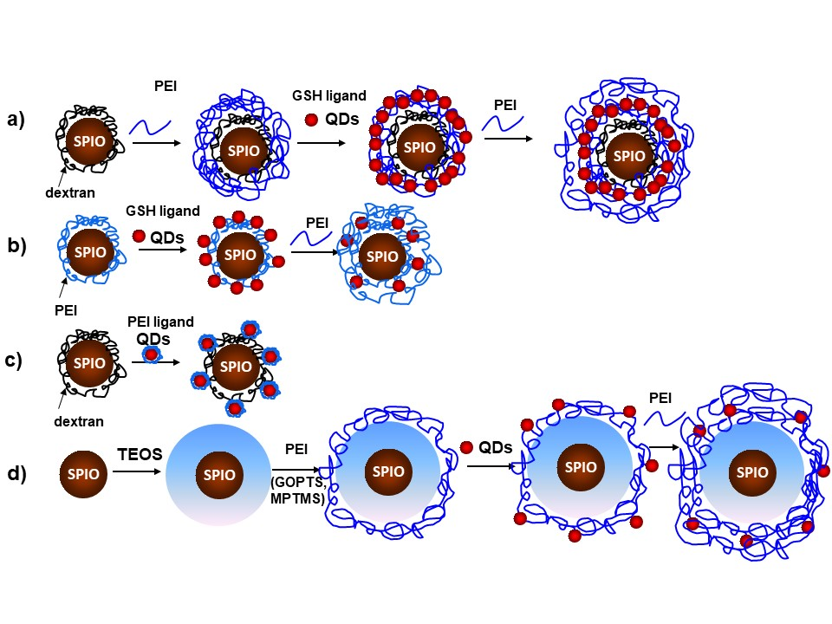
Figure S1. Schematic diagram illustrating the conjugation of QDs to SPIO NPs using different routes of assembly.
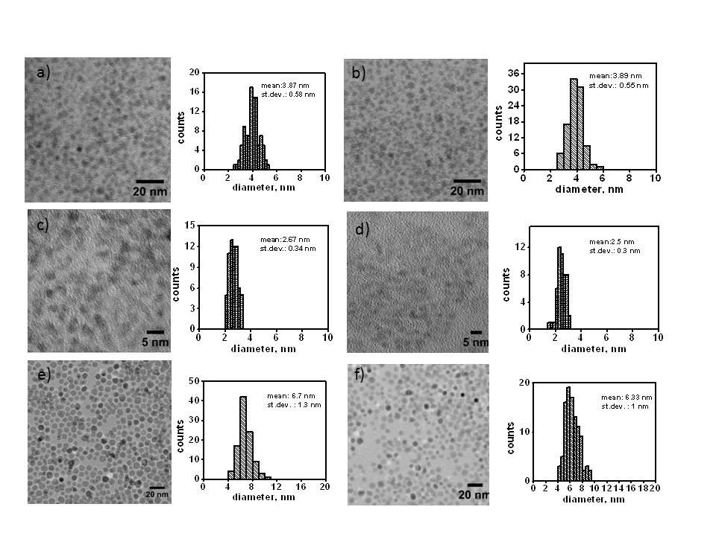
Figure S2. TEM images and size distributions of AgInS₂/ZnS (a,b), CuInS₂/ZnS (c,d) QDs and SPIO NPs (e,f) before and after phase transfer into an aqueous solution.

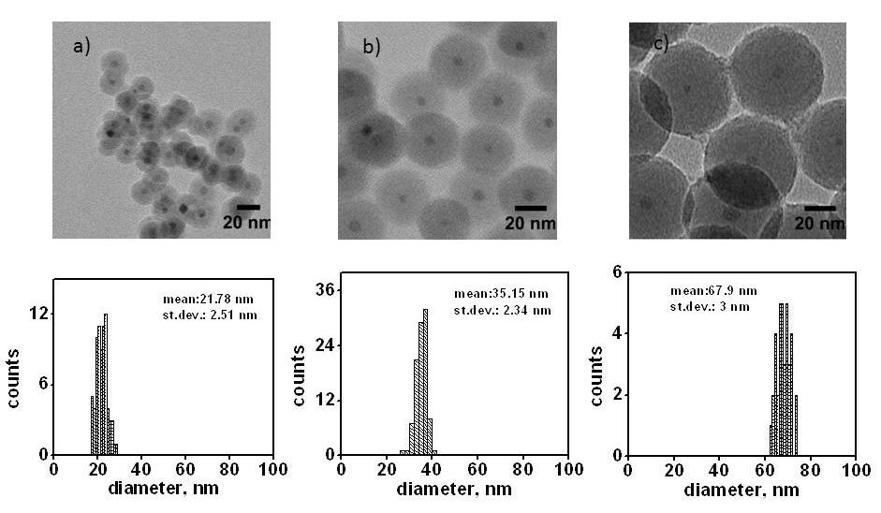
Figure S3. TEM images of SPIO NPs incorporated into silica at different reaction times: a) 18h, b) 24h, c) 48h.

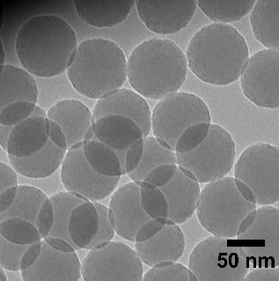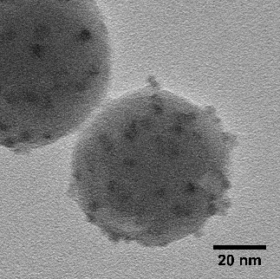
a)
b)
Figure S4. High-resolution TEM images of SiO₂ NPs (a) and SiO₂ NPs further coated by AgInS²/ZnS QDs (b).

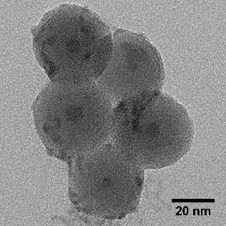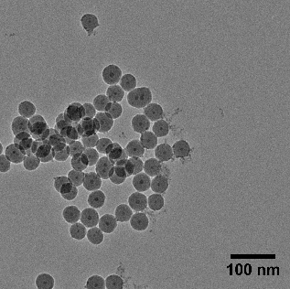
b)
a)

Figure S5. TEM images of MPTMS (a) GOPTS (b) functionalized SPIO-SiO₂ NPs conjugated to QDs.

e)
c)
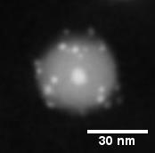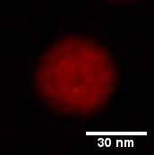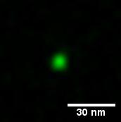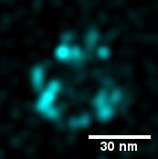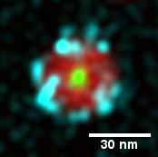
Ag
Fe
Si
d)
b)
a)

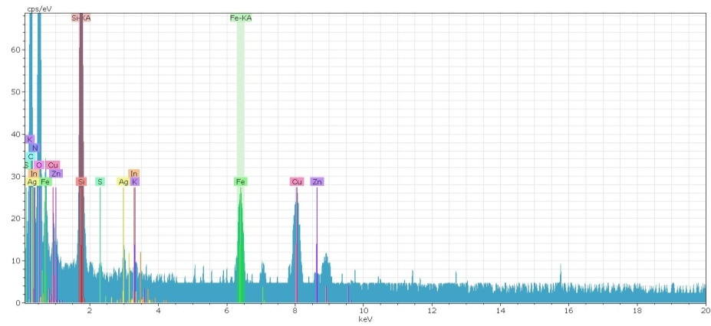
f)

Figure. S6. HAADF image of hybrid NP consisting from SPIO NP incorporated into a silica and coated by PEI and AgInS₂/ZnS QDs(a), EDS maps (b-e) and spectrum (f) of hybrid NPs.

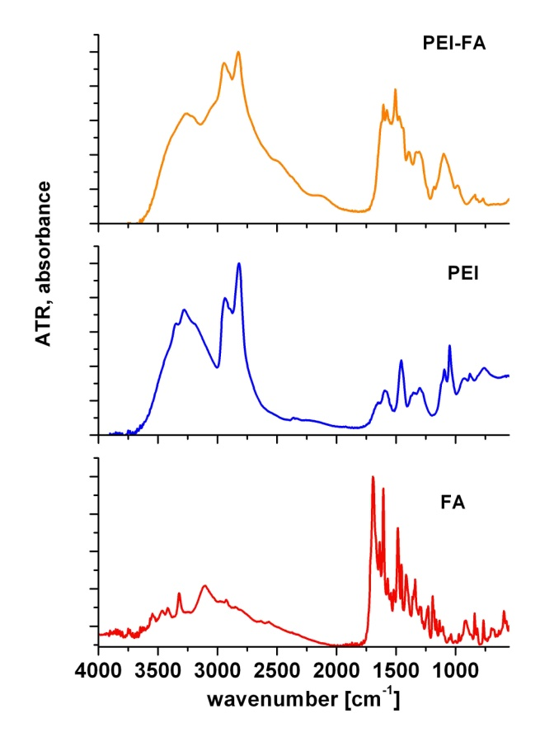
Figure S7. Attenuated total reflection (ATR) spectra of FA, PEI and folate conjugated PEI complex.
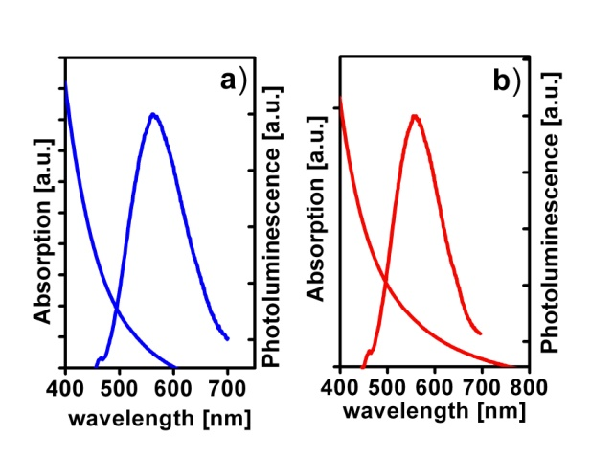
Figure S8. Absorption and photoluminescence spectra of MOHNPs without (a) and with folic acid (b) on the surface.

