Supplementary materials

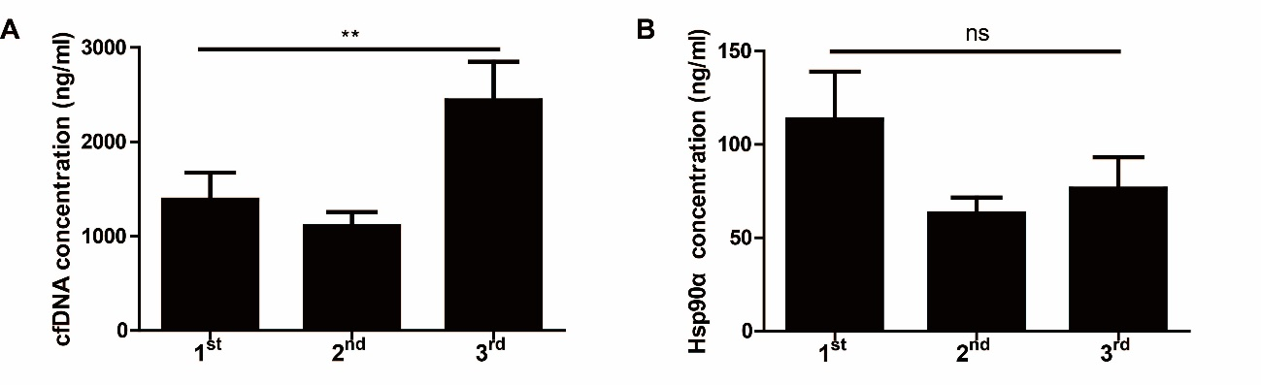
Supplementary Figure S1. cfDNA and Hsp90α concentrations in 10 ESCC patients who received chemotherapy and underwent curative resection successively. A. Bar plot of cfDNA concentrations at three time points. B. Bar plot of Hsp90α concentrations at three time points. 1st, 2nd and 3rd mean different time points of detecting as showed in Figure 1. ** P < 0.01, ns, not significant.

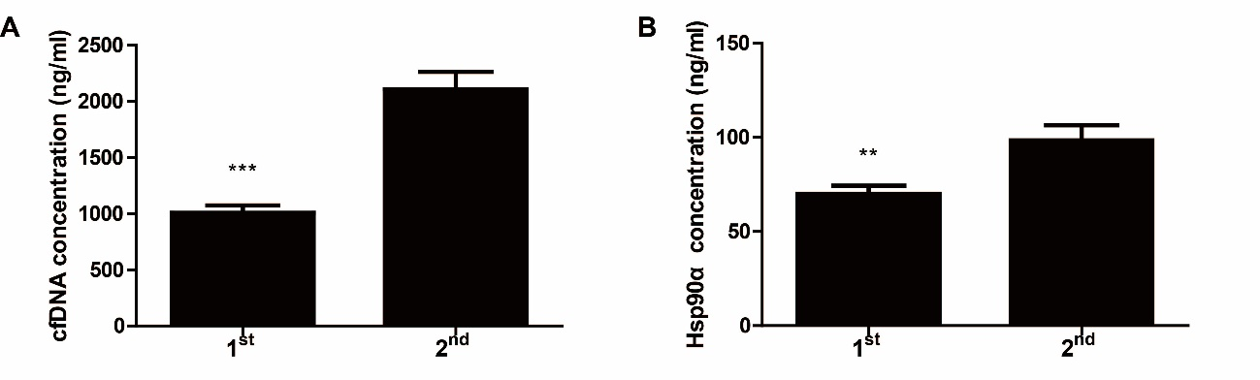
Supplementary Figure S2. cfDNA and Hsp90α concentrations in 61 ESCC patients who only received the surgical treatment. A. Bar plot of cfDNA concentrations at two time points. B. Bar plot of Hsp90α concentrations at two time points. 1st and 2nd mean different time points of detecting as showed in Figure 1. ** P < 0.01, *** P < 0.001.

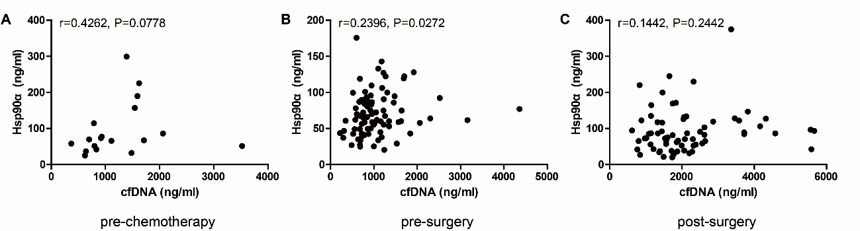
Supplementary Figure S3. Correlation between concentrations of cfDNA and Hsp90α 1-3 days pre-chemotherapy (A, n=18, r=0.4262, P=0.0778), 1-7 days pre-surgery (B, n=85, r=0.2396, P=0.0272), and 7-14 days post-surgery (C, n=67, r=0.1442, P=0.2442).

