Supporting information

Platelet-mimicking drug delivery nanoparticles for enhanced chemo-photothermal therapy of breast cancer
Wenjing Pei, ^{a, b} Biying Huang, ^{a, b} Sijie Chen, ^{a, b} Long Wang, ^{c} Yan Xu ^{a, b} and Chengcheng Niu ^{a, b,} *
ª Department of Ultrasound Diagnosis, The Second Xiangya Hospital, Central South University, Changsha, Hunan 410011, China
^{b} Research Center of Ultrasonography, The Second Xiangya Hospital, Central South University, Changsha, Hunan 410011, China
^{c} Department of Orthopedics, Xiangya Hospital, Central South University, Changsha, Hunan 410008, China
Keywords
Platelet-mimicking, Drug delivery, IR780, Doxorubicin, Chemo-photothermal therapy
Address all correspondence to: Chengcheng Niu, Department of Ultrasound Diagnosis and Research Center of Ultrasonography, The Second Xiangya Hospital, Central South University, Changsha, Hunan, China, 410011; E-mail: niuchengcheng@csu.edu.cn

The preparation of platelet membranes: To isolate platelets, the mice whole blood was first centrifuged at 300 × g for 5 minutes at room temperature. The supernatant is then collected and centrifuged at 300 × g for another 5 minutes. The supernatant obtained is platelet rich plasma（PRP）. Afterwards, the PRP was centrifuged at 2000 × g for 4 minutes in order to precipitate the platelets. The platelets membrane was obtained by repeated freeze–thaw process. Aliquots of PLT suspensions were frozen at −80 °C, and thawed at room temperature. After repeated three times, the pellet was washed with PBS at 2,1000 × g for three times and finally resuspended in water, sonicated for 5 minutes and stored at -80 °C.

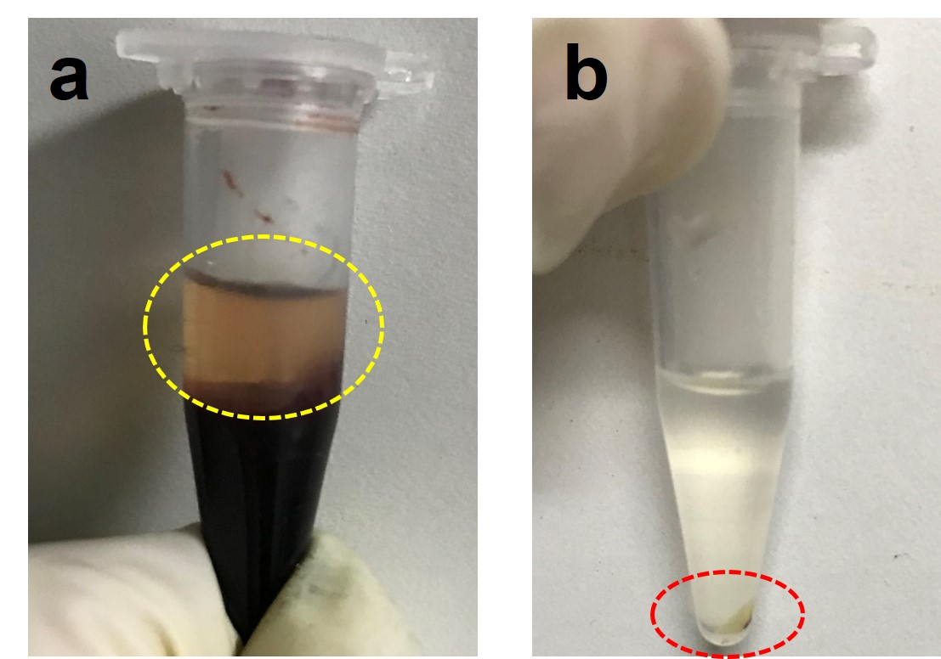
Fig. S1. Centrifugation to obtain platelets. (a) The supernatant was PRP, indicated with yellow dash circle. (b)The precipitation was unpurified platelets, indicated with red dash circle.
Fig. S2. Photograph of platelets isolated from whole blood under light microscope, scale bar: 50 nm.
Fig. S3. Size distribution of PM-NPs.
Fig. S4. Fluorescence images of Raw264.7 cells incubated with NPs and PM-NPs for 0.5, 2.0, and 4.0 h. Scale bar: 100 μm.

Fig. S5. Pharmacokinetics of NPs and PM-NPs after intravenous injection via tail vein at IR780 dose of 0.7 mg/kg. The plasma IR780 concentration curves of the NPs and PM-NPs.
Fig. S6. In vivo fluorescence images of the Dox distribution in tumors of the 4T1 tumor bearing mice treated with NPs and PM-NPs. Scale bar: 100 μm.

Fig. S7. The body weight variation of 4T1 tumor-bearing mice during the treatment.
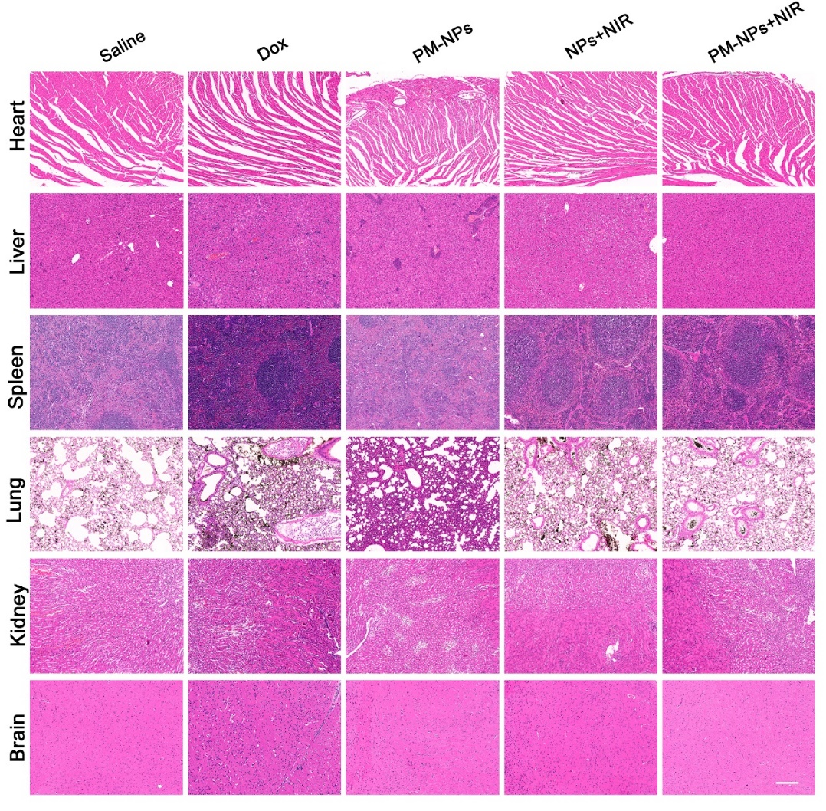
Fig. S8. Histological observation of the organs collected from the 4T1 tumor-bearing mice after the treatment at day 18. The organ sections were stained with H&E. Scale bar: 200 µm.
Table. S1 Drug loading content and encapsulation efficiency of PM-NPs.
 | Drug loading content (%) | Encapsulation efficiency (%)
IR780 | 1.69 | 71.26
Dox | 1.11 | 46.76

Table. S2 Pharmacokinetic parameters of the NPs and PM-NPs.
Parameter | NPs | PM-NPs
AUC (μg/mL·h)_{0-t} | 118.05±7.1 | 213.34±18.14**
T_{1/2} (h)  CL (mL/h) | 12.974±1.8  0.217±0.013 | 30.800±3.1***  0.121±0.010***
AUC_{0-t}: Area under plasma IR780 concentration versus time curves
T_{1/2}: Elimination half-life
CL: in vivo clearance rate
**p˂0.01, ***p˂0.001 (two-tailed Student’s t-test).

